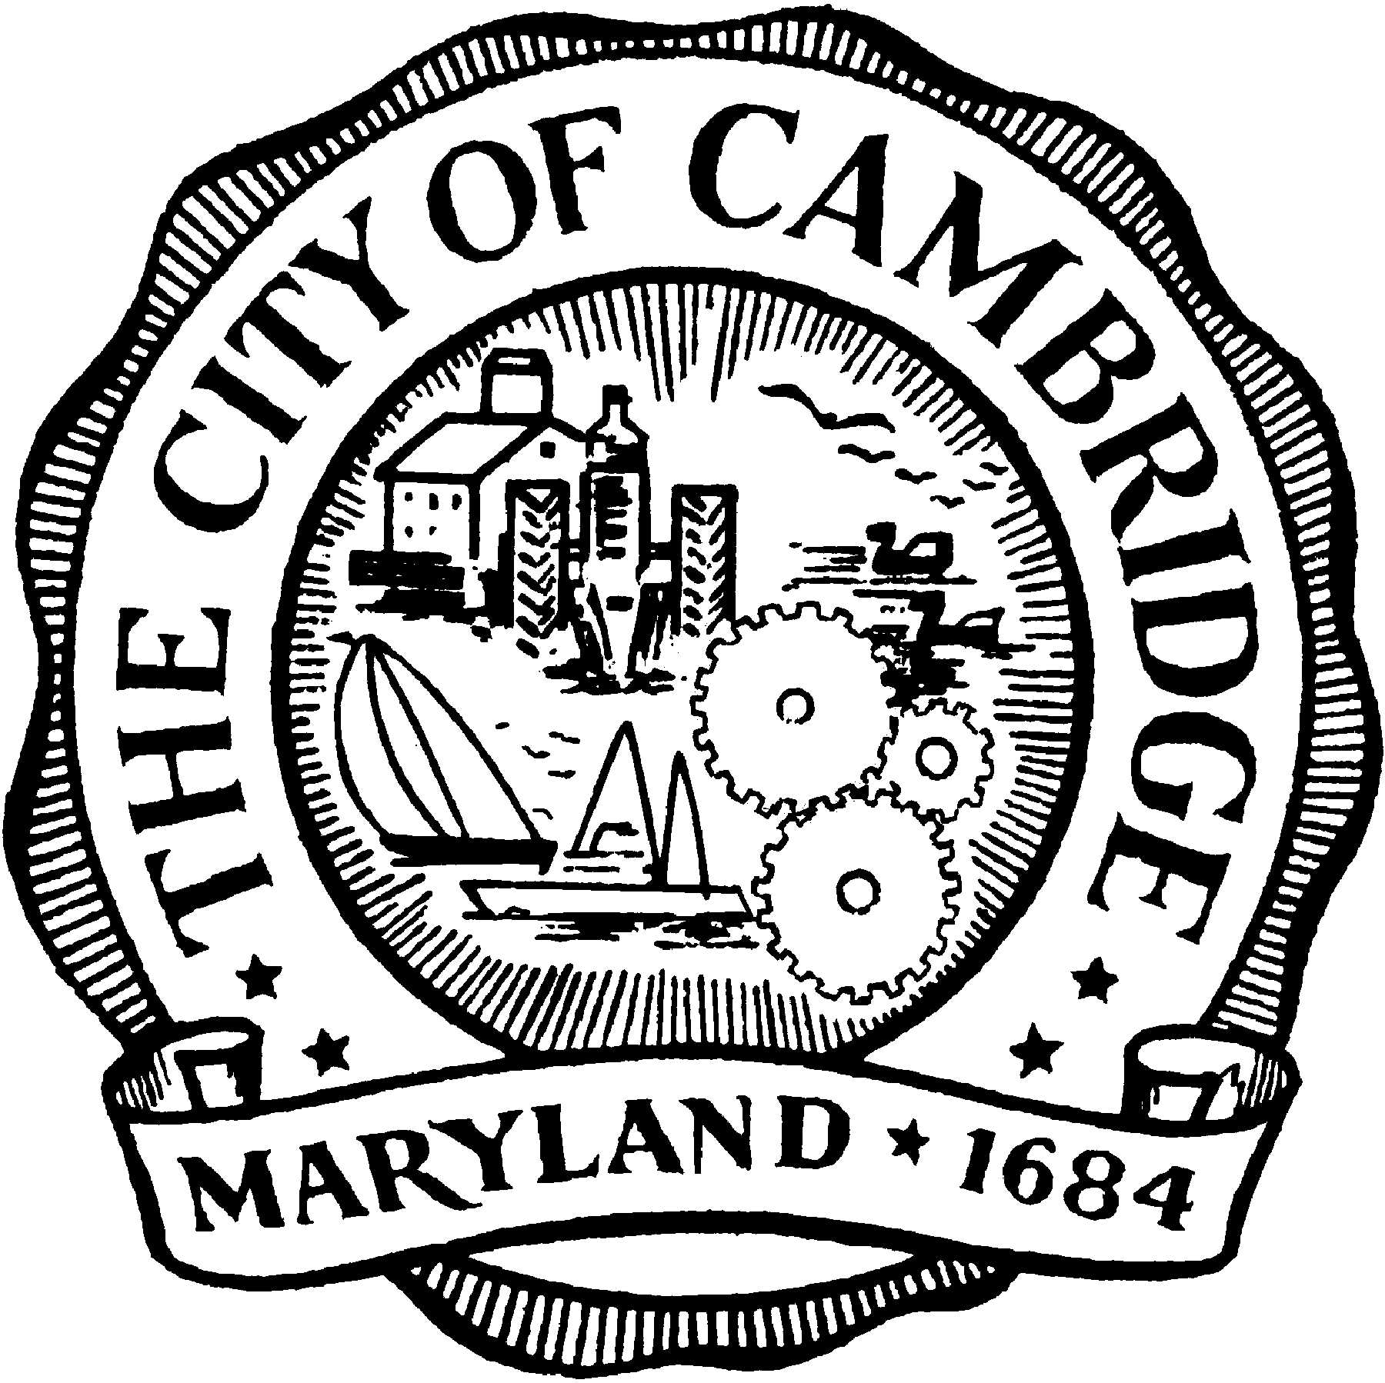
City of Cambridge

Department of Public Works

Planning & Zoning
1025 Washington St.
Cambridge, Maryland 21613
Telephone: 410-228-1955
Fax: 410-228-3814

Community Meeting
about the Historic District Design Guidelines

The City of Cambridge Historic Preservation Commission will conduct a public meeting on Wednesday, January 24, 2018 at 6:00 p.m. at City Council Chambers, 305 Gay Street. The following items are on the agenda for this meeting:

Meet & Greet:
- Introduction of Commissioners and Staff

Presentation of the Design Guidelines:
- General ideas for the Content; Purpose of the Design Guidelines
- Presentation of the main chapters headlines; Guidelines Outline
- Explanation of review process and Guidelines approval

Review of Public Survey:
- Impressions and comments; review of key questions
- Input from the public
- Analysis of survey responses (if available)

Comments:
- From the public on what they would like to see being addressed
- From Staff and Commissioners on the timeline and publication

HPC Design Guidelines – Schedule
January 19, 2018
Nov. 27 RW to provide outline list of Survey questions to be sent to Home owners & contractors (for HPC & staff review and input)
Nov. 29 Work Session with HPC (discussion of issues with current HP Guidelines & review of draft Survey outline)

Dec. 1 Target Date
Survey Draft sent to be reviewed by HPC & Staff
Comment back to staff Dec. 7

Dec. 11 Target Date
Send finalized Survey out (consider 25days for feedback, 15 days for compiling;7 weeks total = Jan.29)

Dec. 19 Meeting - Tentative 6 pm
Regular HPC meeting (possible discussion about Guidelines at 6pm)
Jan. 15-19 Advertise Community Meeting for date during Jan. 24th – send out email blast
Jan. 18 Meeting – Tentative 6 pm
Regular HPC meeting

Jan. 24 First Community Meeting
Announce HP Guidelines revisions to Community, feedback from public) Council notified via email.

Jan.29 Target Date
Results of Survey compiled and published on City’s website – Send out email blast

Feb. 15 Meeting – Tentative 6 pm
Regular HPC meeting

Feb. 19 Target Date
Issue of First Design Guidelines Draft (for HPC to review)

March 2 Target Date
HPC comments to staff by noon

March 12-14 Meeting/Target Date
HPC complied comments to HPC prior to meeting
HPC Comments due; work session to review RW to attend via phone - skype

March 15 Meeting – Tentative 6 pm
Regular HPC meeting

March 19 Target Date
Issue of Second Design Guidelines Draft (for HPC to review)

March 29 Second Community Meeting
Community written comments due

April Work Session

April 16 Target Date
Final Draft of Design Guidelines to HPC

April 19 Meeting – Tentative 6 pm
Regular HPC meeting
April 23 Target Date
Final HPC reach consensus

April 30 Target Date
Report goes to Maryland Historic Trust

To May 15 (45 working days review period from MHT
(May 15 MHT Target Date to submit Draft)
May 17 Meeting – Tentative 6 pm
Regular HPC meeting

June 21 Meeting – Tentative 6 pm
Regular HPC meeting

July 2 Target Date
Staff + RW receives comments from MHT and integrate into Report

July 19 Meeting
Regular HPC meeting

July 23 Meeting
Updated Design Guidelines to City Council

August 6 Target Date
Council Comments are due; staff + RW integrate feedback into comments

August 13 Target Date
HPC and MHT take last look at updated report

August 27 HPC Guidelines to CC for Approval and Adoption

Aug. 28 to 31 Target Date
RW and DPW produce Final Design Guideline report

September 15 Target Date
Publication of Cambridge Historic District Revised Design Guidelines

