

**MORTGAGE SERVICING COMMITTEE**

**The Mortgage Servicing Committee manages Habitat Choptank’s homeowner mortgages.**

**OFFICE**

**Office Volunteers are needed to perform a wide range of administrative tasks in support of Habitat Choptank’s business responsibilities.**

**PARTNERSHIP COMMITTEE**

**The Partnership Committee is responsible for assisting and guiding partner families through the process of becoming homeowners.**

**RESOURCE DEVELOPMENT COMMITTEE**

**The Resource Development Committee works with Habitat Choptank staff in developing fundraising plans, implementing strategies and tasks to generate funds, and soliciting financial support.**

**RESTORE**

**ReStores are outlets that accept donated goods for resale. Volunteers are needed to pick up or accept donations, organize and inventory the materials and goods for resale, greet and assist customers, manage checkout, and assist in the office.**

**RESTORE COMMITTEE**

**The ReStore Committee assists in the operations of the Habitat Choptank ReStore.**

**FAITH RELATIONS COMMITTEE**

**The Faith Relations Committee is responsible for cultivating relationships and partnerships with the faith community in the Habitat Choptank region.**

**FAMILY SELECTION COMMITTEE**

**The Family Selection Committee is responsible for identifying future Habitat Choptank homeowners.**

**FINANCE COMMITTEE**

**The Finance Committee oversees the ongoing financial health of Habitat Choptank.**

**HOS**

**Homeowner Support or HoS are volunteers that donate their professional services or that provide assistance and guidance to existing Habitat Choptank homeowners.**

**LUNCH BUNCH**

**The Lunch Bunch supports Habitat Choptank by providing food for Habitat Choptank events and lunch to team construction volunteers on the jobsite.**

Habitat

for

Humanity

Choptank

Volunteer

Opportunities

**SITE SELECTION COMMITTEE**

**The Site Selection Committee’s responsibilities include land acquisition, land planning, and environmental and community impact planning.**

**SPECIAL EVENTS COMMITTEES**

**Habitat Choptank Special Events Committees are responsible for planning special events.**

**TOOL TENDERS**

**Tool Tender Volunteers organize and conduct a monthly inventory of the tool trailers on the construction sites.**

**VoICE**

**Volunteers in Community Education or VoICE, are representatives of Habitat Choptank that attend various community events on behalf of the organization.**

**YOUTH PROGRAMS**

**Habitat Choptank has several volunteer opportunities for youth including Campus Chapters.**

**DONORS**

**As a nonprofit organization, Habitat Choptank relies on donor contributions. Becoming a donor is another way to support Habitat Choptank. Please consider making a financial contribution or in-kind donation to Habitat Choptank and encourage others to do so as well. Your support empowers hardworking low income families to build a better future through homeownership.**

VOLUNTEER

WITH

HABITAT

**From working on construction sites, in the office, at the ReStore, or serving on committees, volunteers greatly impact every aspect of our organization. For more information, or to learn more about how you can support us, contact our office to get involved!**

**BUILDING COMMITTEE**

**The Building Committee is responsible for guiding the construction program.**

**CONSTRUCTION**

**Construction Volunteers work on nearly every aspect of home building undertaking dozens of tasks such as flooring, renovating, painting, tiling, siding, insulating, framing, and landscaping. No construction experience is necessary!**

**COOKIE CREW**

**The Cookie Crew supports Habitat Choptank by providing cookies to volunteers or for other Habitat Choptank events.**

FOR

HUMANITY

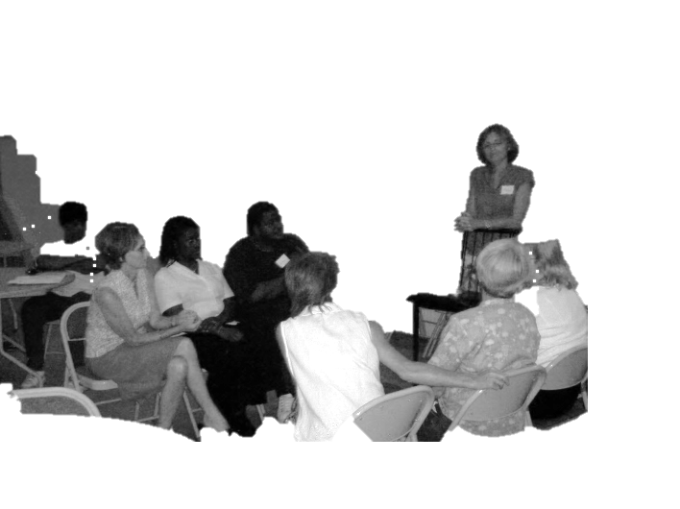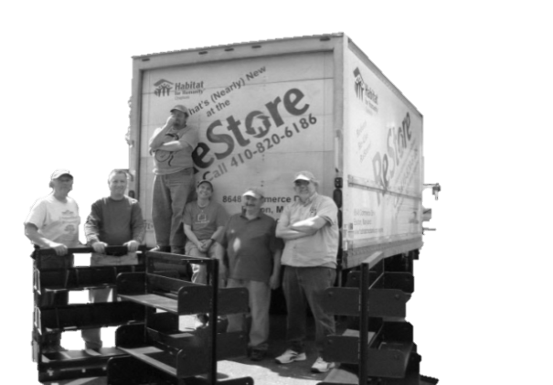 CHOPTANK

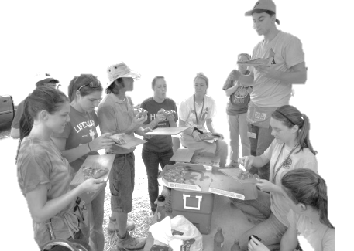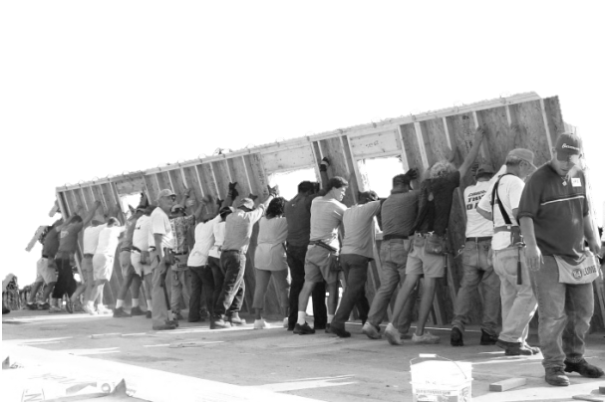

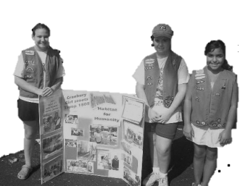

CUT OFF THIS LINE! :)

Updated May 6, 2013

Z:\Volunteers\Volunteer Recruitment\General Volunteering\Volunteer Brochure.docx

Mailing: P. O. Box 2366, Easton, MD 21601

Office: 29350 Maple Avenue, Trappe, MD 21673

Phone: 410 476 3204

Fax: 410 476 3709

Website: www.HabitatChoptank.org

Email: info@HabitatChoptank.org

Like us on Facebook:

www.facebook.com/HabitatforHumanityChoptank

Store: 8610 Commerce Drive, Easton, MD 21601

Phone: 410 820 6186

Fax: 410 820 4144

Website: www.HabitatChoptank.org/ReStore

Email: ReStore@HabitatChoptank.org

Like us on Facebook:

www.facebook.com/HabitatChoptankReStore

“For a community to be whole and healthy, it must be based on people's love and concern for each other.”

**Millard Fuller, founder of Habitat for Humanity**

**Thank you for your interest in volunteering with Habitat for Humanity Choptank! We are delighted that you have taken this opportunity to learn more about how you can support us as we partner with low income families to provide simple, decent, and affordable housing.**

**Since its founding in 1992, Habitat Choptank has made homeownership a reality for over 60 families. Relying on volunteers, financial donations, and material contributions, each Habitat home is the result of a unique partnership among a deserving family, dedicated volunteers, community partners, and inspired donors.**

Volunteerism

and

Habitat

For

Humanity

Choptank

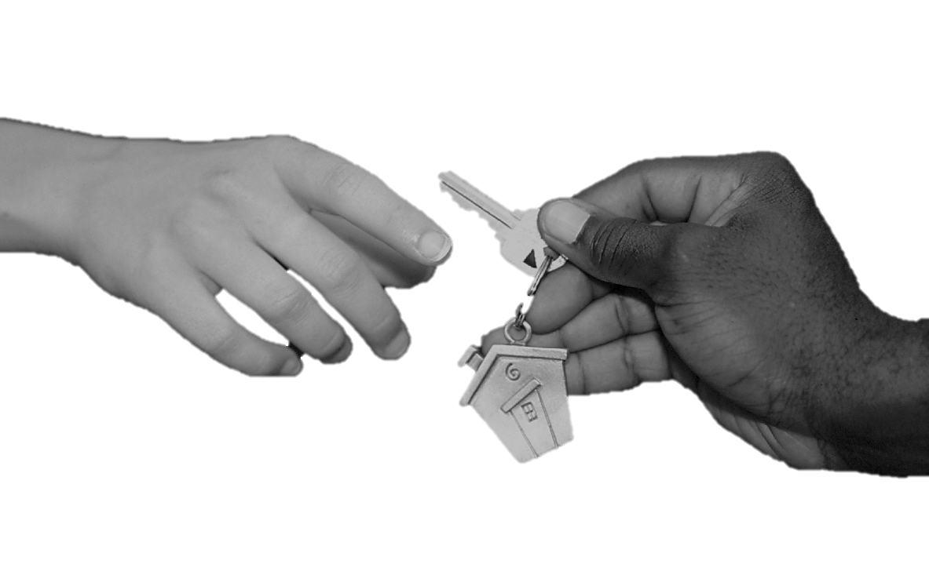

**As a non-profit organization, Habitat Choptank strives to not only build homes but also to collaborate with all people interested in the quality of life in Talbot and Dorchester counties through the creation of affordable housing opportunities.**

**Volunteerism is essential to Habitat Choptank’s program. Volunteering offers many benefits including skill development, career exploration, personal growth, socialization, and the ability to have an impact on the community. Whatever your skill or interest, there is a place for you in our volunteer program. Please contact the Habitat Choptank office to attend a Volunteer Orientation and complete an application and waiver to begin your volunteer experience!**