**APPENDIX B:**

**ARCHITECTURAL STYLES IN THE CAMBRIDGE HISTORIC DISTRICT**

The Cambridge Historic District reflects several centuries of architectural styles. A style means what was in vogue or was considered fashionable at a particular time in history. Shape, materials, detailing or other features make up an architectural style. Many houses reflect the changes in styles that occurred over time. Ornate porch columns may have been replaced with round columns or the roof line altered with a peak.

Throughout its history, Cambridge has always been conscious of architectural trends. The 1852 Italianate section of the Dorchester County Courthouse was designed by John Updike who also designed Trinity Cathedral in New York. The Baltimore architectural firm of Mottu and White designed several houses in the District in the Colonial Revival style.

However, architect, builder and lumber dealer, J. Benjamin Brown has left the most lasting effect on the district. A number of the homes and commercial buildings on Race, High, Mill, Oakley and Locust Streets were designed by Ben Brown. He was self-trained as an architect and his work reflects the architectural styles of the latter part of the nineteenth and early years of the twentieth century. Mr. Brown used Italianate, Queen Anne, Colonial Revival, and Romanesque styles in his designs. He has been credited with at least 40 buildings in the District.

The architecture of the Cambridge Historic District is an indicator of its economic development and changing social values. The described styles demonstrate development of the City of Cambridge within the context of national styles.

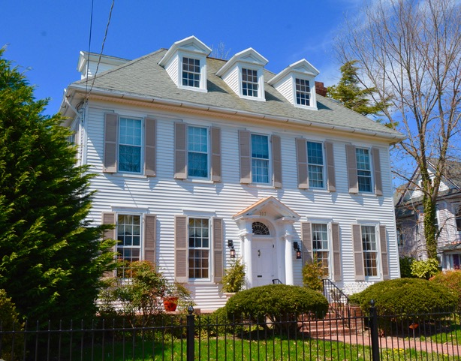

**1. Georgian (1700-1780).**

Named for the English style which was predominate during the reign of the four Georges from 1714 to 1820, the Georgian style has a well-ordered relationship of window and door openings. The main façade usually has a central door flanked by two windows on the first floor and five evenly-spaced windows on the second floor. The paneled front door is frequently capped by a decorative crown supported by flattened columns. In this region, the front entries of early Georgian-style houses lacked decorative ornamentation until around 1760.

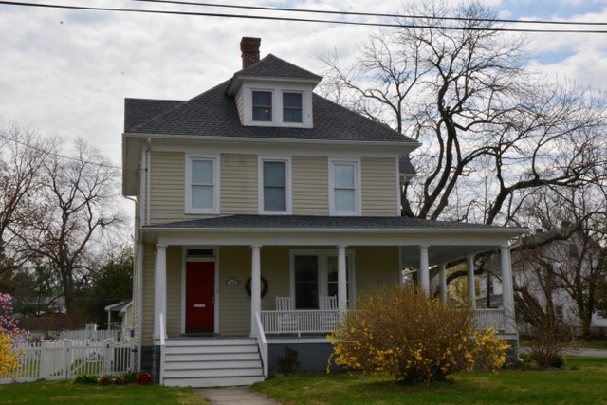

**2. Federal (1780-1820).**

The Federal style flourished after the American Revolution and was essentially a development of the Georgian style. It was also called the Adamesque, after the English architect Robert Adam. The Federal style was characterized by an emphasis on windows due to the ready availability of glass at that time. The Federal-style buildings were two or more rooms deep with door and windows arranged in strict symmetry. Windows were usually large, often having six panes over six and capped with white stone lintels and flat keystones. The elliptical or semicircular fanlight over the front door is almost universal in this style.

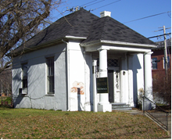

**3. Greek Revival (1825-1860).**

The Greek Revival style (Figure 3) adopted the symmetry and classical proportions of the ancient Greek temple. Constructed with or without a pedimented gable or low-pitched hipped roof, most Greek Revival buildings have full-length or entry porches supported by square or rounded columns. The front door is surrounded by narrow sidelights and rectangular line of transom lights. Exteriors were often stuccoed or painted white. This style was popular for commercial as well as residential buildings.

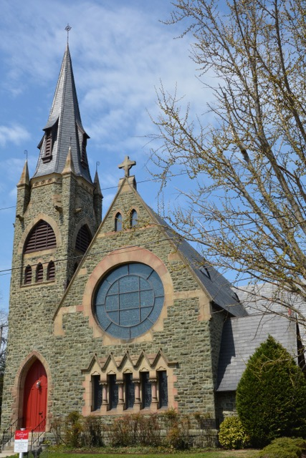

**4. Gothic Revival (1840-1880).**

A hallmark of the Gothic Revival style is the use of a steeply-pitched roof usually with a steep central cross-gable ornamented with scroll-sawn verge boards. The pointed arch frequently present in window openings, door surrounds, dormers and porch ornamentation is another characteristic of this architectural style. Typically, quite elaborate in its architectural details, this style can also be seen in greatly simplified versions. The Gothic Revival style developed as a reaction to classicism and looked toward medieval antecedents for inspiration. It is frequently found in religious buildings.

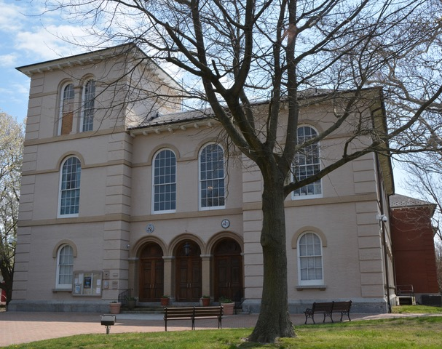

**5. Italianate (1840-1885).**

Most buildings in the Italianate style are at least two stories in height, having low-pitched roofs with widely overhanging eaves with crowns of an inverted “U” shape. A tower or cupola often contributed to the vertical emphasis of the Italianate facade, which can be symmetrical or asymmetrical. On large lots, the buildings are often rambling or “L” shaped. These houses were intended to resemble villas found in the Italian countryside.

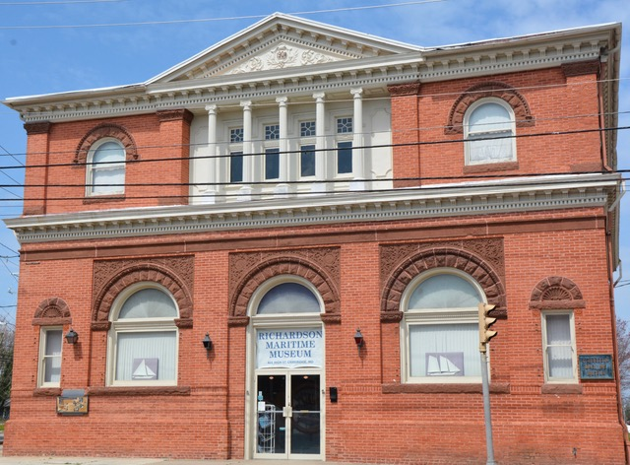

**6. Romanesque (1880-1900).**

Henry Hobson Richardson is frequently identified with the Romanesque style of architecture, which was developed in Boston in the 1870s. It is based on the medieval Romanesque architecture of France and Spain. Of masonry construction, it is characterized by round-topped arches occurring over windows and entrances. Squat dwarf columns, deeply recessed windows and densely carved decoration with interlaced motifs are frequently found on buildings of this style.

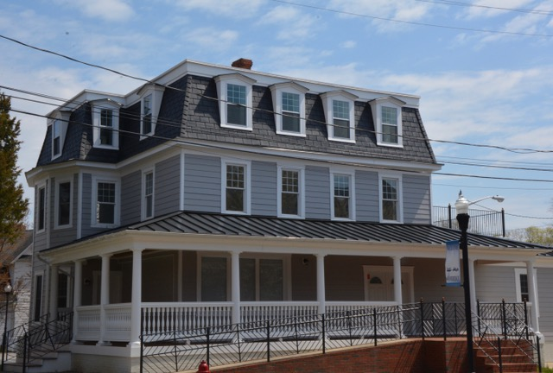

**7. Second Empire (1855-1890).**

The French Second Empire style was derived from the architectural forms that were developed during the reign of Napoleon III from 1853 to 1870. It is noted for its Mansard roof, which most often has dormers that increase floor space and give more light in the attic level. Frequently this style has many decorative elements.

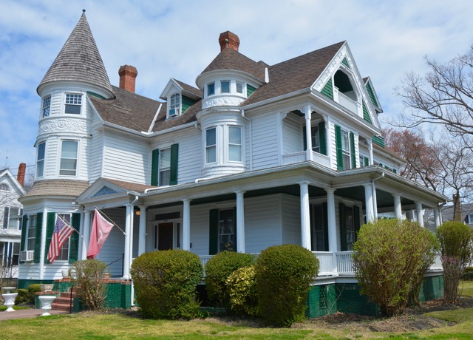

**8. Queen Anne (1880-1910).**

The Queen Anne style popularized by a group of English architects led by Richard Norman Shaw, had little to do with Queen Anne or the formal Renaissance architecture which dominated her reign, but more with Elizabethan and Jacobean models. Irregularly-shaped and steeply-pitched roofs with a dominant front gable and cutaway bay windows were typical. A partial or full-width porch, extending along one or both side walls was used. Windows with a large pane of glass surrounded by smaller square panes help to identify the style. Pattern shingles were used to eliminate a smooth-walled surface. Contrasting forms, textures and materials, and decorative details, such as spindlework (which is also called "gingerbread" or Eastlake ornamentation) mark this style. Towers are usually round or polygonal, rather than square. A Queen Anne sub-style known as Free Classic is frequently found in the Cambridge Historic District. It often used Doric columns the full height of the porch or raised on a pedestal to the level of the porch railing. This style was popular after 1890 and has much in common with the asymmetrical Colonial Revival houses.

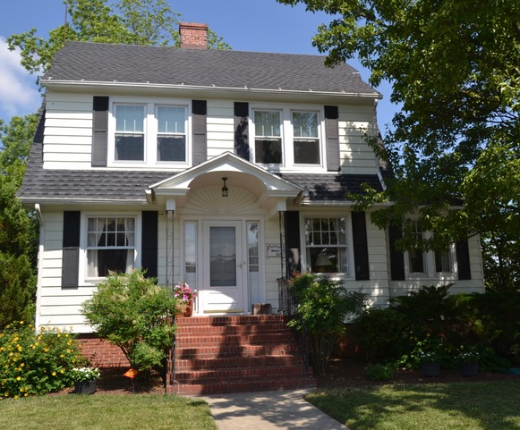

**9. Eclectic (1890-1910).**

The Eclectic style borrowed from all colonial American and European architectural styles. Elements of a number of different styles, such as Georgian, Italianate, Second Empire, Gothic and Greek Revival, and Queen Anne were combined in a single building.

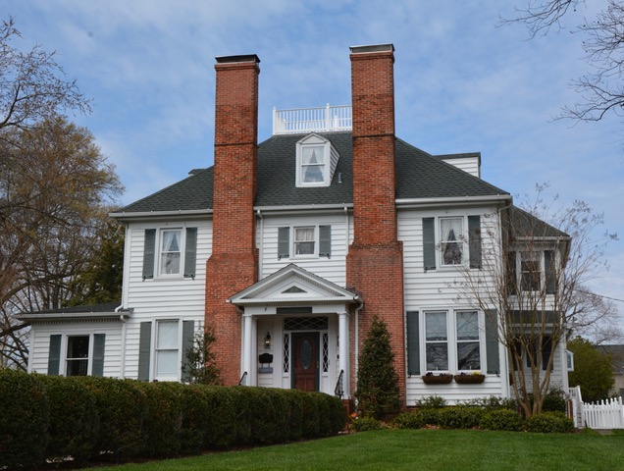 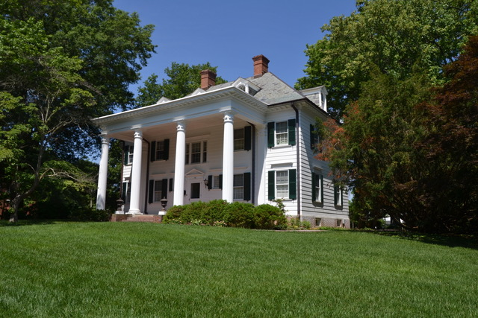

**10. Colonial Revival (1880-1955).**

The Colonial Revival style began to emerge in the beginning of the1880s. There was a growing interest in America's past and in historic preservation. This style borrowed heavily from Georgian, Greek Revival and Federal buildings. Most houses of this period are a mixture of these elements. The accentuated front entries usually featured sidelights with or without fanlights and frequently had porticos supported by slender columns.

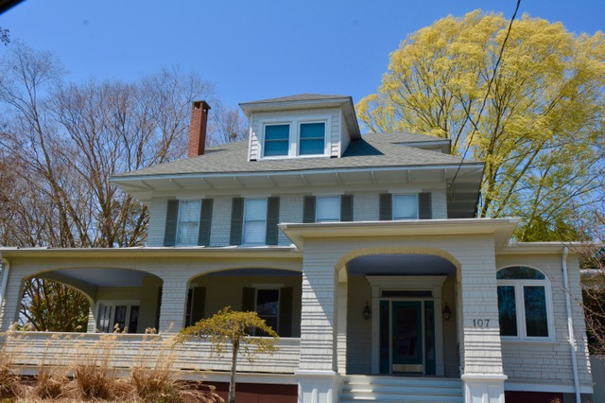

**11. American Four-Square (1890-1920).**

The term "four-square" denotes a type of house which is often grouped with the Colonial Revival style. The American Four-Square is usually a two-story, two-bay building in a cubic shape, using a pyramidal or hipped roof with a one-story porch extending the full width of the main facade. The porch columns often stand on substantial masonry pedestals. Houses of this style frequently had front-facing hipped dormers.

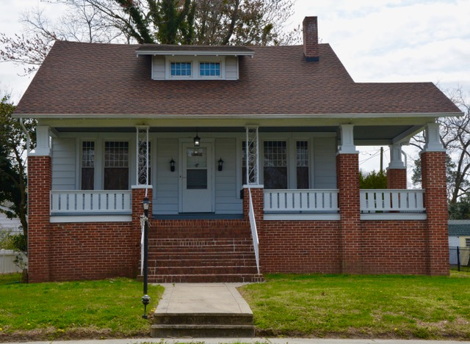

**12. Bungalow (1905-1930).**

The Bungalow style was primarily an independent Western movement in American architecture. Its guiding force was the English Arts and Crafts movement which rejected the mass reproduction and poor design associated with the Industrial Revolution. The Craftsman magazine published from 1901 to 1916 by furniture designer and maker Gustav Stickley (1848-1942) was the American source for these ideas. It coincided with the building boom of the first thirty years of the twentieth century for small single-family and two-family houses which marked the development of the suburb. The style is characterized by a low-pitched gable roof with wide unenclosed eave overhangs. The roof rafters are usually exposed. The porches are partial or full-width, frequently supported by tapered square columns or pedestals. The bungalow may be one or two stories.

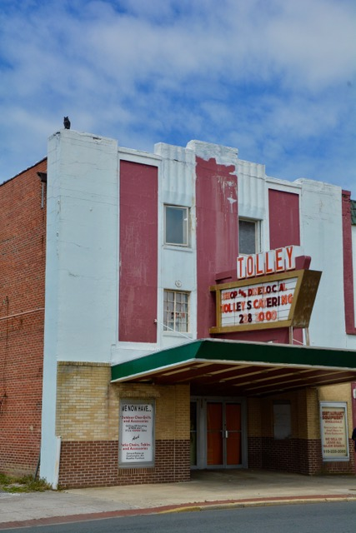

**13. Art Deco (1920-1970).**

The European-based Art Deco style (Figure17) was seldom used in single-family homes, being best suited for apartment buildings, schools and theaters. It was a curious blend of Modernism, history and fantasy, mixed with Mayan, Assyrian and Moorish images. Doorways frequently used tropical motifs. Art Deco buildings made use of new materials such as plywood, reinforced concrete, steel and chrome.