APPENDIX C:
DEVELOPMENT OF CAMBRIDGE — ECONOMIC AND GEOGRAPHIC FACTORS
Note: the following narrative is reproduced from the original HPC Guidelines for the City of Cambridge with references provided.
Cambridge is located on the Choptank River which is the longest river on the Eastern Shore and probably the best known. It is one of the oldest towns in the state and was laid out in 1684. It is the county seat of Dorchester County which has the largest number of square miles (688) of any county in the state of Maryland. Most of the population lives in Cambridge. As a city it is known for its flower gardens, shaded streets, and beautiful buildings.
The Cambridge Historic District is found in Wards I and III. Most of the buildings date from the second half of the nineteenth century and the first three decades of the twentieth century when the town experienced great prosperity and growth. The boundaries of the District are well defined. In general the oldest buildings are found in the eastern part of the District and become more recent as one goes west. The District was nominated to the National Register of Historic Places on July 25. 1990.
Dorchester County was established in 1669 and at that time there was a need for a central government or a courthouse but not a town. It was not until 1683 that the Maryland Assembly passed a bill to set up towns, port and points of entry for the export of tobacco. The records for the establishment of the City of Cambridge are incomplete. The commission that was established to lay out ports and towns may also have made the survey which laid out some lots in which were to become Cambridge. The survey was made in 1684 but it is not clear who made the survey and who had title to the original lots. The land that was to become Cambridge was part of the Choptank Indian Reservation. The name Cambridge was used by the Maryland Assembly on September 15, 1686 and is thought to be the name that was used by the commission that did the survey in 1684.
A Commission appointed by the Maryland Assembly under the Act for Advancement of Trade and Erecting of Ports and Towns in the Province of Maryland was established in 1706. The plat from the earlier survey had been lost and a new survey had to be initiated. The Commission mentioned a courthouse, the Church of Great Choptank Parish, several dwellings, High Street and Wood Street. Race Street was named Wood Street at that time.

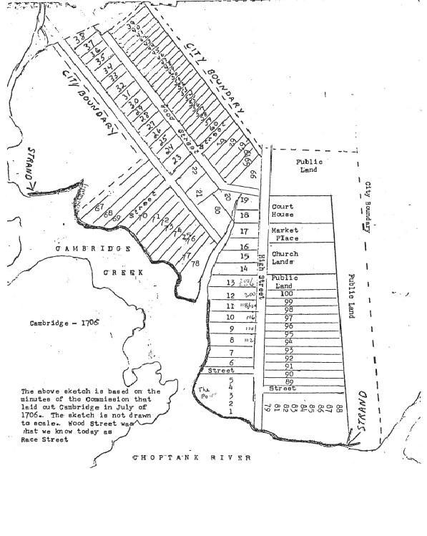
Source: Charles Mowbry
By 1719 trading ships from London and Liverpool began to dock in Cambridge bringing goods and serving as Dorchester County’s major marketing point for tobacco, seafood, and muskrat pelts. It is more than likely with Cambridge’s growth as a port that Africans also entered here. A number of enslaved blacks were brought to the county in 1699 in the ship “African Galley” by Captain Richard Bradshaw of London. As a port Cambridge also began to develop a shipbuilding industry.
In 1745 Cambridge was incorporated by an Act of Assembly and began to grow slowly prior to the Revolutionary War. It is estimated that the city had around 50 houses and a population of about 400 in the 1770’s. In 1770 Cambridge had a race track. It may be during this time that horse racing was conducted on Race Street when the court was in session. A 1799 plat shows many of the early streets of the historic district which are High Street, Mill Street. William Street, parts of Locust and Church Streets, Race Street, Gay Street and Poplar Street.
During the War for Independence Cambridge became the headquarters for military operations on the Eastern Shore due to the influence of local individuals who served on revolutionary conventions. Thousands of pounds of barrels of flour left Cambridge from local grist mills by boat to the Head of the Elk to be trans-shipped to the Continental Army. A number of Tories in 1770 were imprisoned in Cambridge from Worcester and Somerset Counties and in 1778 one hundred and ten men from the British frigate Mermaid captured in Worcester County were taken to Philadelphia from Cambridge. The Colonial Gaol or jail was located on Locust Street. Rev. Freeborn Garrettson, a Methodist missionary, was imprisoned there for preaching the gospel in 1780.
By the 1790’s the output of tobacco was declining as indicated by the inspection records for the crop in Dorchester County. Wheat, corn, and other food crops had become the staples of the county’s agricultural economy. The planting of these crops caused a decline in need for year-round work for enslaved blacks and led to farmers to hire free laborers. Many whites in Dorchester began to free their slaves. In 1790, 36.9% of Dorchester blacks were free and 43.1% were free by 1850.
However, the Deep South began to need more enslaved labor after 1790 for the production of cotton. 0n the Eastern Shore of Maryland county seats were the centers for the trading of slaves. It is more than likely that Cambridge being a port and a county seat was used to ship slaves south.
Increase in grain production led to the shipping of meal and flour from Cambridge prior to the Civil War. The flat land allowed the building of several windmills for the grinding of grain. Mill Street takes its name from such a mill. The last windmill for such use was built at the foot of Muir Street in 1858 by Caleb Shepherd. This activity led to shipbuilding on Cambridge Creek of large coastal vessels. In 1849 James A. Stewart started a shipbuilding business which used local pine and oak.
J. W. Crowell in 1869 established a large lumber and flour mill on Cambridge Creek. This mill produced lumber for the Central Pacific railroad cars, boat frames, and flour barrels. After being destroyed by fire in 1877 the rebuilt firm became known as the Cambridge Manufacturing Company. In the late 1860’s the Cambridge Harbor, Internal Navigation and Wharf Company was formed to remove a sandbar that hindered boat traffic in the creek which eventually gave the city one of the best and safest harbors in Maryland.

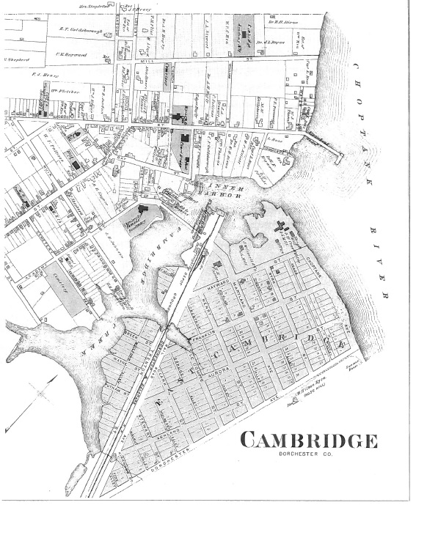

Military supplies during and after the Civil War were shipped from Cambridge. In 1860 the city had a population of around 1200. During the next decade a railroad and telegraph lines were established in addition to improved steamboat service with Baltimore The Cambridge and Seaford Railroad which was completed in 1869 was first called the Dorchester and Delaware Railroad. Its original terminal was to be on the Choptank River on land between Mill Street and Choptank Avenue instead of on present day Maryland Avenue. The line for the first telegraph paralleled the railroad and came to Cambridge in l868.These developments led to a long period of prosperity for the City of Cambridge.
After the Civil War, the economic development and explosion of the Industrial Revolution did not occur in Charleston. It languished in mothballs until early this century when [the] fathers and mothers of our city were smart enough to realize what we had. Its beauty, grace, diversity, and quality have enriched all who have lived there and those who visit.
Charleston Mayor Joseph P. Riley Jr.

In 1876 the population of Cambridge was around 1800 with 436 houses. Two years earlier Colonel James Wallace began packing oysters. He was the first to start raw shucking and steam packing of oysters in Cambridge. Because of the lack of refrigeration oysters needed to be processed if they were going to be shipped or keep for any length of time. This plant, which was located on the water between Gay Street and the Cambridge Creek Bridge employed many ex-slaves. Colonel Wallace was instrumental in the development of packing of oysters and canning of fruits and vegetables which led to tremendous prosperity in Cambridge in the late nineteenth and early twentieth century. James Waddell bought the plant in 1911 and continued to operate it until 1919 when he sold it to The Phillips Packing Company.
In 1885 Mace, Woolford & Co. and George W. Woolford & Co., located at the foot of Commerce Street, were the largest seafood company in Dorchester County. W. Grason Winterbottom began working for them in 1884 at the age of 16 and would eventually buy them out after he formed his own company.
In 1902 Mr. Winterbottom entered into a partnership with Levi and Albanus Phillips and the firm became the Phillips Packing Company. This company dominated Cambridge’s economy until the 1950’s. It had plants in twenty five locations and five states. There were other packing and canning factories but The Phillips Packing Company became the leader.
In 1896 the population of Cambridge had grown to 6,000 and there were 1,121 houses. By the turn of the century a million bushels of oysters were shucked annually in Cambridge which was second only to Baltimore in the oyster trade. The development of the refrigerated railroad car was a boon to the oyster packing industry.
The oyster packers diversified and began to can fruits and vegetables. Cambridge was eventually called the tomato capital of the world. Related industries such as box and basket making developed to store canned goods and hold fresh picked produce.
In the 1880’s the city of Cambridge began to develop westward on what we call today Choptank Avenue, West End Avenue and Willis Streets. Many of these modest homes were developer built. Locust, Church, School and Travers Streets continued in the same direction with the development. Oakley Street began to develop in 1905 with many of the larger homes of the Historic District. Around 1910 homes began to be built on Belvedere Avenue. Glenburn Avenue, which is the western boundary of the District, was developed from Glasgow Plantation which began around 1915 excluding the older home, Glenburn. Glasgow Street represents the development of the city from the east toward Glenburn Avenue. It forms the southern boundary of the Cambridge Historic District. By 1920 the city of Cambridge had grown to population of 8,500. The growth of this area was directly related to the expanding of the canning and packing industries.
The location of the commercial district has remained relatively unchanged since I799. It includes Race, Poplar, Gay and High Streets. What has changed is the physical appearance of the buildings due to a number of fires. Two of the most devastating were on November 30, 1882 and July 30, 1892 which resulted in the rebuilding of much of this area in the late nineteenth century. In 1925 Cambridge had 250 retail and wholesale stores, 2,400 houses and two theaters.

Hulbert Footner, Rivers of the Eastern Shore: Seventeen Maryland Rivers (New York: Rinehart & Company, 1944), p. 170.
Paula S. Reed, Cambridge Historic District Wards I and III: Cambridge, Dorchester County Maryland National Register Nomination Final Project Report (Hagerstown, Maryland: Preservation Associates, Inc., 1990), p. 3.
Elias Jones, New Revised History of Dorchester County, Maryland (Cambridge, Maryland: Tidewater Publishers, 1966), p. 81.
Paula S. Reed, Cambridge Historic District Wards I and III, p. 3.
Ibid., p. 18.
Ibid., p. 3.
Ibid., pp. 7-8.
Calvin W Mowbray. Early Dorchester (Cambridge, Maryland: By the author, 1979), pp. 52-56.
Ibid., pp. 56-59.
Christopher Weeks, ed. Between the Nanticoke and the Choptank: An Architectural History of Dorchester County, Maryland (Baltimore: Johns Hopkins University Press, 1984), p. 32.
Kay McElvey, Early Black Dorchester 1776-1870: A History of the Struggle of African- Americans in Dorchester County, Maryland, To Be Free to Make Their Own Choices (Ann Arbor, Michigan: UMI Dissertation Services, 1990), pp. 48-49.
Paula S. Reed, Cambridge Historic District. Wards l and III, p. 9.
Elias Jones, New Revised History of Dorchester County Maryland, p. 67.
Charles J. Truitt, Breadbasket of the Revolution: Delmarva in the War for Independence (Salisbury, Maryland: Historical Books. Inc., 1975), p. 7.
Ibid., p. 208.
Ibid., pp 11-12.
Calvin W Mowbray, Early Dorchester, p. 67.
Elias Jones, New Revised History of Dorchester, p.67.
Charles J. Truitt, Breadbasket of the Revolution, p.208.
Ibid., p. 84.
Ibid., p. 98.
Elias Jones, New Revised History of Dorchester County, Maryland, p. 61.
Calvin W Mowbray. The Dorchester County Fact Book (Cambridge, Maryland: by the author, 1980, p. 148.
Kay McElvey, Early Black Dorchester 1776-1870, pp. 107-108.
Barbara Jeanne Fields, Slavery and Freedom on the Middle Ground: Maryland during the Nineteenth Century (New Haven, Connecticut: Yale University Press, 1985), pp. 10-11.
Kay McElvey, Early Black Dorchester, 1776-1870, p. 243.
Frederic Bancroft, Slave Trading in the Old South, (Columbia, South Carolina: University of South Carolina Press, 1996), p. 9.
Ibid., p.29.
Paula S. Reed, Cambridge Historic District. Wards land III, p.10.
Calvin W Mowbray, The Dorchester County Fact Book, p. 186.
Elias Jones, New Revised History of Dorchester County Maryland, p. 71.
Ibid., p. 70.
J. Awdry Jordan, Souvenir and Programme of the Maryland Division L. A. W. Bicycle Meet,Cambridge Maryland July 3rd and 4th. 1896 (Baltimore: American Job Printing Office, 1896), pp. 38-39.
Christopher Weeks, ed., Between the Nanticoke and the Choptank, pp. 69-70.
Elias Jones, New Revised History of Dorchester County. Maryland, p. 69.
Ibid., pp. 77-78.
Ibid., p. 70.
J. Awdry Jordan, Souvenir and Programme of the Maryland Division, L.A.W. Bicycle Meet, p. 28.
Elias Jones, New and Revised History of Dorchester County, Maryland, p. 71.
Moses D. Moore, Dorchester County, Md.: Seafood and Cannery Tokens, p. 8.
Ibid., p. 10.
Ibid., p. 33.
Ibid., pp.11-17.
Ibid., p. 29.
J. Awdry Jordan, Souvenir and Programme of the Maryland Division L.A.W. Bicycle Meet p. 28.
Donald L. Reid, Roger Guy Webster and Hubert H. Wright IV, Cambridge: Past and Present (Norfolk, Virginia: The Donning Company, 1986), pp. 70-71.
Paula S. Reed, Cambridge Historic District. Wards I and III, pp. 14-19.
Ibid., section 7 pp. 74-78.
Ibid., section 7 p. 57.
Ibid., section 7 pp. 62-66.
Ibid., section 7 pp. 68-69.
Ibid., section 7 pp. 70-74.
Ibid., section 8 p. 11.
Ibid.

