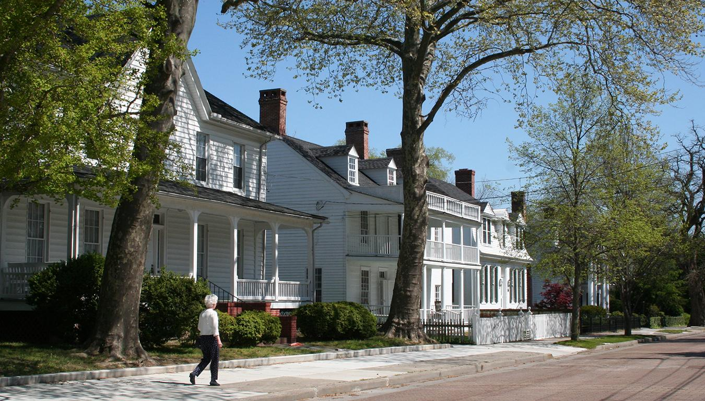
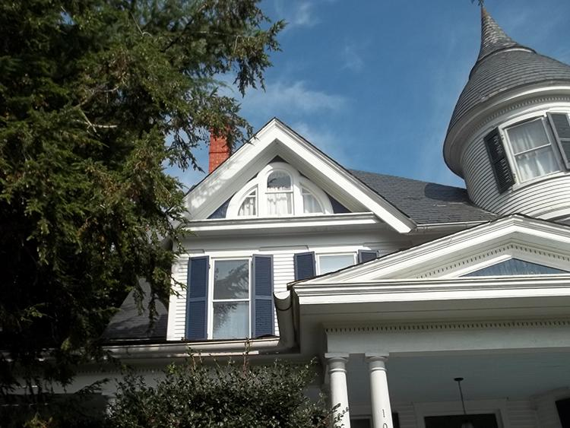
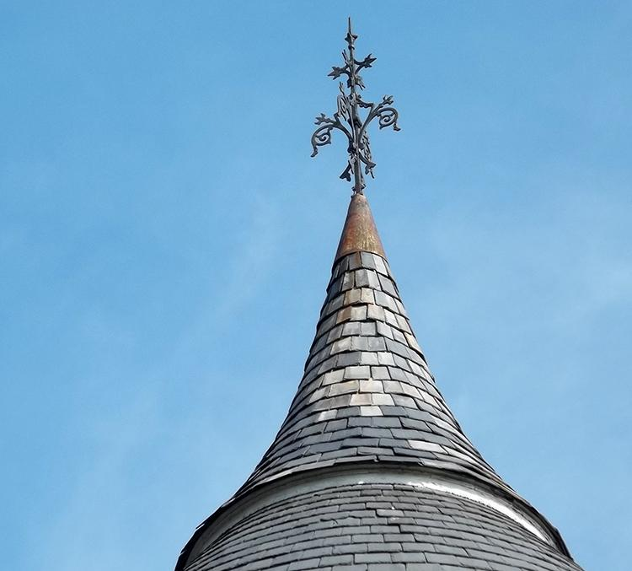

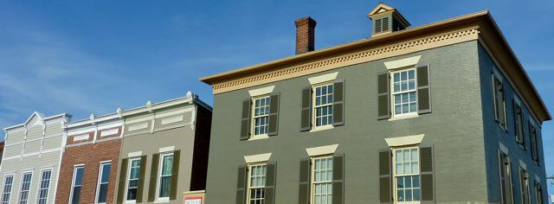
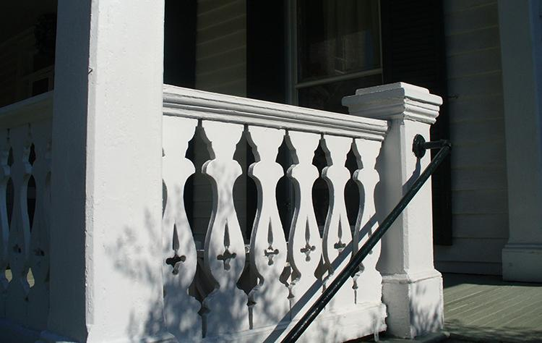
Cambridge Historic District
Design Guidelines

CAMBRIDGE, MARYLAND
ChooseCambridge.com
TABLE OF CONTENTS
CHAPTER ONE: INTRODUCTION ………………………… PG 6

Background to The Design Guidelines.
Organization of The Design Guidelines
Understanding the Context for the Design Guidelines
Secretary for The Interior’s Standards for Rehabilitation
Secretary of The Interior’s Guidelines for Rehabilitating Historic Buildings
Identify, Retain, And Preserve
Protect and Maintain
Repair
Replace

CHAPTER TWO: PROCESSES AND PROCEDURES …… PG 13

Overview of The Historic Preservation Commission

Review and Application Processes
CHAPTER THREE: DESIGN PRINCIPLES
FOR FAÇADE …………………………………………………. PG 16
Introduction
Setback
Orientation
Scale
Proportion
Massing
Rhythm
Materials
Symmetry
Height
Roof Shape
Details and Ornamentation
Style

CHAPTER FOUR: GUIDELINES FOR BUILDINGS………. PG 16
Introduction
Foundations, Masonry Facades & Decorative Elements
Guidelines for Foundations
Recommendations for Foundations
Methods and Information About Foundations:
Masonry Facades and Decorative Elements
Guidelines for Masonry Facades and Decorative Elements
Recommendations for Masonry Facades and Decorative Elements
Methods and Information About Masonry Facades and Decorative Elements:
Wood Facades and Decorative Elements
Guidelines for Wood Facades and Decorative Elements
Recommendations for Wood Facades and Decorative Elements
Methods and Information About Wood Facades and Decorative Elements:
Non-Historic Facade Materials
Guidelines for Non-Historic Facade Materials
Recommendations for Non-Historic Facade Materials
Additional Information for Non-Historic Facade Materials
Roofs
Guidelines for Roofs
Recommendations for Roofs
Methods and Additional Information About Roofs
Windows and Doors
Guidelines for Windows and Doors
Recommendations for Windows and Doors
Methods and Information for Windows And Doors
Porches & Front Steps
Guidelines for Porches and Front Steps
Recommendations for Porches and Front Steps
Methods and Information for Porches and Front Steps
Historic Storefronts
Guidelines for Storefronts
Recommendations for Storefronts
Methods and Information For Storefronts
Exterior Building Equipment (Solar Panels & Utilities)
Guidelines for Exterior Equipment
Recommendations for Exterior Equipment
Methods and Information for Exterior Equipment

CHAPTER FIVE: ………………………………………………. PG 56
Guidelines for Residential Area Landscapes
Introduction - General
Natural Landscapes Introduction
Recommendations for Natural Landscapes
Constructed Landscapes Introduction
Guidelines for Constructed Landscapes
General Landscape Narrative

CHAPTER SIX: ……………………………………………….. PG 61
Guidelines for Additions, New Buildings, Relocated Buildings, Accessibility and Egress
Introduction - Additions to Historic Buildings
Guidelines for Additions to Historic Buildings
Recommendations for Additions To Historic Buildings
Building Addition to Historic Buildings Discussion
Introduction – New Construction
Guidelines for New Construction
Recommendations for New Construction:
Relocation of Existing Buildings Guidelines
Guidelines for Relocating Existing Buildings
Recommendations for Relocating Existing Buildings
Accessibility and Egress into Structures
Guidelines for Accessibility into Structures
Recommendations for Accessibility into Structures

CHAPTER ONE: INTRODUCTION
The City of Cambridge Historic District Design Guidelines were developed to assist the Historic Preservation Commission (HPC) in reviewing proposed projects within the City’s Historic District.
The HPC is charged with preserving the intrinsic qualities of the Cambridge Historic District, such as the design of its buildings, public ways, landscaping, streetscape, and views associated with the Choptank River. The Guidelines do not seek to stop progress or prevent inevitable change; rather, they seek to ensure that changes are appropriate to Cambridge’s unique historic character.
Property owners can use these guidelines to identify projects that are likely to be approved by the HPC and to assist in making decisions about whether to (i) identify/preserve/restore versus (ii) repair versus (iii) replace architectural aspects of their historic properties.
The Guidelines should also be used to prevent inappropriate demolition and demolition by neglect. They should ensure that new construction, whether a new building or an addition, is sensitive to the scale, context, and character of the Historic District.

BACKGROUND TO THE DESIGN GUIDELINES
Historic design guidelines are created by communities concerned with the appearance of their buildings, landscapes, and public spaces, as well as how that appearance contributes to economic health and civic pride. Guidelines should provide the basis for objective decisions about the appropriateness of proposed changes within the Historic District.
Guidelines are also designed to protect the value of "place” such as the historic City of Cambridge. Historic cities with preserved architecture have many values, including the economic value of the buildings and the tax base. The tax base in an urban environment is greater per sf then in a suburban setting. This economic value can keep a city healthy financially.
The HPC design guidelines are applied to a wide range of buildings types, ages, and styles constructed from a range of materials. They include not only primary structures, but other structures such as gazebos, decks, detached garages, and the like, as well as landscapes, sidewalks, and public plazas. Because of the wide range of structures in the Historic District, the HPC guidelines cannot be rigidly applied. Rather, each proposed project must be reviewed individually by the HPC to ensure appropriateness.
In 2017, the HPC determined that its Guidelines needed updating to reflect changing environmental, economic, and cultural conditions in the city, as well as new substitute materials that could be used in rehabilitation projects. The Cambridge Historic District Design Guidelines (2nd Edition) was created (with the assistance of a professional consultant) to assist owners and tenants of historic buildings within the Historic to maintain, preserve, and enhance the character of their property. The guidelines are also intended to assist architects, engineers, and contractors in preserving and enhancing the character of the Historic District by appropriately maintaining its existing buildings, open spaces, and landscapes and undertaking appropriate new construction.
ORGANIZATION OF THE DESIGN GUIDELINES
The Cambridge Historic District Design Guidelines reflect the two principal areas with the Historic District – the downtown commercial area and the adjacent historic residential area.
The remainder of Chapter 1 (below) introduces the important physical features of the Historic District that form the context for the Guidelines, along with the underlying set of National Standards upon which the Guidelines are based.
Chapter Two outlines the procedures used by the HPC in reviewing changes to the exterior of buildings and certain elements of landscapes within the Historic District.
Chapter Three explains the Design Principals characterizing existing historic buildings in Cambridge and how they should be applied to any rehabilitation within the Historic District.
Chapter Four is based on the format for the Secretary of the Interior’s Guidelines for Rehabilitating Historic Buildings, a companion document to the Secretary of the Interior’s Standards for Rehabilitation. Chapter Four itemizes the HPC's specific guidelines for preserving, repairing, and replacing the architectural aspects of structures within the Historic District.
Chapter Five is similar to Chapter Four, but is focused on landscapes and auxiliary buildings within the Historic District. Chapter Five itemizes the HPC's specific guidelines in these areas.
Chapter Six focuses on additions to historic buildings and new buildings located within the Historic District. Chapter Six itemizes the HPC's specific guidelines for such buildings.
Appended to the Design Guidelines is a Glossary of specific terms contained in the Guidelines, as well as a list of appropriate substitute materials that might be considered in addition to original materials when rehabilitation, additions or new construction is undertaken.
UNDERSTANDING THE CONTEXT FOR THE DESIGN GUIDELINES
The Cambridge Historic District is made up of two principal areas, the downtown commercial center and the adjacent residential area.
Add map showing commercial and residential areas
The commercial area is typified by zero lot line, party wall buildings, typically two to three stories tall with masonry exteriors, enframed storefronts, and prominent cornices. Upper floors typically contain regularly spaced windows recessed behind the plane of the wall.
Side elevations at street corners typically contain upper floor windows. Rear elevations are relatively plain and are constructed of brick or in some cases wood. Sidewalks in the commercial area, which connect the storefronts directly to the streets, contain pedestrian street lamps, benches, trash receptacles and other street furniture, as well as a few blocks with street trees. Collectively, the facades, sidewalks and streets make up a recognizable downtown context, familiar to Cambridge’s citizens and visitors alike.
The historic residential area is composed primarily of single family houses in a variety of architectural styles, sizes, and materials separated from neighboring buildings by side yards. The houses are typically set back from streets and sidewalks with landscaped front yards forming uniform streetscapes. Trees, lawns, fences, planting beds, and shrubs contribute to the appearance of the streetscapes.
Most blocks contain houses of similar size, heights, roofline, and other distinguishing features that contribute to the collective context and appearance of the block. In addition, raised front porches are predominant throughout the residential area, also contributing to the collective appearance of the Historic District.

SECRETARY FOR THE INTERIOR’S STANDARDS FOR REHABILITATION
Both the Maryland Historical Trust (the State’s historic preservation office), and the National Park Service (the Federal government’s preservation agency) use the Secretary of the Interior’s Standards for Rehabilitation to judge the compatibility of proposed changes to buildings listed on the State or Federal registers of historic places with the existing character of the building. Originally created in 1976 to determine the appropriateness of proposed changes to income-producing National Register buildings whose owners wished to take advantage of beneficial federal tax considerations, the Standards have become the basis to judge changes to existing buildings, landscapes, public spaces, and new construction in almost every historic district in the country. They are used by the Maryland Historic Trust to determine if changes to historic owner occupied residential and income-producing buildings qualify for Maryland State investment tax credits.
The Cambridge Historic District Design Guidelines (3rd Edition) are based on the Secretary of the Interior’s Standards for Rehabilitation. The Standards for Rehabilitation are:
- A property shall be used for its historic purpose or be placed in a new use that requires minimal change to the defining characteristics of the building and its site and environment.
- The historic character of a property shall be retained and preserved. The removal of historic materials or alteration of features and spaces that characterize a property shall be avoided.
- Each property shall be recognized as a physical record of its time, place, and use. Changes that create a false sense of historical development, such as adding conjectural features or architectural elements from other buildings, shall not be undertaken.
- Most properties change over time; those changes that have acquired historic significance in their own right shall be retained and preserved.
- Distinctive features, finishes and construction techniques or examples or craftsmanship that characterize a historic building shall be preserved
- Deteriorated historic features shall be repaired rather than replaced. When the severity of deterioration requires replacement of a distinctive feature, the new features shall match the old in design, color, texture and other visual qualities and, where possible, materials. Replacement of missing features shall be substantiated by documentary, physical, or pictorial evidence.
- Chemical and physical treatments, such as sandblasting, that cause damage to historic materials shall not be used. The surface cleaning of structures, if appropriate, shall be undertaken using the gentlest means possible.
- Significant archeological resources affected by a project shall be protected and preserved. If such resources must be disturbed, mitigation measures shall be undertaken.
- New additions, exterior alterations or related new construction shall not destroy historic materials that characterize a property. The new work shall be differentiated from the old and shall be compatible with the massing, size, scale and architectural features to protect the historic integrity of the property and its environment.
10. New additions or related new construction shall be undertaken in such a manner that if removed in the future, the essential form and integrity of the historic property and its environment would be unimpaired.
SECRETARY OF THE INTERIOR’S GUIDELINES FOR REHABILITATING HISTORIC BUILDINGS
In addition to the Standards, the National Park Service has created a set of associated Secretary of the Interior’s Guidelines for Rehabilitating Historic Buildings for appropriate treatment of historic buildings and landscapes. The Guidelines are intended to assist in applying the Standards to projects generally; consequently, they are not meant to give case-specific advice or address exceptions or rare instances. For example, they cannot tell owners or developers which features of their own historic building or landscape are important in defining its historic character and must be preserved. The Guidelines pertain to historic buildings of all sizes, materials, occupancy, and construction types; and to additions to historic buildings and new buildings in historic districts.
The Guidelines are structured on four principal phases of intervention, or modification, of existing historic character of a building. The first phase entails the least amount of intervention:

- IDENTIFY, RETAIN, AND PRESERVE
Identifying, retaining, and preserving the form and detailing of those architectural materials and features that are important in defining the historic character of a historic property is the first step to understanding what should be retained in any intervention. It may be something obvious, such as the front porch on an historic house in the residential district, or perhaps not so obvious such as the cornice on a commercial building. The loss of character of an historic building may also be caused by the cumulative effect of a series of actions that would seem to be minor interventions.
- PROTECT AND MAINTAIN
After identifying those materials and features that are important and must be retained during any exterior rehabilitation work, or alterations to an historic landscape, they must be protected and maintained, if possible. Protecting and maintaining generally involve some degree of intervention, such as re-caulking joints around windows and doors, or removing flaking paint and repainting, or pruning hedges and trimming dead branches from trees.
- REPAIR
The next level of intervention is when a character-defining materials and features is beyond maintenance and must be repaired, but not so deteriorated that it must be replaced. Repair of historic materials such as masonry, wood or architectural metals should begin with the least degree of intervention possible such as patching, piecing-in, splicing, consolidating, or otherwise reinforcing or upgrading. Repairing also includes the limited replacement in kind, or with a compatible substitute material, for extensively deteriorated or missing parts of features such as brackets, dentils, steps, and the like, based on existing features or documentary evidence.
- REPLACE
If the deterioration is too extensive, then replacement in kind or with a compatible substitute material is the next step in the intervention process. This may also apply to a missing feature or an historic feature that has been replaced with one that does not contribute to the overall character of the building or landscape. Replacements should be based on existing features or on documentary evidence. However, if neither exists, then the missing feature may be replaced with one that is compatible with the Design Principles used by the building (see Chapter Three). The preference is for the replacement to be in kind (that is, made of the same material as the original or existing). However, if this is not technically or economically feasible, then a compatible substitute material may be considered. A substitute material or feature may also be considered if it is more sustainable (see Appendix) than the original or historic feature, while conforming to the Design Principles.
To provide clear and consistent guidance for owners, contractors, architects and others involved in maintaining or altering Cambridge’s historic buildings and landscape, the Cambridge Historic District Design Guidelines contains both Guidelines, which shall/must be followed, and Recommendations, which should be followed, except as otherwise determined by the HPC upon review of individual proposed projects.

CHAPTER TWO: PROCESSES AND PROCEDURES

OVERVIEW OF THE HISTORIC PRESERVATION COMMISSION
The Cambridge Historic Preservation Commission (HPC) was created in 1990 by Ordinance 814 to protect the historic landscapes and buildings within the Cambridge Historic District. The HPC consists of five members and one alternate appointed by the Cambridge City Council. The majority of members must be City residents and must have appropriate academic or professional backgrounds or have a demonstrated interest in historic preservation.
The HPC holds regular public meetings to review proposed changes to existing buildings and landscapes, such as installing new fences or patios, changing building exteriors, creating additions to existing buildings, or constructing entirely new buildings within the Historic District. It also reviews the demolition of all or part of existing buildings, and certain changes to landscapes, such as removing large trees that contribute to the character of the Historic District. On the other hand, the HPC does not review exterior building painting/repainting, minor in-kind exterior repairs, or minor landscaping changes, nor does it review interior changes.

REVIEW AND APPLICATION PROCESSES
Persons wishing to make changes to the exterior of buildings or landscapes within the Cambridge Historic District should visit the City of Cambridge’s HPC website, review the Application Form and related materials provided there, and consult with the City of Cambridge HPC staff to determine review requirements before staring any project. Certain reviews can be conducted by HPC staff, some can be placed on the HPC's Consent Agenda, and others must receive a full HPC review.
Flow Chart of possible reviews – informal, formal, administrative consent, full hearing.
Applicants who have consulted HPC staff but remain in doubt about the acceptability of proposed projects are strongly encouraged request an Informal Review by the full HPC prior to the Formal Review. Informal Reviews afford an opportunity for applicants to discuss their projects with the Commission and receive feedback as to the resolution of any potential conflicts with the Cambridge Historic District Design. Informal Reviews can be scheduled by providing the appropriate information on the Application to the Historic Preservation Commission form.
To request a Formal Review, applicants should complete the HPC Application (including required accompanying materials) and submit it to HPC staff at least two weeks prior to the HPC review meeting. Staff will review the application and determine if it is complete or if additional information is required. Staff will also determine if the application can be approved administratively or placed on the Consent Agenda (which means that the work is relatively minor, has been routinely dealt with, and that the proposed work conforms to the Cambridge Historic District Design Guidelines). If there are no objections by a Commissioner or member of the public, Consent Agenda items will be approved at the HPC meeting. If there is an objection, the project will be reviewed by the HPC at that meeting. Applicants should not begin work until approval is granted by the HPC.
The HPC strongly encourages applicants to attend the meeting(s) at which their projects are reviewed in order to address any concerns that may result in the project being denied. At the meeting, HPC staff will provide a professional review of the project, and applicants (and/or their agents) will be invited to make additional comments and respond to questions from the Commissioners. Members of the public will also be invited to comment. The Commission will then consider if the proposed project is consistent with the Cambridge Historic District Design Guidelines.
Assuming the HPC has the information, it requires to render a judgement, it may approve the application; may approve the application with certain changes to make it consistent with the Guidelines; or may determine that the application is not consistent with one or more the Guidelines and deny the application. The HPC may also ask that additional visual or written information be provided, and table the application until that information has been received. If changes are required or the application is denied, the HPC will list specific sections of the Cambridge Historic District Design Guidelines that the proposed project fails to meet.
All applicants will be informed in writing of the Commission’s decision within 3 business days of the review meeting. If the application is approved, or approved with certain conditions, a copy of a “Certificate of Appropriateness” will be mailed to the applicant, the City’s zoning administrator, and the Building Inspection Office, which issues building permits should one be required for the project. Please note that a “Certificate of Appropriateness” does not guarantee that the project conforms to the city’s zoning or building codes, only that it is in conformance with the HPC's Design Guidelines. A “Certificate of Appropriateness” is valid for twelve months, and staff may authorize a one-time extension of one year if necessary.
If an application is denied, the applicant (or agent) should review the specific section of the Cambridge Historic District Design Guidelines cited as the basis for the denial and amend those areas so that the proposed changes are consistent with the Guidelines. HPC staff should be consulted if the applicant has any questions about what changes are needed to comply with the Guidelines. Once the changes are made, the proposal can be resubmitted for review by the HPC. Staff can assist the applicant with the resubmission process. Alternatively, an applicant may wait for twelve months before resubmitting the same application. An applicant also has the right to appeal a decision of the HPC to the city’s Board of Zoning Appeals.
Flow chart of process for full formal review with estimated timeline.

CHAPTER THREE: DESIGN PRINCIPLES FOR FACADES
- INTRODUCTION
There are approximately 800 residential buildings and 200 commercial buildings in the Cambridge Historic District. In addition, there are a number of institutional, civic, and religious buildings in the Historic District. While their facades are made from different materials, and they are designed in different architectural styles, almost all are designed using the Design Principles of Setback, Orientation, Scale, Proportion, Massing, Rhythm, Materials, Symmetry, Height, Roof Shape, and Details and Ornamentation. Understanding these principles, which work collectively on individual buildings as well as streetscapes, is very important in any rehabilitation work, as well as when additions to historic buildings or entirely new buildings are contemplated (See the application of the residential design principles in Chapters 4, 5, and 6)
- SETBACK
A building’s Setback is the distance it is located behind its property lines. In the residential areas, the front facades on some streets are setback 8 feet behind the front property lines, while on others the facades are 25 feet inside the front property lines. Side property setbacks vary from 5 feet and 8 feet. Buildings on most residential streets have similar front and side yard setbacks that contribute to the overall appearance of the street.
In the commercial area, most buildings are constructed to both the front and side property lines, giving each block a solid wall of structures.
- ORIENTATION
The direction a building faces the primary street is its Orientation. In the residential and commercial areas of the Historic District, almost all buildings are orientated to face the primary street with their main entry clearly visible.
- SCALE
Scale is the relative or apparent size of a building in relation to its neighbors, typically perceived through the size of building elements, such as windows, doors, storefronts, porches, cornices, facade materials, and other exterior features. Most buildings are designed to be human in scale; that is, they appear to be of a size appropriate for human occupancy and use. Other buildings, such as civic and sometimes religious buildings, are designed to be of monumental scale, giving them physical and symbolic importance. Almost all buildings in the Historic District are designed to be human in scale.

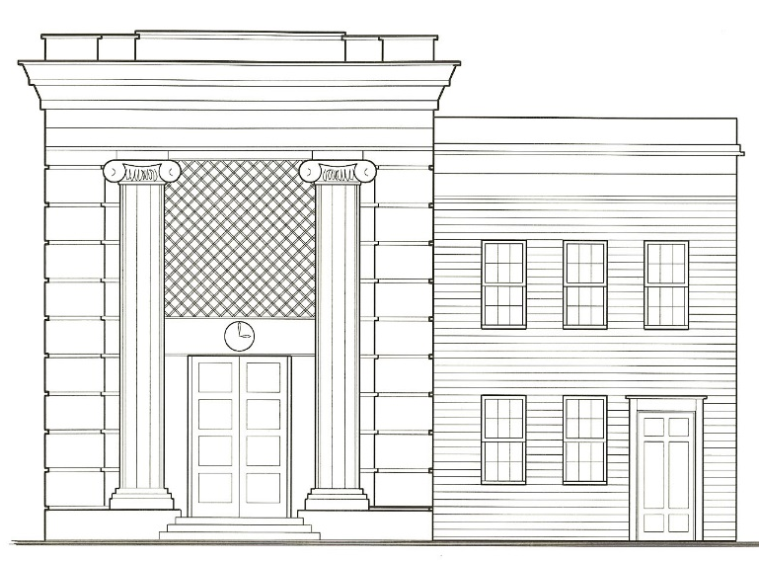
Monumental scale Human scale

- PROPORTION
Proportion is the relation of components of buildings, such as doors, windows, storefronts, porches, and cornices to each other and to their facades. Often proportions are expressed as mathematical ratios, drawn from the architectural theories of ancient Greece and Renaissance Italy. For example, many historic buildings designed in the Classical Revival style use mathematical proportions to locate and size windows, doors, columns, cornices, and other building elements. The majority of the buildings in the Historic District use proportions to compose their primary facades.
Below is a diagram to illustrate how each portion of this façade can be subdivided in elements that relate to each other in their proportions (square and diagonal, radius of house width = eave height etc.)

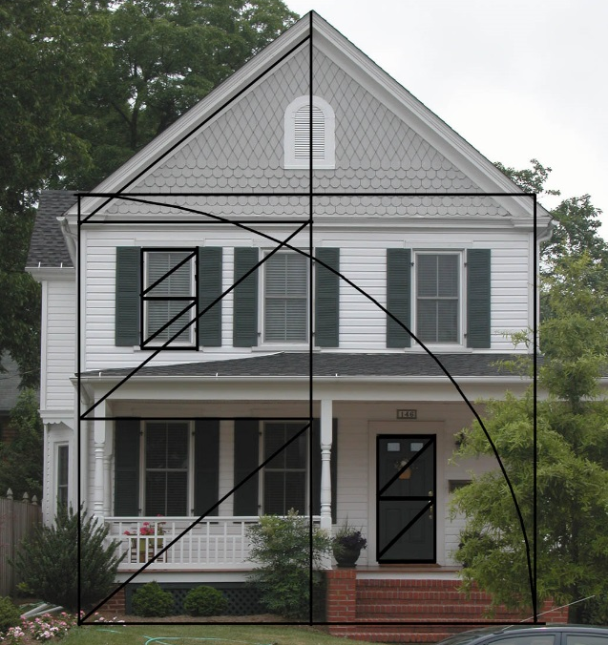
Proportional composition of primary façade
- MASSING
A building's massing refers to the overall size and orientation of a building. It is derived from the articulation of its facade through the use of dormers, towers, bays, porches, steps, and other projections. Every style of architecture has a particular massing signature, and when outside of that signature, it may appear incorrect, disproportionate, and inappropriate. A building’s massing significantly contributes to its character and that of the street, particularly for party wall buildings built to the front property line. In the residential areas, the massing of many houses is derived from their porches, stairs and roof shapes. In the commercial area, most building’s read as a single mass.
- RHYTHM
The vertical and horizontal spacing and repetition of facade elements, such as storefronts, windows, doors, belt courses, and the like give a facade its rhythm. The space between freestanding buildings, or lack of space between party wall buildings, along with a building’s height, towers, and other roof projections establishes the rhythm of a street. The rhythm of the front facades in Cambridge’s Historic District’s residential area varies from street to street, while it is fairly consistent in the commercial area.

Sketch of commercial area showing rhythm of storefronts below.
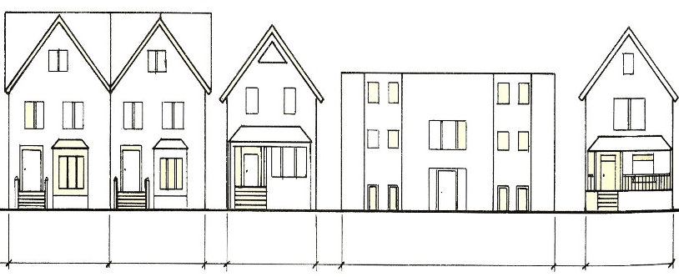
A A A B A
The width and roof shape of B does not respect the rhythm of the rest of the block
- MATERIALS
The type, size, texture, color, surface finish, and other defining characteristics of exterior materials are important to defining the overall character of a building. Existing original facade materials should usually be maintained during rehabilitations.
Sketches showing different types of materials on primary facades.
- SYMMETRY
A building’s facade is symmetrical when the two sides are balanced and equal, such as most of the commercial buildings in the Historic District. A building’s facade may be asymmetrical with one side of the facade more visually dominate than the other, which occurs in a number of the buildings in the residential area of the historic district. The symmetry or asymmetry of facades should be maintained during rehabilitation.
Sketch or symmetrical and asymmetrical facades
- HEIGHT
The height of facades and their cornices, along with rooflines, and projections such as chimneys and towers, contributes to the character of buildings and streetscapes. In the downtown area, the heights of most buildings is fairly consistent, providing a uniform appearance. Similarly, in the residential area the heights of most buildings on each block is also fairly consistent.
Sketch down residential or commercial street.
- ROOF SHAPE
The shape, slope, and orientation of roofs are important to defining the character of buildings. In the downtown area, most roofs are flat and hidden behind cornices on the primary facades, as thus do not significantly affect the appearance of the building. In the residential areas, most roofs are sloping and thus very important in defining the character of the buildings.
Sketch of residential building or similar to below.

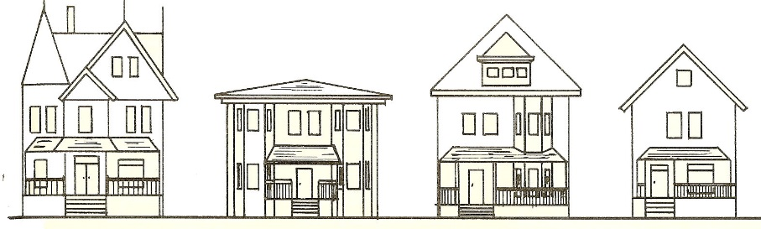
Roof shapes are important character defining features of facades.
- DETAILS AND ORNAMENTATION
Details such as the shape and texture of siding or types of brick courses used for a facade, configuration of cornices, location and appearance of chimneys, and ornamentations such as porch brackets, scrolls, corbels, and the like, significantly add to the character of a façade
Add sketch of residential building with porch brackets, chimney, etc.
- STYLE
Architectural style denotes the overall appearance and common features of a building erected in a certain time period and a certain region to meet the particular tastes and fashion of the time. Examples of styles common to Cambridge include Georgian, Federal, Greek Revival, Italianate, Romanesque, Second Empire, Queen Anne, Victorian, Colonial Revival, Bungalow and Art Deco (See appendix the illustrations of styles found in Cambridge.)
Style is determined by the careful combination of architectural elements according to the traits and “rules” of the particular style. These rules evolved over time, hence terms such as “early Victorian” or “late Federal.” Therefore, many buildings are not purely of one style, and often contain characteristics of two styles.
An architectural style brings together qualities of massing, scale, proportion, materials, rhythm, detail and color according to the parameters of that style. Because of this, adherence to the rules of a particular style results in a balanced and well thought-out design. A clear understanding of the boundaries of a building’s style is critical to preserving its character when maintaining, repairing adding to it.

CHAPTER FOUR: GUIDELINES FOR BUILDINGS
- INTRODUCTION
The architectural character of the residential and commercial buildings in Cambridge’s Historic District is derived from the appearance of the design of their facades, including walls, roofs, doors, windows, porches, storefronts, materials, details and ornamentation, and how these elements are composed using the Design Principles discussed in Chapter Three.
In most cases, the Primary Facades of Cambridge’s historic Residential and Commercial buildings, those that face primary streets, are more elaborate than Secondary Facades, those located on the sides and rears of the buildings. While most residential buildings use the same faced materials on all elevations, the Primary Facade often contains an elaborate entry door and porch not found on Secondary Facades.
Similarly, downtown’s commercial buildings typically contain elaborate storefronts, upper floor windows with pronounced hoods, and projecting cornice, while the rear facades are relatively plain.
The following Guidelines, which apply to all historic buildings, provides a brief description of a component of a building, followed by guidance for its identification, maintenance, repair, and replacement in kind or using substitute materials. (See Chapter One)
- FOUNDATIONS, MASONRY FACADES & DECORATIVE ELEMENTS
Executive Summary:
Above ground foundations are important elements in defining the overall historic character of the building, including the size, shape, and color of brick, stone or cast stone; bond patterns, mortar joints profiles and color.
This chapter addresses the preservation of foundations, the deterioration of mortar and masonry elements, and the methods to apply when repairing and/or replacing masonry foundations.
GUIDELINES FOR FOUNDATIONS
GF 2.A. Original and historic foundations and related elements shall be retained and preserved wherever possible, including: pier size, vents, grilles, lattice, materials, and other significant details.
GF 2.B. Existing historic materials shall be retained and preserved wherever possible, rather than repaired. If repairs are necessary then the new foundation materials shall match the historic materials as closely as possible in size, texture, shape and other character defining characteristics. Replacement of a damaged portion shall not be a reason for wholesale replacement.
GF 2.C. If a historic foundation is deteriorated beyond repair, replacement shall be confined to only the damaged portion using the same materials and finishes as the original, or a substitute material that matches the original in size, shape, texture, finishes, and other character defining characteristics.
GF 2.D. New foundation vents or access doors shall be as inconspicuous as possible in location, and compatible with the character of the foundation and façade in color, size, shape and other defining characteristics. Where possible, basement access doors and other new openings should not be visible from the primary right of way.
GF 2.E. Existing above ground masonry foundation shall not be covered with another material.
GF 2.F Existing, unpainted historic foundations shall not be painted. Previously painted foundations should be repainted an appropriate color, or restored to original masonry finish.
GF 2.G. The new foundation walls or piers shall be compatible with the overall design of the buildings, as well as the design of the existing foundations or piers.
GF 2.H. When located in a flood prone area, the raised foundation shall be screened with plantings, sloped earth berms or both to reduce the perceived height of the elevated building on all facades visible from a public right of way.
GF 2.I. The design of foundation vents shall be compatible with the design of the foundation and facade in which they are located.
RECOMMENDATIONS FOR FOUNDATIONS

RF 2.A. Infill between existing or new foundation brick piers should be recessed a minimum of 1" behind the exterior face of the piers so the original piers stand out. Wood, or compatible substitute material, should be used for lattice or grilles to enclose spaces between foundation piers Concrete block may be used only if covered with a veneer of brick or sand-finished stucco. The use of masonry of any sort for new foundations could disturb piers. Piers foundations under porches should be open wherever possible to promote air circulation to prevent rot and deterioration.
RF. 2.B. The ground floor of a building in the “Flood Zone” should be raised to comply with the UDC Flood Area minimum floor height requirements.
METHODS AND INFORMATION ABOUT FOUNDATIONS:
Foundations.
Above ground foundations are important elements in defining the overall historic character of the building, including the size, shape, and color of brick, stone or cast stone; bond patterns, mortar joints profiles and color; and if the material retains its natural state or has been painted. Preserving foundation walls includes identifying deterioration, such as settlement cracking, spalling, biological growth, retention of water, or peeling paint, before it becomes severe.
Brick, stone, and cast stone are used for most of the foundations in the Historic District. In the residential area the top few feet of the foundation wall can often be seen above grade. Brick is the most prevalent foundation material. Typically made from hard fired brick to prevent ground water wicking up into the walls (called rising damp), many brick foundations have a shaped water table course, which sometimes hides a lead or bituminous damp proof membrane. Sketch of water table course with damp proof membrane. Typically, the size, shape coursing and mortar joints are the same as the brick wall above (See following section).
Stone foundations, often with shaped water table courses containing damp proof membranes to prevent rising damp, and cast stone (also called pillow block), a cementitious material, can be found as above ground foundations in the residential area. Stone and cast stone is often used in combination with other facade materials. Sketch of Cast Stone/stone foundation.
Brick and stone are among the most maintenance free materials used for foundations in historic buildings. However, if the exterior water proof membrane in not intact, spalling, or surface erosion, may occur on interior surfaces. Lightly spalled stone may be patched using appropriate cement-based materials. However, it is often difficult to match the color of the existing stone. Heavily spalled stone, brick or cast stone should be replaced in kind or with an appropriate substitute material, after the water penetration problems have been identified and corrected.
The mortar used in brick, stone, and cast stone foundations is also subject to deterioration. Rising damp will, over time, erode the mortar, which can be seen in basements and crawl spaces. It is particularly important that modern high-strength Portland cement mortar not be used to repoint historic walls containing older low-strength cement mortar.
Elevating Buildings.
Elevating historic buildings that are subject to frequent flooding has been a concern for a number of years by many preservationists. To date, there is no national policy on how this may be undertaken, but there are a number of statewide and local guidelines that have informed the following for Cambridge’s HPC guidance on this issue.
When considering raising a building above current or anticipated future flood levels, the property owner shall consider all character defining features of facades facing public rights of way, including but not limited to foundations, facades, porches, and access such as steps or ramps. The owner shall also consider the effect of raising the building on character defining fences, plantings, sidewalks and other important elements of the natural and constructed landscapes facing the primary public right of way.
- MASONRY FACADES & DECORATIVE ELEMENTS
Executive Summary:
This chapter addresses the different type of masonry facades found in Cambridge, variation in materials and methods, and recommendations on their preservation, repair and/or replacement.
It also includes guidelines about masonry decorative elements such as chimneys, steps, cornices, water tables, coping, sills, columns and piers which contribute in defining the historic character of the buildings.
GUIDELINES FOR MASONRY FACADES & DECORATIVE ELEMENTS
GMF 3.A Historic character defining masonry facades and decorative elements shall be retained and preserved whenever practicable, including walls, chimneys, columns and the like.
GMF 3.B. Historic character defining masonry facades and decorative elements shall be repaired and restored whenever possible, rather than replaced.
GMF 3.C. Sandblasting, high-pressure water blasting, and other abrasive methods which may damage historic masonry shall not be used to clean historic masonry facades and decorative elements.
GMF 3.D Repointing mortar shall be compatible with the historic mortar in color, strength, texture and joint finish. The historic joint width, joint profile, and bond patterns shall be maintained when making repairs
GMF 3. E. Deteriorated stone shall be repaired rather than replaced, using appropriate stone consolidants and fillers.
GMF 3.F. If masonry units are too deteriorated to repair, they shall be replaced in kind, using new or used replacements that match the original units in size, shape, color, surface texture and other character defining features as closely as possible. Stone and Cast Stone replacement units may use appropriate substitute materials that match the original in size, color, shape, texture and other character deigning features.
GMF 3.G. Historically painted masonry facades and decorative features shall be repainted as required, removing peeling paint to a sound surface with hand tools, or if necessary appropriate paint strippers. Repainting should be done with compatible paint in historically compatible colors.

RECOMMENDATIONS FOR MASONRY FACADES & DECORATIVE ELEMENTS
RMF 3.A. Historic masonry facades and decorative elements should be cleaned using low-pressure water washing and mild detergents formulated for the specific application. Chemical cleaners formulated for historic masonry and the stain or biological to be removed should only be used if water and detergent cleaners are not effective.
RMF. 3.B. Water repellant sealers are almost never appropriate for use on historic masonry facades and decorative elements because they may trap moisture, causing deterioration or discoloration.
RMF 3.C. Use only hand tools to remove deteriorated mortar joints, under the direction of a skilled mason. Do not use power tools or saws to remove mortar joints.
RMF 3.D Vegetation and vines should be removed from masonry to prevent structural or moisture damage.
RMF 3. E. Repainting historically painted masonry facades and decorative features should be done with compatible paint in historically compatible colors
RMF 3.F. When it is not technically or economically feasible to replace deteriorated masonry units in kind, a substitute material that matches the original in expansion, contraction, and aspect should be used (See Appendix for list of substitute materials).
METHODS AND INFORMATION ABOUT MASONRY FACADES & DECORATIVE ELEMENTS:
Facades.
Brick, in a wide variety of sizes, shapes, textures, and colors, is the most prevalent masonry wall material found in the Historic District, particularly in the commercial area. The most common types of brick are pressed, common, and utility, although other types are also found.
Prior to the 1870s, brick kilns were fueled by wood, coal or charcoal, producing hard face brick, as well as softer bricks, typically used on interior wythe, and party or rear walls of commercial buildings. In the latter case, the brick was often painted to protect it from deterioration.
By the 1880s most kilns were fueled by gas allowing much higher temperatures to be achieved and a harder brick to be produced. These bricks had the advantage of being non-porous and thus could usually be left unpainted.
Brick walls are laid in different courses or bonds. Pressed brick is usually laid in a running bond. Other types of brick are usually laid in common and Flemish bond. In addition to the coursing, the width, color, and profile of mortar joints contribute significantly to the appearance of a brick wall.
Mortar joints vary from 1/8" to 1/2" in width, although other widths exist. Common mortar joint profiles include struck, weather, and flush. Other less common profiles include raked, vee and concave.
Mortar is naturally a grey-white color, although some mortar used in historic brick walls and foundations is red or some other color due to the addition of coloring agents. The texture of mortar is derived from the size of sand particles used in the mix.
Facades made of stone, commonly (types of stone in Cambridge), and cast stone, are found on institutional and commercial buildings in Cambridge’s Historic District.
The type of stone used, how it is finished and coursed, and the width, color, texture, and profile of the mortar joints all contribute to the appearance of a stone wall or above ground foundation.
In addition to the type of stone used, the appearance of stone depends on how the surface is finished. Stone is traditionally finished using a variety of hand and machine tools including saws, planes, chisels and grinders Common stone finishes include tooth chiseled, tooled, saw face and rock face.
Stone may be hand or machine cut with square edges giving it a geometric appearance (called ashlar) or with irregular edges (called rubble or field). Stone coursing may be regular, broken range, or rough coursed. Cast stone usually appears as rock face, laid in common bond coursing.
Decorative Elements.
Chimneys, steps, cornices, and piers are among the decorative elements made of brick, stone, and cast stone found in Cambridge’s Historic District. Decorative masonry elements come in a variety of specialty shapes such as rowlocks, water tables, copings, treads, sills, lipped, and other unique shapes. Sketch of various shape bricks, stones.
Decorative masonry elements can also be achieved by how the brick, stone or cast stone is coursed, for example, corbelled, basket weave, diagonal, stacked, or offset to name but a few. Sketch of decorative coursing. Colored mortar can also be found in decorative masonry elements.
The mortar used in brick, stone, and cast stone foundations is also subject to deterioration. Rising damp will, over time, erode the mortar, which can be seen in basements and crawl spaces. It is particularly important that modern high-strength Portland cement mortar should not be used to repoint historic walls containing older low-strength cement mortar.
- WOOD FACADES AND DECORATIVE ELEMENTS
Executive Summary:
Wood facades and decorative elements are commonly found on historic residential buildings, although they can also be found on a few historic commercial buildings in Cambridge.
Decorative wood elements include, brackets, eaves, modillions, dentils, and fretwork, typically located at eaves and tops of porch columns
GUIDELINES FOR WOOD FACADES AND DECORATIVE ELEMENTS
GWF 4.A. Existing original wood siding, trim, ornamentation, and decorative elements shall be preserved and maintained wherever possible.
GWF 4.B. Existing wood facades and decorative elements shall be preserved and repaired wherever possible, using appropriate preservation and repair techniques such as epoxies, splicing, and patching.
GWF 4.C. Replacing historic wood facades and decorative elements shall be considered only where the original material is too deteriorated to repair. If replacement is necessary, wood facades and decorative elements shall be replaced in kind with new wood, or appropriate substitute material, that matches the original as closely as possible in species, shape, profile, texture, and other character defining features.
GWF 4.D. Existing wood decorative elements, such as cornices, brackets, pilasters, door and window moldings, pediments, medallions, dentil and modillion molding, corner boards, and other character-defining architectural trim shall be retained and preserved, or repaired wherever possible. If decorative wood elements are too deteriorated to repair, then they shall be replaced in kind using the same wood species, size, shape, and other character defining features, or in an appropriate substitute material.
GWF 4.E. The design of replacement wood facades or decorative features shall be based on surviving examples or documentary evidence.
GWF 4.F. Wood surfaces requiring repainting should be prepared using the gentlest means possible. Sandblasting, high-pressure water blasting, and other abrasive cleaning methods which may damage historic wood facades and decorative elements shall not be used.
RECOMMENDATIONS FOR WOOD FACADES & DECORATIVE ELEMENTS
RWF 4.A. Insulating exterior wood cavity walls without a vapor barrier should not be undertaken as interstitial condensation is likely to occur. Avoid removing original exterior wood siding to install cavity wall insulation.
RWF 4.B. While the HPC does not regulate color, wood facades and decorative features should be painted the original colors or colors appropriate to the style of building. Original paint colors can be found by carefully hand sanding small areas to bare wood in expanding circles. Historically appropriate can be determined by consulting references contained in Appendix XX.
RWF 4.C. Loose paint should be removed by carefully sanding and priming bare areas prior to repainting. Mold and mildew, which will accelerate paint deterioration, should be removed.
RWF 4.D. For better adhesion, the same type of paint as existing (oil or latex) should be applied when wood facades and decorative elements are repainted.
RWF 4.E. Heavily encrusted paint that obscures profiles should be stripped to the bare wood by careful sanding or appropriate chemical strippers before priming and repainting. Prior to repainting, the soundness of the wood should be evaluated to determine if repair or replacement is necessary.
RWF 4.F. Painted wood facades constructed prior to 1978 should be tested for lead based paint before sanding and repainting by a reputable testing service. Maryland’s Department of the Environment has a list of certified lead paint testing and abatement services on its web site.
RWF 4.G. Repairs to wood facades and decorative elements should use epoxy or other appropriate wood consolidants, or patches that match the surround wood in species, texture, size, and profile, inserted. Prior to consolidation or patching rotted or insect damaged areas should be dry and treated with borate or other appropriate chemicals.
RWF 4.H. The use of composite wood, fiberboard and metal should be avoided when replacing wood siding.
RWF 4.I Removing or covering wood facades or decorative elements should not be undertaken as such action compromises character defining features of a building.
RWF 4.J. If replacing wood facades or decorative elements is not technically or economically feasible, then a substitute material of similar appearance when painted should be considered (See Appendix for list of appropriate substitute materials).
RWF 4.K. Blown in insulation should be placed in walls carefully, as not to disturb the integrity of the siding and the moisture control within the wall.
METHODS AND INFORMATION ABOUT WOOD FACADES & DECORATIVE ELEMENTS:
Wood facades and decorative elements are commonly found on historic residential buildings, although they can also be found on a few historic commercial buildings in Cambridge. Many types of wood siding can be found in Cambridge, including clapboard, beveled, German and shiplap; a few facades are made of wood shingles.
Each type of siding gives its facade a unique character and is usual l y associated with a particular architectural style. In most cases, the corners of clapboard and wood shingle facades feature wood corner boards that seal the joint as well as give visual emphasis to the corner. Historically, wood facades were painted to protect them from deterioration.
Decorative wood elements include, brackets, eaves, modillions, dentils, and fretwork, typically located at eaves and tops of porch columns. (Also See Guidelines for Porches, section 7).
They significantly contribute to the architectural character of the building, and are commonly associated with a particular architectural style. Historically, decorative wood elements were painted to protect them from deterioration.
- NON-HISTORIC FACADE MATERIALS
Executive Summary:
This section addresses asbestos shingle siding, as well as aluminum and vinyl in their uses as façade material in the Cambridge Historic District.
GUIDELINES FOR NON-HISTORIC FACADE MATERIALS
GNHF 5.A. Non-historic façade materials that are original to the building shall be retained and preserved. If they are replaced, the new material shall match the original as closely as possible in size, shape, texture and other character defining features.
GNHF 5.B. Damaged asbestos siding shall be replaced with an alternative material, such as non-asbestos fiber-cement shingles with similar texture, thickness, and size as the existing. After replacing, repaint to match the existing. Metal and vinyl siding shall be replaced in kind.
RECOMMENDATIONS FOR NON-HISTORIC FACADE MATERIALS
RNHF 5. A. Peeling paint should be carefully removed from asbestos facades without scrapping the surface of the shingle. Dirt may be rinsed off with a hose, and light stains removed with a mixture of trisodium phosphate cleaner and warm water in the proportions recommended by the manufacturer. Trisodium phosphate will also remove latex paint.
RNHF 5.B. Since the colors of metal and vinyl siding will fade over time, and since modern paint does not bond well with either material without extensive preparation, removing the non-historic material and repairing the underlying historic material should be considered. Dirt, mold and mild
RNHF 5.C. Hairline cracks in asbestos siding should be repaired with clear epoxy. Larger cracks should be patched with a thin grout made of Portland cement and water. Once the repair is dry, it should be repainted to match the existing color. Open joints in metal and vinyl siding should be made watertight with clear expandable epoxy.
ADDITIONAL INFORMATION FOR NON-HISTORIC FACADE MATERIALS
Some buildings in Cambridge’s Historic District have been covered with non-historic materials such as asbestos shingles or vinyl and metal siding. This was usually done to avoid the expense of repainting.
Asbestos shingles were introduced in the early 20th century, remaining popular until the late 1970s when asbestos was regulated as a potential health hazard. They are a cement based material with asbestos fibers that act as a binding agent as well as provide a certain level of fire protection. Often applied directly over existing wood siding, they are left in their natural gray color or sometimes painted.
The Environmental Protection Agency considers asbestos shingles to be “non-friable” that is not easily crumbled or reduced to powder, which releases the asbestos fibers into the air. Intact asbestos shingles do not pose a serious health hazard.
Coated steel and aluminum clapboard siding became a popular faced material for new home constructed immediately after World War II, promoted as a maintenance free material to cover older wood facades.
In the 1960s vinyl siding was introduced, becoming the preferred non-historic siding material by the 1970s due to its lower cost.
- ROOFS
Executive Summary:
Roofs are one of the most important features of historic buildings.
They come in a variety of shapes, materials and details.
This chapter addresses the different types of roofs, such as flat, gable, cross gable, gambrel, hipped, mansard and shed, as well as the materials used for roof construction such as metal, slate, asphalt shingles, wood shakes and roofing membrane.
This chapter also include recommendations and guidelines for alterations or modifications of roofs in the Historic District.
GUIDELINES FOR ROOFS
GR 5.A. Original and character defining roof forms, shapes, materials, and major roof architectural elements such as dormers, gables, chimneys, and eaves overhangs shall be retained and preserved whenever possible.
GR 5.B. Historic roofing details and materials such as slate, standing seam metal, and tile shall be preserved, maintained, and repaired whenever practicable.
GR 5.C. Character defining damaged or deteriorated roofing materials shall be replaced in kind or with an appropriate substitute material.
GR 5.D. New roofing materials shall be compatible with either the existing or original roofing material, in color, shape, size, and texture.
GR 5.E. Character defining historic roof materials and features such as eaves, cornices, rake-boards, dormers, gables, chimneys, finials, cresting, steeples, belfries, cupolas, and railings., shall be retained and preserved whenever practicable.
GR 5.F. If the roof feature is damaged it should be repaired in kind. If the roof feature is too deteriorated to repair, it shall be replaced in kind or in a substitute material that matches as closely as possible the original in size, color, shape, texture and other character defining elements.
GR 5.G. The design and replacement of missing roof features shall be based on physical, contextual or documentary evidence.
GR 5.H. A historic roof slope shall not be altered, unless there is a compelling technical or economic reason. If a historic roof slope must be altered it shall be done in a manner that meets the Design Principles in Chapter Three.
GR 5.I. Contemporary or non-historic roof features, such as skylights vents, or solar panels and collectors, shall only be installed on areas of the roof that are mostly concealed from view from the primary right of way (see UDC Regulations for Solar Panel, and in Appendix).
GR 5.J. Replacement gutters and downspouts shall be installed so that they do not damage or obscure character defining features of the roof or its elements such as the eaves. Replacement gutters and downspouts shall match the existing in size, shape and other character defining features.
GR 5.K. Ridge vents, where needed, shall be of the low-profile type and shall not diminish the original design of the roof or destroy any character-defining architectural details. Other vents, such as gable vents and roof-mounted vents, shall be installed so as not to be visible from the public view where possible. If they must be visible, these elements shall be installed to relate to the architectural details and character of the subject building.
RECOMMENDATIONS FOR ROOFS
RR 5.A. Alterations to existing roofs should not create a false sense of history, such as adding conjectural features lacking sufficient documentary evidence.
RR 5.B. A substitute material used to replace a deteriorated historic roof or feature should complement the visual appearance of the surviving parts of the roof or feature, and should be physically and chemically compatible.
RR 5.C If new dormers are contemplated, they should be located on side or rear elevations if they are not seen from the public right of way. The design of new dormers should be compatible with the design of the building, roof and any existing dormers. The new dormers should not duplicate existing dormers exactly.
RR 5.D. If the existing gutters and downspouts are not historically accurate, and need to be replaced, to the extent practicable, they should be replaced in kind or with ones that are historically accurate at least in size, shape & color, and material if possible.
RR 5.E Deteriorated flashing should be replaced in kind. Avoid installing California Valleys on roofs with existing metal valleys and shingle ridges on roofs with metal ridges.
RR 5.F. If replacement of a roof material in kind is not technically or economically feasible, a substitute material with similar color, texture, size, shape and other character defining features should be considered, including: lead coated copper for terne plate or zinc; synthetic slate for slate; and synthetic wood shakes or shingles for wood shakes or shingles. Since flat roofs are usually not seen from a public right of way, a single ply roof membrane should be considered as a suitable.
METHODS AND ADDITIONAL INFORMATION ABOUT ROOFS
Roofs are one of the most important features of historic buildings. Functionally they shelter buildings from the weather. Visually, their shape, details, and materials significantly contribute to the appearance of buildings. Roofs come in a variety of shapes, including flat, which are primarily found on commercial buildings in Cambridge, and various forms of sloping roofs, which are typically found in the residential area of the Historic District.
The term flat roof is somewhat misleading since most gradually slope toward the rear of the building to drain water. Since a flat roof is typically not visible from the ground, its design does not normally contribute to the character of the building. However, the cornice, parapet, pent roof or other feature at the edges of a flat roof are almost always visible, and thus significantly contributes to the character of a building.
A variety of sloping roofs can be found in the Historic District, including:
Gable, which is formed by two sloping planes rising from the side walls, meeting at a central ridge. The junction between the sloping planes and the walls often contains overhanging eaves. The roof's gable ends are sometimes finished with wood bargeboards or other decorative features.
Cross Gable, which is formed by the intersect ion of two gables, usually at the center of the roof. Typically, this type of roof is found on residential buildings that have T-shaped, L-shaped or cross-shaped floor plans.
Gambrel, which is similar in design to a gable roof, but rather than having a single ridge at the peak, a gambrel roof has three ridges, one at the peak and two along the sloping sides. This roof form is often found on residential buildings with finished attics.
Hipped, which is formed by four sloping roof planes extending from the walls to a ridge. Hipped roofs will often have overhanging eaves on all four sides.
Mansard roofs have steeply sloping planes extending from in a flat roof. Named after the French architect Francois Mansard, the roof provides a large amount of usable space in the attic.
Shed roofs are formed by a single sloping plane rising from one wall to the opposite wall. Typically, shed roofs are found on secondary buildings, such as residential garages or sheds.
A dormer is a small projection above a sloping roof consisting of a window or vent and a small roof. Windows in dormers are commonly double-hung or casement, and less commonly diamond, round and half-round. Vents are commonly rectangular, round or half-round in shape. Dormers are capped with a variety of roof shapes: typical l y gable, hipped, shed, or round. Dormers may be located entirely on the slope of a roof, or attached to a façade, known as an engaged dormer.
Roof Materials
In addition to shape, the materials covering sloping roofs are important to defining the character of a historic building. The most common sloping roof materials are metal, slate, clay tile, asphalt shingles, and wood shingles and shakes.
The appearances of materials used to cover flat roofs are usually not character defining since they are rarely seen from the ground. Common flat roof materials include built-up roofing and EPDM (Ethylene Propylene Diene Monomer), commonly called “rubber roofing”.
Metal. Copper, lead and terne plate were common metal roof materials in the nineteenth century. In the early twentieth century, zinc and galvanized steel were also used to cover sloping roofs. Later coated steel and lead coated cooper were common metal roof materials. The appearance of a metal roof is primarily derived from the type of metal used, how it is finished and the method by which sections are joined together. For example, copper is usually left unpainted, naturally weathering to a green patina. Similarly, lead is usually unpainted, weathering to a soft gray. All other types of metal roofing is painted to resist corrosion.
Metal roofing comes in sections joined together on site. The two types of joints commonly found are flat-seam and standing seam. The first gives a roof a flat, uniform appearance. Standing seam give a roof a distinctive ribbed appearance. In addition, decorative metal roof shingles of varying shapes, sizes and textures may be found on late nineteenth and early twentieth century buildings.
Copper, galvanized steel and terne plate and aluminum is also used to line valleys, and form ridges on metal, slate, wood shingle and shake, and asphalt shingle roofs. They are also used to form drip edges and flashing on sloping and flat roofs.
Slate. Another popular sloping roof material in both the nineteenth and twentieth centuries was slate, which is found in many shapes, including rectangular, diamond and hexagonal, and in a variety of colors including gray, red and green.
Due to rising costs in recent years, slate look-alike materials have been manufactured from replacement materials.
Asphalt Shingles In the late nineteenth century, asphalt shingles were introduced as an inexpensive roofing material. By the mid­ twentieth century, asphalt shingles became the most commonly used material for sloping roofs. They come in a variety of shapes with rectangular, diamond and hexagonal being the most common. Asphalt shingles come in many colors and may be almost white, brown, red, green, gray or black.
Wood Shingles and Shakes Less common, but still found on sloping roofs, are wood shingles and shakes. Wood shingles are machine cut and thus have a smooth surface. Shakes are split by hand or machine and have a rougher texture. Typically made from cedar, wood shakes and shingles are left unpainted, weathering to a silver-gray.
Built-up and EPDM Roofing Built-up and EPDM roofing are used to cover flat roofs. Built-up roofing is traditionally made of two or three layers of felt, tar and gravel. The felt and tar act as the watertight barrier while the gravel functions as ballast to ensure that the roof does not lift during high winds. Modern flat roofs may use a single membrane EPDM system commonly referred to as a rubber roof.
- WINDOWS AND DOORS
Executive Summary:
The design, materials, and location of windows and doors significantly contribute to the architectural character of historic buildings.
As such, this chapter addresses the preservation, repair and replacement of windows and doors in the Historic District.
GUIDELINES FOR WINDOWS AND DOORS
GWD 7.A. Historic windows and doors, including all significant related elements such as frames, sashes, shutters, hardware, glazing, sills, moldings, decorated jambs, sidelights and fanlights, and panels shall be retained and preserved if in good condition.
GWD 7.B. Existing historic windows and doors and their related elements with only minor deterioration shall be repaired where possible, rather than replaced, using appropriate wood epoxies and patches.
GWD 7.C. If deterioration is so advanced that a window or door must be replaced, it shall be replaced in kind, matching the original design as closely as possible, including materials, number of lights, and other character defining features. If replacement in kind is not technically or economically feasible, they shall be replaced in an appropriate substitute material, that matches the original in size, shape, texture, color, number of lights and panels, and other character defining features.
GWD 7.D. Prior to replacing original windows, an in-depth survey of their conditions shall be conducted, their conditions documented, and HPC Staff shall confirm that the window or door must be replaced.
GWD 7.E. If existing deteriorated true divided light windows are replaced, the replacements shall be true divided light, or Simulated Divided Lights (SDL) windows, with appropriate muntins. Thermal glazed windows are permitted.
GWD 7.F. Window and door replacement shall fit the existing opening as closely as possible. Openings shall not be blocked down or enlarged to fit replacement windows or doors. Changes or reductions of window opening sizes on secondary and rear façades shall be subject to review by HPC on a case-by case basis.
GWD 7.G. If storm windows and doors are added to improve energy efficiency, the new storm units shall be compatible with the design, color and finishes other character defining features of the façade in which they are located. Unpainted aluminum shall not be permitted.
GWD 7.H. Storm windows for double hung sash shall have horizontal dividers that are in alignment with the horizontal meeting rails of the original upper and lower sashes. Energy panels shall be undivided, fitted to each sash.
GWD 7.I. Storm doors shall be compatible with the character defining features of the door to which it is attached, in size, texture, and color, and have a single pane that does not obscure the original door.
GWD 7.J. Tinted glass or applied film shall not be permitted for windows, doors, or storm windows and doors that are visible from the public right of way. Clear energy efficient glass such as low-E glass, may be used.
GWD 7.K. All shutters shall be installed so that they will fit the window frame opening if closed. If shutters are operable, they shall be provided with appropriate operable hardware.
GWD 7.L. If shutters are added to windows or doors, they shall be louvered or paneled shutters if there is documentary evidence that the building once had shutters. Shutters may be operable or fixed. The method of attachment of the shutters shall not compromise the integrity of the historic facade.
GWD 7.M. New window and door openings shall not alter significant character defining features of a building, and shall be located on facades that are not visible from the public right of way if at all possible. New window and door openings shall be compatible with the character defining features of the facade in which they are located.
RECOMMENDATIONS FOR WINDOWS AND DOORS
RWD 7.A. Historic windows and doors should not be replaced solely to improve energy efficiency, rather, appropriate storm windows or doors should be added.
RWD 7.B. Missing or deteriorated glazing putty and caulking should be replaced with paintable putty or caulking. Missing or deteriorated weather stripping in windows and doors should be replaced in kind or with weather stripping appropriate to the window’s or door’s material.
RWD 7.C. If a residential window or the upper story windows of commercial building originally had awnings, appropriate fabric awnings should be used if they are replaced. Awnings should fit the enframing opening of the window and be compatible in color and design to the façade to which they are attached
RWD 7.D. If glass requires replacement it should be the same as the existing in color, reflectivity, texture and other defining characteristics.
RWD 7.E. If new screen doors are installed, they should be of wood, painted to be compatible with the color and character defining features of the door.
RWD 7.F. Original or historic shutters should be retained, preserved, and repaired. If shutters are too deteriorated to repair, they should be replaced in kind or with ones that are historically appropriate to the building.
METHODS AND INFORMATION FOR WINDOWS AND DOORS
The design, materials, and location of windows and doors significantly contribute to the architectural character of historic buildings. Windows and doors located on the primary facade of residential, commercial, and institutional buildings are almost always formally arranged in regular patterns. These patterns may be symmetrical, which is typically the case for classically styled buildings, or asymmetrical, which is the case for some Victorian houses. Windows and doors located on secondary, or side and rear facades of buildings may be formally or informally arranged.
Details and ornamentation of windows and doors also differ due to their location and function. Windows located on front facades may contain surrounds featuring a high degree of detail and ornamentation while those found on other elevations will usually be less ornate in design. Some window sash located on front facades contains etched, colored or stained glass, while sash located on side and rear facades almost always uses clear glass. Similarly, main entry doors, which are almost always located on front facades, tend to be more elaborate than side or rear doors.
WINDOWS
Windows are constructed of a number of components. Windows and their frames are placed in window openings. The top horizontal structural framing member is called a lintel, if made of metal or stone, or header if made of wood or brick.
The bottom horizontal member of a window opening is the sill. A window surround frames the window opening. Along with the type of sash used, the surround is almost always a character-defining element of a historic window. Sketch of parts of window
Until the mid-nineteenth century, surrounds of windows in residential buildings were almost always made of wood or brick. In the later part of the nineteenth century, elaborate surrounds of scrolled wood, pressed metal, and patterned brick can be found. Window surrounds sometimes have decorative hoods covering the lintel or header. Usually non­structural, they are almost always character-defining. Similarly, the window sill is an important feature of a building's design. While usually not as elaborate as the hood, it gives visual prominence to the window.
The sides of a window frame are called jambs. The joint between the frame and the opening is sealed with a molding. The operable portion of a window is the sash. Windows are typically described by the number of sash and how they operate. For example, a window consisting of two sash which open and close vertically is called a double-hung window, while one consisting of two that are hinged on the sides are called casements. Sketch of window parts.

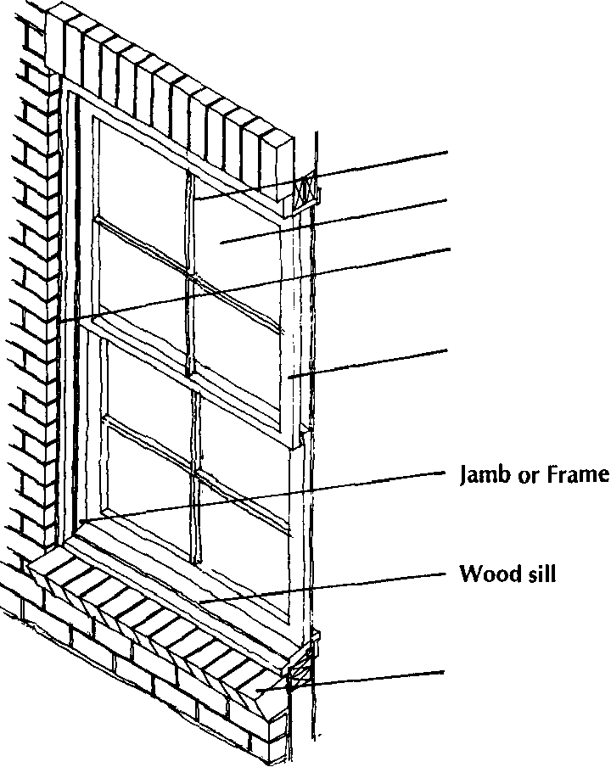
------ Header or Lintel
Muntin
Glass Surround
Sash
Brick sill

The windows of many residential buildings, as well as some operable windows of commercial, institutional, and government buildings, contain storm windows and screens. Historically made of wood, storm windows and screens were hung on brackets in front of the sash, fitting inside the jambs, head and sill.
Historic storm windows and screens for double-hung windows are often divided horizontally at the meeting rail of the sash, while those used on casement and other types of historic windows usually feature an undivided pane of glass.
Modern storm window and screens are typically double hung and made of aluminum. They are fitted inside the wood or masonry opening, typically attached to the window jambs.
Also contributing to the design of windows is the hardware used to operate and secure the window. Historic hardware on double-hung windows consists of counterweights and sash cords hidden in pockets inside the jambs and locks usually located at the meeting rails between the sashes. Casement, jalousie and awning window hardware primarily consist of blind hinges, exposed cranks and locks.
The Historic District contains a number of different types of windows, including double hung, casement, and awning. Round, semi circulator and oval shaped windows can be found primarily in the residential area, while storefront windows are common in the commercial area.
DOORS
The location and appearance of doors are important character defining features of historic buildings. Main entry doors, usually located on front facades, often employ richer materials and more elaborate designs than side, rear or service doors. In addition to allowing access into the building, main entry doors are typically designed to symbolically greet a guest or customer. For example, front entry residential doors usually have a friendly, welcoming appearance while providing security and privacy.
Commercial entry doors are also designed to make the customer or client feel welcome. On the other hand, the main entry doors on government and institutional buildings are often formal and imposing.
Doors have a number of components:
The door opening is framed by jambs on both sides, a header at the top and a threshold at the base. Typically, the opening is framed by decorative surrounds. The operable portion of a door is called the leaf, which may contain a glass panel or solid panels, rails and stiles. Sketch of door parts.
Depending on the building's architectural style, its front door may be located symmetrically or asymmetrically in the front facade. Residential front doors usually contain a high level of detail and ornamentation. In addition to the front door, most residential buildings have a secondary door on the side or rear elevation. Typically, secondary doors are less elaborate than the front door.
Almost all historic residential front doors are made of wood with raised or recessed panels. Many nineteenth century doors had recessed panels enframed by raised molding.
Today, most paneled doors contain recessed panels rather than raised moldings, making them appear flatter. Some historic front doors incorporate plain, colored, stained, beveled or etched glass panels. Secondary residential doors are typically also made of wood, and may or may not contain raised or recessed panels.
Residential door surrounds are made of wood, brick or stone. Some door surrounds also contain metal hoods above the door. The surrounds of front doors are often more elaborate in detail and ornamentation than those found on secondary doors. Transom windows are located above doors, and usually consist of single or multiple panes of clear, colored or stained glass in decorative patterns. Side-lights and fan-lights are windows on the sides and top of main entry doors. They are typically made of wood with the glass subdivided by muntins. Both are normally fixed, although operable fan-lights are found on a few buildings. Sketch of transom and sidelights.
Historic storm and screen doors may be found on residential buildings in Cambridge's Historic District. Typically constructed of wood with interchangeable glazing and screen, their design and detailing should be compatible with the door.
Modern storm and screen doors are usually constructed of aluminum.
Historic doors that have been inappropriately altered should be replaced with a door that duplicates, as closely as possible, the design and detailing of the original. In cases where the altered door is compatible with the character of the existing door and the building, it should be maintained.
Moving or blocking-up existing doors, or adding a new door to a primary facade will change its character, and thus should be avoided. If located on a secondary façade, moving, blocking-up or adding a door may be less critical to the character of the building. However, altering doors on side and rear facades must be approached with care.
- PORCHES & FRONT STEPS
Executive Summary:
The porches and steps of Cambridge’s historic residential buildings are two of their most important character-defining features.
This chapter addresses the elements that compose front porches, such as columns, railings, decking and balusters.
It also includes guidelines and recommendations for the preservation, repair and/or replacement of steps and front stoops.
GUIDELINES FOR PORCHES AND FRONT STEPS
GPF 8.A. Historic porches, and front steps including character defining features such as railings, posts or columns, ceilings, steps, lattice, flooring, piers, ornamental trim, and other character defining elements shall be retained and preserved, if possible.
GPF 8.B. Historic porch and front steps shall be repaired, rather than replaced, using materials and methods that preserves historic material, including patching, epoxy repair, reinforcing, or splicing-in of new wood in place of deteriorated sections.
GPF 8.C. If a historic porch or front steps is too deteriorated to repair, it shall be replaced in kind or in an appropriate substitute material that matches the existing in size, shape, texture, color, and other character defining features.
GPF 8.D. Replacing deteriorated or missing elements of a porch or front steps shall be based on existing elements or documentary evidence. Creating a false historical appearance, such as adding Victorian ornament to a plain early 20'h century porch, shall not be permitted.
GPF 8.E. Enclosing open porches that are seen from the public right of way shall not be undertaken except for adding screening. Porches that are not seen from the from the public right of way may be enclosed or screened if the enclosure is designed and constructed in a manner that preserves the historic character defining features of the porch.
GPF 8.F. Winterizing a screened porch by permanently attaching plastic sheeting or other material shall not be permitted.
GPF 8.G. Adding inappropriate floor covering such as indoor-outdoor carpeting to weather-proof a porch floor shall not be permitted.
GPF 8.H. Removing a porch or front steps that are not repairable and not replacing them, or replacing it with a new porch that does not convey the same character as the removed porch or steps shall not be permitted.
GPF 8.I. Adding a new porch or front steps to facades visible from the public right of way shall not be permitted unless they historically existed based on documentary evidence, or there is a functional reason why they should be constructed. If permitted, the design of the new porch should follow the Design Principals in Chapter 3 and 6.
GPF 8.J. The design of new stairs and ramps shall be compatible with the design of the facade to which they are attached. Consider retaining the existing stairs in front of residential buildings, and adding a landing and additional stair to access the elevated building.
RECOMMENDATIONS FOR PORCHES AND FRONT STEPS
RPF 8.A. Wood that is naturally rot resistant, and has the texture and printability of the original wood used for front steps or porch floors, railings, columns, and other character defining elements should be considered when replacing a front step or porch or their components in kind.
RPF 8.B. Gates on porches to restrain pets or young children should be temporary and reversible, and attached in a manner that does not harm or compromise historic material or details.
METHODS AND INFORMATION FOR PORCHES AND FRONT STEPS
The porches and front steps of Cambridge’s historic residential buildings are two of their most important character-defining features. Functionally, they provide spaces to sit, entertain friends, as well as allow access to a building. Front porches and steps often present a formal appearance to the street and often contain ornate details. On the other hand, rear porches and steps are often more informal and utilitarian in appearance.
Porches consist of several different components including decking, railing, columns, and roofs, which are constructed of a variety of materials, most typically wood, brick, stone, and cast stone. Stairs are typically of brick, stone, cast stone, and concrete. Some rear and side porches may be open without a roof. While most front porches are open, but have roofs, some have been enclosed with screens or windows. Sketch of open and enclosed porches and components
Porches may extend the full length or only some of the front primary façade. Some porches extend around one or both side facades. These porches contribute to the architectural character of the building and any repairs, replacements, or changes should complement the existing character of the facades to which they are attached. Rear porches, which are generally not visible form the public right of way, may differ somewhat from the character of the facade to which they are attached.
Front steps, and those on the sides of buildings visible from the public right of way, are also important character defining features of buildings in Cambridge’s Historic District.
Typically, single family residential buildings houses were raised a few feet above grade to provide a crawl space, or basement windows. Porches are often raised to provide air circulation as well as make the deck level with the first floor. Some institutional buildings have steps that contribute to the more monumental character as well as allow for basement windows.
Altering front porches, such as removing its original roof, railings, ornamentation or columns changes the character of a building and is almost never appropriate. Similarly, enclosing original open porches, except where it cannot be seen from a public right of way, is rarely appropriate. These and other alterations to front porch floors and roofs changes the appearance of the main facade, compromising a building's historic character.
An open front porch is sometimes enclosed to provide additional, year-round living space, or screened to keep out insects. Enclosing a front porch is rarely acceptable because it drastically alters the appearance of the porch and the main facade of the building.
Adding screens to open front porches may be acceptable if the screen is designed and installed in such a way that the open appearance of the porch is retained. A compatibly designed screened porch is one that has proportions, scale, materials, details, colors and other character-defining features that are appropriate to the building. Sketch of appropriate screen porch enclosure.
On the other hand, for rear porches, which are not visible form the public right of way, such alterations may be possible if the design is compatible with the scale, proportion, materials and other character-defining elements of the rear elevation.
Adding a new front porch or steps to a historic building where one never existed will significantly alter the appearance of the front facade and thus is not usually appropriate. On the other hand, adding a new porch or steps to a rear elevation may be appropriate if the scale, proportions, materials, and other character-defining elements of the new porch or steps is compatible with the character of the rear elevation.
Front steps and porch columns and railings have sometimes been removed and replaced with ones that are not compatible with the character of a building. If the inappropriate features are deteriorated and need to be removed, the owner should replace them with ones of compatible design. If original porch roofs have been removed, and the owner wishes to install a new one, it too should be compatible with the original design of the facade on which it is located.
- HISTORIC STOREFRONTS
Executive Summary:
Storefronts are one of the most important elements of the front facades of commercial buildings.
This chapter addresses the preservation, repair and/or replacement of the significant elements that compose historic storefronts, such as cornices, display windows, frames, awning and ornamental details.
GUIDELINES FOR STOREFRONTS
GS 9.A. Existing storefronts that are compatible with the design of the facade of the commercial building shall be retained and preserved.
GS 9.B. If repair of a storefront is necessary, it shall be repaired in kind or using a substitute material that is compatible with the existing in size, shape, color, texture and other character defining features.
GS 9.C. If the existing storefront is too deteriorated to repair, it shall be replaced in kind using the same materials if economically or technically feasible, or if not using substitute materials that resemble the original materials in size, shape, color, texture, and other defining characteristics.
GS 9.D. A replacement storefront shall be designed to fit within the enframing storefront piers and cornice. Drawing of enframing storefront elements. The replacement storefront shall not be recessed behind the front facade except for the entry. (Entrances in new storefronts should usually be recessed).
GS 9.E. Storefronts shall retain the traditional composition of bulkhead, large display windows, and signboard cornice, and enframing piers. If the use of the ground floor requires more privacy than allowed by the large display windows, privacy curtains, blinds, or other interior screening devises shall be installed. Blocking down storefront display windows shall not be permitted.
GS 9.F. Storefront awning frames shall fit within the enframing opening to which it is attached. The shape of the awning shall also complement the design of storefront or window to which it is attached.
GS 9.G. Canvas duck, nylon textured to resemble canvas duck or matt-finished vinyl shall be used for awning material. Metal, shiny vinyl, or semi-transparent backlit material or another inappropriate awning fabric shall not be permitted.

RECOMMENDATIONS FOR STOREFRONTS
RS 8.A. Missing storefront elements should be replaced, in kind, or in a compatible substitute material, based on existing evidence or on documentary. If none exists, the replacement element should be designed to be compatible in size, shape, profile, color and character of the storefront.
RS 8.B. Entrances in replacement storefronts should usually be recessed.
RS 8.C. If appropriate to the design of the storefront, fixed or operable transom windows should be part of a replacement storefront’s design.
RS 8.D. If storefront security systems are added, they should be electronic systems that do not alter the appearance of the storefront.
RS 8. E. Creating a false sense of history in a replacement storefront, such as one with Colonial features, should be avoided.
RS 8.F Storefront awnings should have a minimum clearance of 8’ – 0” above the sidewalk, and should be located a minimum of 1’ – 0” behind the vertical plane of the street curb.
RS 8. G. No more than two colors should be used on an awning. The underside of an awning should be opening, not enclosed.
RS. 8. H. Awnings signs should be on the valance or returns, not on the slope. If a sign is included on the awning, no more than three colors should be used.
RS 8. I. Depending on the material of the existing or original storefront, appropriate substitute materials may include GFRC, fiberglass, cementitious boards, and polyurethane or polypropylene. Plexiglas is not an appropriate substitute material for glass since it tends to yellow or fog when exposed to sunlight.
RS 8.J. Alternatively, if the existing storefront is not original, and documentary evidence existing for the original storefront, the deteriorated storefront may be replaced with a reproduction of the original using materials that are compatible with the façade in which the storefront occurs.
RS 8.K. Awning colors should complement the colors of the facade to which it is attached. No more than two colors should be used. If a sign is included on the awning, no more than three colors should be used.
METHODS AND INFORMATION FOR STOREFRONTS
Storefronts are one of the most important elements of the front facades of commercial buildings. They help attract customers and clients to a business by providing an inviting appearance and allow views into the ground floor retail space.
Traditional storefronts are composed of a storefront cornice, signboard area, display windows, and enframing elements consisting of storefront piers, base and entry. In many cases, traditional storefronts were also designed to have transom windows and canvas awnings.

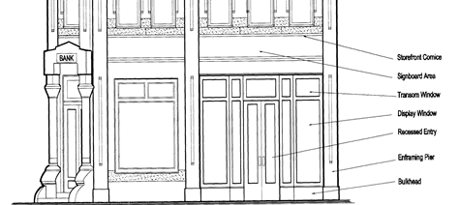

The design of storefronts has evolved over the past 150 years reflecting changes in how retail businesses are operated as well as the evolution of construction materials and methods. In the mid-nineteenth century, cast iron, steel, plate glass, and pressed metal were introduced as storefront materials.
Mass produced cast iron elements for storefront cornices, piers, and bases, produced in Baltimore, Washington DC, and elsewhere, were available on the Eastern Shore. Display windows became larger as glass manufacturing improved, and frames changed from wood to metal.
Entry doors are typically made of metal or wood with large panes of glass. Transom windows, typically containing prism or colored glass, allowed diffused sunlight deep into the store. Often transom windows were operable to provide natural ventilation.
In the 1920s and 1930s, aluminum, colored structural glass, stainless steel, glass block, neon, and other new materials were introduced as storefront materials.
Awnings are used to protect storefront window displays from sunlight, as well as pedestrians from rain. Storefront entries are typically recessed to provide further protection from inclement weather as well as to allow window displays to be viewed from more than one side.
Historically, awnings were found on storefronts and sometimes on the upper floor front facade windows of commercial buildings. Many historic awnings were operable so they could be retracted at night as well as allow sunlight to enter the building during the winter. The slope, returns, and valance of storefront awnings were also often used for business signs.
Awnings were historically made of steel frames and canvas duck. Today the frames are made of aluminum, covered with nylon or canvas duck. Typically, vinyl fabric is inappropriate for storefront awnings due to its reflectivity.
While storefronts are usually confined to the ground floor, in multi-story buildings, there may be a secondary entrance, usually located to the side of a storefront, providing access to upper floors. The placement of windows in upper floor facades is usually related to the composition of the storefront.
It is rare to find original storefronts in commercial buildings built prior to the second half of the twentieth century. As retail fashion and practices changed, or as businesses moved in and out of ground floors, storefronts are often removed and “updated”. In many cases the replacement storefront is very different in design from the original.
If the design of the replacement storefront is good representation of its period and style, and materials remain in good condition, and it remains functional, the owner should consider keeping it rather than replacing it with one that is historically correct.
- EXTERIOR BUILDING EQUIPMENT (SOLAR PANELS & UTILITIES)
Executive Summary
The need for modern mechanical systems is one of the most common reasons to undertake work on historic buildings. Adding modern systems to historic buildings presents one of the greatest challenges to retaining the historic character and appearance of old buildings and grounds. This chapter provides guidance to minimize the disruptive appearance of modern systems – solar panels, power panels, condensers, meters, skylights, antenna, satellite dishes and roof vents – that are commonplace in homes today.
GUIDELINES FOR EXTERIOR EQUIPMENT
GEE.10.A Utilities connections, such as HVAC units, meter boxes, antennae, and satellite dishes shall be located in side or rear yards if possible, and shall not be visible from the public right of way by appropriate screening with plantings, fencing, or other means.
GEE.10.B Thru-wall or thru-window AC units should ideally not be visible from the primary public right of way if at all possible. If they are visible from the primary public right of way, they should be screened from view.
GEE.10.C New or replacement systems shall be installed with a minimum of damage to the historic building and shall be visually compatible with the architecture of the building. They should be installed in a way that is easy to service, maintain, and upgrade in the future.
GEE.10.D Where possible, condensers, solar panels, chimney stacks, vents, skylights or other equipment shall not be mounted on visible portions of roofs or at significant locations on the site.
GEE.10.E Solar panels shall not be mounted on primary roof facades. Where possible, solar panels shall be mounted in the least visible locations, such as side or back yards or outbuildings. Solar panels shall not be mounted in a vertical position, where their appearance is most noticeable, but on horizontal or sloped surfaces not facing a primary public right-of-way.
GEE.10.F When placed on the roof, the solar panels shall not affect the roof façade elevation or roof line. Solar panels shall be low profile and exposed hardware, frames and piping shall have a matte finish and be of a color similar to the roofing material color.
GEE.10.F Non historic, noncontributing out buildings solar panels shall be permitted if the panels are mounted flush with the roof line and shall have a matte finish and be of a color similar to the roofing material color.

RECOMMENDATIONS FOR EXTERNAL EQUIPMENT
REE.10.A On-site solar technology should be considered only after implementing all appropriate treatments to improve energy efficiency of the building, which often have greater life-cycle cost benefit than on-site renewable energy.
REE.10.B A solar device should be installed on the historic building only after other locations have been investigated and determined infeasible.
REE.10.C Where roof mounted, solar panels should be ﬂush with the roof to the extent feasible.
METHODS AND INFORMATION FOR EXTERIOR EQUIPMENT
During the 18th century, heating and ventilation in America relied upon common sense methods of managing the environment. Builders purposely sited houses to capture winter sun and prevailing summer cross breezes; they chose materials that could help protect the inhabitants from the elements, and took precautions against precipitation and damaging drainage patterns. The location and sizes of windows, doors, porches, and the floor plan itself often evolved to maximize ventilation. Heating was primarily from fireplaces or stoves and, therefore, was at the source of delivery
In the 19th century the industrial revolution provided the technological means for controlling the environment for the first time. The dual developments of steam energy from coal and industrial mass production made possible early central heating systems with distribution of heated air or steam using metal ducts or pipes
The twentieth century saw intensive development of new technologies, the ability to cool interior spaces, and the notion of fully integrating mechanical systems. Oil and gas furnaces developed in the nineteenth century were improved and made more efficient, with electricity becoming the critical source of power for building systems in the latter half of the century.
Although twentieth and twenty-first century mechanical systems technology have had a tremendous impact on making historic buildings comfortable, the introduction of these new systems in older buildings poses the problem of installing modern systems to historic buildings without damaging the structure or appearance of the building.
New systems need to work within the structural limits of the historic building, producing no undue vibration, no undue noise, no dust or mold, and no excess moisture that could damage the historic building materials. If any equipment is to be located outside of the building, there should be no impact to the historic appearance of building or site, and there should be no impact on archeological resources.
Retaining historical means of conditioning living space with shutters, operable windows, porches, curtains, awnings, shade trees and other historically appropriate non-mechanical features of historic buildings to reduce the heating and cooling loads is still appropriate.
New equipment must be accessible for maintenance and should be visible for easy inspection. Moreover, since mechanical systems last only 15-30 years, the system itself must be "reversible." That is, the system must be installed in such a way that later removal will not damage the historic structure.

CHAPTER FIVE:
GUIDELINES FOR RESIDENTIAL AREA LANDSCAPES
- INTRODUCTION - GENERAL
The landscape surrounding a historic residential building, and trees, shrubs, lawns, walls, fences, sidewalks, driveways, decks, patios, pools, outbuildings and other associated features, contributes to the overall character of the historic property and its streetscape. As a result, the relationship between the buildings and landscape features within the site's boundaries should be considered in the overall planning for rehabilitation project work.
- NATURAL LANDSCAPES INTRODUCTION
Natural landscapes consist of topography, lawns, plantings, shrubs, hedges, trees and other living elements of a landscape, both planted in the ground or in pots, raised beds or other constructed containers.
RECOMMENDATIONS FOR NATURAL LANDSCAPES
RNL 5.2.A. Historic public and private natural landscapes visible from the public right of way that contribute to the character of the historic district, including open spaces, streetscapes, and yards should be preserved and maintained.
RNL 5.2.B. When removal of a component of a natural landscape becomes necessary due to disease or death, the replacement should be in kind or in a similar plant species and size when mature.
RNL 5.2.C. If a mature tree requires removal due to disease or death, it should be certified by a licensed arborist that the tree must be removed.
RNL 5.2.D. If a tree must be trimmed because it interferes with overhead lines, the trimming plan should be reviewed by the HPC before work proceeds. If a tree must be removed because it interferes with overhead or underground utilities, the utility company shall provide appropriate evidence to the HPC before the work proceeds
RNL 5.2.E. Prior to any additions or new construction on a property, the owner should determine if potential or known archeological sites may be affected and take appropriate measures to preserve them.
RNL 5.2.F. All new plant materials selected for replanting or new planting in publicly visible areas should complement as much as possible those found on the site and in the surrounding area.
RNL 5.2.G. New natural landscapes visible from a public right of way should reinforce the existing character of the streetscape.
RNL 5.2.H. Owners should consider using drought resistant plantings that resemble the existing when replacing diseased or dead natural landscapes.
RNL 5.2.H On properties within close proximity to the water or in low lying areas, appropriate plantings may be those that tolerate moist conditions.
CONSTRUCTED LANDSCAPES INTRODUCTION
Sidewalks, driveways, fences, walls, decks, outbuildings, and patios are some of the more common constructed landscape features found in Cambridge’s residential historic area. When located in front yards or other areas that can be seen from public right-of­ way, their design often contributes to the character of the property and neighborhood.
- GUIDELINES FOR CONSTRUCTED LANDSCAPES
GCL 5.3.A. Historic fence and retaining walls shall be retained, preserved, and repaired wherever possible. Repairs shall be in kind or in a substitute material that closely resembles the original in size, shape, texture, color, and other character defining features.
GCL 5.3.B. The design new fences shall be compatible with the associated building, site, and streetscape in height, proportion, scale, color, texture, material and design. Fence types such as wire, hurricane, chain-link, corrugated metal, and wooden post and rail, and other non-traditional fence types shall not be permitted if visible from the public right of way, but may be permitted if otherwise located.
GCL 5.3.C. Fences shall not exceed a height of four feet in front and side yards or other areas that can be readily be seen from the public right of way. Fences located so they are not readily seen from the public right of way may be up to six feet high.
GCL 5.3.D. New retaining walls shall not exceed a height of two feet, except if site conditions and topography dictates it must be higher. New retaining walls shall be constructed or faced with brick or stone laid in a manner that is compatible with the design of the building and natural landscape on the property.
GCL 5.3.E. The historic materials of sidewalks, driveway and other paved areas shall be preserved, maintained, and repaired in kind or in a compatible new material. New sidewalks, driveways and other paved areas such as patios shall be paved in materials compatible with the detailing, color, and finish the existing paved areas on the property.
GCL 5.3.G. Non-traditional paving edging materials such as landscape timbers, railroad ties and plastic edging or concrete bumpers shall not be permitted in areas visible from a public right of way.
GCL 5.3.H. Historically or architecturally significant constructed landscape features, such as garages and other outbuildings, shall be retained, preserved, and repaired in kind or in appropriates substitute materials.
GCL 5.3.I. Historically or architecturally significant constructed landscape features, such as garages and other outbuildings, that are too deteriorated to repair shall be replaced in kind or removed completely if economically and technically feasible, or rebuilt in appropriate substitute materials if using the original materials is not economically or technically feasible.
GCL 5.3.J. New tool sheds, decks, pergolas, gazebos, swimming pools and other non-traditional constructed landscape features and other traditional constructed landscape may be visible from the public right of way, but shall be compatible with the design of the main structure on the property as well as the Design Principals in Chapter 3.
GCL 5.3.K. New decks or other constructed landscape features that are connected to the main structure shall be done in such a way as not to damage or remove character defining features of the face to which it is attached.
GCL 5.2. L. New structures constructed on docks, boardwalks or piers shall be compatible with the character defining features of the main building on the site.
GENERAL LANDSCAPE NARRATIVE
Landscapes serve both a functional and an aesthetic purpose. American landscape design developed from Colonial gardens, evolved into the pastoral and picturesque designs of the nineteenth century. Victorian carpet bedding, gazebos and outbuildings such as horse and carriage barns and watermen’s sheds were in nineteenth century, some of which can still be seen in Cambridge today.
It emphasized informal groupings of plant materials. The front yard was often separated from the street and public sidewalk by a wood or cast iron fence, or by low stone or brick walls. Shrubs, trees and flower beds were used to define property lines. Cast stone, concrete and cast iron lawn ornaments were popular features, as were shrubs and densely planted flower beds close to a building’s foundations. Carriage houses or stables, usually associated with large nineteenth century houses, were usually located at the rear of the property, connected to a driveway. A portion of the rear yard of smaller houses may have been devoted to drying clothes, a kitchen garden, and a shed for garden equipment.
Landscape design in the early twentieth century returned to classical traditions, while mid and late twentieth century design became outdoor living spaces with patios, decks, barbeque structures and open, easily cared for landscaping. The design of early twentieth century outbuildings was influenced by the design of the main house. For example, a Colonial Revival house was usually accompanied by a Colonial Reveal garage, albeit with more modest detailing. Rear yards changed from “useful gardens” to small-scale formal gardens inspired by Colonial period design.
Historic landscapes rarely survive as plantings and trees died and are replaced, barns and carriage house were removed as they became unnecessary, and open lawns were paved with patios. Gravel driveways are paved with concrete or asphalt, and flagstone or brick sidewalks replaced with concrete. Wood fences are removed or replaced with chain link or poly fencing and landscape features may have been added over time, from new trees and planting beds to pools and ground mounted TV dishes.
The design of landscapes that can be seen from the public right of ways is an important character defining features of historic residential buildings. The front yard, and to somewhat lesser extent, the visible side yards, establishes the context for the main house, as well as its outbuildings. The care and attention shown by owners to the front yard shows the pride that they take in their home and the neighborhood. Not visible, but also important are potential subsurface archeological features which are important in defining the history of the site.
The design and location of sidewalks located in front yards helps to define the character of the streetscape and the neighborhood. Historically sidewalks were constructed of brick, although other materials can be found. The design, materials, and location of driveways contributes to the character of a property and its streetscape through the location of curb cuts and their materials. Existing driveways in the historic residential area are paved with a variety of materials, including asphalt, concrete, and gravel. Driveways typically lead straight from the street to a garage next to a house or in the rear yard, the latter typically associated with the larger houses in the district.
Fences and walls in front yards creates a sense of enclosure, as well as contribute to the character of the streetscape. The height of front yard fences and walls, their design and materials also contributes to the character of the streetscape. Fences on side and rear property lines are used for property definition and sometimes privacy.
Decks and patios become popular in the last half of the twentieth century, providing outdoor living spaces. In most cases they are located rear yards and thus usually cannot be seen from a public right of way. Rarely do existing decks or patios contribute to the character of a property or its neighboring buildings.
The most common outbuildings found in the residential area are garages and sheds. Often located in side or rear yards, garages and sheds constructed at the same time as the main house often use the same materials and colors, with similar but less ornate details and ornamentation. Garages, sheds, and other outbuildings visible form a public right of way contribute to the character of the property and its neighboring buildings.

CHAPTER SIX:
GUIDELINES FOR ADDITIONS, NEW BUILDINGS, RELOCATED BUILDINGS, ACCESSIBILITY AND EGRESS INTO STRUCTURES
- INTRODUCTION - ADDITIONS TO HISTORIC BUILDINGS
Many of Cambridge’s historic commercial and residential buildings have been added to over the years. Some were built to make the building more functional, others to improve the economic viability of the building. Still others were constructed to accommodate changes in building systems and technology, or for other reasons. In some cases, an existing addition to a historic building is compatible with the scale, proportions, materials, and other character-defining features of the original building. (See Chapter Three for discussion of character defining features.) An addition’s design should respect, but not exactly duplicate, the character of the original building. The rationale behind this principal is to not compromise the historic integrity of the historic structures. Further, an addition should not destroy original character defining details and ornamentation. In this chapter we shall look at both existing and new additions to the front, side and rear of structures along with entirely new construction of buildings.
GUIDELINES FOR ADDITIONS TO HISTORIC BUILDINGS
GA. 6.1.A. New additions shall be located at the side or rear so that they have a minimal impact on the facade and other primary elevations of the affected building or adjacent properties.
GA. 6.1.B. Design of a new addition shall be compatible with that of the existing building in setback, height, scale, proportion, and massing so as not to overpower it visually.
GA. 6.1.C. The design of a new addition shall be compatible with the existing building in materials, roof shape, rhythm, orientation, and details and ornamentation
GA. 6.1.D. New additions shall be designed to be harmonious with adjacent properties and surrounding streetscape, and compatible with the rhythm and scale of buildings and landscapes in the surrounding streetscape.
GA. 6.1.E. New additions shall be constructed so that they can be removed without irreversible damage to character defining features of the existing building.
GA. 6.1.F. Character defining features of new additions, including the design and materials of foundations, facades, windows, doors, steps, porches, details and ornamentations, roof membranes, and the like shall be compatible with the character defining features of the original building.
GA. 6.1.G. Roof top additions, including decks, mechanical equipment, additional floors and the like shall be located far enough behind an existing cornice so that it is cannot be seen from the public right of way. If this is not possible, the design of the addition or its screening should be compatible with the character of the building. Roof top additions to buildings with sloping roofs shall be located so they are not visible from a public right of way.
GA. 6.1.H. The area in which the new addition is located shall be examined for potential archeological resources prior to start of construction.
RECOMMENDATIONS FOR ADDITIONS TO HISTORIC BUILDINGS
RA. 6.1.A. Rooflines of new additions should be compatible in form, pitch, and eave height with the roofline of the original building.
RA. 6.1.B. A new addition should not be taller or shorter than one story difference from than the height of the building to which it is attached.
RA. 6.1.C. The colors of a new addition should be compatible with the colors of the building to which it is attached.
Existing additions that have acquired significance in their own right should be retained and preserved. Any changes to significant existing additions should be approached with the same care as changes to the original building.
In other cases, an existing addition is not historically significant or its design is not compatible in scale, proportions, materials or other character defining features of the original building. In these cases, the addition can be removed or its exterior altered to make it more compatible with the character of the original building.
The design of new buildings is critical to preserving the character of the Historic District. New buildings should be compatible with that character by respecting the setbacks, orientations, scales, proportions, rhythms, massing, heights, roof shapes, details and ornamentations, colors, and in the residential area, landscape features, of neighboring buildings and the streetscape. On the other hand the design of new buildings should not seek to duplicate the design of existing buildings as they are new construction and should reflect the period in which they are built. Compatibility is based on a thorough understanding of the design principles of existing buildings, as well as those used to design landscape features and secondary buildings on the property. Compatibility also involves analysis of how these design principles are used in the design of neighboring buildings and those in the streetscape.
Buildings may be relocated from one site to another within the Historic District, brought into the district from other areas, or even relocated vertically to prevent high tides from flooding crawl spaces, basements or even first floors.
New additions to existing buildings, entirely new buildings, and relocated buildings reflect the changing needs of property owners as well as economic, social, and environmental changes in Cambridge. Thus, additions, new construction, and relocations within the Historic District needs to be undertaken with care so that the existing historic and architectural character evolves in a measured manner that reinforces, maintains and protects the best of the existing built and natural environment.
BUILDING ADDITION TO HISTORIC BUILDINGS DISCUSSION
Existing additions may be attached to the front, side or rear elevation of a building in the residential area, and typically to the rear of buildings in the commercial areas. New additions should generally be located on the side or rear of buildings. Particular care must be given to the design of new additions that can be seen from the public right of way.
Existing Front Additions. Some existing front additions were constructed when a residential or other type of building was converted to commercial use. Often these additions were designed as commercial storefronts, and many have achieved architectural or historic significance in their own right, and thus should be retained. If the existing addition has not achieved historical or architectural significance by respecting the building’s rhythm, scale and proportions, the property owner should consider altering or even removing them if they are no longer functional, and returning the building to its original character.
New Front Additions. Adding a new addition to the front of a residential or commercial historic building is almost never appropriate as it will significantly alter the character of the original building.
Existing Side Additions. While not as common as rear or front additions, existing side additions can be found on residential buildings. These include open side porches as well as enclosed additions.
New Side Additions. Since side additions can usually be seen from a public right of way, new side additions should be compatible with the design of the original building, respecting its character without duplicating it exactly.
Existing Rear Additions. The most common type of existing additions found in Cambridge are those located on the rear of residential and commercial buildings. Typically, existing rear additions are relatively plain in design and are compatible with the unadorned nature of most rear elevations. In other cases, they have been designed in stark contrast to the rear elevation. While the latter is not in keeping with the design principles for additions, a contrasting rear addition may be acceptable if it is not visible from a public street or alley and when it does not destroy existing character-defining details, ornamentation, and materials.
New Rear Additions. A new rear addition that can be seen from a public street should be compatible with the design of the rear elevation of the existing building. If the new addition is not visible from the street, a less compatibly designed new addition may be acceptable.
Roof-top Additions. A roof top addition to a flat roof historic building is sometimes necessary for mechanical or communications equipment, solar panels or rarely entire floors.
- INTRODUCTION – NEW CONSTRUCTION
The design of new buildings is critical to preserving the character of the Historic District. New buildings should be compatible with that character by respecting the setback, orientation, scale, proportion, rhythm, massing, height, roof shapes, details and ornamentations, and in the residential area landscape, of neighboring buildings and the streetscape. The design of new buildings should not seek to duplicate the design of existing buildings. Compatibility is based on a thorough understanding of the design principles of existing buildings, as well as those used to design any associated natural or constructed landscape features. Compatibility also involves analysis of how the Design Principles (Chapter Three) are used in the design of neighboring buildings and those in the streetscape.
Compatibility does not mean exactly duplicating existing neighboring buildings or those in the streetscape. New buildings should be seen as a product of its own time. To reproduce a historic building, or to copy exactly a style from the past, creates a false sense of history. By relating to the existing buildings and the streetscape, but being of its own time, new buildings shows the Historic Districts continuing evolution, just as the existing buildings show its past evolution. In short, new buildings should be a good neighbor, enhancing the character of the Historic District.
Note in addition to these Guidelines, all new construction must conform to requirements in the Cambridge Unified Development Code.
GUIDELINES FOR NEW CONSTRUCTION
GNC 6.2.A. New constructed landscape features, including outbuildings and accessory structures, shall be placed in side and rear yards. Locating new constructed landscape features so they obscure the existing principal building's character defining architectural, natural or constructed landscape features shall be avoided.
GNC. 6.2.B. The area in which the new construction is located shall be examined for potential archeological resources prior to start of construction. Also see requirements for Limits of Disturbance Plan in HPC Application & Building Permit.
GNC. 6.2.C. The scale of new construction shall be compatible with the scale of contributing structures on the block or same side of the street.
GNC 6.2.D. The proportions the new construction and its character defining features shall be designed to be compatible with the proportions of surrounding contributing buildings including their character defining features.
GNC. 6.2.E. Windows and doors visible from the public right of way in new construction shall be compatible in proportion, scale, and rhythm, with windows and doors of surrounding contributing buildings.
GNC. 6.2.D. Traditional or approved substitute material shall be used in a traditional manner.
RECOMMENDATIONS FOR NEW CONSTRUCTION:
RNC. 6.2.A. Front setbacks should be compatible with the setbacks of neighboring existing buildings.
RNC. 6.2.B. The pattern of building separation and lot coverage that is found on a streetscape should be maintained.
RNC. 6.2.C. If a contributing building was demolished or moved from the site, design the new construction to be compatible in height, scale, massing, and location as the previous contributing building.
RNC. 6.2.D. Façade materials and details and ornamentation of new construction should be consistent with the materials traditionally used on surrounding buildings.
RNC. 6.2.E. An indication of the date of the new construction should be included on the facade in an appropriate location.
- RELOCATION OF EXISTING BUILDINGS GUIDELINES
The relocation of existing contributing buildings from one site to another inside or outside the Historic District is generally discouraged, unless it is required to save a significant contributing structure from demolition. If the owner wishes to retain its federal or state historic status, the Maryland Historical Trust must be consulted before any action is undertaken, including making application to the Cambridge Historic Preservation Commission.
Raising or elevating an existing building within the historic District to prevent recurring water infiltration problems from high tides or storm driven tides is generally permitted by the Cambridge Historic Preservation Commission. It is also sometime permitted by the Maryland Historical Trust. If the property owner wishes to use investment Tax Credits or and federal or state funds, including loan guarantee funds, in all or part to finance vertical relocation, contact the Maryland Historical Trust before any work is undertaken. For additional information, Guidelines, and Recommendations for vertical relocation, see Ch. 4: Foundations.
GUIDELINES FOR RELOCATING EXISTING BUILDINGS
GRB. 6.3.A. Relocating a contributing building from one site to another shall only be permitted when the only alternative is demolition.
RECOMMENDATIONS FOR RELOCATING EXISTING BUILDINGS
RRB. 6.3.A. When a building is relocated to another site or vertically, the owner should:
1) have the existing conditions documented in drawings, photographs, and text as required to preserve a record of the primary building, and natural and constructed landscapes prior to relocation;
2) utilize professional building movers to prepare the building for relocation, move the building, and lower it onto the new foundations;
3) position the relocated building in the same orientation and setbacks to be compatible with its new location;
4) provide new foundations that are compatible with the façade of the building.; and
5) if moved to a different site, select one that is within the historic district with a compatible streetscape and surrounding buildings as existed at the original site.
- ACCESSIBILITY AND EGRESS INTO STRUCTURES
Sometimes property owners wish to add ADA compliant ramps to houses or must add them to commercial or institutional buildings. In both cases they should be treated as any addition to the exterior of a building, and thus conform to the Design Principals discussed in Chapter Three. In addition, property owners should consult the latest edition of ADA Standards for Accessible Design published by the U. S. Department of Justice, and the latest edition of the Maryland Accessibility Code published by the Maryland Department of Housing and Community Development.
Sketch of compatible ramp.
Meeting contemporary accessibility and egress requirements, particularly when a building is adapted to a new use is one of the greatest design challenges facing property owners. In many cases, the solution is an addition containing an elevator or new egress stairs. In these cases, the Guidelines and Recommendations for Additions earlier in this chapter should be followed.
GUIDELINES FOR ACCESSIBILITY INTO STRUCTURES
GA. 6.4.A. Handicapped ramps shall be designed to be compatible with the facade to which they are attached.
GA. 6.4.B. Handicapped ramps shall be designed so that they do not damage or obscure character defining features of the existing building.
RECOMMENDATIONS FOR ACCESSIBILITY INTO STRUCTURES
RA. 6.4.A. Handicapped ramps should be located, if possible, on non-primary facades.
RA. 6.4.B. Handicapped ramps should be screened from view from a public right of way if possible.
RA. 6.4.C. Handicapped ramps shall be attached to the building in a manner that allows future removal of the ramp without damaging the historic structure.
RA. 6.4D. Prior to designing a handicapped ramp, property owners should consult with Cambridge’s Zoning Officer to determine how to locate and design the ramp.

