CAMBRIDGE MATTERS
By: Commissioner Steve Rideout
swrideout@aol.com

Dear Readers:

Commissioner Hanson forwarded the email below to me for sharing with all of you.
Good news for Shore Health and all of us. See below.

Steve

UNIVERSITY OF MARYLAND SHORE REGIONAL SUBMITS STATE APPLICATIONS TO TRANSFORM HEALTH CARE IN DORCHESTER COUNTY
CarolineCircle July 21, 2018

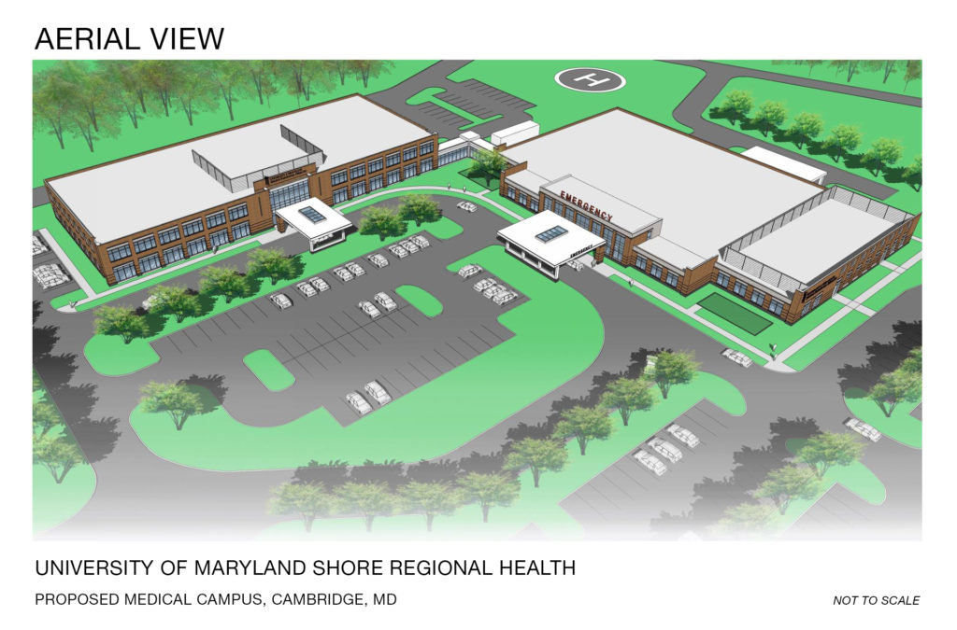
Aerial view of the proposed UM Shore Regional Health medical campus in Dorchester
(design may be subject to change.)

Public Information Session July 31 to Share Proposed New State-of-the-Art Medical Campus in Cambridge, Offering 24/7 Emergency Care, Surgery Center, and Comprehensive Outpatient Services to Meet Dorchester Health Needs

Representing a significant step in a process that began more than two years ago, University of Maryland Shore Regional Health (UM SRH) has filed applications with the Maryland Health Care Commission (MHCC) seeking approval to transform and enhance the health care services offered in Dorchester County.
The filing, called a Request for Certificate of Need Exemption, describes plans to replace UM Shore Medical Center at Dorchester with a new state-of-the-art health care campus offering services including 24/7 emergency care and short-stay observation care, with proposed outpatient surgery center, diagnostic services, outpatient specialty medical care, chronic disease management services, telemedicine and enhanced outpatient behavioral health programs and services.
A free public information session is scheduled Tuesday, July 31, 6:30 p.m. to 8:30 p.m., at Cambridge-South Dorchester High School, to share the proposed plans for this new medical campus with a Freestanding Medical Facility (FMF), to be known as University of Maryland Shore Medical Center at Cambridge.
The proposed medical campus is planned to be located approximately one mile from the current hospital, in Cambridge Marketplace, at Ocean Gateway (Route 50) and Woods Road. This location provides enhanced access to public transportation and ambulances and provides for an adjacent helipad for air transports.
Over the past two years, UM SRH discussed the changing health care environment with Dorchester County physicians, elected officials, Emergency Medical Services, public health and other health care partners, and community business leaders. With their support for the possible conversion of the aged hospital in Dorchester to an FMF, and the relocation of inpatient medical-surgical and behavioral health beds to nearby University of Maryland Shore Medical Center at Easton, the discussions expanded to the wider Dorchester community through a series of community listening sessions around the County in 2017. With positive feedback from these conversations, the Boards of University of Maryland Medical System (UMMS) and UM SRH moved forward with more detailed plans, leading to this month’s applications.
The proposed timeline for the opening of the new UM Shore Medical Center at Cambridge and the relocation of acute care inpatient beds to Easton is mid-2021, depending upon both State approval and funding.
With regulatory approvals, this new model of care will enhance the hospital’s ability to ensure services are available, keeping residents healthy in their community and reducing unnecessary inpatient admissions and emergency room visits. This model also allows for the potential to provide ambulatory surgical care and intensive outpatient behavioral health treatment.
Plans for the sale and ultimate redevelopment of the existing hospital site, located on approximately 14 acres of Choptank River waterfront, took a step forward in May when the City of Cambridge and Dorchester County created a Memorandum of Understanding creating an entity, Cambridge Waterfront Development, Inc. (CWDI), designed to purchase the property, prepare it for development and negotiate its sale by 2021. A second step occurred in early June, as UM SRH CEO Ken Kozel, Cambridge Mayor Victoria Jackson-Stanley, and Dorchester County Council President Ricky Travers signed a Letter of Intent for continued negotiations leading to the future sale of the hospital property to CWDI when health care services transfer to Cambridge Marketplace.
SUMMARY: Proposed UM Shore Medical Center at Cambridge
Approximately 40,000 square foot state-of-the-art Freestanding Medical Facility (FMF), open 24/7/365, to include:
- 18 private emergency treatment rooms serving all ages
- 2 bed resuscitation/critical care suite, serving all ages
- 3 behavioral health rooms
- 10 private short stay observation beds
- Telemedicine capabilities for Emergency Department patient specialist consultation
- State-of-the-art diagnostic/treatment equipment and technology
- Diagnostic services to support emergency care, including CT, MRI, ultrasound and X-ray
- Laboratory services, 24/7
- Helipad for air transport

SUMMARY: Proposed Services- UM Shore Medical Pavilion at Cambridge
Approximately 50,000 square foot, two story facility housing diagnostic, treatment, community education and support services, including:
- Outpatient services/providers in specialties such as cardiology, diabetes/endocrinology, ENT (ear, nose, throat, allergy), gastroenterology, general surgery, gynecology, obstetrics (prenatal care), orthopedics, outpatient behavioral health, outpatient medical oncology, pediatrics and urology
- Ambulatory Surgery Center (1 OR and 1 procedure room)
- Outpatient rehabilitation services, including The Balance Center
- Cardio-pulmonary rehabilitation
- Fully integrated telemedicine services for specialist access
- Community health education hub

