CAMBRIDGE MATTERS
By: Commissioner Steve Rideout
swrideout@aol.com
November 27, 2018

I recently received a copy of the power point presentation that was provided to the Dorchester County School Board during its meeting this past April. I am attaching it to this article for you to consider. It shows some encouraging information about what the county is doing to prepare more children to be ready for kindergarten. The county increased its success rate from 28% in 2016 to 44% readiness in 2017. What is interesting about the Power Point is slide 12, that I have copied below.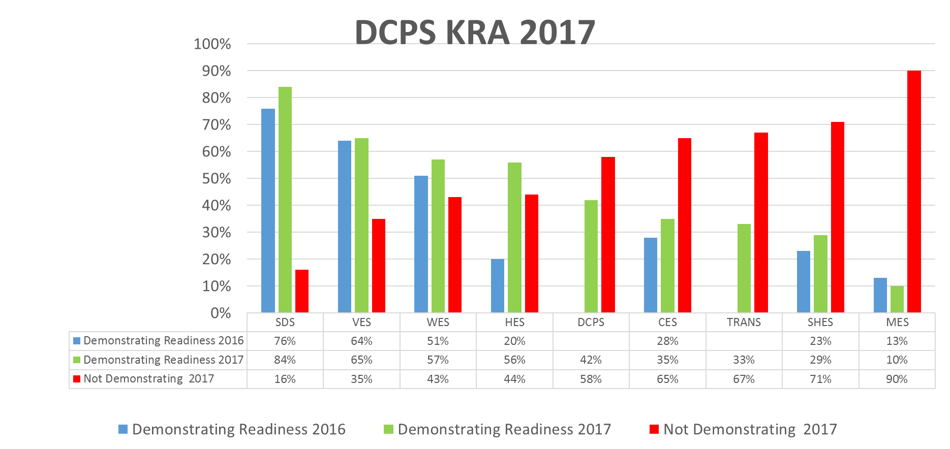

It shows all the elementary schools in the county and the percentage of children entering kindergarten that are demonstrating readiness. Starting from the left, the first four are in the county and, excluding the “Trans” portion that are the transient students, the other three schools are in the City of Cambridge – Choptank Elementary School (CES), Sandy Hill Elementary School (SHES), and Maple Elementary School (MES).

The first four county elementary schools for 2017 received from the various preschool providers over 50% of their incoming students who demonstrated readiness for kindergarten. The three elementary schools in the City of Cambridge received significantly less than 50% of their incoming students demonstrating readiness – 35% at Choptank, 29% at Sandy Hill, and 10% at Maple. In 2017, those 3 schools had187 of the 339 students entering kindergarten in Dorchester County or 55% of the incoming class. Choptank had 55 students. Sandy Hill had 62, and Maple had 70. So, calculating the percentages, only 20 of the 55 children entering Choptank, 18 of 62 children entering Sandy Hill, and 7 of 70 children entering Maple in 2017were ready. That is a failure rate of approximately 76%.

On slide 16 you can see that the Head Start program in 2017 had a success rate of 31%, more than double the prior year’s rate. The Shore Up Head Start Program oversaw 16% of the students entering kindergarten in 2017, approximately 55 children. So, 17 of the children from that program were ready for kindergarten in 2017. What this means is that our Head Start program that year failed to prepare 69% of the children in their care to enter kindergarten ready to learn.
In 2016 there were 24 children in the Shore Up Head Start Program, and their success rate was 13%. Should we not be demanding better performance from the Head Start provider or look for a new one? The link for the 2016 KRA information for Dorchester County is found at https://www.readyatfive.org/download-document/getting-ready/readiness-matters-2017/jurisdictional-data-2017/dorchester-county-1/1442-powerpoint-2017-printer-friendly-version-8/file.html
I am advised that the county school budget for PreK shows a federal contribution of $528,000 and a state contribution of $110,000 for the 2018-2019 school year. Based on the number of children from last year entering kindergarten and using this year’s funding, that comes to $1,882 per child not counting what additional funds, if any, the county contributed. $1,882 dollars spent for a child’s PreK experience and failure rates in Cambridge as noted above do not indicate a school system ready for success or one that will ever be successful until most, if not all, of the Preschool students are ready for kindergarten.
Another resource to consider if the Dorchester County School System 5-year plan for 2018-2023. Here is the link to it.
http://dcps.k12.md.us/images/PDFs/For%20Parents/DCPS_Strategic_Plan_2018-2023.pdf
The goal for having children ready for kindergarten is 98% by 2023 with no incremental indicators for any years between now and 2023.
There are, I am sure, factors that help explain the differences between the rate of failure for children arriving at kindergarten in the county and those arriving in the city. Some are noted in the data on the Power Point that discuss challenges for some of the children attending kindergarten within the City of Cambridge. There are, I am also sure, solutions to those challenges that need to be found and implemented.
We are probably too far into this school year to easily reallocate school resources to address the challenges facing the current preschoolers in the city and the three elementary schools in the city. Trying to do so might take away valuable staff time from working on current efforts to improve outcomes.
While I have my own thoughts, now would be the time for those of you who are or have been educators, early childhood advocates, school administrators, and interested parents and citizens to have your voices heard about what needs to happen here in Dorchester County and especially Cambridge to prepare more children for kindergarten sooner than the current goal of 98% by 2023. Focusing on five years from now rather than having goals for each year between now and 2023 simply allows delays accountability on this issue. If you have ideas or opinions and would like to share them, you can write a letter to the editor of the Dorchester Banner, send me an email or letter, or appear before the School Board at their next meeting and provide them with your thoughts. If you wish to remain anonymous and send me information or ideas, I will honor your request.
Now is the best time for the Dorchester School Board to start considering solutions for the preschool children destined in the future for one of the three elementary schools in Cambridge.
What the School Board can do for the upcoming budget year is ask the Early Childhood Advisory Council immediately to consider your ideas and suggestions. The Advisory Council can develop a plan to bring to the School Board for how best to spend some of the millions of dollars in its budget more effectively for preschool and elementary school students and where to seek grants to address kindergarten readiness on behalf of the children living in the city.
The community needs to take a greater interest in the school system and advocate for more resources for the city’s elementary schools and Preschool providers, as having more children ready to learn as they enter kindergarten will positively impact our economy, improve school performance in the future, reduce the truancy and delinquency rates in the city and county as well as future crime rates. The national data on the rate of school success for children entering kindergarten ready to learn as compared to those children not ready to learn is clear.
As the Members of the Board of Education learned about this situation last April, the community deserves to know what steps, if any, it has taken to address known issues and its 5-year plan. What are they providing to support the Preschool providers as well as the teachers, social workers, and counselors in the elementary schools in the city. How have the two school board members elected to represent the City of Cambridge advocated for and how will they be advocating for more Preschool and elementary school funding and resources that support programs for the children, parents, and teachers in the elementary schools in Cambridge and especially parental engagement.

Preparing the youngest children to be ready for kindergarten is essential in so many ways for the betterment of them and the community. If we are not ready to help the teachers and administrators push for change, we will continue to see too many children arrive at kindergarten and grade one not ready to learn and we will continue to see good teachers leave Dorchester County to teach in other counties that appreciate the knowledge and eagerness to help that they bring to this work.

