Main Street Gallery  Print Making Workshop  June 15  10 a.m. – 3 p.m. |  | 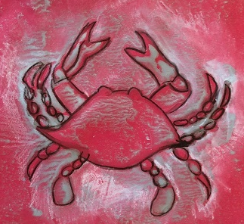
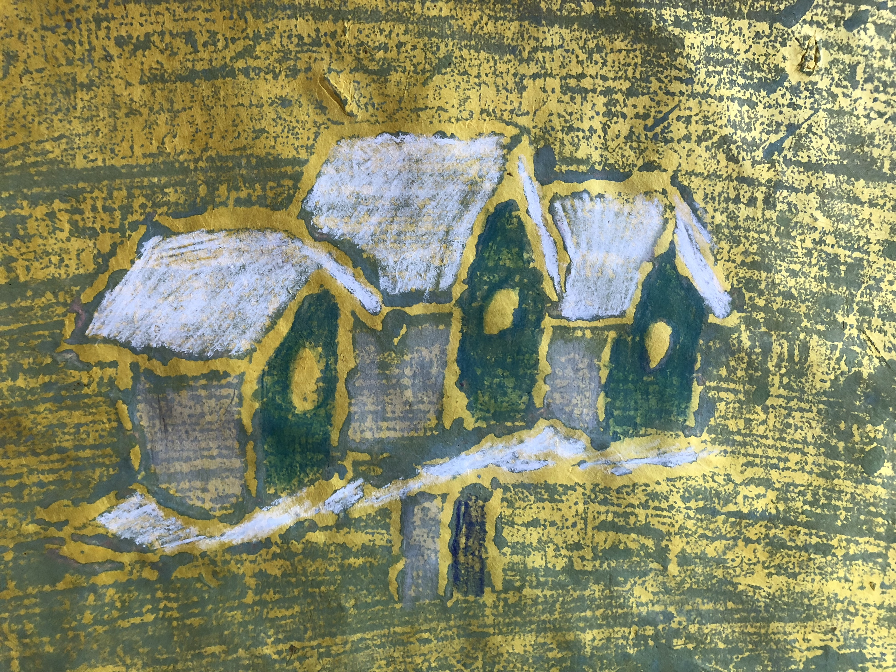 |  | 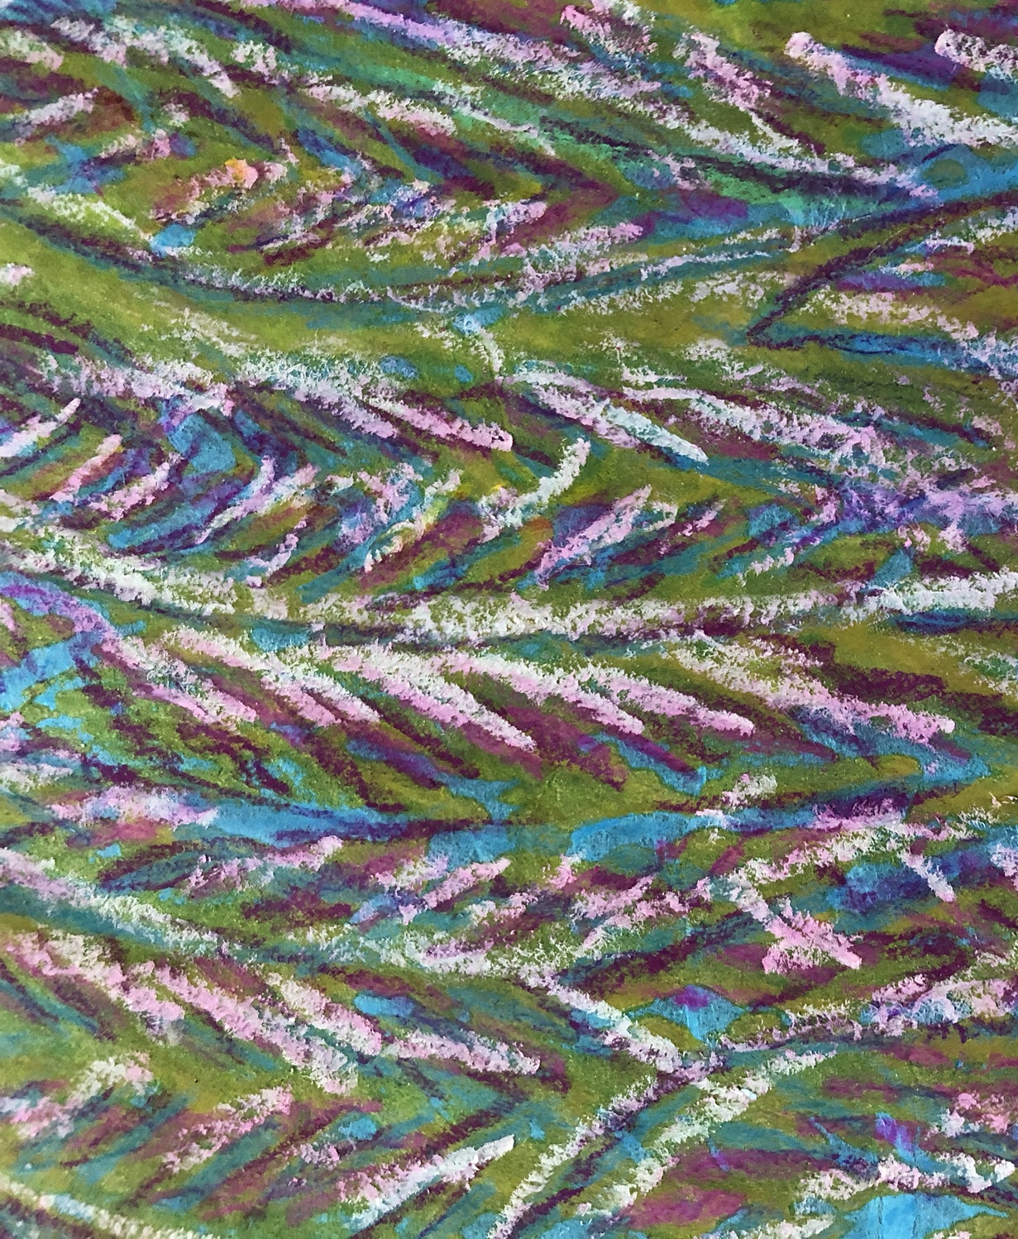
Join artist Kathy Flament, in creating prints using ink or paint, and watercolor pencils. She will teach you how to transfer an image onto foam board, carve that image using only a sharp pencil, apply color, create the print in one or successive applications of color then add finishing touches of color. Class fee: $45
Please go to our website for more information.
  - www.mainstgallery.org
518 Poplar St
410-330-4659

