Posted on: October 10, 2019

Pine Street Neighborhood in progress
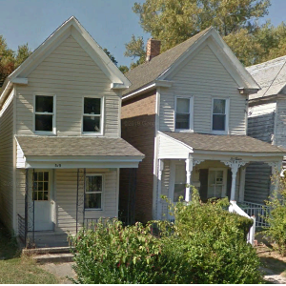
A public coordination meeting to evaluate property potentials in the Pine Street Community Area will take place on October 18, 2019 at Council Chambers (305 Gay Street) from 10 am till noon. All are invited to participate and give opinions on the proposed rehabilitation and sometimes demolitions of critical structures in the neighborhood. Please come and vote on which homes you find are essential to the character of the neighborhood, and which structures you agree have gone past the point of no return, making them candidates for demolition and the reconstruction of better living conditions for all to enjoy.

