CAMBRIDGE IS HONING THE SKILLS OF ITS DORCHESTER CAREER & TECHNOLOGY CENTER STUDENTS

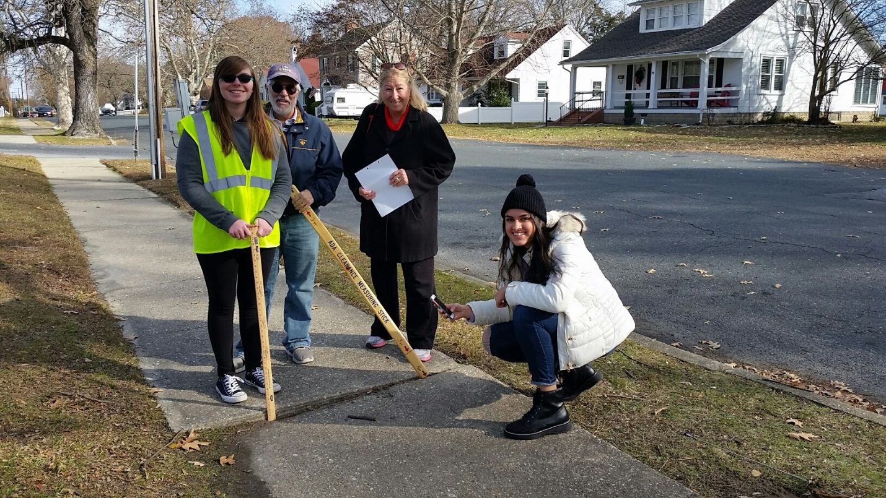
On Saturday December 7, 2019, the first 2 students from the Dorchester Career & Technology Center (DCTC), under a new program of collaboration between city and school system, started the survey of the city’s sidewalks, verifying their compliance with the Americans with Disabilities Act (ADA) and the Design Standards for Accessibility from the Department of Justice.
Amanda Bair and Aamna Alvi are shown here documenting a significant uplift and settlement of a sidewalk slab, which would constitute an obstruction to the path and access of a person with disabilities. They were accompanied and monitored by 2 members of the Cambridge ADA Committee, Patty Kaczmarek and Tom Puglisi, there to provide safety, but also additional training and information when required.
The students are using a Geographic Information System app developed by city employee Scott Shores. The Geographic Information System (also known as GIS) is a software program widely used in various practical business data analysis applications. Education about the issues facing people with disabilities, as well as the use of technology such as GIS, provide the students with both a window into their future as members of society and valuable training as young professionals.
Nine DCTC students are currently enrolled in this program, a partnership between the City of Cambridge and Dorchester County Public Schools (DCPS). Superintendent Dave Bromwell, and city employee Herve Hamon, together with Commissioner Dave Cannon and ADA Committee Chair Jerry Burroughs, struck an agreement that formalizes the hours needed to survey the entire city and give the enrolled students credit in the form of Community Service Hours necessary for their graduation.
This endeavor is expected to be completed by the students in May 2020 and will lead to a full report on the status of Cambridge sidewalks. That report will in turn be presented to the City Council and become the basis to apply for State funding for infrastructure and street improvements.
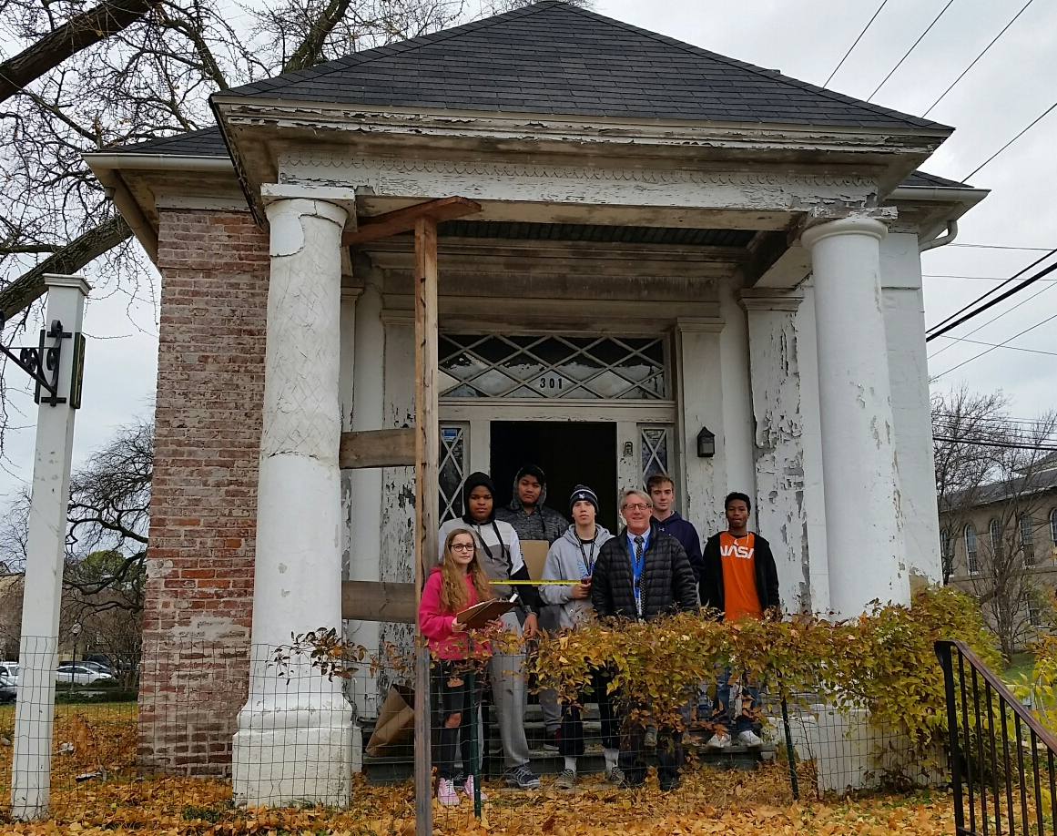
In a second technology-oriented community service project, a group of students from DCTC enrolled in the Computer Aided Design and Drafting (CADD) class and the Construction Design and Management program with Mr. Mark Preziosi performed a full survey and measurements of existing conditions at the Wallace building located on Gay Street. With the sidewalk survey program of collaboration already in place, the same agreement between DCPS and the City of Cambridge was used for this project, which took place on Tuesday, December 10, 2019.
This initiative was spurred by the need to document historic buildings in Cambridge, and is part of a grant application from George Vojtech, Chair of the Historic Preservation Commission, and in charge of the restoration of the Wallace Building.
As a licensed architect, city employee Herve Hamon is able to work in tandem with Mr. Preziosi to provide the DCTC students with valuable insight on how to document the existing conditions, how the building is constructed, and what to look for when the measurements will be transferred in CADD. One of the DCTC student, Mikayla Foreman has expressed her desire to become an architect, and the other students all have interest in construction or engineering. This practical application of field observation, translated later in the classroom with technology into documentation of an historic building, is a most efficient and effective way to make the use software a real and tangible tool.
Both Mr. Preziosi and Mr. Hamon hope that this exercise will provide an invaluable insight into potential careers for the students, as well as giving them a strong reference for their resume when applying for internship jobs in the construction and design field.

