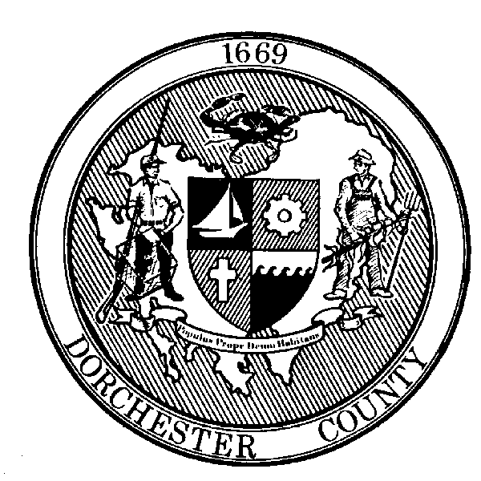

Roger L. Harrell, M.H.A.

Health Officer

FOR IMMEDIATE RELEASE:
Contact: Angela Grove
Direct Line: 410-901-8126
Email: angela.mercier@maryland.gov

Dorchester County Health Department Announces Second Case of COVID-19
And Completes Investigation of First Case

Cambridge, MD (April 1, 2020) – The Dorchester County Health Department announced the second diagnosed case of COVID-19 in Dorchester County. The individual is a female, in her 70s, and hospitalized with underlying medical conditions. The Health Department is currently investigating the case with the help of the Maryland Department of Health. Communicable Disease nurses will identify contacts and advise them of any necessary actions to take. The Health Department will share information, as soon as possible, if any risk to the public is identified.

The local contact tracing investigation for Dorchester’s first confirmed case, regarding a male in his 50s, has concluded. The individual is self-isolating at home and recovering. No risk to the public has been identified.

Residents are reminded to stay home, practice social distancing, and wash your hands and disinfect frequently touches surfaces often. “We understand the sacrifice we are asking you to make by staying at home and practicing social distancing,” says Dr. Casey Scott, Deputy Health Officer. “This is not easy, and we do not take this lightly. However, it is very important to follow the guidance of the Governor and our state health department to try to limit the spread of this virus.”

Individuals experiencing flu-like symptoms, including fever, cough, and shortness of breath, should call their health care provider for guidance. Everyone does not need to be tested for COVID-19. Testing is only indicated in certain circumstances.

Visit coronavirus.maryland.gov for information and resources about COVID-19 in Maryland and follow Dorchester County Health Department’s Emergency Preparedness Facebook page at www.facebook.com/dorchesterhealthemergencypreparedness for updates. Dorchester County residents with general questions or concerns about COVID-19 can call the Dorchester County Health Department at 410-228-3223 Monday through Friday, 8am-4:30pm or 2-1-1 after hours. Call takers cannot share any additional details about the cases, but can help answer residents’ questions.

###

