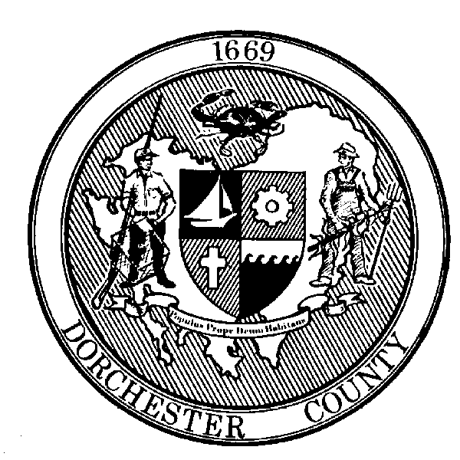

Roger L. Harrell, M.H.A.

Health Officer

FOR IMMEDIATE RELEASE:
Contact: Angela Grove
Direct Line: 410-901-8126
Email: angela.mercier@maryland.gov

Dorchester County Health Department COVID-19 Daily Weekday Update

Cambridge, MD (April 8, 2020) – As the number of diagnosed cases of COVID-19 is increasing, Dorchester County Health Department will release a daily weekday report instead of announcing each individual case. Dorchester County Health Department is reporting eight total confirmed cases in Dorchester County today.

COVID-19 Statistics in Dorchester County
Number of Confirmed Cases: 8
Number of Deaths: 0
Hospitalizations: 1

Cases by Age Range and Gender:
0-9: 0
10-19: 0
20-29: 1
30-39: 2
40-49: 2
50-59: 1
60-69: 0
70-79: 2
80+: 0
Female: 5
Male: 3

“To date, zero of our positive cases have been linked to foreign travel, and the majority of cases have not required hospitalization,” says Deputy Health Officer, Dr. Casey Scott. “We are seeing widespread community transmission of this virus, and this is why it is crucial that all residents recognize the risk we face if we do not follow social distancing recommendations.”

The Health Department continues to investigate cases with the help of Maryland Department of Health. When notified of positive cases, communicable disease nurses identify contacts and advise them of any necessary actions to take. The Health Department will share information if any specific risk to the general public is identified.

Residents are reminded to stay home, practice social distancing, and wash your hands and disinfect frequently touched surfaces often.

Individuals who have been in contact with someone who has tested positive or experiencing flu-like symptoms, including fever, cough, and shortness of breath, should call their health care provider for guidance. Everyone does not need to be tested for COVID-19.

Persons who test positive for COVID-19 may stop isolation once they have been fever free for 72 hours, a week has passed since the onset of their symptoms, and they have seen an improvement in those symptoms.

Visit coronavirus.maryland.gov for information and resources about COVID-19 in Maryland and follow Dorchester County Health Department’s Emergency Preparedness Facebook page at www.facebook.com/dorchesterhealthemergencypreparedness for local updates. Please note local information is the most up-to-date, as there are delays in the Maryland Department of Health case count map.

Dorchester County residents with general questions or concerns about COVID-19 can call the Dorchester County Health Department at 410-228-3223 Monday through Friday, 8am-4:30pm or 2-1-1 after hours. Call takers cannot share any additional details about the cases, but can help answer residents’ questions.

###

