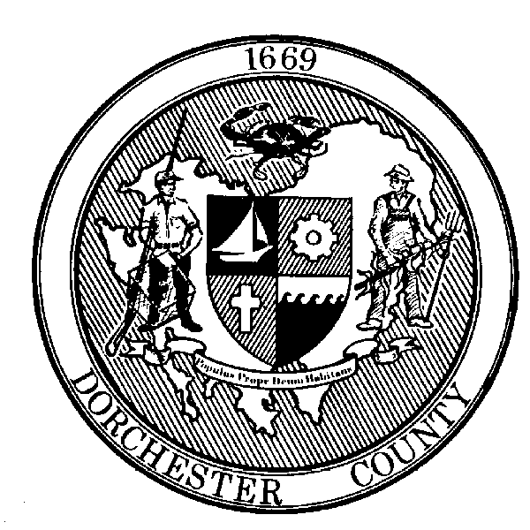

Roger L. Harrell, M.H.A.

Health Officer

FOR IMMEDIATE RELEASE:
Contact: Angela Grove
Direct Line: 410-901-8126
Email: angela.mercier@maryland.gov

Dorchester County COVID-19 Testing Available to Community

Cambridge, MD (May 29, 2020) – Dorchester County Health Department is providing free, drive-thru COVID-19 testing for Dorchester County residents. Testing is open to the general public and will take place at locations throughout Dorchester County. No appointment or doctor’s order is needed. Testing will be offered on a first come, first serve basis. Spanish interpreters will be available. Face coverings will be required. Here is the schedule of testing events, weather permitting:

- Tuesday June 2nd 1pm-3pm at South Dorchester K-8 School
- Thursday June 4th 1pm-3pm & Tuesday June 23rd 1pm-3pm at North Dorchester Middle School
- Tuesday June 9th 1pm-3pm & Thursday June 18th 1pm-3pm at Mace's Lane Middle School
- Thursday June 11th 1pm-3pm at Warwick Elementary School
- Saturday June 13th 9am-12pm & Thursday June 25th 1pm-3pm at Cambridge-South Dorchester High School
- Tuesday June 16th 1pm-3pm at Vienna Elementary School
For updates, such as weather cancellations, follow Dorchester County Health Department’s Emergency Preparedness Facebook page at www.facebook.com/dorchesterhealthemergencypreparedness. Dorchester County residents with questions or concerns about COVID-19 can call the Dorchester County Health Department at 410-228-3223 and visit www.dorchesterhealth.org for more information.

Additionally, the Cambridge Walmart is offering free, drive-thru only testing Mondays, Wednesdays, and Fridays between 7am-9am, weather permitting. Online registration is required at www.DoINeedaCOVID19test.com and individuals will have to meet testing criteria to make an appointment. For questions regarding testing at Walmart, call 800-635-8611.

The drive-thru testing site at Chesapeake College in Wye Mills will close on Friday, June 5th, 2020. However, Dorchester County Health Department continues to support local healthcare professionals in their COVID-19 testing efforts. Tests continue to be offered by private providers, urgent care centers, and the hospital.

###

