Newsletter #22.5 June/July 2022

All CAN Board meetings are announced in advance and open to the public.
Everyone interested in CAN is invited to attend.

IN THIS ISSUE: page
- PRESIDENT’S MESSAGE 2
  - Proposed City Budget 2
  - Popular Street One-Way Pilot Project 3
- CAMBRIDGE CORNER 4
  - Cambridge Real Estate Trends 4
  - Cambridge Police Department – Officer Highlight: Pfc. Rebecca Clark 5
  - Glass Houses – Duplexes vs Apartments 6
  - Historic Preservation Commission (HPC) report 8
- Community News – Cooperating Community Organizations 8
  - Firecracker Kids Triathlon – July 4 8
  - Tubman Stature Fundraiser and Unveiling 10
  - MidShore Meals ‘til Monday 10
  - Main Street Gallery – A Winter Storm is Coming 11
  - Cambridge Empowerment Center – Summer Learning & Fun 12
  - ShoreRivers – Thank You 12
- CAN Mission Statement, Membership Information, and Committees 12

CURRENT LINKS:

- JOIN CAN FOR FREE – https://cambridgecan.org/join-can/
- CAN Meeting Minutes – https://cambridgecan.org/category/meetings/
- CAN’s City Council Meeting Notes – https://cambridgecan.org/category/news/city-council-notes/
- CAN’s Planning & Zoning Notes – https://cambridgecan.org/category/news/p-and-z/
- CAN’s Website – https://cambridgecan.org
- CAN on FaceBook – https://www.facebook.com/CambridgeAssociationofNeighborhoods/
- Contact CAN – CambridgeCAN@yahoo.com

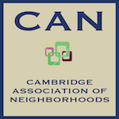
PRESIDENT'S MESSAGE – Proposed City Budget & Poplar Street Pilot Program
By Chuck McFadden, President, CAN, Ragtime31@gmail.com

Proposed City Budget

I have just reread the City’s proposed 16-page budget plus the 6-page amendment for Fiscal year 2022/23 prepared by the New City Manager, Tom Carroll, and the new Financial Director, Deborah Cooper. I am amazed that they were able to put together such a detailed proposal with only weeks on the job. For those of you who do not have the time or inclination to read the document, let me summarize it for you. This summary does not distinguish between the general fund, the City reserve, grants and the Federal government American Rescue Plan Act (ARPA) but instead shows what was approved so far by the Council. The City rolled over the existing budget for FY22 with only one reduction -$250,000 that was the last payment (FY22) on the Marina loan. The Council has approved for FY23 the following:

- Balancing the budget
  - A revenue shortfall in property tax income is projected for the next three years. The City will use $500,000 in FY23, $400,000 in FY24 and $300,000 in FY 25 to supplement the property tax income – all coming from the ARPA funds received from the federal government.
  - The Council reduced the property tax income by accepting “constant yield” –this is an annual reduction of $200,000 to $250,000
  - The Council used some of the unusually large Rainy-Day fund of $5.2 million to fund some of the projects listed.
- City employees
  - At least a 4% increase to all employees (except City Manager, who gets zero). It is an inverse allocation so that lower-level employees will get much more- a General maintenance worker will get 12.7%, an equipment operator -11.8%, new police officer-8.33% but the Dept. head- only 4%. This will compress the salary structure.
  - $200,000 for Community Policing which is broken into $100,000 in FY 23 and $100,000 in FY24.
  - $165,000 for one-time pandemic payments
  - $135,000 for increased health benefits options
  - $36,000 to promote Diversity, Equity and Inclusion
- City systems
  - $30,000 to run the Mayoral election this summer
  - $50,000 for the “Spot Shooter” program for the Police
  - $288,000 to increase the City’s technology systems
  - $100,000 for two street circles, 5 raised crosswalks, 5 regular crosswalks, signs, and restriping
  - $500,000 for repaving streets – no repaving done in the last 4 years
  - $3.5 million to Improvement of the Trenton Pumping station
  - $2.5 million to Implement the West End Sewer Upgrade
  - $200,000 for stabilizing City Hall, estimated refurbishing - $5million
  - $500,000 for public works equipment
  - $500,000 for implementation of Cambridge Harbor
  - $100,000 for small public facilities improvements – restoration of Gay St. Council Building, Reroofing two public works buildings
  - $100,000 for demolition of two vacant proprieties
  - $1 million to capitalize a land bank to acquire land for redevelopment
  - $1 million for affordable housing
  - $750,000 to reduce the City’s energy costs
  - $500,000 for downtown revitalization
  - $300,000 for Economic Development
  - $141,000 to fund a loan for additional fire equipment
  - $343,7784 for Cornish Park refurbishment
  - $500,000 for work on Cannery Park
  - $18,900 for Art in Public spaces
  - $500,000 to improve equipment and technology in the City.
  - $100,000 for replacement of broken video monitoring equipment
  - Changing to leases for Police and Public works cars
- Non-profits
  - $500,000 to Cambridge non-profits based on their requests. This is in addition to $500,000 in FY22.
  - $750,000 to non-profits serving our youth and the reduction of school violence
  - $200,000 for land and building of Harriet Tubman’s father replica cabin near Cannery Way
- Studies (but no additional funding)
  - Reviewing financial options for funding fire equipment
  - Study on sea level rise
  - Study on the revitalization of Pine St. Historic District
  - Study of roadway improvements near the Packing House.
  - Review of the Municipal Utilities Commission (MUC) rates
  - Review of the Marina fund to pay for replacement of 3 piers ($1 million each) and refitting others

There was a Public Comment section after the first budget work session but there were no speakers because after 3 hours, they only got though half of the budget and had made several amendments, so it was very confusing. The Council did not allow any public comments after the second budget work session.
There was no request for increased staffing levels over the FY2021/22 level, so the existing staff will have their hands full trying to carry out the objectives of this budget. The budget is scheduled to be approved on June 27. Hope this helps!

Poplar Street to Go One Way – Pilot Program

On Tuesday June 20th, the City Council approved a pilot program proposed by Commissioner Roche to make Poplar a one-way street. Starting at the intersection of Gay and Race Streets, Poplar St would become one-way going towards High St. Also under the pilot program, the sidewalk on the RAR side would be extended out 10 feet to accommodate outdoor dining. The sidewalk and parking spaces on the other side of the street would remain the same. The traffic lights at Gay & Race streets, High & Poplar streets, and High & Glasgow streets would be removed and replaced with stop signs. Plastic Jersey barriers would line Poplar Street during the pilot program as a temporary safety measure. There were no parameters given as to the length of the pilot or the measures of success.

The vote was 3 to 2 in favor of doing the project. Both Commissioners Cephas voted against. Four Business owners spoke doing the public comment and all were against the project. General comments that I have received from West End residents were not favorable because it will be much harder to get to the Race Street, especially the first block after Poplar, and general concern about not having traffic lights at major intersections. Since this is a pilot program, direct your comments to the City Council. More to Come.

Chuck McFadden, President, CAN, Ragtime31@gmail.com

CAMBRIDGE CORNER

CAMBRIDGE REAL ESTATE TRENDS
by Fred & Marti Phillips-Patrick

National Real Estate Trends

The softening trend in residential real estate nationally continued in June, 2022. The Freddie Mac fixed rate for a 30-year loan continued to rise, reaching 5.81%. A year ago, the rate was 3.06%. As Realtor.com calculates: “Mortgage payments today are 65% larger than they were just a year ago—when homebuyers were already grappling with the steep run-up in prices. That means homebuyers today would be paying 65% more to own the same house due to higher home prices and mortgage rates. (The calculation assumes buyers are putting down 20% on a median-priced home and does not include property taxes, insurance costs, or homeowners’ association fees.)” In light of these trends, let’s see how the Cambridge real estate market is doing in this environment.

Cambridge Market Update

According to Zillow, the typical value of homes in Cambridge is $181,142, slightly up from April. This value is seasonally adjusted and only includes the middle price tier of homes. Cambridge home values have gone up 11.0% over the past year. Realtor.com recently characterized Cambridge as a balanced market, which means that the supply and demand of homes are about the equal. The sale-to-list price ratio was 99.5%, which means that homes in Cambridge sold for slightly less than their asking price on average in June. However, according to Movoto, some 43 properties have had their asking price reduced in light of market developments.

Cambridge Sales

Currently, according to Realtor.com, there are now 139 homes for sale (116 single family homes and 23 condos and townhomes) in the Cambridge area, up 36% from April. There are also 6 multifamily units for sale, as well as 64 plots of land, and 1 farm for sale, about the same as April.

According to Realtor.com, only 19 single family, townhouses, and condo sales have been completed so far in June (as of the 25th), ranging in value from $700,000 to $35,000. They are:
207 High St $605K 1529 Global Cir $245K 404 Phillips Ave $225K
6213 Twin Point Rd $700K 1204 Hambrooks Blvd $540K 312 E Appleby Ave $250K
114 Oakley St $335K 302 Choptank Ave $305K 409 Pine St $40K
802 Locust St $150K 1006 Washington St $89K 504 Governors Ave $150K
1675 Terrapin Cir $321K 2522 Westwind Blvd $240K 827 Fairmount Ave $35K
1119 High St $248K 2930 Old Route 50 $106.7K 208 Aurora St $90K
2700 Willow Oak Dr Unit 101A - $252K

Conclusion: As Realtor.com stated, Cambridge continues to be a more or less balanced market. Home values have increased 11% over the last twelve months, but have slowed more recently. However, as a neighbor, it was nice to see 302 Choptank sell for $305,000. And we wait for more news on the development of the 201 Mill Street Property, as well as the exciting redevelopment of “Cambridge Harbor”.

THE CAMBRIDGE POLICE DEPARTMENT – Officer Highlight: Pfc. Rebecca J. Clark
By Captain Justin R. Todd, N.A#258

Happy Summer to everyone. I wanted to spend a quick moment to let everyone know that on June 16th we graduated three new officers from the Eastern Shore Criminal Justice Academy. Two of the three have already began field training and we hope to have them working the streets of Cambridge on their own by late August. I encourage everyone that when they see one of our officers out and about, rather walking or at a restaurant, etc. please walk up and introduce yourself and get to know the officers. We have had many new faces become a part of our agency in the past couple of years. I know they would appreciate it.

Speaking of new faces, I wanted to highlight another one of our officers. Her name is Rebecca J. Clark. Pfc. Clark began her employment in Law Enforcement in 2007 when graduating the Police Academy and was hired by the City of Carbondale Police Department where she specialized in many different areas such as Patrol, Code Enforcement, Juvenile Crimes, School Police Officer and an investigator with sex crimes and assisted with interviews and investigations at a local Children’s Advocacy Center.  During the summer of 2016, Pfc. Clark was hired full time by Delaware Valley School District as a School Police Officer where she was responsible for two of the school districts seven school buildings. While there she was certified in Drug Abuse Resistance Education (DARE). In the summer of 2019 Pfc. Clark moved from Pennsylvania to the Eastern Shore where she spent a short time with the Caroline County Sheriff’s Department until being hired by the Cambridge Police Department in March of 2020.  Since being hired by Cambridge Police Department, Pfc. Clark has helped with many roles throughout our agency. After a short time in Patrol, she | 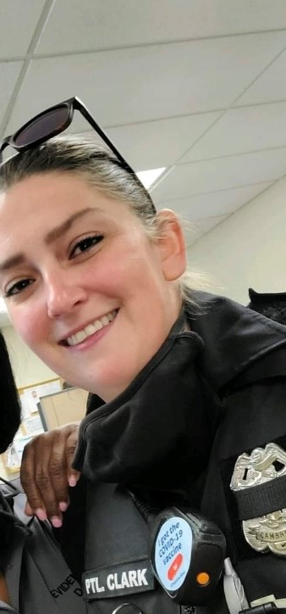
was transferred to the Criminal Investigations Division where she excelled in investigating crimes which include major assaults, carjackings, and have assisted the Maryland State Police in homicide investigations.
Pfc. Clark also plays an active role in getting to know the community and will be seen regularly at community functions showing her desire to engage the citizens of Cambridge. Pfc. Clark resides in the Trappe, Maryland, with her husband, David Clark who has also been recently hired by us and is currently a K-9 Handler. They live together with their three children.

We are very proud to have Pfc. Clark on our team. Pfc. Clark is a dedicated officer who is always willing to step in and help anyway that she can. The detail and caring for victims of crime and the citizens of Cambridge in general is impressive. We look forward to having Pfc. Clark on our team for many years to come.

I hope you enjoyed the read and please remember to feel free to reach out to me with any questions or comments or concerns. – Captain Todd

“The greatness of a community is most accurately measured
by the compassionate actions of its members” - Coretta Scott King

GLASS HOUSES: Duplexes vs Apartment House – What is the Difference?
By Judd Vickers

Duplex

A duplex is defined as a two-family residential unit, sharing a vertical common wall, with each unit having living space on the first floor, with separate entrances to the outside. Duplexes commonly have bedrooms on the second floor and were constructed with the intent of being a two-unit property. A residential duplex is permitted as a Special Exception in the Neighborhood Conservation (*NC - see note at end of this article) and Residential zones. Recently, a new duplex was approved for Robinson Avenue Other newer duplexes have been constructed as part of the Appleby School Development, also zoned NC2.

The depiction to the left below represents a typical example of modern duplex construction. Examples of modern duplexes constructed prior to the City adopting a zoning ordinance exist throughout the NC zones. The use of these duplexes may continue, even if they become vacant for a period of time.

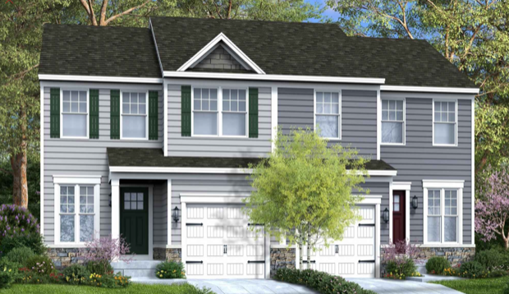 | 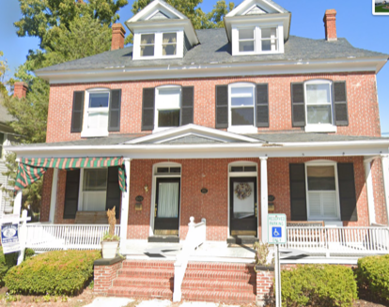

The depiction to the right above represents an example of an historic duplex, constructed in the early 1900’s.
A Special Exception (SE) is required for any new duplex, as well as an existing, older duplex that might have discontinued for a period of time. A SE allows the Planning Commission to review, and potentially place conditions on the use to improve conformity and harmony in the existing neighborhood. For example, a SE can include conditions on parking, as well as appearance. The Planning Commission then forwards the SE to the Board of Appeals for final approval.

Apartment House

An apartment house conversion is differentiated from a duplex in that it was originally constructed as a single-family home, then converted at a later point to two or more apartments. For example, a two-unit apartment house will typically have one entire living unit contained on the first floor, and another entire living unit on a second floor, making the separation of living units horizontal in nature. Often you will enter the original foyer to access the first-floor apartment, then ascend the historic staircase of the home to reach the second-floor unit.

Many conversions of single-family homes to apartment houses occurred prior to the adoption of zoning, until the early 1990’s, when the trend started to reverse. A conversion of a single-family home to an apartment house is now prohibited. An existing apartment house may continue and is considered a non-conforming use. However, if the apartment use lapses in its entirety (meaning all apartments become vacant) for 90 days or greater, the house must be converted back to the conforming single-family use.
Some apartment houses retain their single-family appearance from the exterior.

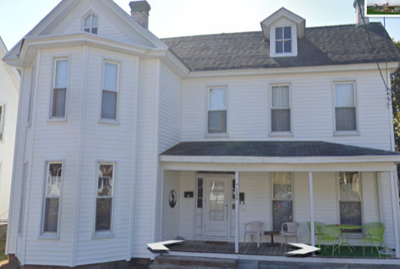 | 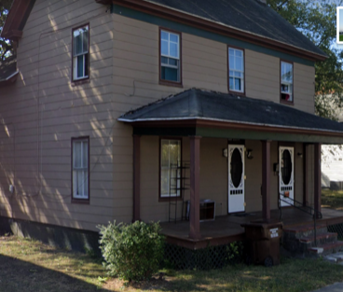
Note the only exterior feature above that reveals this has two apartments are the two mailboxes. Others have been visibly modified as to reflect two or more units. | Note the two front doors above, one likely to access the lower floor apartment, and the other to access the staircase and upper floor apartment.

* There are four NC Districts, the substantive difference between the districts is typically related to lot size requirements, setbacks, etc., which are based on traditional development patterns of each neighborhood.

Note that any exterior modifications to structures in the West End Historic District require prior approval from the Historic Preservation Commission (HPC).
Historic Preservation Commission (HPC) Report
By Sharon Smith

The May Historic Preservation Commission (HPC) meeting was held on May 18, 2022 in Council Chambers at 305 Gay Street. Administrative approval had been granted by City staff to six applications, mostly for porch and roof repairs or replacement. Four cases were approved on the consent agenda.

The Commission heard nine additional cases, one which was deferred for additional information. These applications were for garage doors, fences, decks, siding and windows. One applicant was required to remove and replace under-sized windows that had been installed without HPC approval.

The June HPC meeting was held on June 15, 2022 in Council Chambers. Administrative approval had been granted by City staff to three applications for shingle replacement, emergency porch floor repair and a single window replacement. One was approved on the consent agenda for continuation of a back yard fence.

Seven cases were heard in full by the Commission. Two applications were partially or conditionally approved pending additional information. One application for window replacement was deferred pending a site visit and inspection. Four cases were approved for windows, doors, decks, new construction and shed demolition.

The meetings are also available on Townhallstreams.com. Meetings are held on the third Wednesday of the month. The next meeting is scheduled for July 20th at 6pm in Council Chambers and online.

COMMUNITY NEWS – COOPERATING COMMUNITY ORGANIZATIONS

Firecracker Kid’s Triathlon – July 4th, 2022

The local Cambridge triathlon group, Cambridge Multi-Sport, (CMS) announces the return of their annual “Firecracker Kid’s Triathlon” on Monday, July 4, 2022, at the Robbins Family YMCA at 201 Talbot Avenue in Cambridge, MD. Rebranded in memory of local Ironman, MD organizer and director Gerry Boyle, this year marks the 10th anniversary of the triathlon. The event begins at 8:00 am as children from ages 6 to 15 will swim, bike, and run various distances based on their age group.

The swim will be completed inside the Dorchester YMCA facility and the bike and run will take place in the residential neighborhood around the YMCA with guidance and direction from the Cambridge Police Department and the membership of CMS.

The cost for this USAT (USA Triathlon) sanctioned event is $30/child with an additional mandatory $10 fee for USAT’s one-day membership. All money raised during this event will go to CMS’s High School Scholarship fund that awards 4 college scholarships yearly for students from North Dorchester and Cambridge South-Dorchester High Schools that have shown academic success and competed in Cross Country, Swimming or Track and Field during their high school years.

For more information or to register your child for the “Gerry Boyle Firecracker Kids Triathlon” on Monday, July 4, 2022 in Cambridge, MD, please visit their Facebook page (”Gerry Boyle Firecracker Kids”) or click to: www.trisignup.com/FirecrackerKidsTri .

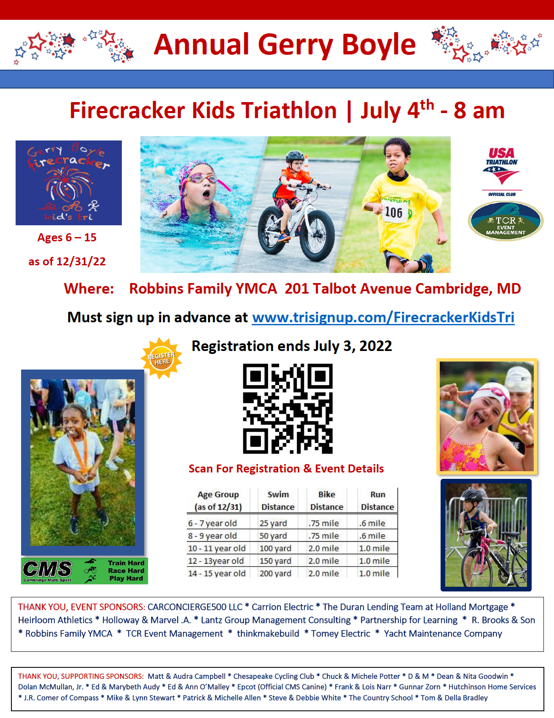
HARRIETT TUBMAN STATUE – Fundraiser and Unveiling

SAVE THE DATE! Harriet Tubman Bicentennial Celebration!
Saturday, September 10th! A Day of Resilience/Harriet Tubman Statue unveiling!
We are selling bricks that will be placed around the Harriet Tubman statue. You can leave a legacy by putting YOUR own words around the Harriet Tubman statue @ the Dorchester County Courthouse. Visit our website today- https://www.bricksrus.com/donorsite/harrietsjourneyhome. Thanks again for your time and support!

Adrian R. Holmes, President and Program Director, Alpha Genesis Community Development Corporation, Rev. John Green Jr., Founder, PO Box 125, Cambridge, MD 21613, www.AlphaGenesisCDC.org

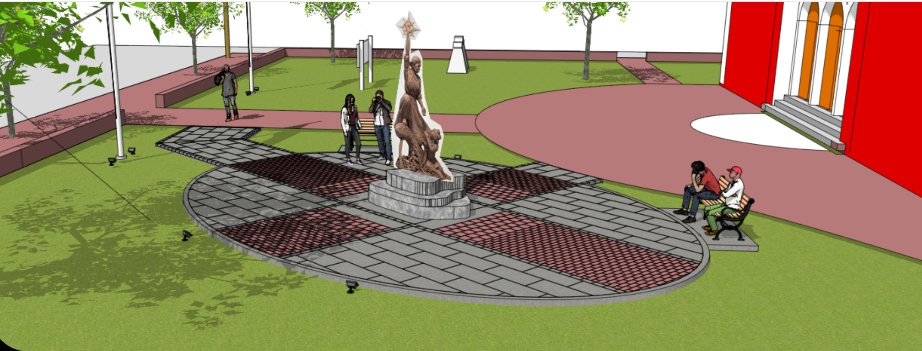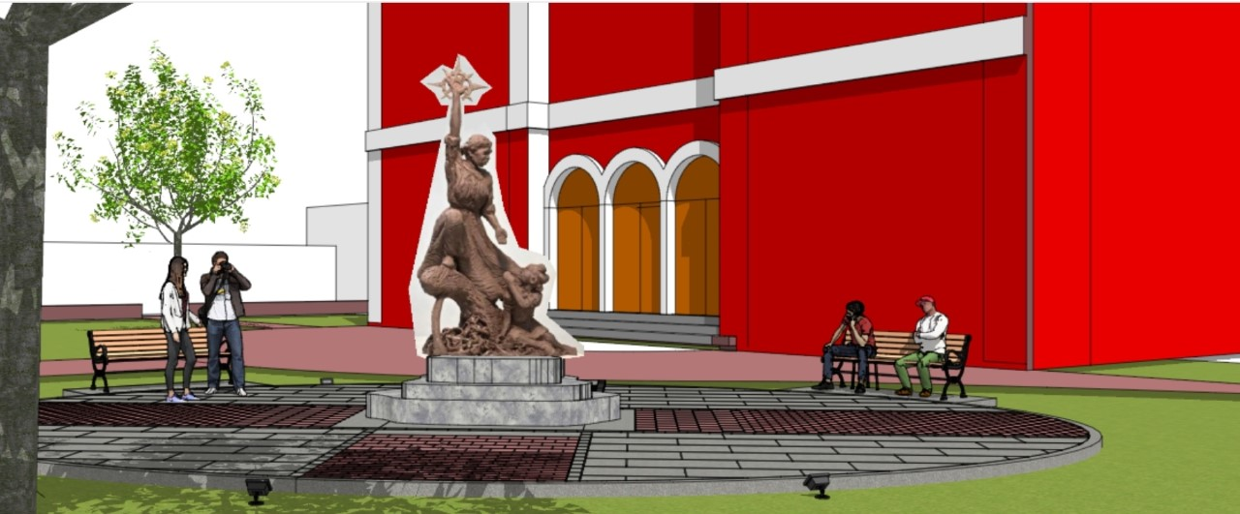

MIDSHORE MEALS TIL MONDAY

MidShore Meals 'til Monday is working to end childhood hunger on Maryland’s Eastern Shore by providing weekend food for food-insecure children in Dorchester County. Meals ‘til Monday sends home healthy, nutritious food for children at the end of each school week and during the summer months for breakfast, lunch and snacks to bridge the hunger gap for children without access to adequate food. Meals ‘til Monday programs currently provide food for more than 500 elementary, middle and high school students.

Meals ‘til Monday needs your support to keep providing essential nourishment to our children. Donations are fully tax deductible and can be made at https://www.mscf.org/donate-online/. For more information about MidShore Meals ‘til Monday, please call Leslie Bishop, Director, at 703-371-5191, or visit their Facebook page or website at www.midshoremealstilmonday.org/

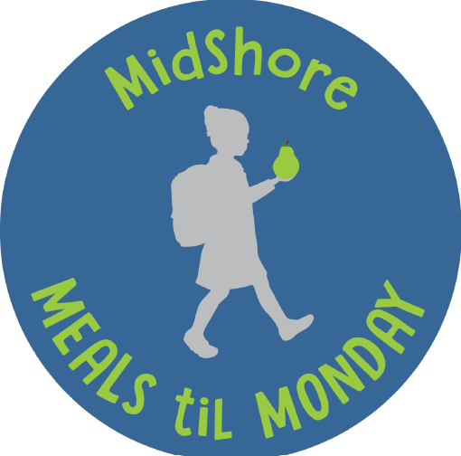

MAIN STREET GALLERY - Winter Storm In Summer Is Coming

Main Street Gallery is delighted to have Cambridge artist, Winter Storm, as guest artist for July and August. Her show of unique paintings and drawings is titled “A Winter Storm in Summer”.

Winter Storm was actually born Winter Coachella Christine De Lacruz, a name she says reflects her diverse lineage of Puerto Rican, Native American and African descendants. When she started making art, however, she decided to embrace Storm as her studio name, a name which aptly suits the fierce manner in which she approaches her paintings as though taking the canvas by storm. The self-taught artist uses vivid, often pulsating colors and passionate brushstrokes to create compositions that she says express emotions like joy, pain, triumph and loss. When she first started making art, her pain, she says, became her purpose and her artwork became an outlet for her feelings. From abstracts, to landscapes to portraits of people and animals, her works are full of movement, energy and verve. She says her favorite artists are Van Gogh, Frida Kahlo and Picasso and that their influences live on in her portfolio of works.
Winter is not only a prolific artist but works in the mental health field as well as with the drug and alcohol population. She says “helping people to find their greatest version of themselves has given me a greater sense of empathy for the human condition and has informed my artwork considerably”.

In addition to Cambridge, Storm’s work has gained attention in several venues in the Washington, DC area. At the D.C. Tree Lighting Ceremony at the Wilson Building in Washington, the artist was honored to present D. C. Mayor Muriel Bowser with a portrait she painted of her. Her most recent presentation was in Chicago at the Mosque Maryam where she gifted Minister Farrakhan his portrait.

“A Winter Storm In Summer” will open on Thursday, July 7 and run through Sunday August 28. There will be two artist receptions from 5-8 pm on Second Saturdays, July 9 and August 13. Main Street Gallery is located at 518 Poplar St. in Cambridge, MD. in the city’s Arts and Entertainment district. Please note the gallery’s hours for this show which are Thursday through Sunday from 11-5. Visitors may also see the exhibit by appointment, by calling the gallery at 410-330-4659 or browsing the gallery’s website at www.mainstgallery.net. Main Street Gallery is Cambridge’s only artist-owned and run cooperative and is currently reviewing work from prospective members and guest artists. Please contact the gallery if you are interested in being a part of this vibrant artist community.

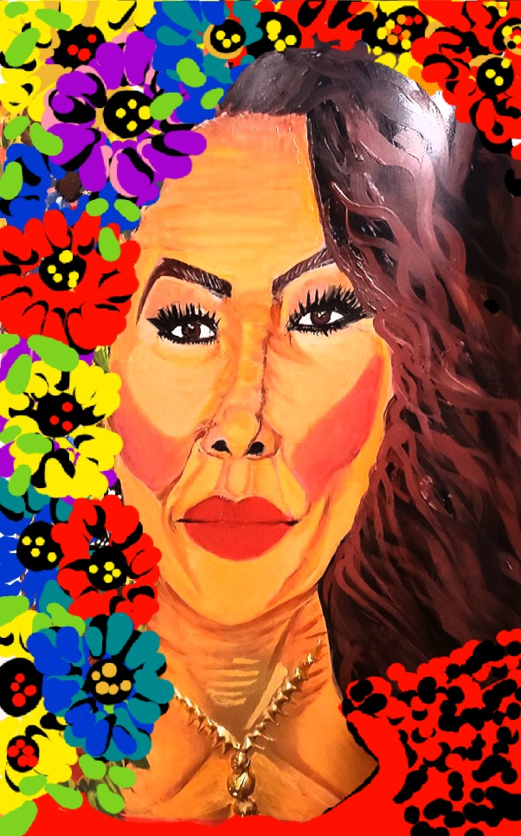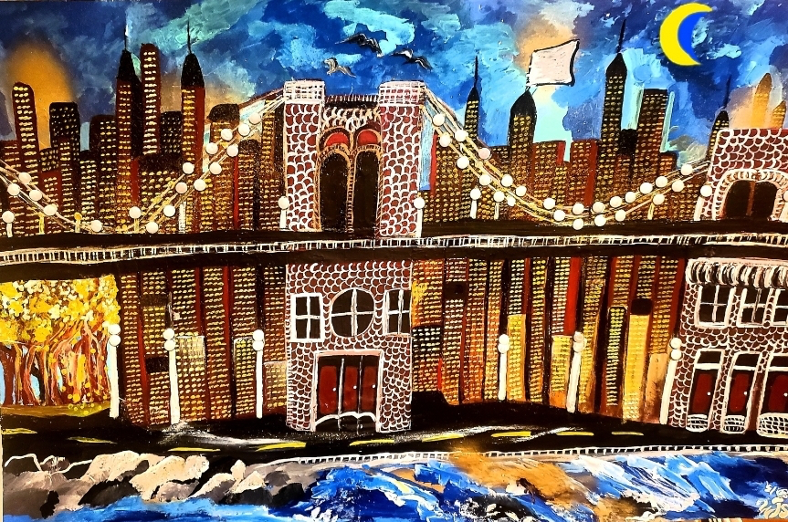
CAMBRIDGE EMPOWERMENT CENTER – Summer Learning and Fun

This summer, the Empowerment Center is planning learning and fun activities for 40 to 50 children for 7 weeks, Tuesday through Friday from 8:00 a.m. to 4:00 p.m. for Dorchester County’s low income/poverty areas who would otherwise have no positive summer experience. A small fee of $65 is required so that the parents have some “buy-in” to the program. However, no child is turned away and we provide some scholarships for those who cannot pay. Our actual cost is $1,000 to $1,500 per child.

We are asking for donations to support our effort to provide Dorchester County youth with a low-cost option for a quality summer experience. Checks can be made out to “Cambridge Empowerment Center” and sent to P.O. Box 949, Cambridge, Md. 21613, or dropped off at our Center (615B Pine Street, Cambridge). We are always looking for volunteers to help in our programs. To get more information, please call Andrew Shannon at 410- 901-1397.

___

SHORERIVERS – Thank You!

Thank you to everyone who made this year's Solstice Celebration a success! ShoreRivers is proud to say support from our community is leveraged to more than three times its value in state and federal funding. Check out our website at https://www.shorerivers.org

CAN MISSION, MEMBERSHIP, and COMMITTEES
___

The Cambridge Association of Neighborhoods (CAN) fosters neighborhood cohesion and community involvement to (a) enhance the quality of community life for all residents of Cambridge through community events, social activities, and neighborly assistance; and (b) protect and enhance the value of properties in Cambridge by improving building and zoning codes, supporting adherence to those codes, and engaging constructively with City Government, including the Historic Preservation Commission.

CAN welcomes members from all Cambridge neighborhoods who are interested in organizing and working together, building a diverse membership reflecting the diversity of Cambridge residents. Membership is FREE for CY2022 – information is available on the CAN website at https://cambridgecan.org/join-can/.

CAN HOUSING QUALITY COMMITTEE – PLANNING AND ZONING ISSUES
The Housing Quality Committee monitors issues affecting the quality of housing and the maintenance of property values in the City, including code enforcement. Committee members attend Planning Commission meetings to monitor zoning-related issues and report the information to the Board and Membership. Please contact Chuck McFadden at Ragtime31@gmail.com to volunteer.

NEIGHBORHOOD DEVELOPMENT COMMITTEE – SOCIAL EVENTS & 'NEIGHBORS HELPING NEIGHBORS'

"Neighborhoods" are organized by small groups willing to work together to address neighborhood issues through small social events and "neighbor-helping-neighbor” activities. The Social Events Subcommittee organizes community-wide events. Contact Chuck McFadden at Ragtime31@gmail.com to volunteer.

CAN COMMUNICATIONS COMMITTEE – WRITERS NEEDED

CAN'S Communications Committee desperately needs writers and photographers to develop articles about CAN and its activities, get them published in local newspapers, and have them promoted by local media.

We also need volunteers to take unofficial notes at County Council, City Council, and City Commission meetings. Please contact Tom Puglisi at tom.puglisi@comcast.net to volunteer.

POWER WASHER AVAILABLE

CAN has an electric power washer available to members. Contact Chuck McFadden at
Ragtime31@gmail.com if you would like to borrow it for a project.

