Newsletter #23.07 July 2023

All CAN Board meetings are announced in advance and open to the public.
Everyone interested in CAN is invited to attend.

IN THIS ISSUE: page
- PRESIDENT’S MESSAGE 2
- CAMBRIDGE CORNER 2
  - Cambridge Real Estate Trends 2
  - Cambridge Fun Facts and Lore 4
- Community News – Cooperating Community OrganizationS 5
  - Cambridge Empowerment Center – Pine Street Enrichment Summer Program 5
  - Mainstreet Gallery – Celebrating 12 Years - Summer Show 2023 6
  - WHCP-FM 91.7 – Now on the Air! 7
  - CWDI 8
  - Midshore Meals ‘til Monday 8
- CAN Mission Statement, Membership Information, and Committees 9

CURRENT LINKS:

- JOIN CAN FOR FREE – https://cambridgecan.org/join-can/
- CAN Meeting Minutes – https://cambridgecan.org/category/meetings/
- CAN’s City Council Meeting Notes – https://cambridgecan.org/category/news/city-council-notes/
- CAN’s Planning & Zoning Notes – https://cambridgecan.org/category/news/p-and-z/
- CAN’s Website – https://cambridgecan.org
- CAN on FaceBook – https://www.facebook.com/CambridgeAssociationofNeighborhoods/
- Contact CAN – CambridgeCAN@yahoo.com

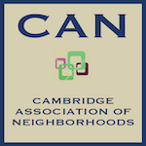
PRESIDENT'S MESSAGE – What is CAN?
-- Charles McFadden, President, CAN

The Cambridge Association of Neighborhoods (CAN) was founded over 6 years ago to be an organization to get to know and help our neighbors. CAN is a non-political, non-profit organization. In its short life, CAN has grown to over 500 members in all wards of the City. The mission for CAN has also grown. We still want members to reach out to their neighbors in need of assistance, but our primary focus is on providing members with what is going on in Cambridge and representing our members at public meetings. CAN provides summaries of City and County meetings as follows: City Council, Planning and Zoning, Historic Preservation committee, and Board of Education meetings. We also cover the Shore line Restoration project, Cambridge Waterfront Development, Regional Environmental issues, the City Marina, and new interests in Boarding house regulations, Trash pick-up, traffic issues, short term rentals and where is the YMCA going?

In addition to the above, we also like to gather members to help on a specific project like tearing down a fence, painting a stoop, and general clean-up projects. If any of these projects interest you, and you would like to get involved please contact me at Ragtime31@gmail.com. or if you have other projects we should look at, let us know.

Thanks for your support.

The City Marina -- Just a short note on the City Marina to congratulate the City on getting a $430,000 grant for a Wave Screen from the $13 million dollar Maryland State program to improve the waterfront. The wave problem in the Marina has been a problem since the Marina was redesigned back in 2001. Hopefully, this new Wave Screen will tamper down the wave action in the Marina. So, thanks to the City for trying to fix the problem.

-- Chuck McFadden, President, CAN

CAMBRIDGE CORNER

CAMBRIDGE REAL ESTATE TRENDS
-- Fred & Martha Phillips-Patrick

National and Regional Residential Real Estate Developments

According to Freddie Mac, as of July 6th, “mortgage rates continued their upward trajectory again this week, rising to the highest rate this year so far. This upward trend is being driven by a resilient economy, persistent inflation and a more hawkish tone from the Federal Reserve. These high rates combined with low inventory continue to price many potential homebuyers out of the market.” How is Cambridge fairing in this market environment? Let’s see.

Cambridge Market Update

Realtor.com characterizes the City of Cambridge as a buyer’s market in June 2023, which means that the supply of homes is greater than the demand for homes. In June 2023, the median listing home price in Cambridge was $260K, trending up only 4% year-over-year. However, in March, for example, the median listing home price hit a high of $296K, and has trended down since then. The median home sold price was $222K in June; in March, the median home sold price was $297.5K, perhaps reflecting a different mix of homes sold. In June, homes in Cambridge sold after just 47 days on the market. In March, on average, homes in Cambridge sold after 60 days on the market. Median days on market in Cambridge have trended down. In summary, median prices have trended down as have days on the market. Many properties have lowered their prices over the last several months.

Sales: Currently, according to Realtor.com, there are now 159 homes for sale (109 single family homes and 50 condos and townhomes) in the Cambridge area. There are also 3 multifamily units for sale, as well as 66 plots of land. The properties’ asking prices range from $29,900 to $1,999,999.

According to Realtor.com, only 27 single family, townhouses, and condo sales were completed in June, ranging in value from $18,000 to $470,000. They are:

313 Somerset Ave $258K 513 Seaway Ln $270K 416 S Seaway Ct $325K
399 Robbins Farm Rd $300K 1001 Locust St $207K 916 Roslyn Ave $215K
309 Terrapin Cir $315K 153 Regulator Dr. $360K 218 Brant Way $220K
622 High St $18K 1543 Global Cir $222K 607 Edlon Park Dr $122K
213 Belvedere Ave $400K 319 Shepherd Ave $140K 413 Glenburn Ave $352K
402 Osprey Cir $349K 208 Aurora St $223K 1205 Hambrooks Blvd $298K
301 Terrapin Cir $290K 603 Muir St $138K 803 Maces Ln $195K
5 Shawnee Rd $195K 5 Shawnee Rd $460K 908 Hudson Rd $150K
606 Water St Apt 6 $157K 713-715 Robins St $110K 109 Vue De Leau St $470K

Other Developments

Research suggests that three major factors affect neighborhood home values: accessibility (location, location, location!), the level of crime (property and personal safety), and the quality of the educational system. Last issue we looked at Cambridge’s relatively high crime rate, by some measures the fourth highest among cities in Maryland. Now let’s take a brief look at the educational system.

Dorchester County Public Schools (DCPS) 2022-2023 annual budget is $72.6 million. Current enrollment is 4,662, which means the County spends $15,558 per student each year, about average for the state. Overall, the DCPS spends about 40% of its budget on instruction, 9% on special education, and 11.6% on administration and school management and support. The other 39.6% covers fixed charges, transportation, operations, maintenance, etc.

Currently, DCPS has 13 schools and 4,662 students enrolled. In 1970, there were over 6,600 students, about 40% more than now. The district’s minority enrollment is about 60%. Also, 70.6% of students are characterized as economically disadvantaged.

According to US News and World Report, using 2021-2022 data, math proficiency declines as students move on to the next level in their education. For elementary students, 33% tested at or above the proficient level; in middle school, 30% tested at or above, then it dropped to 10% among high school students. In reading, however, 33% of the elementary students tested at or above the proficient level; in middle school, 45% tested at or above, then in high school, the level dropped down to 36%.

Public School Review assessed DCPS performance based on 2021-2022 data from MD Department of Education as follows: Graduation Rate: 79% (Bottom 50% in MD); Math Proficiency: 10% (Bottom 50%); Reading Proficiency: 23% (Bottom 50%). Overall, this source ranked DCPS as 22nd out of the 25 school districts in Maryland. The data suggest that much needs to be improved to give our children an adequate education.

According to Superintendent of Education W. David Bromwell, in an open letter on February 4, 2023: “Education in Dorchester County will change immensely over the next decade and these three driving factors – the Blueprint, the facility feasibility study, and the budget – will all play a large role in these changes. Our student data shows that we need to start thinking about the education of our students differently. It is time for change. Our aim is to ensure we provide the young people of Dorchester County with an education for the future, not for the past; the support of the community is crucial in this effort.”

CAMBRIDGE FUN FACTS AND LORE
-- Martha Phillips-Patrick

Cambridge and Seaford Railway (1869-1950)

The major railroad line from Philadelphia arrived in Seaford, Delaware, just 29 miles from Cambridge, in 1856. A short line from Seaford to Cambridge was proposed to connect to the mainline to Philadelphia at Seaford. State charters for the short rail line were granted in Maryland in 1866 and in Delaware in 1867, and the Seaford and Cambridge short rail line was built at a cost of $300,000.

The short line opened with full passenger service in 1869. The train left Cambridge at 7:00 am and passed through nine stations on its way to Seaford, arriving at 9:12 am. Those early stations were Thompson, Airey, Linkwood, East New Market, Hurlock, Williamsburg, Federalsburg, Oak Grove, Flowertown, and finally, Seaford. (Seaford Historical Society)

The Old Cambridge Passenger Depot on Trenton Street (c1904 - Present)

The Cambridge Passenger Depot, still in existence today, was built by the Pennsylvania Railroad after its acquisition of controlling interest in the peninsular railroad system in 1891. In the decades following the Civil War and the establishment of the short rail line from Cambridge to Seaford in 1869, Cambridge exploded in population, industry and commerce. By the turn of the century the population had quintupled since the initial establishment of the Cambridge and Seaford rail line. This growth, and the need for better passenger accommodations, served as catalysts to convince the Pennsylvania Railroad to finance a new station in Cambridge, which we see on Trenton Street and Maryland Avenue today. The new depot was built c.1905. It is deemed one of the largest and best preserved of the train depots on the Eastern Shore of Maryland.

The Cambridge Depot remained in use until the post-World War II era when personal travel by rail diminished as individuals turned more and more to their private cars. After the passenger service was discontinued, the Cambridge Depot was used in part as a Trailway bus stop and was leased privately for a period of time before being sold to Charles C. Powell for $30,000 by the Trustees of the Penn Central Transportation Company in 1977. The property was sold to Valerie Powell Brown and Jeffrey Brown in 2005 for $241,000. The Depot has been headquarters for the Powell Realty Company since its purchase in 1977. (Maryland Historical Trust, Maryland Inventory of Historic Properties Form, Inventory No. D-187)

COMMUNITY NEWS – COOPERATING COMMUNITY ORGANIZATIONS

CAMBRIDGE EMPOWERMENT CENTER – Pine Street Enrichment Summer Program

The Pine Street Enrichment Summer Program at the Empowerment Center is in full swing. We are serving 45 students ages 5 to 13 who attend 4 days a week (Monday through Thursday) from 8:30 to 4:30 for 9 weeks. Every day the children work on maintaining or improving their academic skills, especially reading and math. They are using an online learning program called IXL. This program is used daily for grades K to 8. The Preschoolers are using Khan Academy Kids. We also provide activities such as arts and crafts, STEM, music, sports, swimming, and of course, free play and games. We have weekly trips to educational sites.

A big thank you to the directors, Ms. Sharon Chester, and Tammy Washington, and to the 10 other staff members who are teaching and guiding these children.

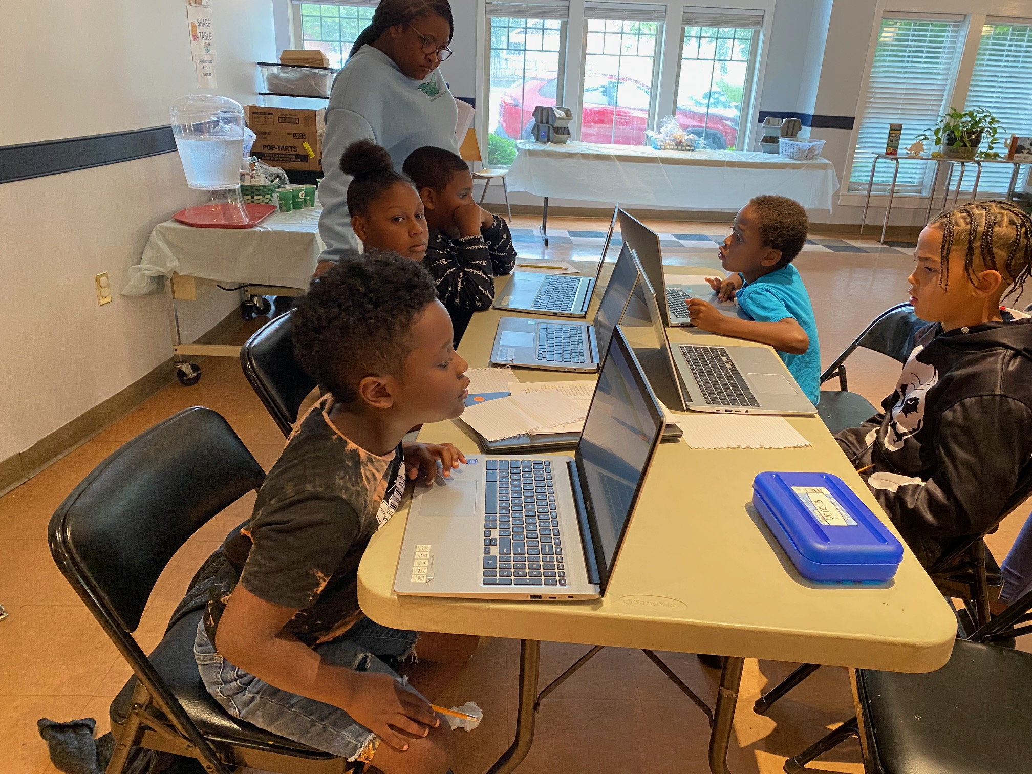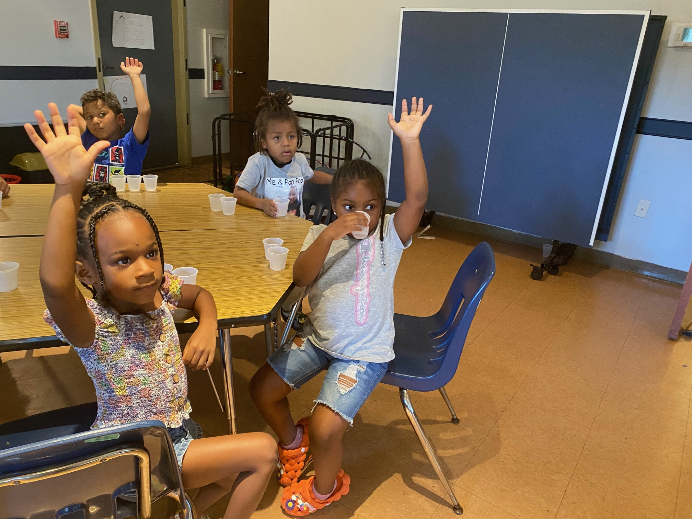
We are grateful to organizations who have made this program possible with generous grants: The City of Cambridge, Waddell Foundation, Women and Girls Fund of the Eastern Shore, Todd Foundation, Mid-Shore Community Foundation, Robbins Charitable Foundation Trust, Bondservants, Elks Lodge 223, Partners in Giving, Christ Methodist Church, Christ Episcopal Church, Cambridge Lions Club, and The Bryan Brothers Foundation. We also are so thankful to the many individuals who gave us personal donations to help support our program.

The Cambridge Empowerment Center is a nonprofit, multi-use community center in the heart of the Pine Street Historic District in Cambridge, MD The Center is governed by a board of directors, known as The Pine Street Committee, Inc. who oversee the programs and the use of the building. Donations are critical to our success and are appreciated. You can donate at our website cambridgeempowermentcenter.org, or send a check to The Pine Street Committee, PO Box 494, Cambridge, Md. 21613.

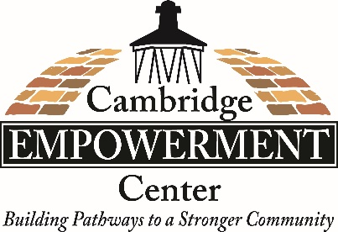

MAIN STREET GALLERY – Celebrating 12 Years – Summer Show “Creating Texture with Photo Encaustics”
-- Theresa Knight McFadden

Main Street Gallery in Cambridge, MD has lots to be excited about. The city’s only member owned and operated Coop is turning 12 this summer and will celebrate with a champagne party on Second Saturday, August 12 from 5-8 pm. This is a free event, and all are welcome to join us and meet our artists. The gallery will also be celebrating its guest artist for the July/August exhibition, Karen Jury, a resident of Chester, MD, whose show, “Creating Texture with Photo Encaustic” will be on the walls for the celebration.

If you are wondering what photo encaustic is, Karen says, “It all starts with a camera and a photograph and ends with wax and heat.” To make a photo encaustic image an artist prints a photo onto paper and adheres the paper to a substrate. Then comes the wax and heat part as the artist paints the photo with a heated wax mixture called encaustic. The many and varied results of this process can be seen in Karen’s arresting images of nature. “My love of flowers, landscapes and textures is evident is my work” she says.

Karen didn’t start her career as a photo encaustic artist, however. After graduating with a Bachelor of Fine Arts degree from Carnegie Mellon University she worked as an art director for a number of companies and colleges until she decided to take time off to raise her family. It was then that she rediscovered photography. Initially she photographed families, their pets and their significant events. Later she had the opportunity to photograph performances during Songwriter Festivals in Miami and Key West. “I enjoyed the creative aspect of portrait photography” she says “….and the creative aspect of shooting talented musicians”. Still, the artist wanted to figure out something more creative to do with her photography. It was a friend, who after listening to Karen speak about her past and her love of textures, suggested she try Photo Encaustics. “Eureka….!”, Karen said. “I fell in love. I took courses online, a lot of trial and error, no injuries, and years later I am happy to share my encaustics.” In addition to Main Street Gallery, Karen’s work can be seen at The Artist’s Gallery in Ellicott City. She has also shown her work at Kent Island Federation of Arts and the Maryland Federation of Art in Annapolis.

“Creating Texture with Photo Encaustic” will open on Thursday, July 6 and run through Sunday, August 27. The public is invited to two artist receptions which will take place on Second Saturdays, July 8 and August 12 from 5-8 pm. The receptions are free and light refreshments will be served. Karen will give a brief artist talk on the July 8 opening at 7 pm and the August reception will also be the champagne celebration of the gallery’s 12th Anniversary. Gallery hours are Thursday, Friday, Saturday and Sunday from 11-5. Online shopping is always available on the gallery’s website at mainstgallery.net.

Main Street Gallery is located at 518 Poplar St. in Cambridge. The gallery is currently reviewing work from prospective members and guest artists. Please contact the gallery through its website or by phoning 410-330-4659 if you are interested in being a part of this vibrant artist community.

WHCP-FM 91.7 – Now on the Air!

WHCP recently won a rare new broadcast license from the FCC to expand from a low-power (LP) station (101.5 FM) reaching 10 miles around Cambridge to a much more powerful station (91.7 FM) reaching all of Dorchester, most of Talbot and other counties on the Mid-Shore, a service area with more than 70,000 people.

WHCP-FM will be the best of WHCP-LP and much more, providing information and inspiration that helps Maryland’s Mid-Shore flourish. We will do this by being obsessively local while including adding National Public Radio (NPR) programs Morning Edition and All Things Considered.
2023 WHCP Fundraisers

Kentavius Jones and Friends Unplugged. August 3 at the 447 Venue ($40/ticket). Kentavius Jones is part of a new generation of music artists with new energy and purpose on the Eastern Shore. A regional favorite, Kentavius grew up listening to Stevie Wonder, Miles Davis, Eric Clapton, and Jimi Hendrix on his father’s turntable. A gifted vocalist and guitarist, Kentavius nods to those influences while fashioning a unique brand of soulful rock. KJ killed it last year as one of WHCP’s event series performers, so by popular demand he is back! And he is bringing some of his musician friends as well. Do not miss this opportunity to celebrate WHCP’s expansion this summer into the greater Mid-Shore!

Dave Chappell Band featuring Tommy Lepson. Sept 2 dinner and a show at the Dorchester American Legion ($55/ticket includes dinner). Dave Chappell is one of is one of the most sought after and respected musicians on the East Coast. He has performed with legends Jerry Lee Lewis, Sam Moore, Percy Sledge and Johnny Johnson. For this show he’s bringing Tommy Lepson, a nationally-recognized Hammond organist, singer and winner of eleven WAMMIE awards. His gritty and flexible R&B voice conjures images of James Brown one moment and Sam Cooke the next. He’s appeared with the Kinks, the Fabulous Thunderbirds, NRBQ and Chuck Berry and recorded with Nils Lofgren and many more. It’s a special dinner and a show Labor Day weekend in Cambridge MD.

CWDI

CWDI has added a "Documents" link to the footer on our website www.cambridgeharbor.org. There you can find Meeting Minutes and the Board Roster. The Agenda for our July meeting will be posted on Monday, July 17.

MIDSHORE MEALS TIL MONDAY

MidShore Meals 'til Monday is working to end childhood hunger on Maryland’s Eastern Shore by providing weekend food for food-insecure children in Dorchester County. Meals ‘til Monday sends home healthy, nutritious food for children at the end of each school week and during the summer months for breakfast, lunch and snacks to bridge the hunger gap for children without access to adequate food. Meals ‘til Monday programs currently provide food for more than 500 elementary, middle and high school students. Meals ‘til Monday needs your support to keep providing essential nourishment to our children. Donations are fully tax deductible and can be made at https://www.mscf.org/donate-online/. For more information about MidShore Meals ‘til Monday, please call the Director, at 703-371-5191, or visit their Facebook page or website at www.midshoremealstilmonday.org/

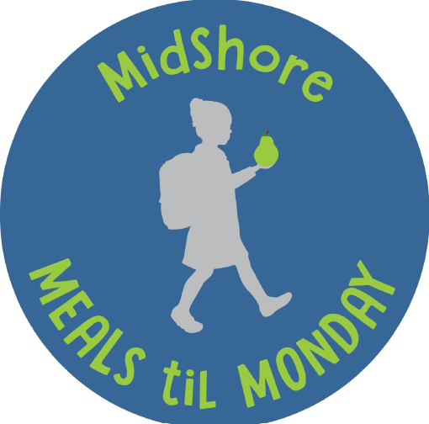

CAN MISSION, MEMBERSHIP, and COMMITTEES

The Cambridge Association of Neighborhoods (CAN) fosters neighborhood cohesion and community involvement to enhance the quality of community life for all residents of Cambridge through community events, social activities, and neighborly assistance; and protect and enhance properties in Cambridge by improving building and zoning codes, supporting adherence to those codes, and engaging constructively with City Government, including the Historic Preservation Commission. CAN welcomes members from all Cambridge neighborhoods who are interested in organizing and working together, building a diverse membership reflecting the diversity of Cambridge residents. Membership is FREE – information is available on the CAN website at https://cambridgecan.org/join-can/

CAN HOUSING QUALITY COMMITTEE – PLANNING AND ZONING ISSUES
The Housing Quality Committee monitors issues affecting the quality of housing and the maintenance of property values in the City, including code enforcement. Committee members attend Planning Commission meetings to monitor zoning-related issues and report the information to the Board and Membership. Please contact Chuck McFadden at Ragtime31@gmail.com to volunteer.

NEIGHBORHOOD DEVELOPMENT COMMITTEE – SOCIAL EVENTS & ‘NEIGHBORS HELPING NEIGHBORS’

"Neighborhoods" are organized by small groups willing to work together to address neighborhood issues through small social events and "neighbor-helping-neighbor” activities. The Social Events Subcommittee organizes community-wide events. Contact Chuck McFadden at Ragtime31@gmail.com to volunteer.

CAN COMMUNICATIONS COMMITTEE – WRITERS NEEDED

CAN'S Communications Committee needs writers, including volunteers to take unofficial notes at public meetings. Please contact Tom Puglisi at tom.puglisi@comcast.net to volunteer.

POWER WASHER AVAILABLE

CAN has an electric power washer available to members. Contact Chuck McFadden at Ragtime31@gmail.com if you would like to borrow it.
