Newsletter #23.08 August 2023

All CAN Board meetings are announced in advance and open to the public.
Everyone interested in CAN is invited to attend.

IN THIS ISSUE: page
- PRESIDENT’S MESSAGE 2
- CAMBRIDGE CITY CHARTER – Proposed Changes 2
- CAMBRIDGE CORNER 5
  - Cambridge Real Estate Trends 5
  - Cambridge Fun Facts and Lore 6
  - Police Department Update 7
  - Historic Preservation Commission 8
- Community News – Cooperating Community OrganizationS 9
  - One Mission Cambridge 9
  - Mainstreet Gallery – 9
  - Nanticoke Watershed Alliance 10
  - Cambridge Waterfront Development, Inc. 12
  - Midshore Meals ‘til Monday 12
- CAN Mission Statement, Membership Information, and Committees 12

CURRENT LINKS

- JOIN CAN FOR FREE – https://cambridgecan.org/join-can/
- CAN Meeting Minutes – https://cambridgecan.org/category/meetings/
- CAN’s City Council Meeting Notes – https://cambridgecan.org/category/news/city-council-notes/
- CAN’s Planning & Zoning Notes – https://cambridgecan.org/category/news/p-and-z/
- CAN’s Website – https://cambridgecan.org
- CAN on FaceBook – https://www.facebook.com/CambridgeAssociationofNeighborhoods/
- Contact CAN – CambridgeCAN@yahoo.com

SAVE THESE DATES FOR UPCOMING CAN MEETINGS

Thursday, September 7, 6:30 pm at the Library – Cambridge Waterfront Development Corporation, Inc
Tuesday, October 10, 6:30 pm at the Library – Habitat Choptank

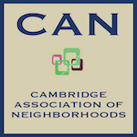
PRESIDENT'S MESSAGE – Lots going on!
-- Charles McFadden, President, CAN

There’s a lot going on, both big and small, these summer months in Cambridge. I will start big with proposed changes to the City Charter. This process has just begun and is a bit confusing. The City Manager and the City Attorney are proposing numerous changes to the General and Special election sections of the Charter to correct a number of problems that popped up during the last two years. The CAN Board has reviewed the proposed changes and suggested improvements which are outlined in the article below. However, if you want to see all this firsthand, the current City Charter is posted on the City Website and the proposed changes are an attachment to the agenda for the special Council session for August 14th, 2023. I will warn you in advance, it is tough to plow through.

As to the YMCA, the Council approved for first readings, two ordinances #1226 and #1227 which would limit what could be built on the site if the “Y” moves. A third ordinance is in process and all three should go to final readings and public input in late October. The “Y” has stated that no final decisions have been made but they spent $40,000 on architectural drawings for a new building that fits on the Cambridge Harbor site.

Cambridge Waterfront Development , Inc. (CWDI), for its part, says that no final decisions have been made about the “Y” moving to Cambridge Harbor. However, all their site lot drawings have included the “Y” on the waterfront. If you would like to see what the CWDI is up to, visit their website at cambridgeharbor.org. The minutes of their meetings are listed under the Documents section. Cambridge Harbor has agreed to make a presentation at a CAN meeting in September.

Finally, for smaller things, CAN is pushing the City to come out with an understandable chart on Trash Pickup requirements. It is unclear to many citizens what Chesapeake Waste will pick up. Citizens are not sure what to do with yard waste, and I personally don’t know what to do with my dog’s personal packages (which I put in my 96-gallon trash can every day only to watch the trash men reach in and pull out the large bags but leave the small pup packages. While it may be hard for the trash personnel to lift the 96-gallon trash cans, they do expect that our senior citizens get theirs to the curb. Please keep an eye out for anyone struggling with their trash cans and be a good neighbor and help out, because Chesapeake Waste won’t.

CAN will try to summarize and keep you up to date with the issues. If you have a problem, let us know.

Chuck McFadden, President

CAMBRIDGE CITY CHARTER – Proposed Changes
-- Comments by the Cambridge Association of Neighborhoods (CAN) Board of Directors

The Cambridge City Council is considering changing the City Charter in regard to General and Special elections. The City Manager and the City Attorney have recommended numerous changes to the Council at a Special Session on August 14th. The Council has proposed holding public listening sessions before any changes are adopted. The first of these listening sessions has been scheduled for August 30th, 2023, from 6:00 pm to 7:00 pm at the Empowerment Center, 615B Pine Street, in Cambridge. Additional listening sessions will be announced shortly.

The following is a summary of the recommended changes to what I will call the “Amended Charter”:

- The Amended Charter would change to the voting cycle from the Presidential cycle of every four years on the even years to every four years on the odd years. The Dorchester County Board of Elections cannot handle a City election at the same time as a National, State or County election. So, the City has to move to the odd years for the Board of Elections to handle the process. Besides costing less that using an outside contractor to organize City elections, there are many technical reasons for using the County Elections Board.
- The Amended Charter would allow for a special election if a vacancy occurs in the first two years of a term and an appointment process for a vacancy occurring in the last year and eight months of a term. If a vacancy occurs within the last four months of a term, the seat would remain vacant. The Amended Charter does not lay out how the appointment process would work.
- The Amended Charter would add to the conditions under which Commissioners could move out of their Ward, while still giving them 12 months to decide whether or not they are moving back. The Amended Charter would set a firm date (75 days after the 12-month period ends) when a special election would be called.
- The Amended Charter would retain the existing requirement for residency in the Ward at 6 months before an election.

The CAN Board has reviewed the proposed Amended Charter and feels that the amendments do not address all the important issues. The Board has made the following recommendations:

- The Council should put together a committee of concerned citizens to make recommendations for the Charter Changes. This would allow for greater community involvement.
- The CAN Board agrees with moving to an odd-year election cycle but would also recommend having staggered terms (i.e., 3 Council Commissioners elected on first election date, and the Mayor and 2 Council Commissioners elected two years later). This would have solved the problem with the last election when we had a new Mayor and 5 new Council people, all learning the process together. This would help ensure some continuity in Council operations.
- The CAN Board agrees with going to a 4.5-year cycle with the next election to achieve the odd year cycle mention above. The proposed 2.5-year cycle is too short for the Council to be effective. If the 4.5-year cycle is adopted then next election would still be in November 2024, but the following election would be in May, 2029. Adjustments to the Amended Charter would have to be made relative to special election and appointment timing to fill vacancies and for staggered terms, if adopted.
- The Amended Charter would specify that if a vacancy occurs in the first two years of a term, then there would be a special election. However, if the vacancy occurs in the last two years of a term, the Council would appoint a person to fill the vacancy, with the exception of vacancies occurring in the last 4 months of a term, when the seat would remain vacate. The CAN Board recommends having a special election for vacancies occurring in the first three years of a term and an appointment process for vacancies in the last year of a term, with the exception of vacancies occurring the last 4 months of a term, when the seat would remain vacate.
- The Amended Charter would specify appointing a person to fill vacancies occurring in last 2 years of a term (as mentioned above). However, it does not provide any methodology for making the appointment. The CAN Board would recommend having a call for qualified volunteers from that Ward to be reviewed by a committee of 3 to 5 community leaders/residents who would make a recommendation to the Board. The Mayor would have a vote and the total number of votes needed to make the appointment would be 4. Failure to achieve a 4-vote majority would result in a Special election, except if it occurs in the last 4 months of a term.
- The CAN Board recommends that the Amended Charter include an option to remove a Council Commission or Mayor if the individual misses too many meetings within a specified time period.
- The CAN Board recommends eliminating runoff elections. At present, if a candidate does not receive 50% plus one of the votes cast, there has to be a runoff election between the top two candidates. A runoff election costs the same as a special election and delays seating a winner by 3 or 4 months. There are two possible solutions – (a) let the person with the most votes win, or (b) as the CAN Board recommends, go to “Ranked Choice” voting.
- The Amended Charter would permit Commissioners to move out of their Ward and give them 12 months to move back into their Ward in the event of damage, destruction, or extensive renovations to their home, the sale of their residence and/or their lease being terminated. The CAN Board has several recommendations in this area. First, there needs to be a statement that the Commissioner must remain a citizen of Cambridge and not move out of the City. Next there needs to be a tiered system, as follows:
  - Damage or Destruction of a Residence would give Commissioners 12 months to move back into their Ward, with a possible extension of 3 months upon unanimous vote from the Council.
  - Loss of Lease would give Commissioners a 3-month period to sort out any problems and move back into the Ward.
  - Sale of House or Major Renovation would reflect a personal choice by the Commissioner and would require the Commissioner to establish a new residence within the Ward upon vacating the former residence.
  - Elections would be held 75 days after the end period for any of the above.
- The Amended Charter keeps the current residency requirement – a candidate must live in the Ward 6 months before the election. The CAN Board thinks this requirement is too short and allows for a “carpet bagger” approach where candidates move into a Ward shortly before the election because they think they have a better chance of winning. The CAN Board would prefer that a residency requirement of at least 12 months (or possibly 24 months) before the election, so the candidate has a “feel” for that particular Ward and the issues the Ward residents are concerned about.

Charles McFadden, President, CAN, for the CAN Board

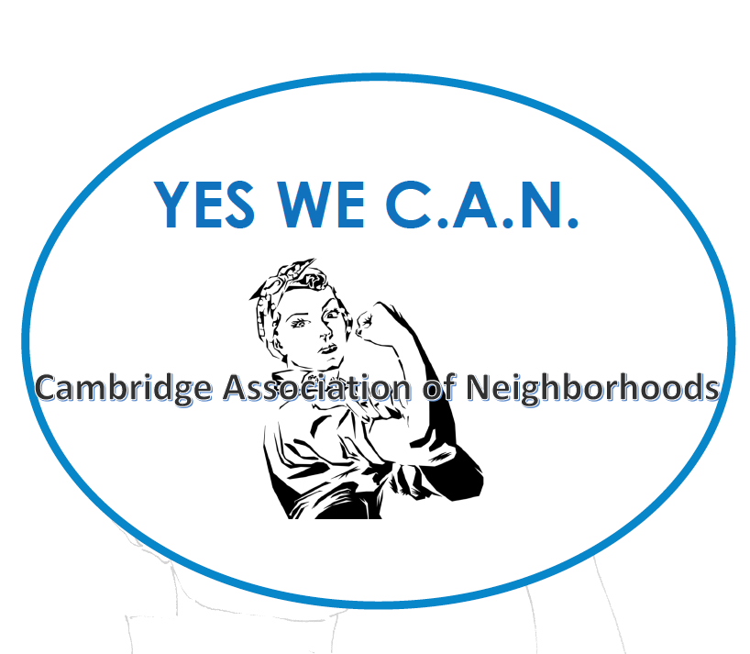

CAMBRIDGE CORNER

CAMBRIDGE REAL ESTATE TRENDS
-- Fred & Martha Phillips-Patrick

National and Regional Residential Real Estate Developments

As of August 10, 2023, Freddie Mac reported that “for the third straight week, mortgage rates continued creeping up and are now just shy of seven percent. There is no doubt continued high rates will prolong affordability challenges longer than expected, particularly with home prices on the rise again.” How is Cambridge fairing in this market environment? Let’s see.

Cambridge Market Update

Realtor.com characterizes the City of Cambridge as a buyer’s market in July 2023, which means that the supply of homes is greater than the demand for homes. In July, the median listing home price in Cambridge was $262.5K, flat year-over-year. The median home sold price in July was $265K. Homes in Cambridge sold after 57 days on the market in July, up from 47 days in June. However, homes sold for just about asking price in July.

Sales: Currently, according to Realtor.com, there are now 164 homes for sale (112 single family homes and 52 condos and townhomes) in the Cambridge area, up slightly from June’s 157. There are also 3 multifamily units for sale, as well as 68 plots of land. The properties’ asking prices range from $29,900 to $3,995,000. As in June, only 27 single family, townhouses, and condo sales were completed, ranging in value from $90,400 to $655,000. They are:

706 Pine St $95.4K 616 Hubert St $177K 407 Glenburn Ave $265K
415 Cambridge Lndg $655K 106 Hayward St $375K 304 Academy #101 $493K
2408 Canterbury Dr $500K 107 Rambler Rd $185K 301 Muir St #202 $355K
9 Bay Heights Ave $175K 309 Wood Duck Dr $215K 2541 Southside Ave $315K
105 Audubon Ct $260K 1678 Terrapin Cir $290K 422 Oakley St $115K
604-1 Water St $250K 2 Dorchester Ave $289K 602 Glasgow St $213K
213 Hibiscus Ln $300K 327 Cemetery Ave $90.4K 203 Oakley St $312K
3204 Holly Ln $400K 207 Camb Lndg 207B $555K 713 Peachblossom Ave $160K
304 Academy St #403 $445K 1672 Terrapin Cir $310K 317 Willis St $125K

Other Developments

The YMCA, located at 201 Talbot Avenue, has been in the news recently because it is considering moving its facility to the waterfront here in Cambridge. The potential move has created concerns among many nearby residents about what might happen to that property in their neighborhood.
To address the potential use of the property, the Cambridge Planning and Zoning Commission held a public hearing on August 1, and then voted that evening, on a 4 to 3 vote, to recommend to the City Council that an “institutional overlay district” be put on the property should the YMCA decide to move from its current location.

According to the Dorchester Star’s article on August 4, “In the event the YMCA were to move, the drafted ordinance lists 13 uses that would be prohibited with the overlay. These uses include homeless shelters, boarding houses, airports, day care centers and nurseries with more than 30 clients, medical treatment facilities, nursing care institutions, colleges, museums or cultural centers, fire stations, rescue squads and public utility buildings.

The overlay would remain in effect for five years or until the city’s next comprehensive rezoning — whichever comes first.” The Cambridge City Council provided a first reading of the proposed ordinance on August 14, 2023.

CAMBRIDGE FUN FACTS AND LORE - Cambridge and Its Western Residential Expansion
-- Martha Phillips-Patrick

Dorchester County was established in 1669. The land that, according to varying survey maps, became Cambridge sometime between 1684 and 1706 was originally part of the Choptank Indian Lands. By 1719 trading ships from London and Liverpool began to dock in Cambridge bringing goods and serving as Dorchester County's major marketing point for tobacco, seafood, and muskrat pelts. At the same time Cambridge began to develop its own shipbuilding industry. In 1745 Cambridge was incorporated by an Act of Assembly and began to grow slowly prior to the Revolutionary War. By the 1770s, the estimated population of Cambridge was about 400 with about 50 residences.

A 1799 plat shows many of the early streets of what we today call the eastern historic district of Cambridge including High Street, Mill Street, William Street, Locust Street, Church Street, Race Street (originally Wood Street), Gay Street and Poplar Street. The location of the commercial and governmental center of Cambridge has remained relatively unchanged since 1799, though the physical appearance of the buildings has changed considerably due to a number of fires. Two of the most devastating were on November 30, 1882, and July 30, 1892, which resulted in the rebuilding of much of this area in the late 19th century.

By the turn of the 19th century, as its population and labor force grew, the City of Cambridge began to develop residentially westward from the early streets of the historic district to Choptank and West End Avenues and Willis Street. Many of the modest homes built on these streets were developer built in response to the rapidly growing population of Cambridge. Locust, Church, School and Travers Streets continued in the same western direction with their expansions. In 1905 Oakley Street began to develop with the building of many of the larger homes in the historic West End district of Cambridge. Then homes began to be built on Belvedere Avenue and in 1915 on Glenburn Avenue (developed from Glasgow Plantation) which is the western boundary of the historic district. Glasgow Street represents the development of the city from the east part of the historic district west toward Glenburn Avenue, forming the southern boundary of the Historic District.
Cambridge's industrial and economic expansion led to a long period of prosperity for the City. By 1925 its population had doubled to over 8,000 since 1900; and Cambridge supported 250 retail and wholesale stores, 2,400 houses and two theaters. The growth of the western historic district was directly related to the expanding of the canning and packing industries.

Sources:
Paula S. Reed, Cambridge Historic District Wards I and III, 1990
Christopher Weeks, ed. Between the Nanticoke and the Choptank, 1984
Elias Jones, New Revised History of Dorchester County, Maryland, 1966
Calvin Mowbray, Early Dorchester, 1979, and the Dorchester Co Fact Book, 1980

CAMBRIDGE POLICE DEPARTMENT UPDATE
-- Justin Todd, NA, Chief of Police

I hope everyone is enjoying their summer as it seems to have passed by quickly and the kids will be heading back to school before you know it.

Throughout the summer the Cambridge Police Department participated in the Portia Johnson­Ennels Youth Internship Program in which we have had two youths join us for about the last 8 weeks. They played a big part in helping our Community Policing efforts as they served many snow cones and other good snacks to the many summer programs throughout our city. The youths assigned to us have been able to see firsthand the daily operations at the Police Department and see how the Police Department is building relationships within the Community and the positive interactions that we are developing.

Crime

One of the biggest issues the Police Department has dealt with over the last six months is stolen vehicles throughout the city. This is a problem that has not only been an issue for our city but throughout the nation. A large majority of the vehicles stolen are Hyundai's and Kia's. The Cambridge Police Department has made several arrests which have been juveniles, some of which are repeat offenders for the same type of crime.

The Cambridge Police Department has ordered several anti-theft devices for vehicles that we will be handing out to our Cambridge Citizens who own Hyundai and Kia vehicles. As soon as they arrive, we will be announcing a date/time and what proof will be needed to obtain one of the anti-theft devices through the Police Department

Neighborhood Watch Program

In the coming weeks, myself, and other members of the Cambridge Police Department will be working throughout neighborhoods in the city to develop neighborhood watches. I feel that part of connecting with our citizens is assisting them in working together with their neighbors to lessen crime and take pride in where they reside. It also gives the Police Department opportunities to meet with the citizens we serve and get to know one another.
Miscellaneous Information

During one of the council meetings there was a question regarding animals, specifically dogs, in the city and what type of ordinance that the city had regarding Animals and foul. That ordinance has been placed on our website as well as access to all the city ordinances. If anyone has any questions, please do not hesitate to contact me at any time.

We are hiring! Please pass the word along as we continue to work hard to build staffing back up to par. If you or know of someone who is interested in a career in law enforcement, please have them go to policeapp.com/CambridgeMd to fill out the application form.

We offer ride-a-longs and would like as many citizens as possible to have this experience and see how your Police Department operates and serves the City of Cambridge. If interested contact the P.D for a form.

I hope you enjoyed the read and please do not hesitate to contact me with any questions, comments, or concerns jtodd@cambridgepd.org

-- Justin Todd, NA, Chief of Police, Cambridge, MD

HISTORIC PRESERVATION COMMISSION
-- Sharon Smith

The June meeting of the Historic Preservation Commission was held Wednesday, June 21, 2023 at 6:00 pm at City Hall. Three applications were granted administrative approval during the month for in-kind roofing replacement. One application for in-kind deck flooring replacement was approved on the consent agenda. Seven cases were heard in full by the commission: one was deferred for additional information, others were approved for fences, shed, gravel driveway, paved pathway, door and windows.

The July meeting of the Historic Preservation Commission was held on July 19, 2023. The commission welcomed the new Director of Planning assuming Pat Escher's position, Mr. Steve Kaii-Ziegler. Susan Webb, the Director of Planning and Zoning for Dorchester County, joined as a commissioner, and Penny Introcaso, a local realtor, joined as an alternate commissioner.

Four cases for various improvements were passed on the consent agenda. Seven cases were heard in full by the commission. One case was deferred as the applicant was not present to answer questions. One case for a wire fence was disapproved as the Design Guidelines do not permit it. The other five cases were approved for: an addition, driveway, deck, porch and deck replacement. The laundromat on Choptank and Travers will be getting façade improvements and new commercial glass.

Note that any exterior modifications to structures in the West End Historic District require prior approval from the HPC. Applications and design guidelines are available on the City of Cambridge HPC website at https://www.choosecambridge.com/206/Historic-PreservationCommission or from the Department of Planning and Zoning. HPC meetings will be held on the third Wednesday or Thursday of each month at 6:00 pm in the City Council Chamber at 305 Gay Street. Meetings are open to the public and available on Town Hall Streams at https://townhallstreams.com/towns/cambridgemd.

COMMUNITY NEWS – COOPERATING COMMUNITY ORGANIZATIONS

ONE MISSION CAMBRIDGE

One Mission Cambridge, a nonprofit organization in Dorchester County, just celebrated its one-year anniversary!! One Mission Cambridge collaborates with many community organizations and members to operate a vibrant mission center at 614 Race Street. The programs offered include community navigation, community dinners, counseling services, and a food pantry! Over 350 different households were served at the mission center just in the month of July. These individuals supported household members, thus impacting 817 people (265 children, 382 adults, 170 seniors). The most recent community dinner hosted 87 guests and 13 volunteers for a night of fellowship and delicious food!

Would you like to be a part of this awesome community outreach organization? We rely on volunteers to help us build relationships with our neighbors and provide them with practical support! It's also a great time to meet our terrific community partners who also assist at the different programs such as the mission center and/or community dinners. We'd like to meet you and tell you more about these exciting volunteer opportunities! Please stop by for a brief tour (The mission center is open Mon, Tues, Thurs 1-6pm) or contact the mission center manager, Ashley: 443-521-5226.

MAIN STREET GALLERY – Main Street Gallery’s Fall Show Features Mosaics by Pam Watroba
-- Theresa Knight McFadden

Main Street Gallery is excited to feature one of its own member artists for the September/October exhibit. Titled “No Limits” this show is all about the rich, colorful and imaginative mosaic pieces that Pam Watroba makes in her studio on the Eastern Shore.

Some are zany and whimsical; others are inspired by the diverse ecosystems from the ocean to the mountains of Maryland and many of her most recent pieces favor an abstract or contemporary style. “I absolutely love mosaics,” she says. “I love to use repurposed items and make them into things of beauty. I also love to combine the beauty of glass with the hardness of metal”. Pam’s fascination with mosaics may have come, she says, from doing puzzles with her parents who were avid puzzle enthusiasts. “We would spend hours looking for the perfect piece to fit in a space in large, complex puzzles. I still get that thrill when I find a piece of tesserae that fits perfectly in a piece of art.”

Tesserae, or the small blocks of tiles, stones, glass or other materials that make up a mosaic, come in so many forms and colors, Pam says. When she combines them with found objects, a story, often an unexpected one, is allowed to unfold. “Sometimes I start with a thought of what I am trying to create and end up with something entirely different” she declares.

A Maryland native who grew up in Baltimore County and moved to the Eastern Shore in 1990, Pam is a self-taught artist. She has spent countless hours, she says, studying the art of mosaics and learning through trial and error. After a career in education and healthcare and raising a family, Pam is finally able to pursue her true passion of creating mosaic art on a full-time basis. Besides being a member of Main Street Gallery, she is a member of several local arts councils and has participated in many member shows. Main Street Gallery’s other member artists will be showing their work alongside Pam’s for this show.

“No Limits” will open on Thursday, August 31 and run through Sunday, October 29. The public is invited to two artist receptions which will take place on Second Saturdays, September 9 and October 14 from 5-8 pm. The receptions are free and light refreshments will be served. Pam will give a brief artist talk on the September 7 opening at 7 pm. Gallery hours are Thursday, Friday, Saturday and Sunday from 11-5. Online shopping is always available on the gallery’s website at mainstgallery.net.

Main Street Gallery is Cambridge’s only artist owned and operated gallery and is part of the vibrant Arts and Entertainment District. Located at 518 Poplar St. in Cambridge, the gallery is currently reviewing work from prospective members and guest artists. Please contact the gallery through its website or by phoning 410-330-4659 if you are interested in being a part of this vibrant artist community.

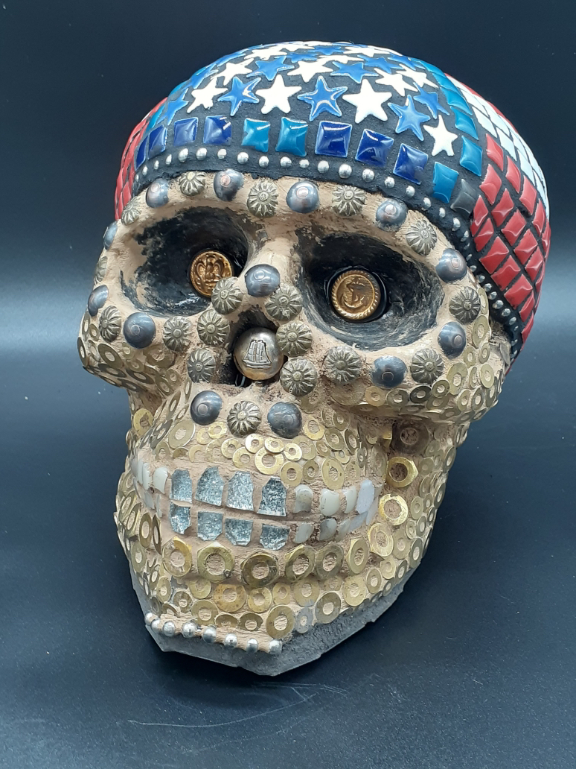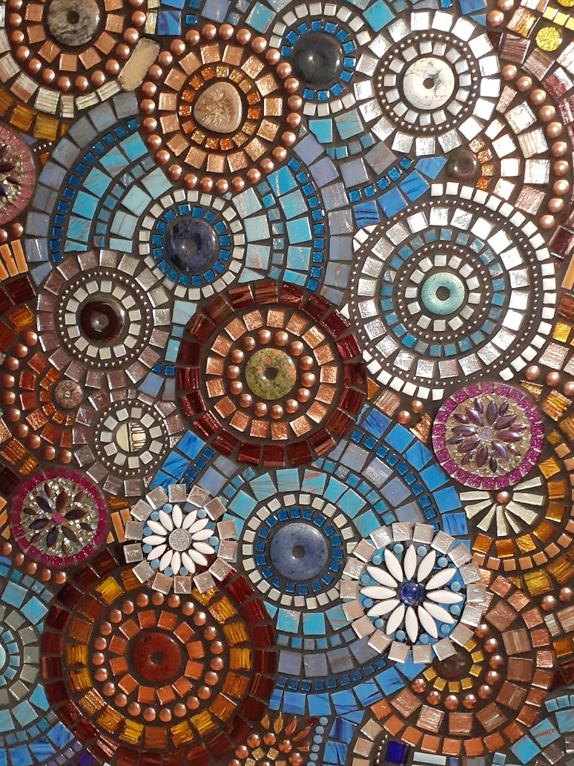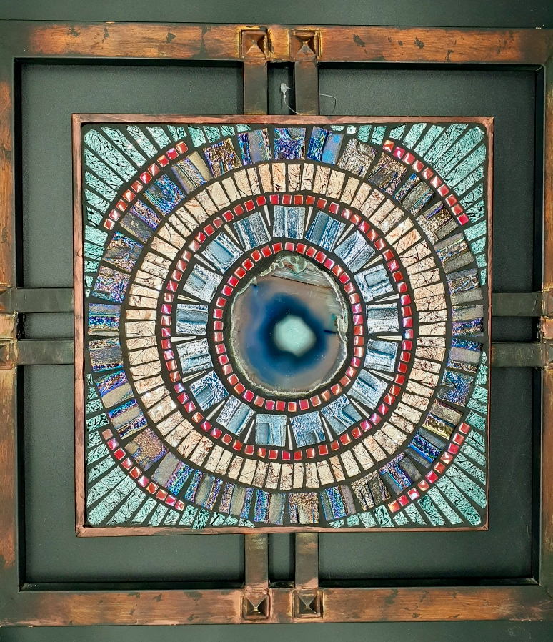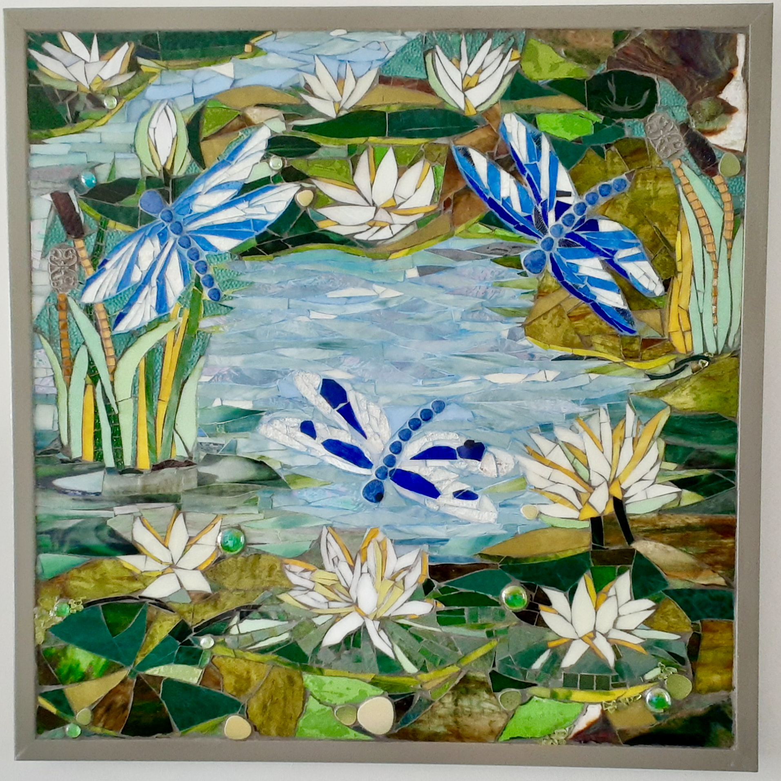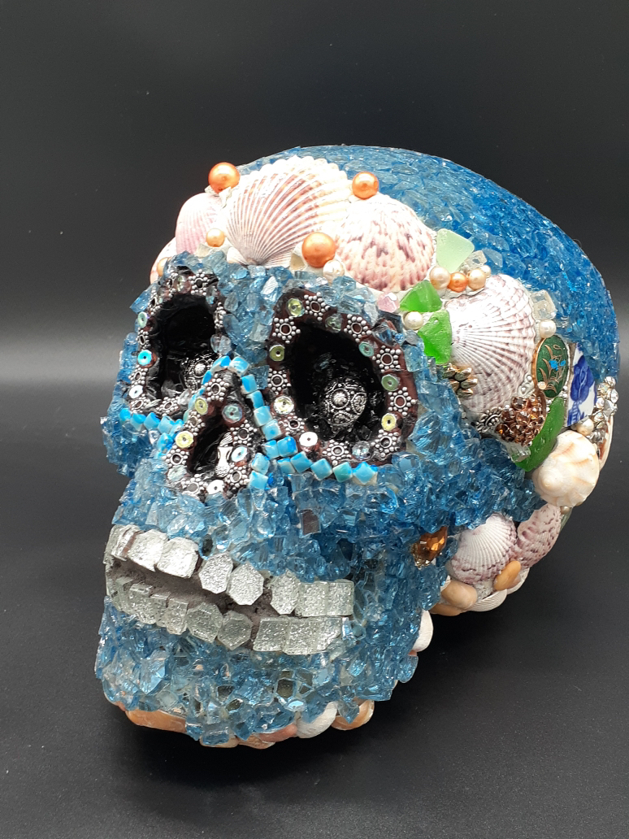

NANTICOKE WATERSHED ALLIANCE
-- John Sandkuhler, Restoration Coordinator

More Plants, More Crabs?

I have been told there was a day when a bushel of crabs could be caught right in the creek. I have no reason to doubt this but also have not heard if any crabs are currently being caught there. Is anyone even trying to crab the creek? Regardless of the past or present catch, we at Nanticoke Watershed Alliance (NWA) focus on the future by using proven, effective practices that give the best chance for a Cambridge Creek crab feast with crabs pulled straight from that water.

Many of these practices involve implementing green infrastructure. Defined by the Water Infrastructure Improvement Act in 2019, green infrastructure is "the range of measures that use plant or soil systems, permeable pavement or other permeable surfaces or substrates, stormwater harvest and reuse, or landscaping to store, infiltrate, or evapotranspirate stormwater and reduce flows to sewer systems or to surface waters." You’ve probably seen some of these such as the Maryland Ave. curb bump-outs and the Long Wharf parking lot bioswales/permeable sidewalk that were created to address flooding and stormwater runoff.
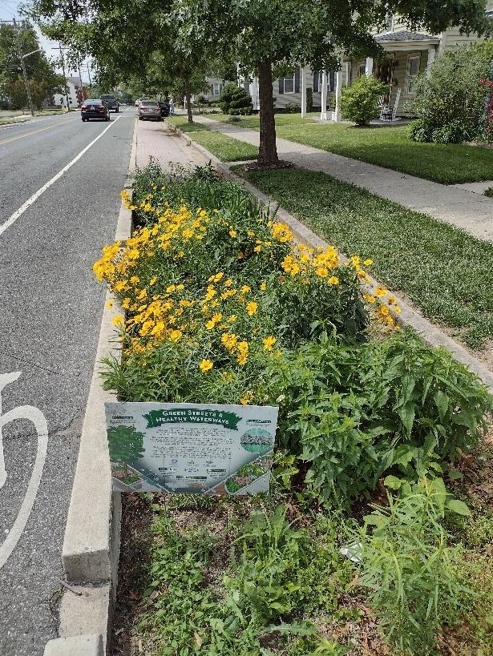  Maryland Ave | 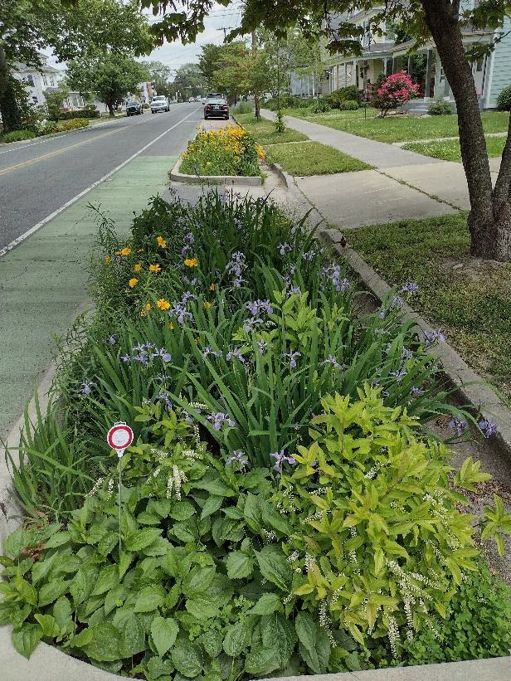  Curb Bump-outs

They’re doing their job by reducing, but not necessarily eliminating, these negative impacts. They absorb and filter stormwater on location. More certainly needs to be done to reduce these impacts, but green infrastructure is an important tool in the toolbox. And just like many tools, these projects require some maintenance.

Our Green Infrastructure interns are working hard to keep these and other projects throughout the city functioning at optimum levels while offering some aesthetic appeal. Weeding, invasive plant species removal, trash pick-up, and installing/watering new plants are just some of their regular tasks. You, too, can help the cause in many ways though. Picking-up your pet waste, disposing of trash properly, and planting native species on your property are just a few examples.

The stars of the show are the plants, and not just any plants. Specifically selected for each of these sites, these native plants are the parts of some of these tools that make the projects so valuable. They take- up nutrients, transpire water, stabilize soils, provide wildlife habitat and food, add biodiversity to the landscape, can lower air and water temperature, and of course, look better than concrete, asphalt, or just turfgrass. Many of these benefits have a direct positive impact on water quality, and thus, provide aquatic life the best chance to not just survive, but to thrive. So, consider native plants for your yard, enjoy the ones already in your community, and let’s continue to do some good for our favorite crustacean.

And if you’re wondering why NWA is working in the Choptank River watershed — well, we were
presented with an opportunity to serve the Cambridge community that we couldn’t pass up, and we hope to be invited someday to that Cambridge Creek crab feast. Afterall, our waters, like our people, are connected.

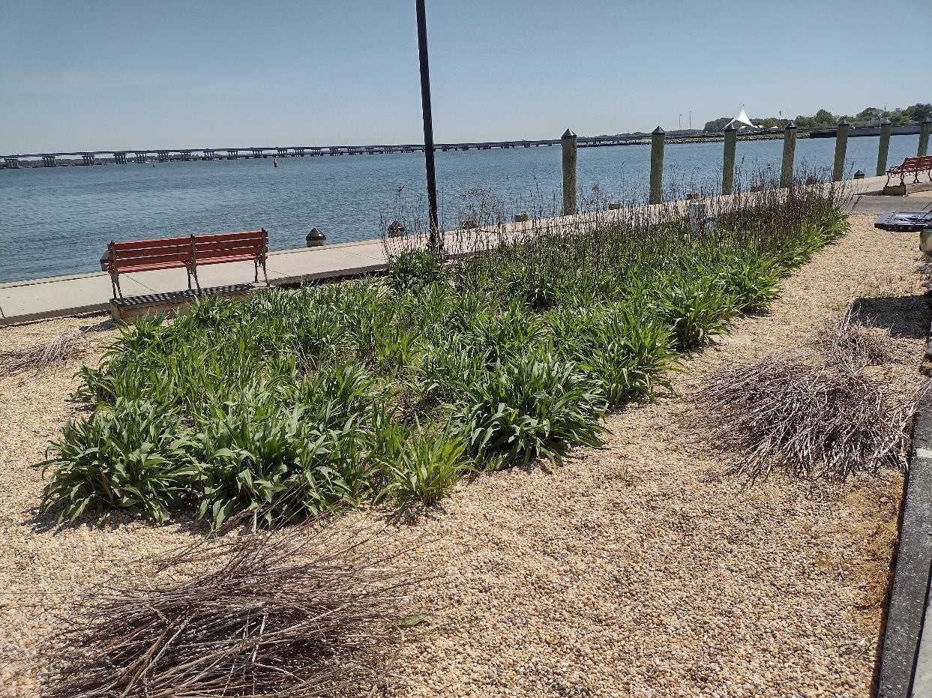
Cutting back old flower stalks off Solidago sempervirens, seaside goldenrod -- Long Wharf bioswale

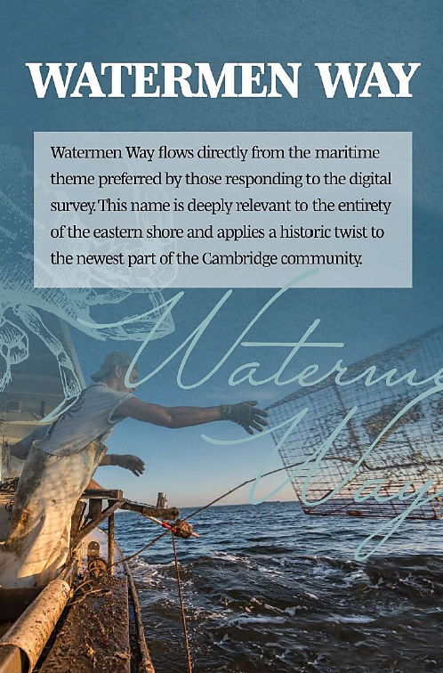
CAMBRIDGE WATERFRONT DEVELOPMENT, Inc. (CWDI)

On August 8, 2023, citizens and elected officials came together and named a new street being built at Cambridge Harbor. The new street will be named Watermen Way.

CWDI has added a "Documents" link to the footer on its website at www.cambridgeharbor.org. There you can find Meeting Minutes and the Board Roster.

MIDSHORE MEALS TIL MONDAY

MidShore Meals 'til Monday is working to end childhood hunger on Maryland’s Eastern Shore by providing weekend food for food-insecure children in Dorchester County. Meals ‘til Monday sends home healthy, nutritious food for children at the end of each school week and during the summer months for breakfast, lunch and snacks to bridge the hunger gap for children without access to adequate food.

Meals ‘til Monday programs currently provide food for more than 500 elementary, middle and high school students. Meals ‘til Monday needs your support to keep providing essential nourishment to our children. Donations are fully tax deductible and can be made at https://www.mscf.org/donate-online/. For more information about MidShore Meals ‘til Monday, please call the Director, at 703-371-5191, or visit their Facebook page or website at www.midshoremealstilmonday.org/

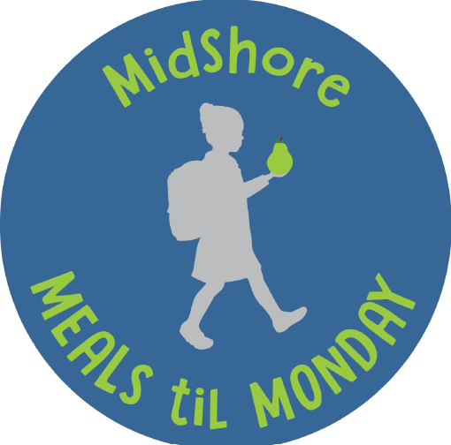

CAN MISSION, MEMBERSHIP, and COMMITTEES

The Cambridge Association of Neighborhoods (CAN) fosters neighborhood cohesion and community involvement to enhance the quality of community life for all residents of Cambridge through community events, social activities, and neighborly assistance; and protect and enhance properties in Cambridge by improving building and zoning codes, supporting adherence to those codes, and engaging constructively with City Government, including the Historic Preservation Commission.

CAN welcomes members from all Cambridge neighborhoods who are interested in organizing and working together, building a diverse membership reflecting the diversity of Cambridge residents. Membership is FREE – information is available on the CAN website at https://cambridgecan.org/join-can/

CAN HOUSING QUALITY COMMITTEE – PLANNING AND ZONING ISSUES
The Housing Quality Committee monitors issues affecting the quality of housing and the maintenance of property values in the City, including code enforcement. Committee members attend Planning Commission meetings to monitor zoning-related issues and report the information to the Board and Membership. Please contact Chuck McFadden at Ragtime31@gmail.com to volunteer.

NEIGHBORHOOD DEVELOPMENT COMMITTEE – SOCIAL EVENTS & ‘NEIGHBORS HELPING NEIGHBORS’

"Neighborhoods" are organized by small groups willing to work together to address neighborhood issues through small social events and "neighbor-helping-neighbor” activities. The Social Events Subcommittee organizes community-wide events. Contact Chuck McFadden at Ragtime31@gmail.com to volunteer.

CAN COMMUNICATIONS COMMITTEE – WRITERS NEEDED

CAN'S Communications Committee needs writers, including volunteers to take unofficial notes at public meetings. Please contact Tom Puglisi at tom.puglisi@comcast.net to volunteer.

POWER WASHER AVAILABLE

CAN has an electric power washer available to members. Contact Chuck McFadden at Ragtime31@gmail.com if you would like to borrow it.

