Newsletter #23.10 November 2023

CAN’s Upcoming Meeting – December 13th
Meet Chief Todd and Captain Patton

CAN will hold its December meeting at 6:30 pm on December 13th in the lower level of the Cambridge Library. The meeting will provide an update from Cambridge Police Chief Justin Todd on crime in the City, police staffing, and the new Juvenile Reform Act. In addition, we Captain Antoine Patton will talk about how to start your own Neighborhood Watch program. Hopefully, our Mayor, a former Juvenile Court Judge, will drop by to talk about his efforts with juveniles and adjusting programs to make it work better for individuals and the community. So, it will be an informative meeting on key issues facing the City, mark it on your calendar in red ink now.

All CAN Board meetings are announced in advance and open to the public.
Everyone interested in CAN is invited to attend.

IN THIS ISSUE: page
PRESIDENT’S MESSAGE – Happy Thanksgiving 2
CAMBRIDGE CORNER 4
- Cambridge Real Estate Trends 3
- CWDI Closed Meeting 4
- Cambridge Fun Facts and Lore 5
- Historic Preservation Commission 6
Community News – Cooperating Community OrganizationS 7
- Cambridge Empowerment Center 7
- One Mission Cambridge 9
- Mainstreet Gallery – All That Glitters 9
- Midshore Meals ‘til Monday 10
CAN Mission Statement, Membership Information, and Committees 11

CURRENT LINKS

JOIN CAN FOR FREE – https://cambridgecan.org/join-can/
CAN Meeting Minutes – https://cambridgecan.org/category/meetings/
CAN’s City Council Meeting Notes – https://cambridgecan.org/category/news/city-council-notes/
CAN’s Planning & Zoning Notes – https://cambridgecan.org/category/news/p-and-z/
CAN’s Website – https://cambridgecan.org
CAN on FaceBook – https://www.facebook.com/CambridgeAssociationofNeighborhoods/
Contact CAN – CambridgeCAN@yahoo.com

PRESIDENT'S MESSAGE – Happy Thanksgiving
-- Charles McFadden, President, CAN

The CAN Board would like to wish all of you a very happy and prosperous Thanksgiving. As you sit around the table with family and friends, please put in a good word for our less fortunate neighbors. CAN is joining with our Mayor to try and support our financially limited neighbors. As the Mayor noted in his Cambridge Matters newsletter, there are several organizations that support our neighbors that you can help this holiday season. Some are as follows:

- Salvation Army which is the largest supplier of free overnight housing in Cambridge but is always filled. In addition to shelter, the Salvation Army provides hot meals and basic social services to the homeless in Cambridge. Donate to http://cambridge.salvationarmypotomac.org
- Meals till Monday, a nonprofit founded by our own Leslie Bishop provides food to children during those times when food is not otherwise available to them -- after school, weekends, holidays, and school vacations. You can volunteer to pack bags or donate funds to help. http://midshoremealstilmonday.org/
- Valerie Davis of Delmarva Community Services is also involved in providing shelter. She noted to the City Council at the November 13 meeting, that Cambridge is in desperate need of more shelters for the homeless. She noted the aging population of the homeless, the lack of places to take them and the upcoming winter cold. She needs volunteers and donations and can be contacted at 410-911-2996.
- Lead 4 Life with Cambridge coordinator, Kourtney Postley has come to Cambridge to help with just released prisoners to help them adjust to society. They provide help with getting jobs, getting licenses, funds for medical and dental, help with mental issues, and Life coaching. They are also involved in gun issues with our youth plus food and coats to our community. You can go to their website: lead4lifeinc.org.
- Habitat Choptank also provides great opportunities to volunteer. They need people to actually help build houses, work at the ReStore in Easton, and/or be mentors to new homeowners. They also need donations in cash or furniture and will pick up large pieces from your home. Habitat is in the process of building 8-12 homes on Chesapeake Court off High St. Habitat can be contacted at habitatchoptank.org.
- Several Churches in the City provide daytime shelter and food banks to our fellow citizens of Cambridge. They can always use volunteers and donations.

So, while you are at the Thanksgiving table, take a moment to think about helping the less fortunate of our community. They are our neighbors.

-- Chuck McFadden, President

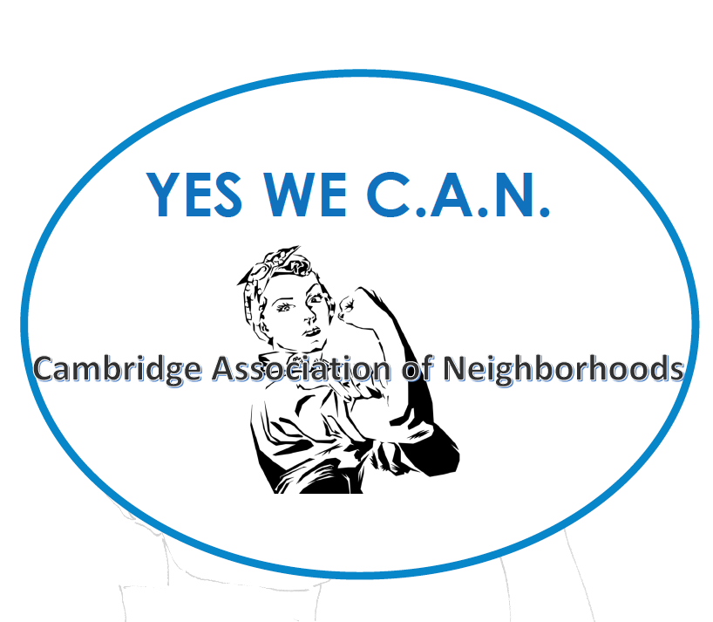

CAMBRIDGE CORNER

CAMBRIDGE REAL ESTATE TRENDS
-- Fred & Martha Phillips-Patrick

National and Regional Residential Real Estate Developments:

According to a survey conducted by Fannie Mae in October, “a survey-record 85% of consumers indicated that it’s a “bad time” to buy a home, with most respondents citing high home prices and high mortgage rates as the primary reasons.”

However, more recently, on November 16, 2023, Freddie Mac reported that “for the third straight week, mortgage rates trended down, as new data indicates that inflationary pressures are receding. The combination of continued economic strength, lower inflation and lower mortgage rates should likely bring more potential homebuyers into the market.” The current rate on a thirty-year fixed rate mortgage is now 7.44%, down from 7.79% at the end of October, a hopeful sign.

How did Cambridge fair in this very tough market environment in October, the latest data we have? Let’s see.

Cambridge Market Update:

Realtor.com characterizes the City of Cambridge as a buyer’s market in October, 2023, which means that the supply of homes is greater than the demand for homes. It reports that “homes in Cambridge sold for 2.95% below asking price on average in October 2023. However, on average, homes in Cambridge, MD sell after 53 days on the market. The trend for median days on market in Cambridge, MD has gone down since last month, and slightly down since last year.”

Sales: Currently, according to Realtor.com, there are now 184 homes for sale (132 single family homes and 52 condos and townhomes) in the Cambridge area, up slightly from September. There are also a 4 multifamily unit for sale, as well as 56 farms and plots of land. The properties’ asking prices range from $15,000 for a small plot of land on Edgewood Avenue to $2,395,000 for a home on Ross Neck Road.

In October, only 20 single family, townhouses, and condo sales were completed, ranging in value from $4,000 to $3.6 million. The ones marked in red sold for less than the asking price. They are:

503 Sandy Hill Rd $445K 1500 Hambrooks Blvd $1,470K 807 Wood Duck Dr $179K
5100 Ragged Point Rd $3,600K 10 Merryweather Dr $230K 5327 Ragged Point Rd $600k
1617 Terrapin Cir $305K 216 Rambler Rd $210K 2151 Horns Point Rd $60K
900 Marshy Cv #403 $268K 1104 Holland Ave $165K 804 Allen St $96K
802 Allen St $4k 625 Cross St $82K 900 Marshy CV #103 $259K
175 Leonards Ln $175K 1623 Terrapin Cir $295K 700 Cattail CV #311 $165K 102 Holland Ave $250K 411 Waterfield Ct $270K

New Code Enforcement Initiative

One of the many factors affecting home values is the condition of the properties in the neighborhood. In a promising development, according to a report by WBOC, “starting November 27th, the city's Code Enforcement officers will be pounding the pavement three days a week, aiming to enhance their efforts in maintaining community standards. City leaders emphasize that the current fleet of three officers, while competent, finds its limitations in vehicular patrols.

By opting for foot patrols, officials believe they can dedicate more time to assessing properties for issues such as trash accumulation, debris, broken windows, crumbling stairs, or chipping paint. The initiative is set to kick off the first month with officers concentrating on key areas, including Robbins Street, Glasgow Street, Maces Lane, Academy and Light Street, Maryland Avenue and Rambler Road, Patamoke Way, Pleasant Street and Radiance Drive.

Brandon Hesson, the Assistant City Manager of Cambridge, underscores the importance of this approach, stating, "Really, it's just to make sure we're doing even-handed code enforcement. Some of this is a public-facing effort. But it's also to make sure we spend enough time on a house. When you drive by a house, you miss a few things, but if I commit standing in front of a house for 10 minutes, you start to see a few things."

Hesson emphasizes that this move aims to ensure that residents understand the standards and that neighborhoods receive equal attention. The initiative will span all five wards of Cambridge, demonstrating a commitment to comprehensive and thorough code enforcement practices.

As the city takes this step to reinforce its commitment to community well-being, residents can expect to see Code Enforcement officers on foot, diligently working to maintain the aesthetic and structural integrity of neighborhoods across.”

A good start!

CWDI – Closed Meeting Held
-- Jim Brady, WHCP

The Cambridge Waterfront Development Incorporated (CWDI) board held a joint meeting on November 13 with the Cambridge City Council, the Dorchester County Council and several consultants hired by CWDI, but the meeting was closed, over the objections of the press, to keep the public from hearing about plans and developments at Cambridge Harbor.

Two of the three City Council members who attended voted against going into closed session at the beginning of the meeting after Mayor Steve Rideout said the meeting would likely violate the Maryland Open Meetings Act. County Council President Lenny Pfeffer stated that the County Council would not deliberate or vote on any matters, but the Council nevertheless took part in the closed session without taking a vote to authorize it.

City Council member Jameson Harrington left before the closed session began so that the City Council would not have a quorum present, in order to keep from violating the law.

CWDI cited what it considered to be two exceptions to the open meetings law. One was that the location of a business would be discussed, and the second was “to discuss a matter where public discussion would adversely impact the public body’s proposal process.”

Prior to the meeting, CWDI distributed a “closed meeting agenda” to invited officials and consultants – but not the public – that described the meeting topics as “Cambridge Harbor Plans and Progress” and “Cambridge Harbor Funding/Financing.”

Dorchester Star Democrat Executive Editor Jim Johnson and I both objected at the beginning of the meeting that the closed session would violate the Open Meetings Act, but CWDI Executive Director Matt Leonard ignored the objections and directed members of the press to leave.

Johnson and I on November 15 filed a complaint with the Open Meetings Act Compliance Board of the Attorney General's office, citing multiple violations by CWDI and the County Council and arguing that CWDI sought to evade the public's awareness of a range of topics discussed by officials. The exceptions to the law that CWDI cited to close the meeting, we pointed out, were illegitimately applied.

Leonard stated after the meeting that the group discussed funding plans for Cambridge Harbor that included a tax increment finance (TIF) district. This funding method would divert future tax revenue from going to the City and instead pay for Cambridge Harbor development and incur years of public debt.

WHCP will be airing stories about CWDI and the Cambridge Harbor project in the coming days. Stay tuned.

CAMBRIDGE FUN FACTS AND LORE – Early European Settlers and the Tidewater Indians
-- Martha Phillips-Patrick

Native American cultures began inhabiting the Eastern Shore some 10,000 years ago.

“In 1600, an estimated 20,000 native fishermen, farmers and hunters lived on the Delmarva peninsula; in less than 150 years after European contact, most of the native people had been driven to near extinction on the peninsula” by disease, war and displacement.

“The first European to explore the Chesapeake was Capt. John Smith, who in 1608 left the new English settlement at Jamestown in an open boat with a small crew to see if the Bay…provided passage to the Pacific and to the riches of the Orient. Instead, he found the primitive cultures of the Tidewater region. The Choptank and the Nanticoke were among the first with whom he made contact. Smith’s discovery of the peninsula and his remarkably accurate map identifying each river and tribe encouraged further English exploration. In 1624 King Charles I claimed Delmarva and ordered the land divided and parceled out as gifts for fellow royalty.”

Still by 1631, there was an active trading post in Kent Island where the Bay Bridge connects with Maryland’s Eastern Shore. “Tribes from all over the region paddled canoes heaped with stacks of beaver pelts to trade with the Europeans for modern tools, cheap jewelry, textiles, firearms and alcohol (“hot water” unknown to Native Americans before).”

There were periods of peace and war between the British and the Tidewater Indians. The Nanticoke was the largest tribe. Though it often allied itself with the British because of trade interests, war was declared against the Nanticoke in 1642 by the Governor of Maryland. In 1668, after 26 years of harassment, “Chief Unnacokasimmon agreed to a peace treaty that essentially stripped his tribe of all land rights and privileges.”

In the 1700s most of the Nanticoke left Maryland and scattered to states to the north and west. Most of those who did not leave the Peninsula left their original lands in Maryland and settled in Delaware near Millsboro on the Indian River.

Nanticoke descendants and the Nanticoke Indian Association in Millsboro are dedicated to preserving what they can of their culture: “Once a year, for two days in the fall, the Native American culture of the Eastern Shore lives again as descendants of the Nanticoke and visiting members of other Eastern tribes join in a powwow — a celebration and social gathering featuring native dance, music, food and fellowship.” The public is welcome. The Nanticoke lands along the Indian River include a museum and a learning center, established in 1980 in two vacant Nanticoke schools.

This year’s Powwow was held in September at Hudson Fields on Eagle Crest Road in Milton, DE 19968. Watch for dates and details next fall.

“The Lost Tribes 0f the Eastern Shore” by Robert Kyle (in Washington Post, September 1, 1991)
Nanticoke Indian Association, www.easternshore.com, https://msa.maryland.gov/

HISTORIC PRESERVATION COMMISSION
-- Sharon Smith

Any exterior modifications to structures in the West End Historic District require prior approval from the Historic Preservation Commission (HPC).

Applications and design guidelines are available on the City of Cambridge HPC website at https://www.choosecambridge.com/206/Historic-PreservationCommission or from the Department of Planning and Zoning. Requirements generally include photographs of the object to be altered, be it a building, fence, major landscaping or hardscaping, or sign; detailed drawings and plans of the proposed alteration or improvement; detailed specifications for materials to be used; and a site plan, to scale, showing property lines and lot dimensions, adjacent streets and existing structures. Incomplete applications may be rejected.

HPC meetings are held on the third Wednesday or Thursday of each month at 6:00 pm in the City Council Chamber at 305 Gay Street. Meetings are open to the public and available on Town Hall Streams at https://townhallstreams.com/towns/cambridgemd.

COMMUNITY NEWS – COOPERATING COMMUNITY ORGANIZATIONS

CAMBRIDGE EMPOWERMENT CENTER –
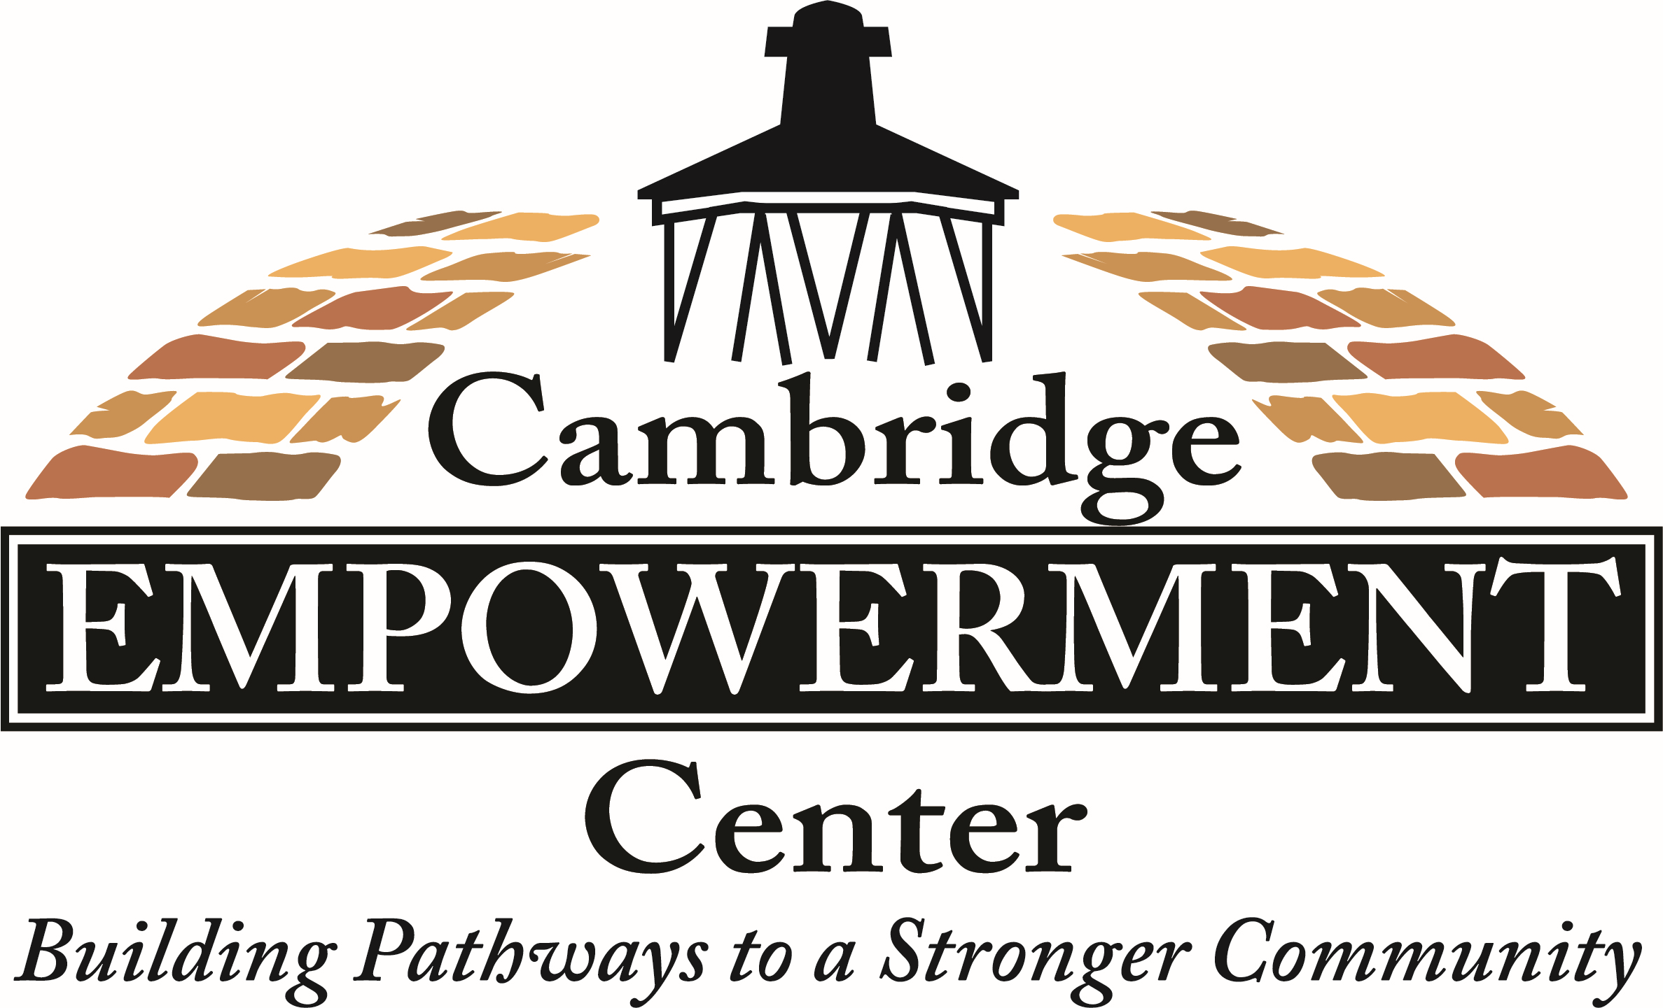
New Executive Director, Sharon Chester
New Growth & Development Director, Judith Prahl

The Board of Directors of the Pine Street Committee, Inc. also known as the
Cambridge Empowerment Center, is proud to announce the appointment of
Sharon Chester as the new part-time Executive Director. Ms. Chester grew up in Cambridge and graduated from Cambridge Senior High School. She went on to attend, and graduated from, the University of Maryland Eastern Shore. After graduating, she moved to Prince Georges County, Maryland to start her career.

Ms. Chester worked in the field of Early Childhood education for over forty-three years. She also served as the Regional Manager for the Office of Childcare in Prince George’s County. After retiring, Ms. Chester moved back to Cambridge. She is a dedicated member of the Progressive of Dorchester, Temple #224 where she currently serves as the Daughter Ruler. She is also a Board Member of the Maces Lane Community Center, former Oziel Chapter #23 Order of the Eastern Star, Fellowship Chapter #58 Order of the Eastern Star and Ravens Roost #35 of Annapolis, Md. She was a vital former member of the Prince George’s County Commission for Women and the PG County Inter-Agency Committee where she was the recipient of the Judith P. Hoyer Award in 2012 for Outstanding Services to Children.

Ms. Chester was hired by the Empowerment Center in October 2022 to help us apply for a Maryland State Childcare License. She was essential in the re-opening of the Pine Street Enrichment Program which offers a licensed after-school and full-time summer program for children aged 5 to 13 years old.

Her motivation and enthusiasm to serve the youth in our community is driven by the day-to-day relationships that she so naturally develops with children. Ms. Chester says, “I believe that my purpose is to encourage each child to seek and grow into the best version of themselves. I hope that the precious memories that are created among the children, staff, and volunteers at the PSEP will be used as steppingstones in their life journey and inspire each of them to be motivated, respectful, honest, and caring individuals, no matter what career path they embrace in life.”

Ms. Chester is a dedicated wedding and event planner, and enjoys crafting, line dancing, bowling, football and spending time with her family and friends. She and her husband James are both natives of Dorchester County and reside in Cambridge.

The Board of Directors is also proud to welcome Ms. Judy Prahl as the new part-time Director of Growth and Development. She comes to us with many years of experience in both the private and public sectors.
Ms. Prahl graduated with an RN degree from New England Baptist School of Nursing, and a BBA from Mercer University with a major in Marketing and Accounting. She currently (since 2007) owns her own internet business which helps companies and organizations improve their online presence. She was a marketing communications manager for Cambridge International from 1994 to 2004. She has worked with other companies prior to this and has lots of experience in grant writing, fundraising, PR, advertising, and social media. Ms. Prahl has held a pilot’s license and enjoys sailing and cooking. She currently lives in Cambridge, Maryland. Ms. Prahl says, “I look forward to helping this strong Board and Executive Director to achieve their goals and the Empowerment Center’s mission.”

We are very excited to have both talented women working with us to help grow the programs at the Empowerment Center to better serve the community.

CAMBRIDGE EMPOWERMENT CENTER – Free School-Age After Care Program – Enroll Now

The Cambridge Empowerment Center announces the re-opening and available slots for our School Age After Care Program known as the Pine Street Enrichment Program (PSEP). The PSEP is located on 615 Pine Street and operates Monday through Thursday from 3:00 PM to 5:30P M servicing children aged 5 to 13.

Dorchester County Public School System (DCPS) will provide free bus transportation daily after school for all children who attend Sandy Hill, Maple, or Choptank Elementary School. The center follows the DCPS calendar and does not operate on half-days, snow days, holidays, etc.

At no cost to the parents, the program serves a meal each day and provides a safe and well supervised nurturing environment. The children receive homework assistance, academic practice, as well as fun indoor and outdoor activities. For more information or to enroll, feel free to visit the center or contact Tammy Washington at 410-901-1397 or email at info@cambempowermentcenter.org

Maryland State Department of Education License #259390

Volunteers Needed

The Empowerment Center is always looking for volunteers to help at the after-school program. The kids, ages 5 to 12, love some one-on-one time, reading, doing math or a craft project. This year we have some youngsters who really crave this and beg to be taken by volunteers.

The volunteer time is Monday through Thursday, 4:30 to 5:30. If you can spare one or two hours a month, please contact us through our email - info@cambempowermentcenter.org. After a brief orientation, no time commitment is needed. You can come whenever available if you let us know a few days in advance. Thanks!

ONE MISSION CAMBRIDGE – Volunteers Needed

Are you looking for a great opportunity to positively impact your community? Would you like to meet your neighbors as well as other local volunteers? One Mission Cambridge has many opportunities to volunteer! You can shop with clients and be an encouragement to others at a vibrant mission center on Race Street in Cambridge.

An average of 353 individuals use the mission center services every month, and we rely on volunteers to help us serve food and provide information! Would you like to tour the mission center and see how we impact the community? Would you like to join the mission center team? Please contact Susan, the One Mission Cambridge Manager, at manager@onemissioncambridge.org, 443-521-5226 for more information.

MAIN STREET GALLERY – All That Glitters
-- Theresa Knight McFadden

Main Street Gallery is thrilled to announce that beginning on Thursday, November 2nd, All That Glitters: A Women’s Metalsmith Collective returns to the Cambridge art co-op to present a dazzling showcase of jewelry and artwork! The seven talented Eastern Shore metalsmiths and glass artists showed at the gallery last year and will exhibit again alongside Main Street Gallery’s twelve member artists. The exhibition will be open to the public until December 31 with two receptions, November 11 and December 9 from 5-8 pm. Light refreshments will be served, and all are welcome.

The seven exhibiting jewelry and glass artists include Cindy Ayd, Jeanne Barr, Melissa Kay-Steves, Alexa Matthai, Robin Morgan, Linda Starling and Barbara Trower. As they did last year, each artist will be showing numerous pieces of exquisitely hand-fabricated jewelry and sculpture in sterling and fine silver and semi-precious and fused glass. This eclectic group of women met while taking classes in metalwork at Charmtree Jewelry Studio in Stevensville which is owned by Melissa Kay, one of the exhibitors. While they come from many different backgrounds and careers, they have found their bliss in jewelry-making and glass work.

It was early in 2022 that local artist, Linda Starling, who is a member of Main Street Gallery and who specializes in beach glass and silver jewelry, envisioned a holiday show at MSG with her Charmtree classmates. She says that after taking classes and working alongside all seven women and watching them grow not only in artistry but in friendship, she thought a show together might be an exciting next step.

That first show was so successful that the artists decided to try it again and are happy to show together once more. Linda explains that these classmates have become an important network for her and each other. They routinely share ideas and new techniques and while working together they continually challenge each other. The extra added bonus, she says, has been the lasting friendships they have formed. Through their classes the artists have learned or improved upon their skills in fabrication, metal clay, soldering, enameling and more and all have continued in their education taking online classes and traveling to learn from some of the best in the jewelry industry.

Main Street Gallery is open Thursdays through Sundays from 11 to 5 and online shopping is always available at: mainstgallery.net. The gallery is located at 518 Poplar St. and is Cambridge‘s only artist-owned and operated cooperative. The gallery is currently reviewing work from prospective members and guest artists. Please contact them through their website or by calling 410–330–4659 if you are interested in being part of this vibrant artist community.

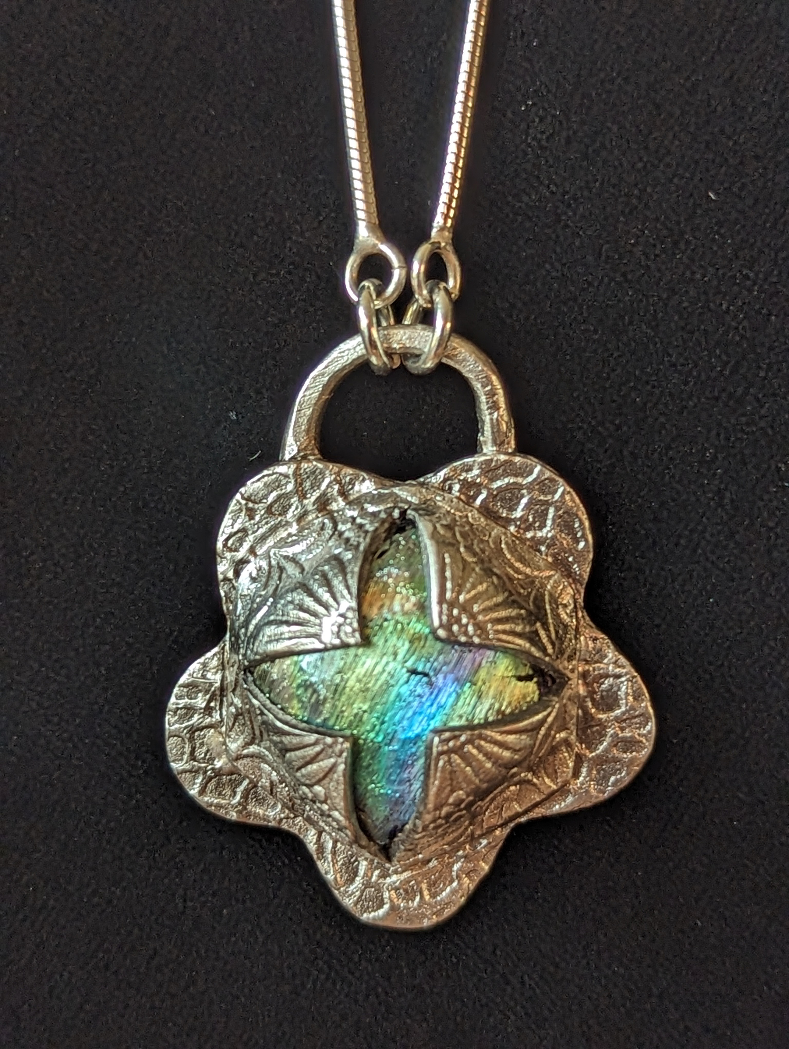

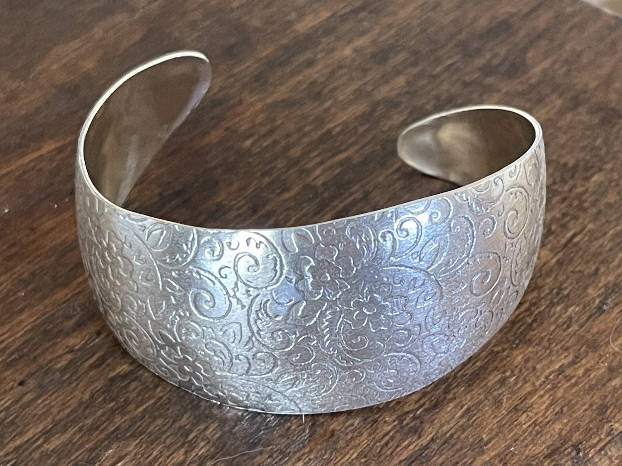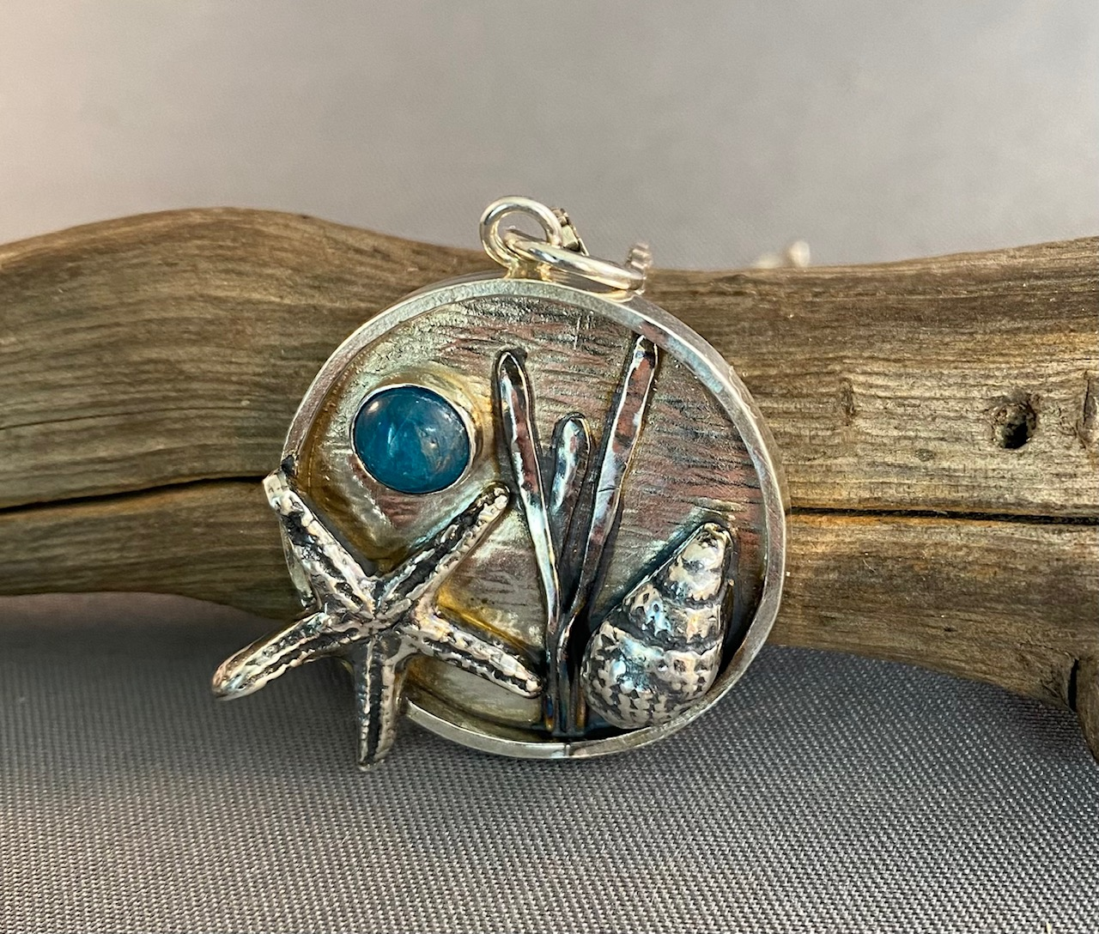

MIDSHORE MEALS TIL MONDAY

MidShore Meals 'til Monday is working to end childhood hunger on Maryland’s Eastern Shore by providing weekend food for food-insecure children in Dorchester County. Meals ‘til Monday sends home healthy, nutritious food for children at the end of each school week and during the summer months for breakfast, lunch and snacks to bridge the hunger gap for children without access to adequate food.

Meals ‘til Monday programs currently provide food for more than 500 elementary, middle and high school students. Meals ‘til Monday needs your support to keep providing essential nourishment to our children. Donations are fully tax deductible and can be made at https://www.mscf.org/donate-online/. For more information about MidShore Meals ‘til Monday, please call the Director, at 703-371-5191, or visit their Facebook page or website at www.midshoremealstilmonday.org/

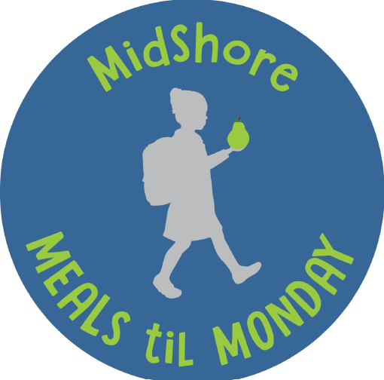

CAN MISSION, MEMBERSHIP, and COMMITTEES

The Cambridge Association of Neighborhoods (CAN) fosters neighborhood cohesion and community involvement to enhance the quality of community life for all residents of Cambridge through community events, social activities, and neighborly assistance; and protect and enhance properties in Cambridge by improving building and zoning codes, supporting adherence to those codes, and engaging constructively with City Government, including the Historic Preservation Commission.

CAN welcomes members from all Cambridge neighborhoods who are interested in organizing and working together, building a diverse membership reflecting the diversity of Cambridge residents. Membership is FREE – information is available on the CAN website at https://cambridgecan.org/join-can/

CAN HOUSING QUALITY COMMITTEE – PLANNING AND ZONING ISSUES
The Housing Quality Committee monitors issues affecting the quality of housing and the maintenance of property values in the City, including code enforcement. Committee members attend Planning Commission meetings to monitor zoning-related issues and report the information to the Board and Membership. Please contact Chuck McFadden at Ragtime31@gmail.com to volunteer.

NEIGHBORHOOD DEVELOPMENT COMMITTEE – SOCIAL EVENTS & ‘NEIGHBORS HELPING NEIGHBORS’

"Neighborhoods" are organized by small groups willing to work together to address neighborhood issues through small social events and "neighbor-helping-neighbor” activities. The Social Events Subcommittee organizes community-wide events. Contact Chuck McFadden at Ragtime31@gmail.com to volunteer.

CAN COMMUNICATIONS COMMITTEE – WRITERS NEEDED

CAN'S Communications Committee needs writers, including volunteers to take unofficial notes at public meetings. Please contact Tom Puglisi at tom.puglisi@comcast.net to volunteer.

POWER WASHER AVAILABLE

CAN has an electric power washer available to members. Contact Chuck McFadden at Ragtime31@gmail.com if you would like to borrow it.

