Newsletter #23.12 DECEMBER 2023

SEASONS GREETINGS FROM CAN!

ANNUAL BUSINESS MEETING AND BOARD ELECTIONS
TUESDAY - JANUARY 16, 6:30 PM - LIBRARY BASEMENT MEETING ROOM

CAN member meetings are announced in advance and open to the public.
Everyone interested in CAN is invited to attend.

IN THIS ISSUE: page

PRESIDENT’S MESSAGE – Happy Holidays 2

CAMBRIDGE CORNER 2
- Cambridge Real Estate Trends 2
- Cambridge Fun Facts and Lore 4
- Candidates for CAN Board of Directors 4

Community News – Cooperating Community OrganizationS 5
- Mainstreet Gallery – Winter Brings Serendipity 5
- Habitat Choptank 5
- Cambridge Empowerment Center 6
- One Mission Cambridge 7
- Midshore Meals ‘til Monday 7

CAN Mission Statement, Membership Information, and Committees 8

CURRENT LINKS

JOIN CAN FOR FREE – https://cambridgecan.org/join-can/
CAN Meeting Minutes – https://cambridgecan.org/category/meetings/
CAN’s City Council Meeting Notes – https://cambridgecan.org/category/news/city-council-notes/
CAN’s Planning & Zoning Notes – https://cambridgecan.org/category/news/p-and-z/
CAN’s Website – https://cambridgecan.org
CAN on FaceBook – https://www.facebook.com/CambridgeAssociationofNeighborhoods/
Contact CAN – CambridgeCAN@yahoo.com

PRESIDENT'S MESSAGE –
-- Charles McFadden, President, CAN

The CAN Board and I would like to wish each and every one of you a safe and happy holiday season. We also wish the Mayor, City Council, the City Manager, the Department heads and City staff a happy and restful holiday season because they are going to need all the energy they can muster for the upcoming year. The City Manager has staffed up and now has a number of projects and challenges for next year, such as:

1. In-depth planning for the new sewer system on Water St. and the shore-line resilience project on the Choptank, plus the new drainage system between Mill and Choptank Av.
2. Rethinking Cambridge Harbor Plans to be more of an economic engine for the City and County and getting the project moving.
3. Removing traffic lights in the downtown area and replacing them with stop signs
4. A number of housing projects and improvements in the Pine St. area and implementing the new land bank system for purchasing and replacing old houses.
5. Finalizing the Hearn Building plans on Race St.
6. Installing a new City-wide computer system and replacing worn out fire and maintenance equipment.
7. Gearing up the new Code enforcement program.
8. Taking back the operation of the City Marina and planning capital improvements that reflect the rising tides and the shoreline resilience project.
9. Increasing the Police Department numbers to reflect the needs shown in the new management study; improving crime statistics (as we have this year) and supporting the Police with Neighborhood Watch programs.
10. Dealing with gangs and gun violence through electronic surveillance, increased police presents and a focused approach.
Have a wonderful holiday season!
-- Chuck McFadden, President

CAMBRIDGE CORNER

CAMBRIDGE REAL ESTATE TRENDS
-- Fred & Martha Phillips-Patrick

National and Regional Residential Real Estate Developments:

According to a survey conducted by Fannie Mae in November, “Consumers’ perceptions of homebuying conditions remain overwhelmingly pessimistic, as only 14% of consumers believe it’s a good time to buy a home, a new survey low. Pluralities of respondents also continue to expect both home prices and mortgage rates to increase over the next 12 months.”
However, more recently, on December 14, Freddie Mac reported that “Potential homebuyers received welcome news this week as mortgage rates dropped below seven percent for the first time since August. Given inflation continues to decelerate and the Federal Reserve Board’s current expectations that they will lower the federal funds target rate next year, there will likely be a gradual thawing of the housing market in the new year.”

How did Cambridge fair in this tough market environment in November, the latest data we have? Let’s see.

Cambridge Market Update:

Realtor.com characterizes the City of Cambridge as a buyer’s market in November, 2023, which means that the supply of homes is greater than the demand for homes. It reports that “homes in Cambridge, MD sold for 2.65% below asking price on average in November 2023. However, on average, homes in Cambridge, MD sell after 55 days on the market. The trend for median days on market in Cambridge, MD has gone up slightly since last month, but down since last year.”

Sales: Currently, according to Realtor.com, there are now 165 homes for sale (130 single family homes and 35 condos and townhomes) in the Cambridge area, down from October. There are also a 5-unit multifamily dwelling for sale, as well as 44 farms and plots of land. The properties’ asking prices range from $20,000 for a small plot of land on Willis Street to $2,500,000 for 134.9-acre lot on Town Point Road.

In November, only eight single family, townhouses, and condo sales were completed, a new low, ranging in value from $170,000 to $1.15million. The ones marked in red sold for less than the asking price. They are:

329 Choptank Ave $300K 607 Hubert St $170K 207 Buena Vista Ave $255K
411 Leonards Ln $210K 404 Edlon Park Dr $221K 5820 Ross Neck Rd $1,150K
1643 Terrapin Cir $305K 1635 Terrapin Cir $292K

New Ward Realignment

According to a news release from the City, the following changes will be made to the Cambridge’s Wards. These changes will make it so that each Ward has a population size within the lawful plus or minus 5% range of the City’s mean population. Wards must be within this range for elections. According to Council documents, there are currently more residents in Ward 1 than the range allows and fewer residents in Ward 5 than the range allows. The realignment involves:

- Moving the area bounded by Locust Street, Oakley Street, Park Lane and Willis Street from Ward 1 to Ward 3.
- Moving the area bounded by Robbins Street, Maces Lane, Bradley Avenue and High Street from Ward 2 to Ward 4.
- Moving the area bounded by Virginia Avenue, Peachblossom Avenue, Washington Street, Front Street, Brohawn Avenue and Perimore Street from Ward 3 to Ward 5.
- Moving the area bounded by Washington Street, Peachblossom Avenue, Boundary Avenue and Front Street from Ward 4 to Ward 5.

CAMBRIDGE FUN FACTS AND LORE – RFC Train Garden
-- Martha Phillips-Patrick

The Rescue Fire Company Train Garden in Cambridge is the longest continually operating fire department train display in the United States, and it remains in the same home it has occupied since 1934 at the "Old Firehouse" downtown at 307 Gay Street. For 89 years, volunteers with the Cambridge Rescue Fire Company have created the Train Garden for the holidays, changing the displays every year. In 1935, the layout was 26' x 18'; today it's 40' x 16'. More recently Santa has visited children at the Engine House descending from the roof via the fire pole, but when Rescue Fire Company first acquired an aerial ladder truck back in 1938, his visit began including a descent from the building's landmark bell tower.

This year's Train Garden will be open from December 1 to December 31, open Monday through Friday from 6-9 PM; and Saturday and Sunday from 1-4 PM and 6-9 PM. Only closed on Christmas Day. Admission is free; donations happily accepted.

CANDIDATES FOR CAN BOARD OF DIRECTORS

Under Article IV of the Bylaws of the Cambridge Association of Neighborhoods (CAN), members of the Board of Directors are elected by majority vote of the CAN members present at the Annual Business Meeting held in January of each year.

The 2024 ANNUAL BUSINESS MEETING AND BOARD OF DIRECTOR ELECTIONS will take place on TUESDAY, JANUARY 16, at 6:30 PM in the LIBRARY BASEMENT MEETING ROOM.

The following slate of candidates for terms extending from January 2024 through January 2026 was developed from nominations received prior to the December 15, 2023 deadline. No additional nominations were received.

President – Chuck McFadden
Treasurer – Dave Thatcher
Member at Large – Mary Ellen Jesien
Member at Large – Kim Miller
Member at Large – Brad Rice
Member at Large – Donna Towers
Member at Large – Judd Vickers

Terms of the following Board Members expire in January 2025:
Vice-President – Roman Jesien
Secretary – Tom Puglisi
Member at Large – Andre Duerinckx
Member at Large – Rick Klepfer
Member at Large – Sharon Smith

COMMUNITY NEWS – COOPERATING COMMUNITY ORGANIZATIONS

MAIN STREET GALLERY – Winter Brings Serendipity to Main Street Gallery

From January 4 through February 25 the Main Street Gallery in Cambridge will be showing the works of their member artists in a special show called “Serendipity”. The dictionary defines serendipity as an unplanned fortunate discovery and the artists at the city’s only artist owned and operated cooperative are promising just that. “You don’t know what you might find at our “Serendipity” show", says director Linda Starling. “You may discover a beautiful painting at a significant discount or a unique piece of knitwear perfect for a cold winter day. Happy surprises await visitors to this show.”

Hours for “Serendipity” are Thursdays through Sundays from 11-4pm. Two Second Saturday events are planned for the show. On Second Saturday, January 13, the gallery will be open from 5-8 pm during the Cambridge Ice and Oyster Festival and there will be something warm and tasty for visitors. The next Second Saturday will be on February 10 from 5-8pm. Light refreshments will be served, and all are welcome to both receptions. There will be a brief artist talk by one of the coop members at each opening. The gallery asks that children under 18 be accompanied by an adult.

Main Street Gallery is located at 518 Poplar St. in Cambridge, and is part of the lively Arts and Entertainment District. The gallery is currently reviewing work from prospective members and guest artists. Please contact the gallery through its website mainstgallery.net or by phoning 410-330-4659 if you are interested in being a part of this vibrant artist community.

(Jewelry is by Linda Starling, untitled painting (Strife!) is by Deborah Colburn, "Cambridge Kite Festival" painting is by Lesley Giles and the mixed media collage "How Do I Look?" is by Theresa Knight McFadden.)

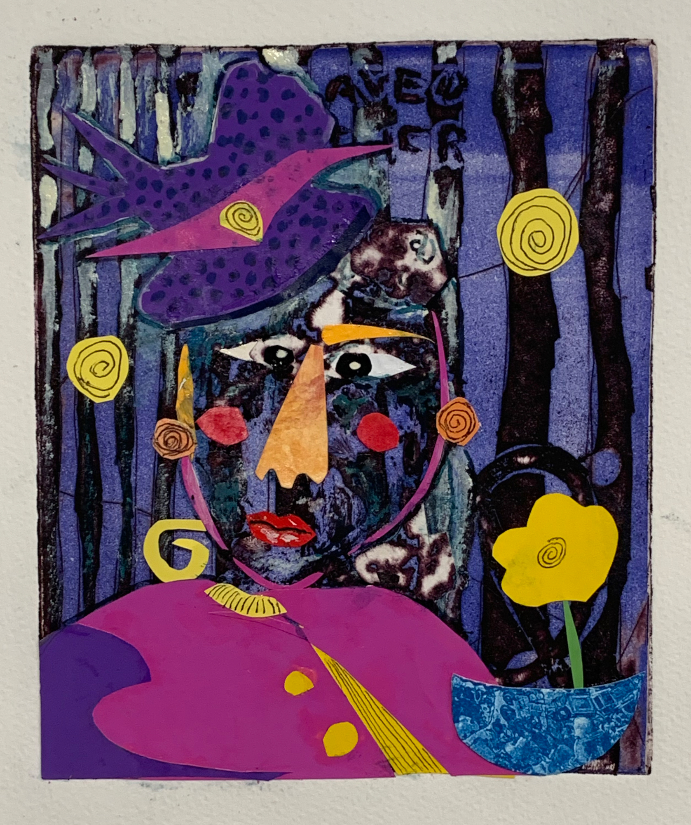

HABITAT CHOPTANK – Volunteers Needed

Habitat for Humanity Choptank’s Home Repair Program partners with low-income homeowners who need help to maintain and perform necessary repairs on their homes, allowing them to reclaim their homes with pride and dignity. Volunteers are needed to conduct home visits with a member of our repair staff and to help do the repairs.

Below are descriptions of both opportunities:

Home Visits:
- No experience necessary.
- 1 hour time commitment per home visit.
- Sign up for individual home visits as your schedule allows.
- Conduct visits in either Cambridge, Easton, St. Michaels, Hurlock, or Trappe - whatever is most convenient for you!

Repair work:
- Learn new skills to put to work in your own home.
- No experience necessary - our construction staff will teach you what you need to do.
- Sign up for individual repair shifts as your schedule allows.

Interested in either of these opportunities? Contact volunteers@habitatchoptank.org.

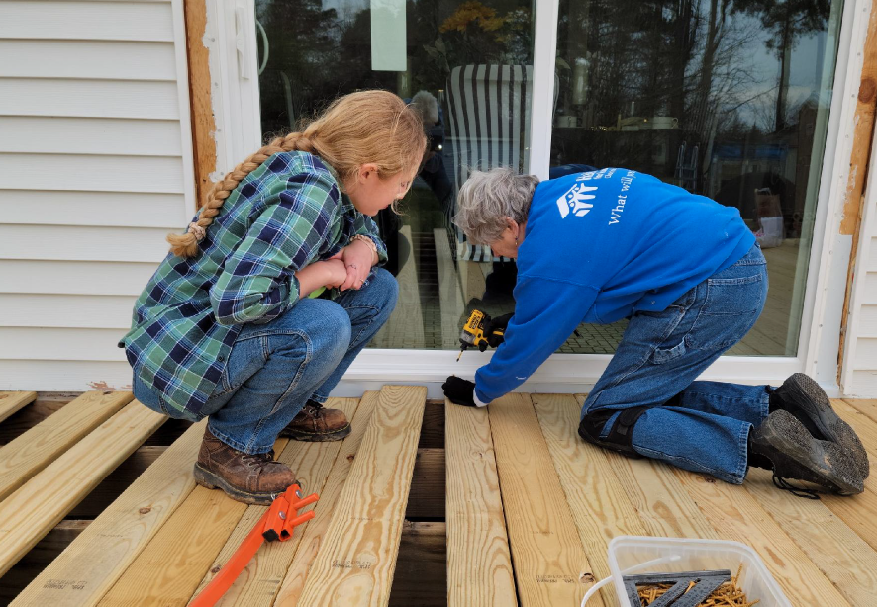

CAMBRIDGE EMPOWERMENT CENTER

The Empowerment Center is always looking for volunteers to help at the after-school program. The kids, ages 5 to 12, love some one-on-one time, reading, doing math or a craft project. This year we have some youngsters who really crave this and beg to be taken by volunteers.

The volunteer time is Monday through Thursday, 4:30 to 5:30. If you can spare one or two hours a month, please contact us through our email - info@cambempowermentcenter.org. After a brief orientation, no time commitment is needed. You can come whenever available if you let us know a few days in advance. Thanks!

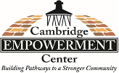

ONE MISSION CAMBRIDGE – Volunteers Needed

Are you looking for a great opportunity to positively impact your community? Would you like to meet your neighbors as well as other local volunteers? One Mission Cambridge has many opportunities to volunteer! You can shop with clients and be an encouragement to others at a vibrant mission center on Race Street in Cambridge.

An average of 353 individuals use the mission center services every month, and we rely on volunteers to help us serve food and provide information! Would you like to tour the mission center and see how we impact the community? Would you like to join the mission center team? Please contact Susan, the One Mission Cambridge Manager, at manager@onemissioncambridge.org, 443-521-5226 for more information.

MIDSHORE MEALS TIL MONDAY

MidShore Meals 'til Monday is working to end childhood hunger on Maryland’s Eastern Shore by providing weekend food for food-insecure children in Dorchester County. Meals ‘til Monday sends home healthy, nutritious food for children at the end of each school week and during the summer months for breakfast, lunch and snacks to bridge the hunger gap for children without access to adequate food.

Meals ‘til Monday programs currently provide food for more than 500 elementary, middle and high school students. Meals ‘til Monday needs your support to keep providing essential nourishment to our children. Donations are fully tax deductible and can be made at https://www.mscf.org/donate-online/. For more information about MidShore Meals ‘til Monday, please call the Director, at 703-371-5191, or visit their Facebook page or website at www.midshoremealstilmonday.org/

CAN MISSION, MEMBERSHIP, and COMMITTEES

The Cambridge Association of Neighborhoods (CAN) fosters neighborhood cohesion and community involvement to enhance the quality of community life for all residents of Cambridge through community events, social activities, and neighborly assistance; and protect and enhance properties in Cambridge by improving building and zoning codes, supporting adherence to those codes, and engaging constructively with City Government, including the Historic Preservation Commission.

CAN welcomes members from all Cambridge neighborhoods who are interested in organizing and working together, building a diverse membership reflecting the diversity of Cambridge residents. Membership is FREE – information is available on the CAN website at https://cambridgecan.org/join-can/

CAN HOUSING QUALITY COMMITTEE – PLANNING AND ZONING ISSUES
The Housing Quality Committee monitors issues affecting the quality of housing and the maintenance of property values in the City, including code enforcement. Committee members attend Planning Commission meetings to monitor zoning-related issues and report the information to the Board and Membership. Please contact Chuck McFadden at Ragtime31@gmail.com to volunteer.

NEIGHBORHOOD DEVELOPMENT COMMITTEE – SOCIAL EVENTS & ‘NEIGHBORS HELPING NEIGHBORS’

"Neighborhoods" are organized by small groups willing to work together to address neighborhood issues through small social events and "neighbor-helping-neighbor” activities. The Social Events Subcommittee organizes community-wide events. Contact Chuck McFadden at Ragtime31@gmail.com to volunteer.

CAN COMMUNICATIONS COMMITTEE – WRITERS NEEDED

CAN'S Communications Committee needs writers, including volunteers to take unofficial notes at public meetings. Please contact Tom Puglisi at tom.puglisi@comcast.net to volunteer.

POWER WASHER AVAILABLE

CAN has an electric power washer available to members. Contact Chuck McFadden at Ragtime31@gmail.com if you would like to borrow it.
