CAMBRIDGE ASSOCIATION OF NEIGHBORHOODS

* * * * *

ANNUAL MEMBERSHIP BUSINESS MEETING
JANUARY 17, 2023

Note: CAN’s Membership Meetings are livestreamed at https://www.facebook.com/WHCPRadio/live/ and can thereafter be viewed on YouTube at https://www.youtube.com/@whcpstudio4716 and FaceBook at https://www.facebook.com/WHCPRadio/videos.

MINUTES

Board Members President: Chuck McFadden (President), Roman Jesien (Vice President), Tom Puglisi (Secretary), Dave Thatcher (Treasurer), Mary Ellen Jesien (virtual), Judd Vickers (virtual), and Jane Weeks. Seven of 11 members being present, a quorum of the Board was achieved.

Board Members Absent: Andre Duerinckx, Brad Rice, Sharon Smith, and Rick Klepfer.

CAN Secretary Tom Puglisi counted over 30 members present at the beginning of the meeting, thus exceeding the 20 members required under Article IX of CAN’s Bylaws.

- Opening Comments. CAN President Chuck McFadden convened the meeting at 6:30 pm at the Dorchester County Public Library, 303 Gay Street in Cambridge. He thanked WHCP-FM’s Julian Jackson for livestreaming the meeting tonight, and expressed special thanks to Jane Weeks for her years of service as CAN Treasurer and a Member of the CAN Board. Chuck noted that the CAN Board has honored Jane with the title of Board Member Emerita. Chuck also thanked Susan Olsen for her previous service on the Board He then invited all those in attendance to introduce themselves.

- Goals for 2024. Chuck noted that one of CAN’s core goals is to provide timely reports to its members on important issues related to the City of Cambridge in general and City Government in particular. In addition, the CAN Board has decided to focus this year (2024) on housing issues and economic development projects in Cambridge. He pointed out that the City, under the leadership of City Manager, Tom Carroll, has developed an aggressive plan to reduce blight by 30% in five years, enhancing home ownership for residents with an emphasis on people of color and raising the property values for all. The City’s initiatives include the Homemaker Helper Program, the Sidewalk Revolving Fund, the Home Ownership (HOW) Program, the Land Bank Initiative, Waterfront Development, code enforcement, and enhanced data systems (see the January CAN Newsletter for more information on these programs).

- Treasurer’s Report. Treasurer Dave Thatcher reported that CAN currently has $4,135.67 its coffers.

- CAN Board Elections. Pursuant to Article IV Section 14 of CAN’s Bylaws, CAN Vice-President Roman Jesien presented the nominees for positions on the CAN Board of Directors for terms extending from January 2024 through January 2026.

President – Chuck McFadden  Treasurer – Dave Thatcher  Member at Large – Mary Ellen Jesien  Member at Large – Kim Miller  Member at Large – Brad Rice  Member at Large – Donna Towers  Member at Large – Judd Vickers | Note: Terms of the following Board Members expire in January 2025:  Vice-President – Roman Jesien  Secretary – Tom Puglisi  Member at Large – Andre Duerinckx  Member at Large – Rick Klepfer  Member at Large – Sharon Smith
Nominees were unopposed and were approved unanimously by the CAN members present.

- Bylaws Revisions. CAN Secretary Tom Puglisi reported that the CAN Board has proposed a revision of CAN’s Bylaws to describe three types of meetings: i.e., Membership Meetings (including the Annual Business Meeting), Board Meetings, and Executive Committee Meetings. Proposed revisions (see attached) were posted on the CAN website (https://CambridgeCAN.org) and distributed at the meeting. The members present vote unanimously to accept the proposed revision

- WARD 1 COMMISSIONER LAUREL ATKISS. Chuck welcome Ward 1 Council Commissioner Laurel Atkiss to the meeting. (Note: The complete text of her remarks is attached.)

Commission Atkiss thanked CAN for inviting her to speak and for all the work that CAN does to keep the neighborhoods of the City informed and organized. Ms. Atkiss noted that while some areas of the City are thriving, other areas are not. While violent crime numbers are down across the country other numbers are glaringly up. Homelessness, poverty, food insecurity, mental illness and depression are all at record highs. Eviction protections have expired from when they were established during Covid, monies that were provided to help families during the pandemic have ended as the cost of everything a family needs have gone through the roof. Ms. Atkiss reminded the audience that where poverty, blight and struggle are concentrated so will we find crime, addiction, depression and mental illness.

Ms. Atkiss asked the audience to consider the following questions: How do we see healthy growth in neighborhoods where it’s easier to find cheap drugs than an affordable, healthy meal? How do we heal the division that is deeply ingrained in our citizens and our culture? How do we expand education and opportunity, improve our workforce and heal our blighted neighborhoods? How do we improve our tax base and lower our crime to invite investors and businesses to come here?

Ms. Atkiss remarked that these questions are easy to ask but hard to answer. She observed that no answer stands alone, no single solution will solve the problems, and nothing will be fast. We have a starting point, and we are making the right moves and looking at the problems holistically. But we are going to have to make the moves together. Not the city, the police department, the school system, nor the families can address all of the contributing factors alone.

Ms. Atkiss encouraged everyone to take on a constructive endeavor with the City and its youth. She urged attendees to volunteer, mentor and engage with our City and our children and share their wisdom, experience and energy. She also emphasized the importance of leading by example as we move through the City and through our day-to-day lives. One thing that children respond to more than anything else is the example that they are shown by adults.

Questions and Comments from Attendees.
- Where does one go to find information and progress on important issues like crime statistics, the Hearn Building status, and the Bradford House
  - Annual crime reports are available from the police department website,
  - The latest update is that Green Street Partners may undertake rehabilitation of the Hearn Building as they did with the New Horizons housing project on Muir Street.
  - The absence of local reporters and newspapers make it difficult to obtain local information. CAN tries hard to keep citizens up to date with its city meeting note, email distributions, and newsletters.
  - A new management company now managing Bradford House, and residents are being given an opportunity to have their apartments inspected and present the concerns to a judge.
  - The City recently received a spotless “clean” audit of its finances, which is attached to the January 8, 2024, City Council meeting agenda and is available on the City website at https://www.choosecambridge.com. Sadly, City Finance Director Deborah Cooper died unexpectedly at the end of December.
  - City Manager, Tom Carroll has developed a detailed list of the City’s accomplishment in 2023, available in CAN’s January newsletter at https://CambridgeCAN.org,
- The most recent project to address flooding at the end if Oakley Street was a failure. The City has signed a contract to address sewage overflow, but citizens have been given little information as to when it will occur, what will be done, and who will be affected. Citizens would like to see the comprehensive plan for this project.
  - The City and the contractor have three months to develop a specific plan for the project, which. The contract itself is attached to the January 8, 2024, City Council meeting agenda and is available on the City website at https://www.choosecambridge.com.
  - The Sewer Project will require borrowing, even though a local company is being used, as the bid was $470,000 over what the City had anticipated.
  - It is often the case that only one company bids on contracts that the City advertises.
- A Central listing of volunteers and a volunteer clearinghouse would be helpful.
  - See list of provided by Commissioner at the end of her statement (attached)
- The central challenge facing Cambridge is poverty, which is at the root of many of our problems. We have to address poverty. We all need to talk to each other and care enough to address these problems. The City and the Police Department cannot solve these problems without community involvement.
- Business development is needed, and new businesses are coming in, but we need a more educated workforce. The level of performance of DCPS students is not sufficient to attract business to the community.
  - Cambridge Waterfront Develop is projected to bring in about 1000 jobs for construction, several hundred jobs once established.
- Cedar Street is due for renovations, including improving the tree canopy, to create a “Green” street.

Chuck thanked Commission Atkiss for her participation, and meeting was adjourned 7:33 pm.

*****

Attachment 1. Bylaws Article IV excerpt with revised language underlined and previous language lined out.

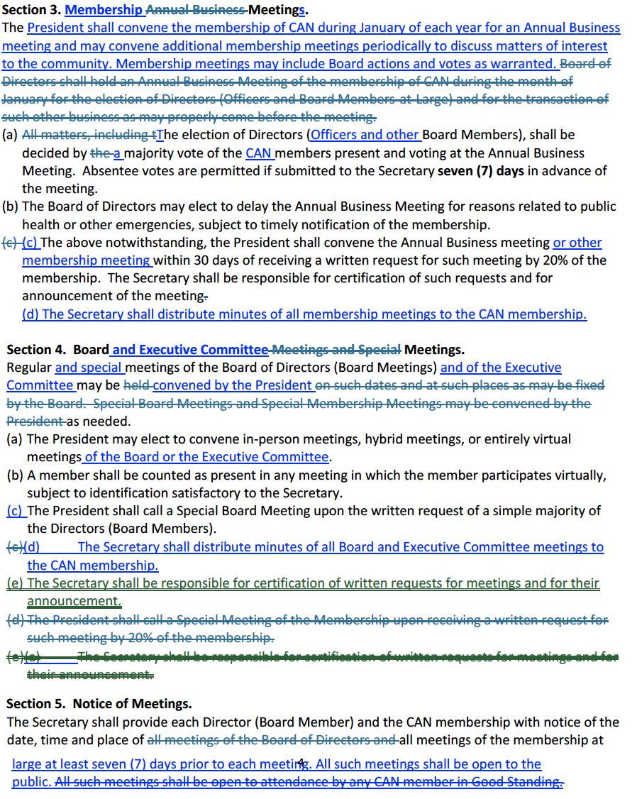

Attachment 2. Remarks from Commissioned Laurel Atkiss

Good evening and thank you to Chuck, the board members and all the CAN community members for having me here tonight and for all of the work that you do to keep the neighborhoods of our fair city informed and organized. It is warming and inspiring to see involvement and passion for this place that we call home, whether we rose here or chose here, as we lovingly say. In the nearly 10 years that I have called Cambridge my home I have seen vast improvements in many areas, but there is still so much to be done.

In this quaint, historic West End we have seen over 115 homes renovated and returned to single family dwellings and we continue to see investments being made in properties throughout that area. We have also witnessed some rapid expansion in new developments on the edges of the city, as well as in existing neighborhoods like Deep Harbor and Cattail Crossing. But as lovely as these neighborhoods are becoming, and as nice as it is to see the expansion, we have others that are still heading in an opposite direction and none of them are far from each other, as the sounds of gunfire carrying so well through these flat streets reminds us on some nights. No matter which ward or neighborhood you live in, we share a city and a community, and we all want to see it thrive. Is easy to ask why all neighborhoods in Cambridge are not thriving, but it is admittedly hard to hear the answers.

While violent crime numbers are down across the country other numbers are glaringly up. Homelessness, poverty, food insecurity, mental illness and depression are all at record highs. Eviction protections have expired from when they were established during Covid, monies that were provided to help families during the pandemic have ended as the cost of everything a family needs has gone through the roof. The ARPA child tax credits and government policies in 2021 helped keep 30% of all black children, 24% of all Latino children and 10% of all Asian and White children above the poverty line. So many more families and individuals are one crisis away from homelessness now than anyone would like to believe. A financial survey was released in 2019 encouraging people to save and it exposed that 59% of Americans were at risk by being one paycheck away from losing their living arrangement, whether it be rental or mortgage. In 2020 national poverty climbed so rapidly in one summer that nearly 8 million Americans sunk into poverty and therefore despair. The policies and measures taken to change those preARPA statistics are gone now and families are suffering. It is not just expired benefits and food insecurity that created this storm, corporate price gouging, underemployment, rent burden and wage stagnation all add to the issue across the country. Rents continue to rise drastically, along with housing purchase prices, leaving many people simply unable to afford anything on the market and often unable to stay up to date on utilities and other bills either.

So, when we meet on a Wednesday night in December at 6:30 and see that the faces in the room do not match the faces throughout the city we need to know that this is because the lives lived throughout the city do not match either. We do not all face the same challenges in life, and it is admittedly hard to look outside of one’s own reality and comfort to acknowledge such disparity and to empathize with it. And in complete honesty the imbalance is not only in skin tones and ward boundaries, but greatly in age, life path and financial stability. Working, parenting, prepping for the holidays and travel, working an extra job to manage expenses, getting the kids to sports, dance or other activities, grocery shopping or cooking dinner, other commitments and keeping one’s own business open are all very real reason people may not be able to take part in these meetings. Another reason that is harder to discuss is that the city was built up, in many ways, to be divided and kept separated.

Prior to the Treaty of Cambridge African Americans in Cambridge were rented actual chicken shacks, they lacked basic plumbing, suffered from crippling unemployment after the Packing house closed, and had no access to health care outside of Baltimore. After the Treaty created a provision for safe public housing in 1963, which the City wouldn’t even honor until after the riots, the housing built for the community has been low-income developments with units packed together in one underserved section of the city. In many cases the properties have been unmanaged and unmaintained by the companies responsible, leaving residents living in conditions that are less than ideal, if not dangerous for human habitation. Many units are inhabited by more people than they were designed for, further stressing utilities and infrastructure while Security services are not provided as contracted to keep the areas safe for residents. Where poverty, blight and struggle are concentrated so will crime, addiction, depression and mental illness be.

Another very important aspect of life in these areas is compounded generations, higher risks of mortality and rampant illiteracy. We have unprecedented numbers of older matriarchs raising their grandchildren and great grandchildren where parents are absent or deceased. There is a young man in Cambridge who lost one parent to an overdose and the other to illness, and this happens more than one would like to think. So, it is easy to ask where the parents are when we see juveniles choosing crime and delinquency, but it is admittedly hard to hear the answer. While African Americans typically have lower access to health care they have a higher risk of heart disease, stroke, cancer, pneumonia, asthma and diabetes. African American mothers are more than 3 times as likely as white or Hispanic mothers to die from pregnancy related complications and older black women are dying from strokes and heart disease at a staggering rate. In addition to this 2/3rds of children that do read proficiently by 4th grade are destined for prison or welfare and 85% of juveniles that encounter the court system are functionally illiterate. Beyond that African American men are twice as likely to go to prison and have a very high rate of recidivism, around 70%. So, we have neighborhoods full of children that have little to no parental structure or support, no ability to read and advance in society, no generational knowledge being passed down and very little hope for better.

So, how do we change it? How do we see healthy growth in neighborhoods where it’s easier to find cheap drugs than an affordable, healthy meal? How do we heal the division that is deeply ingrained in our citizens and our culture? How do we expand education and opportunity, improve our workforce and heal our blighted neighborhoods? How do we improve our tax base and lower our crime to invite investors and businesses to come here? All these questions are easy to ask and admittedly hard to answer. No answer is stand alone, no single solution will solve the problems, and nothing will be fast. But we have a starting point, and we are making the right moves and looking at the problems holistically. But we are going to have to make the moves together. Not the city, the police department, the school system, nor the families can address all of the contributing factors alone, the community is needed to also invest in this change we all want to see for Cambridge.

Our amazing new City Manager, Tom Carroll has helped us start addressing blight with land banking and reforming some of our most at-risk neighborhoods with the help of Habitat of the Chesapeake. Assistant City Manager, Brandon Hesson, has kicked off our new program to equitably address code violations throughout the city giving us a starting point to manage not only owner-occupied homes, but especially rentals that are not being kept to acceptable standards. The foot patrol methods being used will take a full 2 years to complete the entire city, but we hope to see better communication between our residents and city staff in solving façade, safety and blight problems in all neighborhoods.

Our Cambridge Police Department has made great strides in not only protecting and serving the populace and reinforcing their numbers, but also through redefining their relationship with the community and its youth through vast community policing efforts that are now being mirrored across the state because of the amazing impact they are having. I participate in regular ride-alongs with our officers to see, hear and experience how the department is working, not just for us but for the people working in it. From responding to shot-spotter alerts and violent crimes, handling abuse and vitriol from residents, to backing each other up in traffic stops, and handling domestic and emotional situations, these hard-working men and women are doing everything we need them to do and more to take care of this place we call home.

And here is where I want to encourage everyone to take on a similar endeavor, redefine your relationship with the city and its youth. Volunteer, mentor and engage with our city and our children and share your wisdom, experience and energy. I don’t have to tell this group to attend meetings and stay informed, but also step up and help the city realize things that matter to you, whether it be community events, gardening efforts or better opportunities for youths. Talk to children on the street with kindness and let them feel welcome and a part of your community, their community, OUR community. Become a tree steward and help us create a greener city and organize other beautification projects not just in your neighborhood, but in others that need investment the most. Join a board or committee to help the city and organizations within plan and execute events that families and children can enjoy and be a part of. We also have some truly amazing organizations in the city that are all in need of mentors, volunteers and other forms of support; All4Love- New Beginnings Youth & Family Services- The Boys & Girls Club and the Empowerment Centers on both Pine and Chesapeake Streets offer ways in which you can connect with and inspire children in our city and therefore the future of our city.

My personal endeavor is an art program that I do with the children at New Beginnings after school twice a month. For those that do not know, New Beginnings is a youth and family services center that operates at the Altair apartments on Greenwood Avenue, the newest of the developments I discussed previously. The after-school program is active for children pre-K through 6th grade and provides a snack, homework help, physical activity, artistic enrichment and dinner for 25-50 children at a time. In the summer they keep the children during the time that would be a school day and add in excursions and day trips to the experience. Starting in the’22-’23 school year I began doing a creative art project with the group twice a month, the Dorchester Center for the Arts reached out to me with grant money to fund it and I have been able to carry it all the way through the summer and we are still going. Last week we made an aurora borealis polar bear scene with tissue paper and bear silhouettes and Barb Seese at the DCA helped me apply for funds to continue into the ’24-’25 school year as well as branch out to the Boys & Girls Club with similar funding and projects. Anyone is welcome to join me at any time, I usually spend 5-8 hours prepping the materials and the kids completely consume the project in 30-45 minutes! I teasingly call it construction paper and controlled chaos. But the personal growth that I have witnessed in the children from these simple interactions over glue sticks, colored papers and self-expression is astounding. Fine motor skills, material management, organization, communication, sharing, helping, cooperating, cleaning up, conserving supplies, creativity and personal pride are all real-time lessons from our time together.

If you aren’t an artist, you can take a kid fishing, if you don’t fish, you can play a game of basketball, if you don’t shoot hoops, you can share and read a favorite book, and if you don’t like your voice, share some of your favorite music, can’t pick a favorite? Listen to theirs!

To bring my thoughts to a sort of a closing point I want to also speak briefly on leading by example as we move through the city and through our day-to-day lives. One thing that children respond to more than anything else is the example that they are shown by adults. From driving habits to how we treat servers and cashiers, children are always watching us and learning from us. It is up to us to show the children around us what we would like to see in them. From the words we use to describe ourselves to the words we use to influence others, children are always listening and learning from us. It is up to us to teach them words and ways of using them that are what we want to hear. We, as citizens, touch more than the people directly involved in our lives. How we move through our days and our actions and responses can inspire or disappoint someone at any time. Try to live to inspire.

- New Beginnings Youth & Family Services, 522 Greenwood Ave./410-228-1950
- All4Love 411A Dorchester Ave/ 410-450-4053
- One Mission Cambridge 614 Race St/ 443-521-6825
- Empowerment Center 615 Pine St/ 410-901-1397
- Delmarva Community Services 2450 Cambridge Beltway/410-221-1900

