Newsletter #24.01 JANUARY 2024

CAN member meetings are announced in advance and open to the public.
Everyone interested in CAN is invited to attend.

IN THIS ISSUE: page

PRESIDENT’S MESSAGE – 2

CAMBRIDGE CORNER 4
- Cambridge Real Estate Trends 4
- Cambridge Police Department 6
- Cambridge Fun Facts and Lore 7
- Cambridge 2023 by (Some of) the Numbers 7
- CAN Board of Directors 11

Community News – Cooperating Community OrganizationS 11
- Mainstreet Gallery – Winter Brings Serendipity 11
- Habitat Choptank 12
- Cambridge Empowerment Center 12
- One Mission Cambridge 13
- Midshore Meals ‘til Monday 13

CAN Mission Statement, Membership Information, and Committees 14

CURRENT LINKS

JOIN CAN FOR FREE – https://cambridgecan.org/join-can/
CAN Meeting Minutes – https://cambridgecan.org/category/meetings/
CAN Meeting Videos – https://www.facebook.com/WHCPRadio/videos or
https://www.youtube.com/@whcpstudio4716
CAN’s City Council Meeting Notes – https://cambridgecan.org/category/news/city-council-notes/
CAN’s Planning & Zoning Notes – https://cambridgecan.org/category/news/p-and-z/
CAN’s Website – https://cambridgecan.org
CAN on FaceBook – https://www.facebook.com/CambridgeAssociationofNeighborhoods/
Contact CAN – CambridgeCAN@yahoo.com

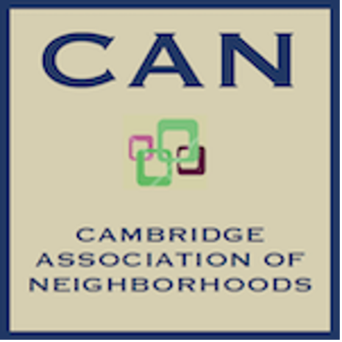
PRESIDENT'S MESSAGE –
-- Charles McFadden, President, CAN

For 2024, the CAN Board has decided to focus on housing issues and economic development projects in Cambridge. So, with that in mind, I would like to give you a few base statistics on Cambridge as follows:

- The Total population of Cambridge is 13,129, of which 20% are over the age of 65; 25% are under the age of 19; 48% are male and 52% are female. Cambridge only grew by 800 people between the 2010 and the 2020 census. (This is somewhat confusing considering all the new subdivisions that were built. More on this in latter issues.)

- The average income in Cambridge $44,114, which is 52% less than the State of Maryland and 34% less than the nation, and 22% of our residents are below the poverty level.

- Residential units in Cambridge number 5,314, of which approximately 3,000 or 56% are rentals. We only have 44% home ownership. These percentages (of 56% rentals and 44% home ownership) are reversed in most municipalities. Cambridge home ownership is 44% compared to the State of Maryland with 68%. We have approximately 800 unoccupied housing units, or 15% of the total number, which is the cause of major blight in many neighborhoods.

The City, under the leadership of City Manager, Tom Carroll, has developed an aggressive plan to reduce blight by 30% in five years, enhancing home ownership for residents with an emphasis on people of color and raising the property values for all. In order to meet this goal, the City will focus on the following:

- Housing Improvements. These programs are being developed to help homeowners fix up their homes.

  - The Homeowner Helper Program has set aside $500,000 for use in FY24. This program will have the City make necessary repairs that homeowners can’t afford. The City will put the money up front to pay for the work and then put a 0% lien on the property to get the money back when the house sells.

  - The Sidewalk Revolving Fund is funded at $200,000 and is similar in financing to the Homeowner Helper Program. This program helps homeowners who need to repair their sidewalks but cannot afford the cost all at once.

  - The Healthy Homes Program is a new effort that the City is trying to get the Department of Housing and Urban Development (HUD) to fund. The program’s primary goal is to eliminate lead paint exposure, especially in households with children under the age of 6

  - The Home Ownership (HOW) Program. HOW is a new pilot program funded by the State of Maryland at $10 million for Baltimore and Cambridge. The City has received $5.6 million for this effort. The program is aimed at helping first time home buyers, supporting critical home repairs, and facilitating legal services to solve title issues. HOW will build new, subsidized homes on property owned by the City near Waugh Cemetery, School House Lane, and Chesapeake Court.

- The Land Bank Initiative. The Land Bank is funded at $1 million for FY24. The program allows the City to acquire abandon or run down houses and either tear them down or fix them up for resale. It will be a revolving fund.

- Code Enforcement. The City has hired a third code enforcement officer and has set up a schedule of street reviews evenly spread out across all the City’s Wards. This effort should help clean up some major headaches blighting the neighborhoods.

- Community Engagement. The City has hired a housing program specialist, Mr. Gavin Woolford, who will help residents with housing problems. This will help residents get though some of the paperwork involved with the above programs.

- Cambridge Waterfront Development. Waterfront development is a major effort by the City, County and State to improve the old hospital site into a commercial and residential area. This effort is led by an independent corporation, Cambridge Waterfront Development, Inc. Development of the waterfront will have a significant impact on the City. The project will require a major funding effort by the City, County and State to provide the infrastructure needed, so the effort needs to be economically impactful and beneficial to the community.

- Enhanced Data Bases. This program, funded at $300,000 for FY24, is aimed at improving data management, particularly with rental properties, vacant properties, and short-term rentals.

The City has undertaken a considerable number of challenging programs to improve the City and should be commended for that.

CAN would like to follow these efforts, try to understand the underlying problems as they unfold, and make constructive suggestions to the City Manager and Council. As it is easy to see from the City’s statistics, housing and income go hand in hand. Therefore, the City Manager and Council need to focus on both issues to make long term improvements.

The CAN Board needs your ideas and input on how to be effective and help the City move forward.
Please contact me at Ragtime31@gmail.com with your ideas.

-- Chuck McFadden, President

CAMBRIDGE CORNER

CAMBRIDGE REAL ESTATE TRENDS
-- Fred & Martha Phillips-Patrick

National and Regional Residential Real Estate Developments:

According to Freddie Mac on January 11, 2024, “Mortgage rates have not moved materially over the last three weeks and remain in the mid-six percent range, which has marginally increased homebuyer demand. Even this slight uptick in demand, combined with inventory that remains tight, continues to cause prices to rise faster than incomes, meaning affordability remains a major headwind for buyers. Potential homebuyers should look closely at existing state and local resources, such as down payment assistance programs, which can considerably help defray closing costs.”

For information on Maryland’s mortgage programs, https://mmp.maryland.gov/Pages/default.aspx provides detailed descriptions of the programs and eligibility requirements for such assistance.

How did Cambridge fair in this tough market environment in December? Let’s see.

Cambridge Market Update:

Realtor.com characterizes the City of Cambridge as a buyer’s market in December, 2023, which means that the supply of homes is greater than the demand for homes. It reports that “In December 2023, the median listing home price in Cambridge, MD was $279.9K, trending up 3.7% year-over-year. The median home sold price was $202.5K. Homes in Cambridge sold for approximately the asking price on average in December 2023.”

Sales: Currently, according to Realtor.com, there are now 149 homes for sale (117single family homes and 32 condos and townhomes) in the Cambridge area, down from November. There are also a 3 multifamily unit for sale, as well as 39 farms and plots of land. The properties’ asking prices range from $20,000 for a small plot of land on Willis Street to $2,500,000 for 134.9-acre lot on Town Point Road.

In December, 21 homes were sold, ranging in value from $70,000 to $670,000.

705 Hughlett St $80K 904 Peachblossom Ave $180K 1418 Town Point Rd $670K
1645 Terrapin Cir $293K 203 Bowline Dr $316K 11 Jenkins Creek Rd $295K
200 Killarney Rd $103K 321 Willis St $120K 604 Widgeon Way $248K
9 Oriole Dr $329K 113 Holly Ter $240K 401 Osprey Cir $335K
318 E Appleby Ave $175K 604 Bethel St $180K 311 Cemetery Ave $98K
1629 Terrapin Cir $310K 1015 Central Ave $70K 1507 Winters Ct $375K
720 Glasgow St $95K 1100 Glasgow St $214K 211 Yellow Bill Ln $239K

In a preview of our next report, on January 2, 2024, 110 Choptank Avenue, a house that had been completely renovated, sold for $555,000.

Volunteers Needed to Serve on Several Boards

According to the Dorchester Star (January 4, 2024):

The City of Cambridge is actively seeking volunteers to serve on several boards and commissions. Interested citizens are encouraged to apply to be a member of these committees by completing the application form located on the city website at: https://www.choosecambridge.com/FormCenter/City-Hall-14/Boardand-Commission-Volunteer-Interest--84.

PLANNING AND ZONING COMMISSION. The Planning and Zoning Commission meets monthly to review applications from property owners requesting a change in zoning or who are planning new communities or uses of vacant land within the city’s limits. The Commission also creates ordinances for adoption by the City Council related to zoning. The seven-member committee meets with applicants monthly in a public meeting. Knowledge of planning and zoning topics is a plus. Vacancies: One member and one alternate member.

HISTORIC PRESERVATION COMMISSION. The HPC was established by statute to safeguard Cambridge’s historic sites and structures in the designated historic district. The Committee members with support of city staff are charged with reviewing applications and materials from property owners planning to make modifications to the exteriors of their properties in the Historic District. The five-member committee meets monthly with applicants in a public meeting. Professional or academic experience in historic preservation is a plus. Vacancies: One member and one alternate member.

BOARD OF APPEALS. The Board of Appeals reviews applications from property owners who are challenging a ruling by the Planning & Zoning Commission or the Historic Preservation Commission. The Board reviews the applications and the appropriate governing zoning code or guidelines to make a determination. This Board meets as needed based on the flow of applications. Vacancies: Two members and one alternate member.

ETHICS COMMISSION. The Cambridge Ethics Commission was established to address issues raised under the Cambridge Ethics Code. There are three members and one alternate member of the Commission. The Ethics Commission meets as needed to hear and decide complaints filed by individuals against an elected or appointed city official or a member of city staff that asserts a violation of the city ethics code. The Commission also provides Advisory Opinions that can be public or private depending on the request made by an individual. Vacancies: One member and one alternate member.

POLICE ADVISORY BOARD. The Police Advisory Board is responsible for advising the Cambridge Police Department on complaints from the citizens and improvements in the operation of the police department. This board shall also be responsible for making recommendations to the city council for areas in which police activities can better serve the citizens of Cambridge. The Board meets every other month. Vacancy: One member who resides in Ward 3.

Please consider these opportunities to make a difference in Cambridge.

CAMBRIDGE POLICE DEPARTMENT
“WITH PRIDE WE SERVE”

CHIEF JUSTIN TODD, N.A.
(410) 228-3333 / Fax# {4IO) 228-5836 / MD RELAY (TTY) 7•1·1 or l-800-735-2258
jtodd@cambridgepd.org
Happy New Year!!

I want to begin by thanking everyone for their tremendous support throughout the 2023 year. I look forward to the new year and achieving many accomplishments, not only as a Police Department but also together as an entire community. I would also like to thank the CAN community for allowing myself and Captain Patton the opportunity to speak at the December 13th meeting. I believe that sharing information to our community on crime issues/trends and what the Police Department is doing to combat those issues is key and helps build trust and shows transparency between the Police and the community.

As our 2023 crime statistics are being finalized, I am happy with the progress that is being made, especially when it comes to Homicides, Aggressive/Violent Assaults, Burglaries, and Theft. There is much work which will require time and dedication from not only the Police Department but the community to continue to see these numbers decline. Part of the Police Department's goals for the 2024 year will be working with data driven technology which involves heat mapping to assist in recognizing where our crimes are occurring, times of day, and days of the week. This will help our Patrolling with Purpose guidelines that we will implement beginning on February 1st. This type of data will also assist us in getting the information out to our community at a more advanced pace.

I would be remiss if I did not thank the women and men that patrol our city streets day in and day out. These officers work countless hours to protect and serve our citizens. The Criminal Investigations Division, even being short staffed, have closed cases that is well above the national average. This has resulted in several of our violent offenders being taken off our streets. I would also like to add that the Dorchester County Task Force, which is made up of law enforcement officers from all our local/state agencies, have spent countless hours in our city doing larger scale investigations/operations. All this combined is a big reason why we are progressing toward a safer community for all of us.

One area of concern is the number of overdoses that we have seen for the 2023 year within the city as it appears that those numbers have climbed which includes fatal overdoses. This problem affects so many families. Anyone that is struggling or knows of someone who is struggling there are resources available. If anyone has any questions or needs information on this, please do not hesitate to reach out for guidance on
what resources are available and where. As always if anyone has any questions or concerns, please do not hesitate to contact me jtodd@cambridgepd.org.
Justin Todd
CAMBRIDGE FUN FACTS AND LORE – The Nathans of Cambridge
-- Martha Phillips-Patrick

Ever wonder why there's a boat, a building and a commercial block in Cambridge bearing the name Nathan?

Meyer Nathan arrived in Cambridge around 1870 working as an itinerant peddler and tinkerer travelling the County by horse and wagon. Over the years, he acquired enough capital to lease property at 315 High Street where he opened a furniture store which became one of the largest on the Eastern Shore. Unfortunately, in July of 1892, his High Street home, the store and the furniture storage shed were all destroyed in a fire. He soon had new quarters for his store and continued his profitable furniture business. Meyer died in 1911 and the business passed to his son, Milford Nathan, who proved to be an accomplished businessman and entrepreneur. He expanded the store on High Street, and eventually opened 8 other furniture stores on the Delmarva Peninsula. Upon Milford's death (circa 1963), his will established the Nathan Foundation as a charitable organization for the good of the Dorchester community. The Nathan Foundation is the largest charitable foundation in Dorchester County. Its charitable gifts have totaled well over $3.5 million, which included $75,000 contributed toward the building of the Skipjack replica in Cambridge known as "The Nathan of Dorchester." (Charles Rouse)

Founding of the Dorchester Center for the Arts at the Nathan Building on High Street

In 2002 Dorchester County purchased the Nathan Building site at 321 High Street for the designated use of the Arts Center. Originally known as the Nathan Furniture Store, this building was the last addition to a complex that originated in the late 1800s, a series of connected buildings on historic High Street that included the furniture store of the Meyer Nathan family. That block is officially designated as the Nathan Commercial Block. The Nathan building is early 20th century with a 1930s Art Deco facade renovation.

The dramatic first floor main gallery staircase was part of the original structure. When the building was Nathan Furniture Store, high school choirs came in during the Christmas season, lined up on the steps and sang holiday songs, while visitors sat below on the store furniture and enjoyed the performance. That tradition continues today during the December Second Saturday Artists' Reception with community choir members filling the steps. (From Dorchester Center for the Arts website. Center hours: Wednesday, Friday and Saturday 11am - 5pm, Tuesday and Thursday Noon-8pm, Second Saturday 11am-8pm.)

CAMBRIDGE 2023 BY (SOME OF) THE NUMBERS
-- By Cambridge City Manager Tom Carroll

As 2023 drew to a close, I had some time to think back on the year, pondering what the City accomplished, what it is still working on, and what more we need to do in 2024 and beyond. I decided to put together a 2023 recap in the time-honored, end of the year tradition of preparing a list. Although my list was decidedly less interesting than the typical media ones like Top 5 Celebrity Marriages of 2023 or 7 Habits to Jumpstart the New You, I wanted to offer some numbers that jumped out at me as I reflected on the past year.

0 - The amount of PFAS detected in Cambridge’s water system. PFAS is commonly known as “forever chemicals” and is a carcinogen now found in most public water supplies. That we have found none in our water system is incredibly good news.
0.8096 - The City’s property tax rate this fiscal year, the same as it was in FY 23 and lower than it was in the previous five years. This is essentially 81 cents per $100 of real estate value. The City is trying to hold it steady in the upcoming budget year.

1 - The employee ranking I am assigning to Executive Assistant Tyasia Johnson who has worked in the City Manager’s Office for a full year now. Tyasia is the glue that holds the CMO together. She is as close to perfection as any mortal I have ever met, and she is here to help you anyway she can.

2 - The number of checklists Administrative Services Director Ina Holden has created. One checklist is for onboarding a new employee, and the other is for whenever an employee separates from City service. All City department heads were issued copies of The Checklist Manifesto by Atul Gawande and asked to develop checklists for municipal use. We need more systems in place to help us reduce errors and manage processes, and checklists are a great tool. Department heads have also been issued copies of The Sum of Us by Heather McGee and Dear White Friend by Mel Gravely. I recommend all three books.

3 - The number of certified police officers the CPD hired in 2023. Combined with new officers graduating from the academy less officers who have left CPD, we now have 37 sworn police officers. These three certified police officers have been essential to the CPD rebuilding efforts. Assuming the two recent academy graduates complete their field training successfully in the coming weeks, three of our four patrol squads will have a full complement of six officers of various ranks on duty. The other squad has five officers of various ranks on duty at a given time. (Of course, on any given shift the number of officers patrolling may be reduced by training, vacations, court, sick leave, or some other duty. But the point is our certified officers are helping us rebuild the patrol function staffing levels.)

3.829 - The true interest cost (TIC) as a percentage for the $2,500,000 the Commissioners of Cambridge borrowed in April for the West End Sewer Project. The good news is this interest rate is better than assumed in the 2022 utility white paper pro forma. The bad news is the City needed another $500,000 or so to undertake the project in 2024. Council awarded the contract on January 8th and the project should start next month with plans that it will be completed in 2024.

4 - The number of small geographic areas moving from one ward to another to rebalance the City’s wards for the next few years. About 97% of Cambridge residents remain in the ward they are already in, and the five wards are even closer in population size than in the last redistricting process.

5 - The number of employees who were dismissed from employment by the City in 2023. Two were dismissed for gross misconduct, one was let go for not meeting standards during his probationary period, and two did not pass necessary classes to continue employment. While we never wish to see employees separated involuntarily, we need to uphold clear standards for performance and conduct.

6 - The number of extra months Assistant City Manager Brandon Hesson served in the dual role of acting Director of Public Services and Director of Development. When he returned to the City in February, I expected him to serve in this split capacity for two months and it ended up being eight months in total. I so appreciate the extra work he did running two complex departments, both in the midst of reorganization processes. Staffing has been a challenge for the City, as it has been for many organizations.
7 - The number of departments we have in our revised organizational chart if we include the Rescue Fire Company as a City department. And we should, as RFC provides an incredibly valuable service to our community, and I too often fail to call out the hard work and service RFC provides our community.

8 - Employee evaluations I completed (or almost) last year for staff reporting to me for some or all of 2023. CPD and Finance each did performance reviews annually as part of their own department procedures before I became city manager, but the rest of the organization has had a spottier record of annual performance reviews. Setting up a management system that gives clear and candid feedback to all employees is essential to improving our operations. Evaluations need to be forward-looking too, to give specific, measurable, actionable, realistic, timely (SMART) goals for employees. One simply does not hit a target that has not been identified. The City is putting in place systems for all employees to have an annual review, too.

9 - The number of employees the City hired who took a third-party, pre-employment personality assessment which I have found to be very helpful in the hiring process. It is not determinant, but it is a very useful tool to include in our overall candidate review process for professional roles.

10 - The number of additional Work Sessions City Council held in 2023 to discuss a wide range of topics, including special elections, ward realignment, the draft budget, and housing. This figure excludes two joint work sessions held with our legislative delegation in January and with Dorchester County in July. I subtracted these two joint work sessions only because I already had what I thought was a clever idea for number 12.

12 - This is the number of bonus months of public service the City will receive from George Hyde, the City Engineer for 25 years. Technically, only one of these 12 months (December) of additional service was in 2023, so this should really be in the 2024 list (spoiler alert!). But I think it is worth mentioning how fortunate we are to have another year of George’s service to our community. Bucky Jackson is now officially the City Engineer, and George will be known as our Senior Projects Engineer.

13 - Portia Johnson-Ennels interns employed in 2023. We will continue this program for at least four more years and expect to have ten in 2024. Staff learned a lot through the first year of this new program, and we hope to make it better each year. The absolute highlight of my year was the reaction from the interns when Greg Olinde from Bay Vanguard announced his bank was opening accounts in each intern’s name with $500 in it. Two of the PJE interns remain working with the City, and one has become our first ever Stafford Fellow in 2024 (Cameron Waters who works in Finance).

24 - The number of paid weeks of parental leave employees enjoyed after welcoming a new baby. (One employee who was the birth parent enjoyed 12 weeks and two non-birth parents enjoyed six weeks apiece.) This was the first fiscal year we offered this benefit, and it is part of a broader review of benefits and policies we are examining to increase our organizational competitiveness and be an employer of choice.

27 - The number of new employees hired in 2023. Of these, 14 are people of color, 3 are women, and 2 identify as members of the LGBTQ community. We have a long way to go to make our organization a better reflection of our community, particularly in senior and professional positions. But we are making progress.

30 - The number of years Oliver “CeeCee” Freeman has served the City of Cambridge Department of Public Services as of September in 2023. First Sergeant Jose Hernandez and City Engineer George Hyde each clocked 25 years of service this year. Three employees are now able to say that they have worked for the City for 20 years: Lisa Jones in CPD, Tynell Molock in the water division of Public Services, and Lavonte Edmonds of the buildings and grounds division of Public Services. It’s a bit strange to think about how CeeCee has quite a few more cumulative years of service than the most recently hired 27 employees. As much as I want to call to everyone’s attention the fact that we have a huge number of new employees, we do have some seasoned veteran coworkers who are the backbone of the organization.

65 - The number of employees who selected $150 gift cards from local businesses this year, helping to recycle some of the Commissioners’ holiday gift card dollars back into the Cambridge business community. What I am still trying to understand is why 45 employees opted for smaller $100 gift cards that were not tied to a local business. I would have thought more would opt for the more generous card that also supported community businesses. This has me wondering how the City can make sure that its investments provide as much benefit locally as possible, and how we can leverage our workforce to benefit the community.

481.2 - The value in millions of dollars of the amount of planned construction projects in the Cambridge community over the next five or so years. If we are not careful and intentional, most of this construction investment will go to employees and companies outside our area and we will not enjoy the full social and economic benefit of this amazing amount of construction. This list of projects is far from all inclusive, so it is fair to say Cambridge has more than half a billion dollars of construction on the books in the 2020’s.

200,000 - Amount of bond bill dollars the City received for a phased approach to the renovation and restoration of the Old City Hall at 309 Gay Street. This funding will be combined with $100,000 from Maryland Historic Trust and $400,000 in local appropriations for a good first phase project in 2024. Special Projects Coordinator Cheryl Hannan was instrumental in both the bond bill and the MHT grant.

1,025,000 - Amount of DHCD Community Legacy grant dollars awarded this month to Cambridge-based projects. The City benefits from a great working relationship with DHCD. Special Projects Coordinator Lynne Widli completed our Sustainable Communities recertification earlier this month, without which we would not be eligible for this funding. This is essential behind-the-scenes work that does not get a lot of attention.

1,063,463 - Amount of dollars the Commissioners of Cambridge have set aside in the City’s General Fund as a “debt reserve” reserve. This is the amount of General Fund debt service the City has in FY 25. The debt reserve policy essentially has the City squirreling away next year’s debt obligation as well as funding the current year debt service payment.

2,444,337 - Amount of dollars the Commissioners of Cambridge have set aside as a “rainy day” reserve. I am pleased with the ways in which Deborah Cooper and I were able to advance our annual budget as a policy document this year. This includes starting to establish some fiscal policies and reserve policies.

3,792,630 - The bid price in dollars for the West End Sewer project that will go forward with in 2024.

Every good year-end list inevitably comes to an end, if for no other reason than time runs out. But all of these metrics some way or another relate to the five goals City Council set in February. If you have any questions about this, please feel free to email me at TCarroll@ChooseCambridge.com.

CAN BOARD OF DIRECTORS

CAN members present at the Annual Business Meeting on January 16 honored Jane Weeks as a Member Emerita and elected the following individuals to positions on the CAN Board of Directors for terms extending from January 2024 through January 2026.
President – Chuck McFadden  Treasurer – Dave Thatcher  Member at Large – Mary Ellen Jesien  Member at Large – Kim Miller  Member at Large – Brad Rice  Member at Large – Donna Towers  Member at Large – Judd Vickers | Terms of the following Board Members expire in January 2025:  Vice-President – Roman Jesien  Secretary – Tom Puglisi  Member at Large – Andre Duerinckx  Member at Large – Rick Klepfer  Member at Large – Sharon Smith

COMMUNITY NEWS – COOPERATING COMMUNITY ORGANIZATIONS

MAIN STREET GALLERY – Winter Brings Serendipity to Main Street Gallery

From January 4 through February 25 the Main Street Gallery in Cambridge will be showing the works of their member artists in a special show called “Serendipity”. The dictionary defines serendipity as an unplanned fortunate discovery and the artists at the city’s only artist owned and operated cooperative are promising just that. “You don’t know what you might find at our “Serendipity” show", says director Linda Starling. “You may discover a beautiful painting at a significant discount or a unique piece of knitwear perfect for a cold winter day. Happy surprises await visitors to this show.”

Hours for “Serendipity” are Thursdays through Sundays from 11-4pm. The February Second Saturday will be on February 10 from 5-8pm. Light refreshments will be served, and all are welcome to both receptions. There will be a brief artist talk by one of the coop members at each opening. The gallery asks that children under 18 be accompanied by an adult. Main Street Gallery is located at 518 Poplar St. in Cambridge, and is part of the lively Arts and Entertainment District. The gallery is currently reviewing work from prospective members and guest artists. Please contact the gallery through its website mainstgallery.net or by phoning 410-330-4659 if you are interested in being a part of this vibrant artist community.

(Jewelry is by Linda Starling, untitled painting (Strife!) is by Deborah Colburn, "Cambridge Kite Festival" painting is by Lesley Giles and the mixed media collage "How Do I Look?" is by Theresa Knight McFadden.)

HABITAT CHOPTANK – Habitat ReStore

Who knows about the Habitat Choptank ReStore in Easton? The ReStore is a retail business that sells donated furniture, building materials, home décor, appliances, and seasonal goods at discounted prices. The ReStore’s revenue supports Habitat Choptank in its mission to build homes, community, and hope in Dorchester and Talbot Counties. The ReStore needs volunteers to run smoothly and ensure it generates the revenue needed to build homes! Volunteers are needed for:

- Customer assistance on the sales floor.
- Assisting in the donation warehouse.
- Sorting and pricing donated items.
- Creating attractive vignettes on the floor to enhance sales.
- Assisting in repurposing donated furniture.

No experience is necessary! You will just need to complete our volunteer orientation and we will get you to work! If you are interested in volunteering at the ReStore, contact development@habitatchoptank.org.

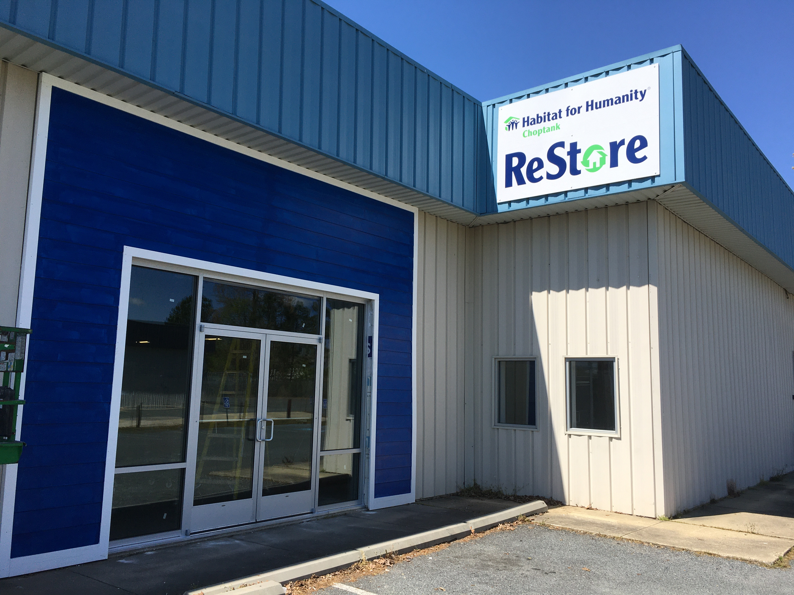

CAMBRIDGE EMPOWERMENT CENTER

It's cold outside! We offered Moms with children in our After-School Program the chance to get a free winter coat for their children. This photo shows a small selection of the number who got coats.  Thanks to all our Donors, WBOC and the Red Hat Ladies, and YOU who have made such a wonderful Christmas for our kids!  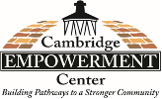 | 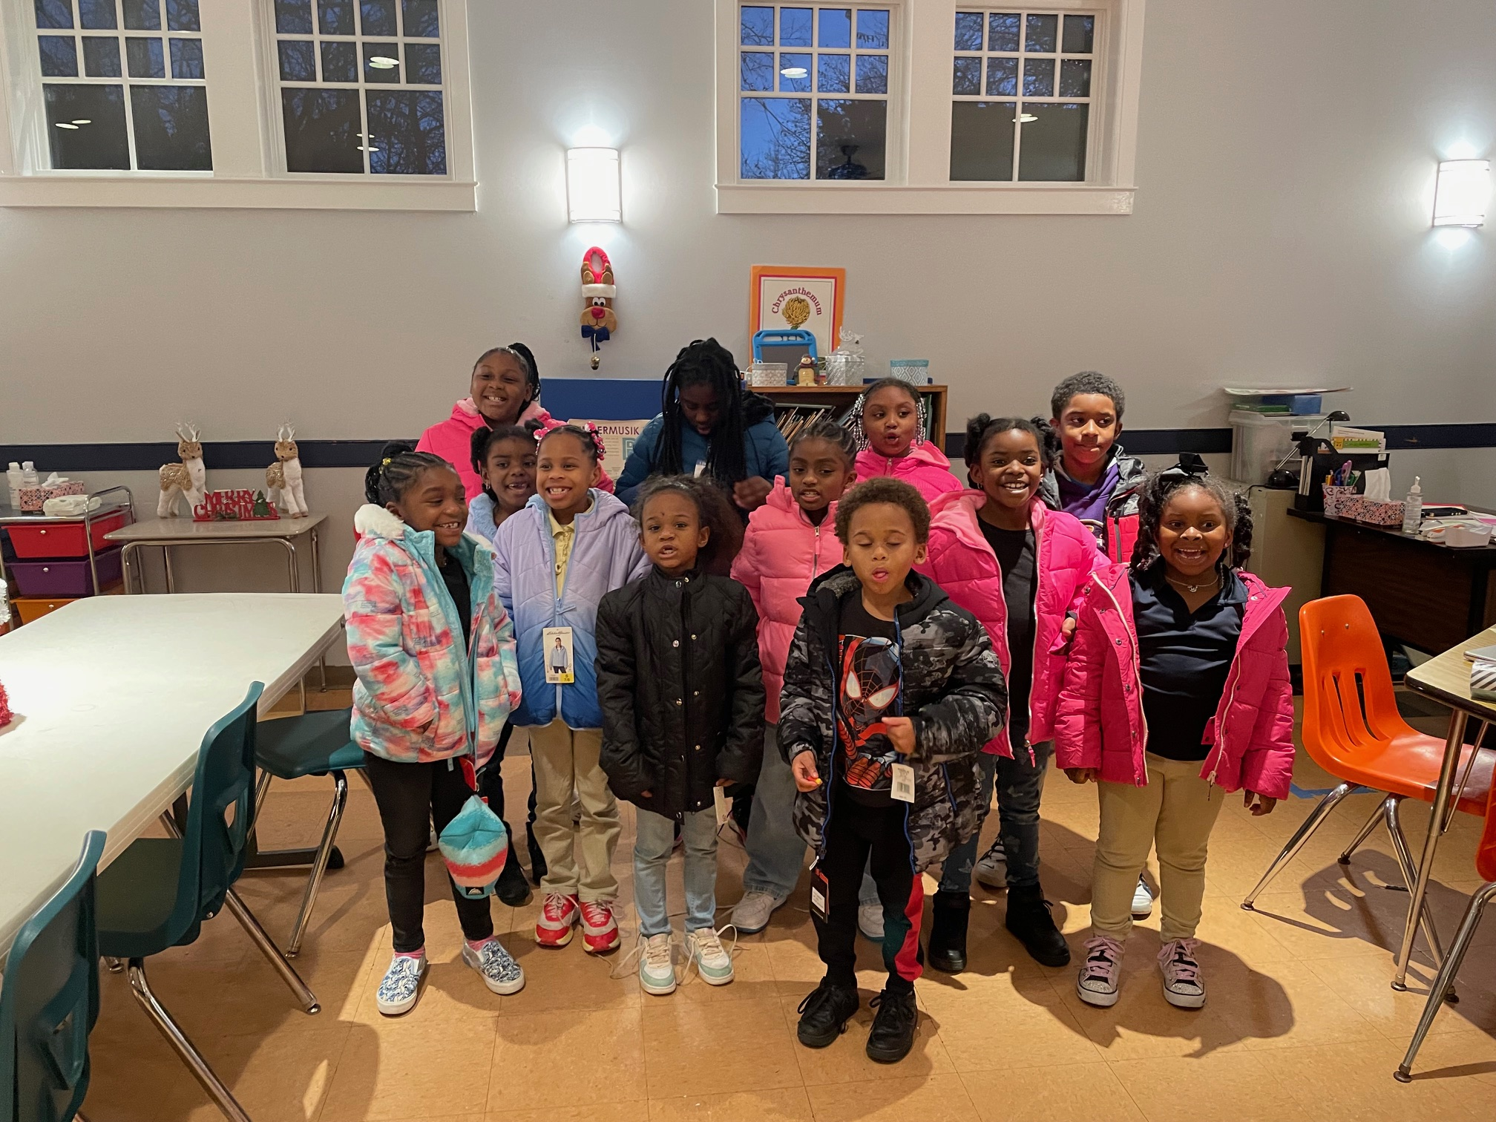

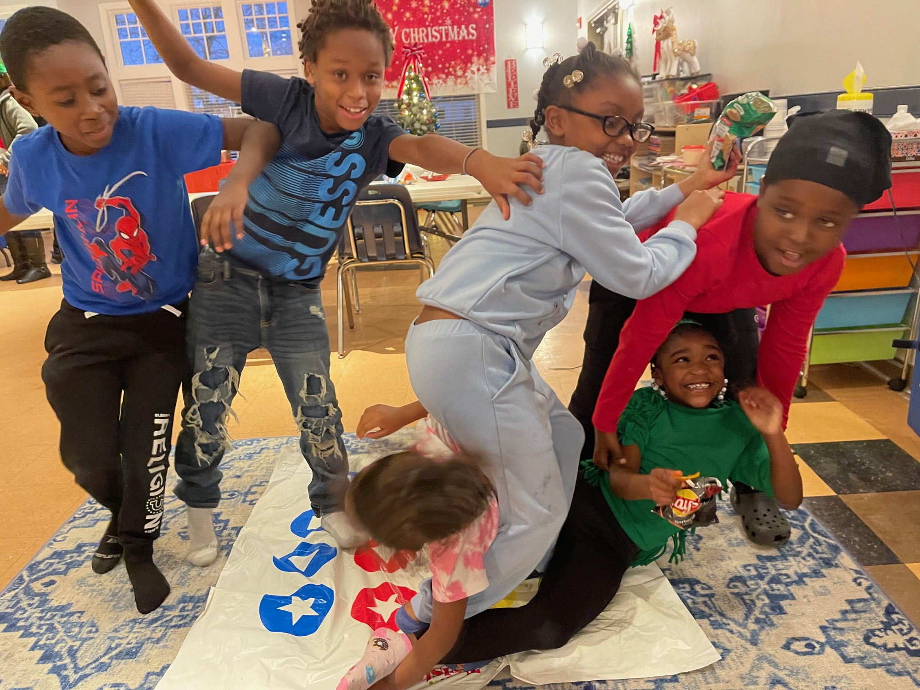 | The Empowerment Center is always looking for volunteers. If you have helped us this past year to maintain a safe place for our younger kids to learn and grow, we thank you so much.  We are currently gearing up for our summer program.  If you have a little left to donate, we would really appreciate it.  https://www.cambridgeempowermentcenter.org/

ONE MISSION CAMBRIDGE – Volunteers Needed

Are you looking for a great opportunity to positively impact your community? Would you like to meet your neighbors as well as other local volunteers? One Mission Cambridge has many opportunities to volunteer! You can shop with clients and be an encouragement to others at a vibrant mission center on Race Street in Cambridge. An average of 353 individuals use the mission center services every month, and we rely on volunteers to help us serve food and provide information! Would you like to tour the mission center and see how we impact the community? Would you like to join the mission center team? Please contact Susan, the One Mission Cambridge Manager, at manager@onemissioncambridge.org, 443-521-5226 for more information.

MIDSHORE MEALS TIL MONDAY

MidShore Meals 'til Monday is working to end childhood hunger on Maryland’s Eastern Shore by providing weekend food for food-insecure children in Dorchester County. Meals ‘til Monday sends home healthy, nutritious food for children at the end of each school week and during the summer months for breakfast, lunch and snacks to bridge the hunger gap for children without access to adequate food. Meals ‘til Monday currently provides food for more than 500 elementary, middle and high school students. Donations can be made at https://www.mscf.org/donate-online/. For more information, please call the Director at 703-371-5191 or visit their website at www.midshoremealstilmonday.org/.

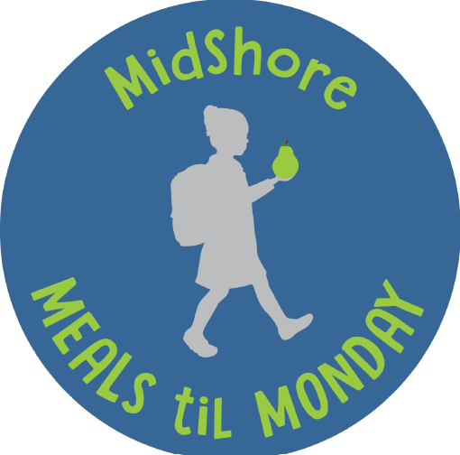

CAN MISSION, MEMBERSHIP, and COMMITTEES

The Cambridge Association of Neighborhoods (CAN) fosters neighborhood cohesion and community involvement to enhance the quality of community life for all residents of Cambridge through community events, social activities, and neighborly assistance; and protect and enhance properties in Cambridge by improving building and zoning codes, supporting adherence to those codes, and engaging constructively with City Government, including the Historic Preservation Commission.

CAN welcomes members from all Cambridge area neighborhoods (broadly defined) who are interested in organizing and working together, building a diverse membership reflecting the diversity of Cambridge residents. Membership is FREE – information is available on the CAN website at https://cambridgecan.org/join-can/

CAN HOUSING QUALITY COMMITTEE – PLANNING AND ZONING ISSUES
The Housing Quality Committee monitors issues affecting the quality of housing and the maintenance of property values in the City, including code enforcement. Committee members attend Planning Commission meetings to monitor zoning-related issues and report the information to the Board and Membership. Please contact Chuck McFadden at Ragtime31@gmail.com to volunteer.

NEIGHBORHOOD DEVELOPMENT COMMITTEE – SOCIAL EVENTS & ‘NEIGHBORS HELPING NEIGHBORS’

"Neighborhoods" are organized by small groups willing to work together to address neighborhood issues through small social events and "neighbor-helping-neighbor” activities. The Social Events Subcommittee organizes community-wide events. Contact Chuck McFadden at Ragtime31@gmail.com to volunteer.

CAN COMMUNICATIONS COMMITTEE – WRITERS NEEDED

CAN'S Communications Committee needs writers, including volunteers to take unofficial notes at public meetings. Please contact Tom Puglisi at tom.puglisi@comcast.net to volunteer.

POWER WASHER AVAILABLE

CAN has an electric power washer available to members. Contact Chuck McFadden at Ragtime31@gmail.com if you would like to borrow it.

