Newsletter #24.02 FEBRUARY 2024

CAN member meetings are announced in advance and open to the public.
Everyone interested in CAN is invited to attend.

IN THIS ISSUE: page

PRESIDENT’S MESSAGE – State Support for City Priorities 2

CAMBRIDGE CORNER 3
- Cambridge Real Estate Trends 3
- Dorchester County Health Department Update 4
- Cambridge Fun Facts and Lore – John Barth 5
- Cambridge Waterfront Development Inc – Message from the President 6
- Make Cambridge Resilient – Flood Mitigation Update 7

Community News – Cooperating Community OrganizationS 8
- Dorchester Citizens for Planned Growth – Valley Proteins 8
- Mainstreet Gallery – When Wylde Women Dream 8
- Habitat Choptank 10
- Cambridge Empowerment Center 10
- One Mission Cambridge 11
- Midshore Meals ‘til Monday 11

CAN Mission Statement, MEMBERSHUP, Board OF DIRECTORS, and Committees 12

CURRENT LINKS

CAN’s Website – https://cambridgecan.org
JOIN CAN FOR FREE – https://cambridgecan.org/join-can/
CAN Meeting Minutes – https://cambridgecan.org/category/meetings/
CAN Meeting Videos – https://www.facebook.com/WHCPRadio/videos or
https://www.youtube.com/@whcpstudio4716
CAN’s City Council Meeting Notes – https://cambridgecan.org/category/news/city-council-notes/
CAN’s Planning & Zoning Notes – https://cambridgecan.org/category/news/p-and-z/
CAN on FaceBook – https://www.facebook.com/CambridgeAssociationofNeighborhoods/
Contact CAN – CambridgeCAN@yahoo.com

PRESIDENT'S MESSAGE – State Support for City Priorities
-- Charles McFadden, President, CAN

The City Council and City Manager met with State Officials – Delegates Chris Adams, Tom Hutchinson, Sheree Sample-Hughes and Senator Johnny Mautz – on January 22, 2024. The purpose of the meeting was to energize our State representatives around priorities that are heavily dependent on State funding or legislative changes. The City Manager laid out the City’s priorities as follows:

Priority #1 is Housing and Pine St. Development. The State provides significant funding though the Home Ownership Works (HOW) program and other Department of Housing and Community Development (DHCD) grants, and it is important to the City that those funds continue. The State Representatives seemed to reflect the City’s view of the need and said they would push hard for continued funding. The City stressed its own effort with the $1 million land bank program, which buys degraded houses and either restores them or tears them down. It should be mentioned that the City is also working closely with Habitat for Humanity and the Empowerment Center to improve this area.

Priority #2 is restoration of the old City Hall at 307 Gay St. The building has been vacant since 2008 because of mold and lead paint contamination. It will take approximately $10 million to restore the building. The City is beginning the process this year but needs State grants to complete it. The Representatives said they will push the project.

Priority #3 is the major capital improvement project of $20 million over the next five years to fix the water and sewer systems. This should be a priority for the State, as well, because it protects the health of its citizens and of the Choptank River and the Chesapeake Bay. This water/sewer project is in the final design phase and should begin actual construction in late Spring.

Priority #4 is revision of the State Juvenile justice system. This part of the program was led by Mayor Rideout, who emphasized that revisions are needed to provide parents and the Police Department with more effective tools to deal with problematic youth, especially those under the age of 13. The Representatives understood the problem and said it was a State-wide issue.

Closing out the meeting, Delegate Tom Hutchinson asked why the Cambridge Harbor project was not a City priority. The minutes of the meeting did not provide the City’s response, but I am sure that it had something to do with the fact that the project is under the control of the private, independent corporation know as Cambridge Waterfront Development Inc. (CWDI) and not the City.

In summary, the City has placed a huge emphasis on Pine St. development, which it should. Improving this area will help the local residents and improve the overall image of the City. This area has a great history, and the City is correct in focusing on bringing back its greatness.

The CAN Board needs your ideas and input on how to be effective and help the City move forward.
Please contact me at Ragtime31@gmail.com with your ideas.
-- Chuck McFadden, President

CAMBRIDGE CORNER

CAMBRIDGE REAL ESTATE TRENDS
-- Fred & Martha Phillips-Patrick

National and Regional Residential Real Estate Developments

The 30-year conforming fixed rate mortgage hit a record rate high of 18.63% in 1981! According to Freddie Mac, last week, the 30-year fixed rate mortgage was 6.64%, and the 15-year fixed rate mortgage was 5.90%, not much changed from a month earlier.

Nationally, according to Forbes, “Existing-home sales cooled in December, down 1% from the month before and 6.2% from a year prior. 2023 ended with existing-home sales plummeting to 4.09 million, a 28-year low, according to the latest monthly National Association of Realtors (NAR) data.”

Nationally, the residential market was tight, with limited supply of homes and those that were put up for sale had higher prices. How did Cambridge fair in this tough market environment in January? Let’s see.

Cambridge Market Update

Rocket Homes reports that in January, Cambridge has remained a Buyers Housing Market, which means prices tend to be lower and homes stay on the market longer. It reports that “The median home sold price in Cambridge was $265,000 in January 2024, up 6% from last year.” However, 23 homes were sold in January, up from the 21 sold in in December, 2023. In January 2023, the average time to sell was 41 days; in January 2024, the average time to sell was 55 days, an increase of 33%.

Cambridge Sales

Currently, according to Movoto.com, there are now 125 homes for sale (92 single family homes and 33 condos and townhomes) in the Cambridge area, down a bit from December. There are also 17 multi-family units for sale, as well as 48 farms and plots of land. The properties’ asking prices range from $10,000 for a small plot of land (.06 acres) on Phillips Street to $2,500,000 for 134.9-acre lot on Town Point Road. According to Zillow, in January 2024, 23 homes were sold, ranging in value from $56,000 to $1,850,000.

409 Muir St $244K 303 Shepard Ave $167K 601 Edlon Park $273K
5516 Mallard Ln $315K 3754 Griffith Neck Rd $1,850K 204 Choptank Ave $130K
3 Oakley St #306 $385K 1631 Terrapin Cir $300K 200 Franklin St. $70K
519 Pine St $ 56K 610 Academy St $150K 301 Muir St #101 $479K
700 Moores Ave $ 65K 22 Oak St $ 70K 502 Byrn St $250K
805 Hight St $195K 102 Shawnee Cir $610K 602 Maryland Ave $220K
610 Water St $480K 4631 Egypt Rd $350K 710 Moores Ave $135K
900 Roslyn Ave $110K 110 Choptank Ave $555K

Dorchester County in the News

The recent spate of high tides that have, for example, repeatedly flooded Water Street has underscored the damaging effects of the rising saltwater table in and around Cambridge. According to the Dorchester Star, “The upcoming episode of Maryland Public Television’s Maryland Farm and Harvest will hit home for Dorchester County residents. A segment of this season’s 10th episode of the series, airing Tuesday, Feb. 13 at 7 p.m., will delve into the topic of saltwater intrusion with Cambridge-based grain farmer Wendell Meekins. Meekins, a grain and poultry farmer who was born and raised in Dorchester County, has been in the business for 27 years.

According to a news release from MPT, Meekins will give a survey of his fields in the episode to show how high soil salinity has affected his crops. In the segment, University of Maryland Agroecology Lab Director Kate Tulley discusses the issue and possible solutions, including flood lands, natural buffers and repurposing land. Last year, a tidal event killed about 65 acres of corn that Meekins had planted. In an interview, Meekins said the loss of income that farmers are facing due to this problem are “very great.”

Should be an interesting episode.

DORCHESTER COUNTY HEALTH DEPARTMENT – Community Partner Update
-- Hannah Mayhew

Respiratory Virus Vaccines: DCHD COVID-19 Vaccine Clinics continue at 10 Aurora Street: We plan to
continue to offer COVID-19 booster clinics at our satellite COVID Office located at 10 Aurora St in
Cambridge. Clinic dates and times will remain the same: Tuesday and Wednesday from 9 am -12 pm and 1
pm -3 pm. On Thursdays, we offer clinics from 9am-12 pm & 1 pm - 5:30 pm (early evening hours available).
Individuals will park in the front parking lot. Please call 410-228-0235 to pre-register. If folks are looking to get the new booster immediately, we encourage folks to go to the local pharmacies. We continue to keep seasonal influenza vaccines on hand. However, we do not have RSV vax for adults at the health department and have been encouraging folks to go to local pharmacies.

Homebound Vax Services: Continue to be provided. We want to emphasize that an individual does not have to be fully "homebound" to qualify. If it's easier for us to come to them due to mobility issues, we certainly will. Call 410-228-0235, if interested.

Respiratory Virus Testing: Drive-up curbside testing remains available by appointment Monday-Friday at
10 Aurora Street in Cambridge. Curbside Rapid COVID-19 PCR Tests are available for symptomatic
individuals by appointment. We currently use PCR testing cartridges that test for RSV, COVID, Flu A & B. Individuals should bring insurance cards, if applicable. If an individual doesn't have insurance, there is no
out-of-pocket fee. Please call to make an appointment and pre-register at 410-228-0235. Appointments are
scheduled daily so individuals may call at 8 am to get a same-day appointment. Appointments will be
scheduled based on staff availability.

FREE COVID Tests & KN95 masks continue to be available to the public anytime M-F from 8 am-4:30 pm. Drive up and call 410-228-0235 and we'll bring them to your car. Please let us know if your community organization or office needs at-home rapid tests or KN95 masks! We will coordinate timely delivery or pick-up. Unsure about the expiration date? Call us at 410-228-0235. If folks would rather tests be delivered directly to their house, the federal government reinstated their at-home test program. Folks can
request tests here: https://www.covid.gov/tests.

As always, we will continue to work diligently to serve our community. Please help us spread the word about
these upcoming events by sharing info with your clientele, friends, and family. If you have any other questions or concerns, please don't hesitate to let me know. We'll try to connect you to whoever can help at the health department! Take care & stay well.

CAMBRIDGE FUN FACTS AND LORE – John Barth
-- Martha Phillips-Patrick

John "Jack" Barth (b. 1930), today considered one of America's pre-eminent writers of Postmodernism, was born and raised in Cambridge at 107 Aurora Street. (His father was owner of Whitey's Candyland on Race Street.) Barth graduated from Cambridge High School in 1947. He considered a career in music and for a short time studied at Julliard, but ended up at Johns Hopkins studying journalism and writing, receiving both a B.A. and M.A. in creative writing in 1952.

He then went on to teach at Penn State. While there he started on a "cycle" of 100 stories he called Dorchester Tales, however, he abandoned that larger project to write his first two novels: The Floating Opera and The End of the Road, published in 1956 and 19558 and in large part written in an apartment on High Street. Barth sets these two early novels in twentieth century Maryland and almost all his works are set in the landscapes of Maryland. As Barth has said: "It was my happy fate to be born and raised in the town where 'the real Eastern Shore begins.' For decades, Cambridge and its tidal waters have nourished my writing."

Barth returned to Johns Hopkins as teacher of English and creative writing in 1973, retiring in 1990 as Professor Emeritus. Throughout his life, he has maintained his attachment to the Eastern Shore (and to sailing), spending time at his summer home near Chestertown where he lived after retirement until recently when his health forced a relocation to Florida.

To be continued. More about Barth's first novel The Floating Opera and The James Adams Floating Theatre and Edna Ferber's Show Boat.

CAMBRIDGE WATERFRONT DEVELOPMENT, INC – Message from the President
-- Angie Hengst

As Cambridge Waterfront Development, Inc. (CWDI) advances its mission to develop Cambridge Harbor, we plan to keep the public informed on our progress and what you can look forward to in the coming months/year. To assist with that, each month I’ll be putting out a letter to the community relaying what the board has been working on. As with any large-scale development project, it may seem that things are moving slowly but rest assured, much is happening! I will share what details I can along the way.

First, I would like to introduce our new slate of Officers, elected at our January 2024 Annual Organizing Meeting:
Angie Hengst – President; Shay Lewis-Sisco - Vice President; Frank Narr - Secretary/Treasurer. The remaining seats on our board are filled by Dion Banks, Rich Zeidman, and Mike Frenz. Matt Leonard serves as our Executive Director. We do have one vacant seat waiting to be filled by a County Council appointment.

Board members also serve on our various committees, implemented to advance and drive different aspects of the project. They include:

Planning - currently working with our design partners on plans for the public infrastructure and parks, including most recently the public promenade and East Gateway along Rt 50.

Finance - tasked with maintaining the budget, tracking and reporting, risk management and insurances.

Communication and Outreach - focus on messaging to the community, social media and the website.

Government Relations - we have recently brought on Owen McEvoy, former Deputy Secretary of Maryland’s Department of Housing and Community Development, to help us better partner with our city, county and state partners.

Hotel Development - currently negotiating a $30,000,000 deal with a boutique hotel developer. This committee ensures that the hotel developer’s concept and design align with the overall plans for Cambridge Harbor, and CWDI’s community-first approach to its development.

We hope to finalize our hotel deal and announce it to the public in the coming months. We plan to break ground on a portion of the new Waterfront Promenade this year.

The 3.5-acre Waterfront Park, east of the boat ramp and bordered by the current boardwalk and the new road, Watermen Way, is available for public use. We welcome organizations that would like to have an event here to please reach out to us.

In addition, this past year we purchased the Richardson Maritime Museum (RMM) property and are working with them to help expand and advance their mission of preserving Cambridge’s maritime heritage and history. We have also been working with Yacht Maintenance to facilitate their $25,000,000 expansion including the construction of a one-of-a kind travel lift that will significantly increase their capabilities.

Our Board Meeting calendar has been set for 2024 and all of our meetings have an Open Session that the public is welcome to attend. All meetings occur on Wednesday afternoons beginning at 4:00PM in the Chamber of Commerce Conference Room (306 High Street) as follows: March 20th, May 22nd, July 31st, September 25th, and November 20th

I’m looking forward to an exciting year for CWDI. If you have any questions or concerns as we move through the various phases of development, please do not hesitate to reach out to myself, Angie Hengst (Angie.hengst@cwdimd.org), Matt (matt.leonard@cwdimd.org), or any of the board members. We will be happy to chat with you.

Cheers

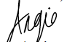
MAKE CAMBRIDGE RESILIENT INITIATIVE – Flood Mitigation Update
-- Larry White, P.E. - Project Manager

We are ready to start Phase I Design of our Flood Mitigation Project once we receive official notification of funding from the Federal Emergency Management Agency (FEMA). On January 17, Mayor Rideout and City Manager Tom Carroll received Congressional Notification from Senator Van Hollen’s office that the City was being award our grant for Phase I Design for $1.7M plus $85,000 for Grant Management. We are now waiting for the official FEMA letter of award through the Maryland Department of Emergency Management so we can begin work. The period of performance will extend to August 5, 2025. FEMA is reserving $16M in funding for Phase II Construction once they approve our final design, Benefit -Cost Analysis (BCA), and Environmental Compliance Report. Design and Construction will be a 3–4-year project.

We are ready to go. We have developed our design workplan and have contract support agreements ready to sign with Bayland Consultants and Designers, our engineering support contractor and the University of Maryland Center for Environmental Science (UNCES) Horn Point Laboratory, who will be doing advanced modeling and analysis to optimize the design of our living shoreline and assess the effectiveness of our flood mitigation project against projected sea level rise and major storms in the latter half of the 21st century. We are also lining up resources. For example, we are expecting the award of two grants under the Maryland Department of Natural Resources (MDNR) Waterway Improvements Grant program for dredging Jenkins Creek and Lodgecliff Canal for material we can use in the construction of our living shoreline. These projects were named in the Governor’s recent budget so we are optimistic we will be awarded these grants. Also, Mayor Rideout just sent a letter that we created to the US Army Corps of Engineers Navigation Branch requesting the dredging of Cambridge Harbor and Channel to support economic development with a plan for the City to use the dredged material to complete the construction of our living shoreline.

We are continuing to make considerable progress in making things happen on our Community Development Grant. You may recall we submitted a grant application under the MDNR Parks and Recreation Program for the purchase of the acre parcel behind the Mill Street School for the development of Mill Street Nature Way Park. The funding for this purchase was also shown in the Governor’ s budget, which is good news. We have subsequently developed a concept plan for the development of the site along with a plan for including the swale area below School Street between Mill Street and Choptank Ave in the green infrastructure plan. We held a public meeting on this project at the Yacht Club. Based on the input the team received from residents, we plan to hold a design Charrette with residents after grant award so they can participate in the detailed design of the project. We submitted a grant application for funding the detailed design and construction of this project under the MDNR Chesapeake and Coastal Grants Program in December 2023.

Finally, we have submitted a grant application to the National Oceanic and Atmosphere Administration in collaboration with the UMCES for the design and construction of habitat restoration features in our living shoreline and rock sill/breakwater. The award of this grant would allow the project team the opportunity to enhance the ecological co-benefits of our project including the oyster reef at the toe of our living shoreline,

We plan to restart our public outreach sessions about mid-March 2024. This initial session will be focused on both our flood mitigation project and our community development grant activities particularly in the development of a green infrastructure plan for the City and helping residents and businesses reduce their individual property flood risk.

COMMUNITY NEWS – COOPERATING COMMUNITY ORGANIZATIONS

DORCHESTER CITIZENS FOR PLANNED GROWTH (DCPG) - Continuing Legal Challenge to Valley Proteins
-- Fred Pomeroy, DCPG President

The plaintiffs in an ongoing legal challenge to the MDE (Maryland Dept. of Environment) wastewater discharge permit for the Valley Proteins (now Darling International) chicken rendering plant at Linkwood are reporting that of this writing there has been no ruling on our efforts to have that discharge permit remanded back to the agency for strengthening.

On Nov. 2, 2023, five Eastern Shore environmental non-profits appeared in Dorchester County Circuit Court to ask for a legal ruling that would direct MDE to re-write the operating permit for an industrial facility with a long history of polluting the Transquaking River, which lies within the boundaries of Dorchester county. Although disappointed with the lack of a quick decision on the merits of our case, we are not prepared to write the Transquaking off for lost and pledge to continue our efforts to bring about a positive change in this severely impaired watershed.

In the meantime, the non-profits, which include Dorchester Citizens for Planned Growth, Shore Rivers, Chesapeake Bay Foundation, Wicomico Environmental Trust, and Friends of the Nanticoke, are working to craft a bill to be introduced to the Maryland General Assembly which addresses the related problem of industrial sludge created by the rendering process being applied without proper oversight to Maryland farmland, much of it in Dorchester county.

We will notify CAN readers regarding the outcome of our legal challenge to the wastewater permit and the legislative efforts toward oversight of the amount and contents of sludge being applied to Dorchester farmland in future press releases.

*Additional background on this issue can be accessed in the October 2023 issue of this newsletter.

MAIN STREET GALLERY – When Wylde Women Dream is at Main Street Gallery in March/April;

For Cambridge artist, Tammy Vitale, things that seem worn, torn or broken to most people are her treasures. She takes these cast offs and dreams up a new life for them by refashioning them into something different and altogether new! Colorful collages and engaging mixed media art pieces come to life under her skilled and creative hands.

For March and April Tammy will be showing her collages and mixed media work along with pieces of her beadwork jewelry at the Main Street Gallery where she will be a guest artist. Her pieces will be shown alongside the work of the Gallery’s nine member artists. When asked about the creative spelling of “wylde” in the title of her show, Tammy explained it’s something of a trademark for her. While living and working in Southern Md. she was a part of a coop gallery where the women artists called themselves “wylde women” to express their open and experimental approach to their art. Wild became “wylde” to differentiate the word from meanings that might come up in a google search.

Tammy’s art journey began when she was a child in Arlington, Virginia, and discovered she loved drawing horses. For a period of her early career, paint was her preferred medium; however, in the 1990s she discovered clay sculpture and was hooked. She loved making sculptures adorned with her found objects and eventually started making large outdoor pieces both for herself and for commissions. If you’ve been to the Visitor’s Center on the boardwalk in North Beach in Calvert County, Maryland, you’ve seen her 7.5’ by 11’ architectural tile installation called “Chesapeake”.

Lately Tammy finds herself creating in a smaller studio space and has focused her attention on her collages and mixed media pieces as well as making art books and Gelli prints. She also loves creating and sharing tiny totems from her treasure trove of beads and clay shards. Lucky visitors to Main Street Gallery’s Little Free Gallery often find one or more of these small gems on its shelves.

Since moving to town in March of 2023, Tammy has become well known in the community as a passionate promoter and defender of the visual arts in Cambridge. “I want to get the word out that the arts are truly alive here in Cambridge,” she says. “I want Cambridge to be the center of the art world on the Eastern Shore!” To that end the artist, who is working on an MFA in nonfiction writing, has been spreading the word by writing articles featuring Cambridge artists and art events for the Cambridge Spy. She also interviews Cambridge artists on her weekly radio spot called “The Arts Are Alive in Cambridge”. The spot airs on WHCP every Wednesday during the Midshore Midday program. In addition, Tammy maintains a FB page with the same name.

When Wylde Women Dream will open on February 29 and run through April 28. Gallery hours are Thursdays through Sundays from 11 am-4 pm through March and 11 am-5 pm starting in April. Two Second Saturday artist receptions are planned for March 9 and April13 from 5-8 pm. Tammy will be giving a brief artist talk at 6 pm at the April reception. Both receptions are free, and all are welcome. Light refreshments will be served. The gallery asks that children under 18 be accompanied by an adult.

Tammy will also be giving a fun, family friendly workshop on making tiny totems on Saturday, March 2 from noon to 3 pm at the Gallery. All are invited to attend.

Main Street Gallery is located at 518 Poplar St. in Cambridge, and is part of the vibrant Arts and Entertainment District. The gallery is currently reviewing work from prospective members and guest artists. Please contact MSG through its website @mainstgallery.net or by phoning 410-330-4659 if interested.

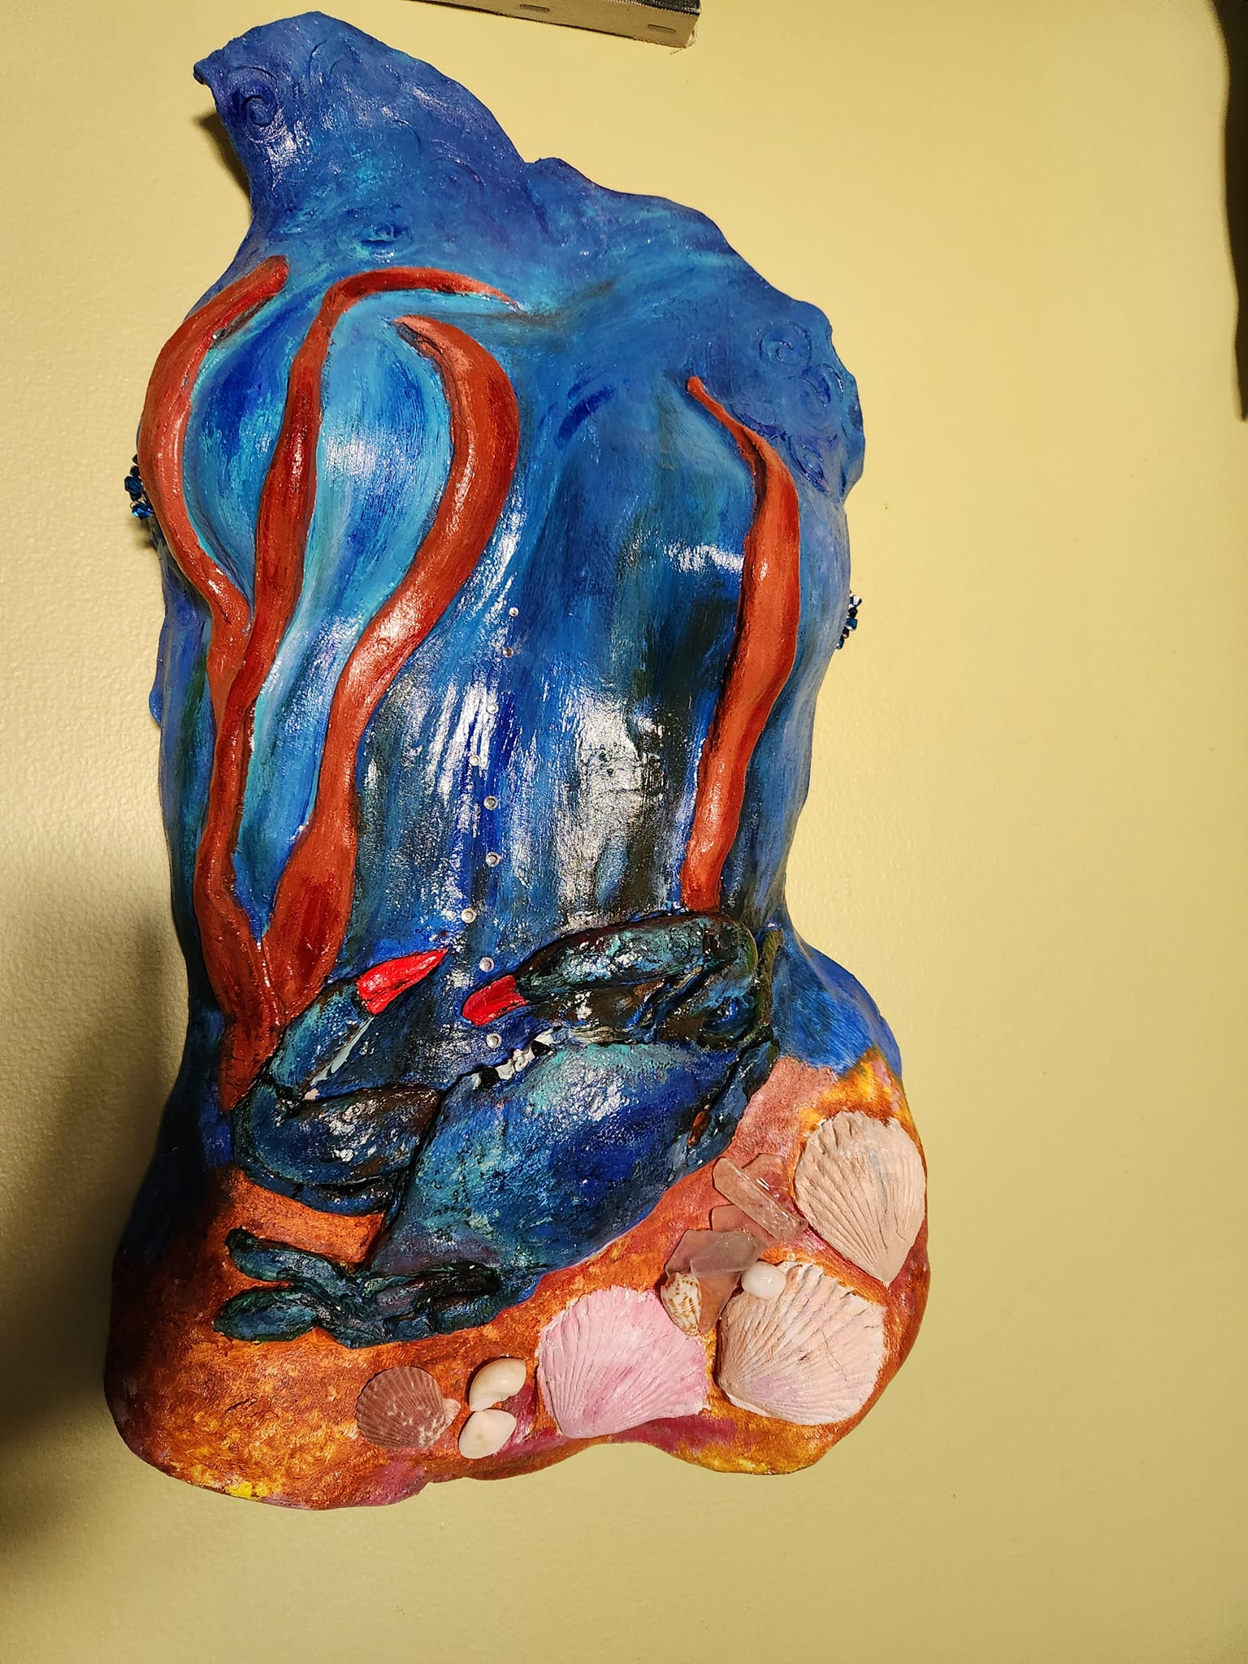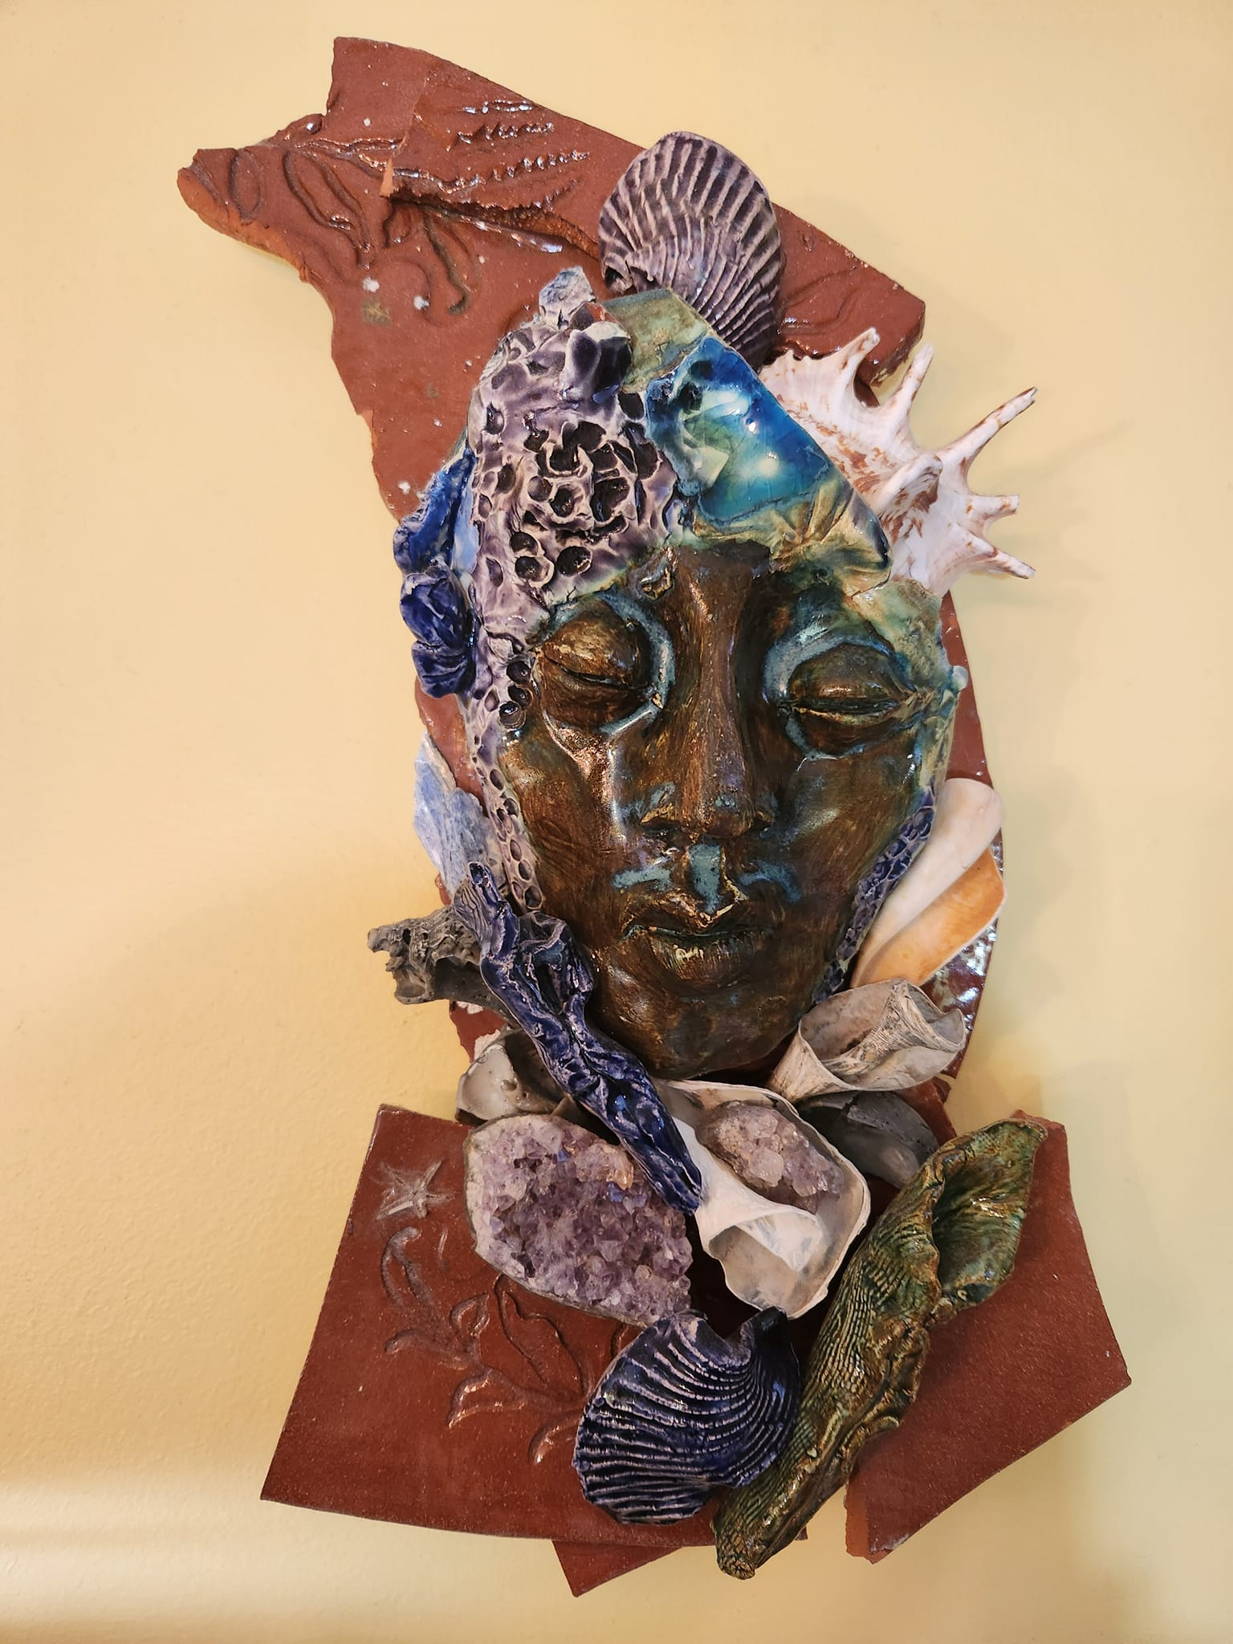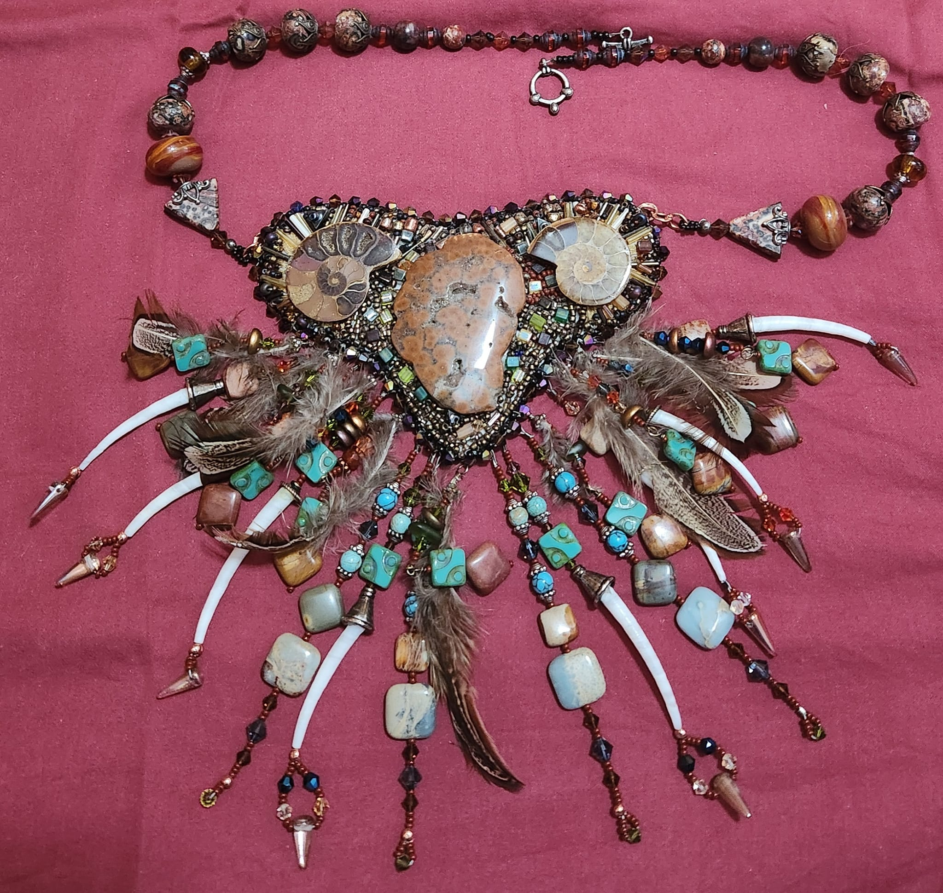

CAMBRIDGE EMPOWERMENT CENTER – We need your help!!

We are starting to plan our summer activities and need to raise enough money to be able to offer 45 children, ranging in ages from 5 to 13, from the Cambridge area a safe and productive summer. All the children’s programs at the CEC are licensed by the State of Maryland, which requires us to pay a higher salary for qualified staff. Our expenses also include operating costs of the building (electric, gas, WIFI, phone and more). Unfortunately, there are no COVID or ARPA funds to help offset the costs. We depend on generous donors, and grant funding to offer a full program of education, STEM, art and other fun activities for our children.

The program is comprised of 4-hour to 7-hour days each week, begins soon after the end of school on June 24th and lasts for 9 weeks. The children will receive 2 meals and a snack daily. In addition to academics, the days will include arts and crafts, physical education, music, games, educational trips, science experiments, building and making things, sensory play, cooking and more. A recent article in the New York Times presented a study which showed that in numerous areas of the country, including Dorchester County, children have not recovered from COVID academic losses. Many of our children are 2 years behind or more in math and reading. Our goals and passion are to assist these children recover some of their losses. Children will participate in learning activities, including an online learning program, for 2 or more hours each day. Last summer 70% of our students made a 2-month or more gain in reading level, and a 50% gain in math.

We are also looking for volunteers to help tutor, mentor, or work one-on-one with our students. To make a difference in a child’s life, please email us at info@cambempowermentcenter.org. Please help us move this program forward! You can make a difference in the lives of our children and create a lasting impact in our community! To donate online, go to our website – cambridgeempowermentcenter.org or send a check to: Cambridge Empowerment Center, PO Box 494, Cambridge, Md. 21613

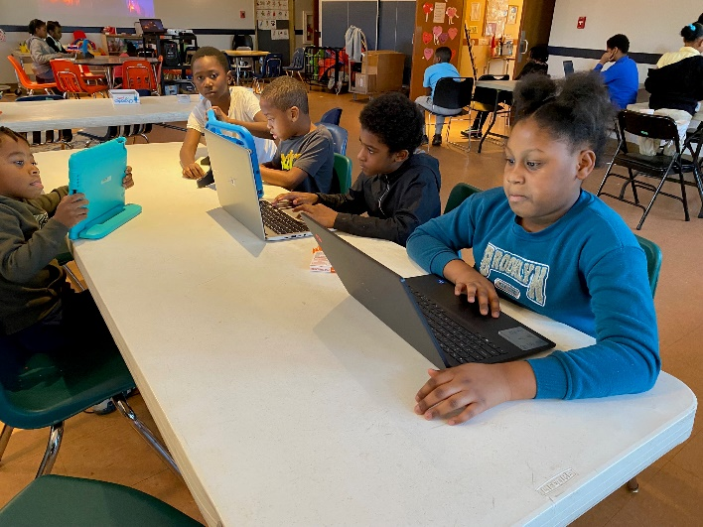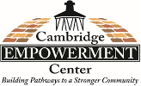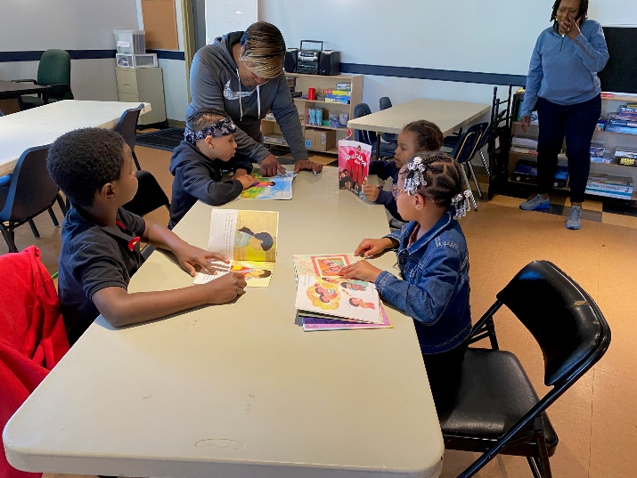

HABITAT CHOPTANK – Donate Your Car to Habitat

Did you know by donating your vehicle to Habitat you can help build and repair affordable homes while also helping the environment? Since launching the national vehicle donation program, Cars for Homes, in 2005, Habitat has accepted over 120,000 vehicles for reselling or recycling, raising funds for Habitat to partner with local families to build stability and security that a safe affordable home allows. In addition to cars and trucks, Cars for Homes welcomes RVs, motorcycles, boats, and farm and construction equipment. Your vehicle donation does not have to be running, but it must be whole and have four inflated tires so it can be moved by Habitat’s towing operators.
Since Habitat is a 501(c)(3) nonprofit organization, vehicle donations may be claimed as deductions on your federal tax return, if you itemize. Once your vehicle is sold, the selling price determines the amount of your donation. If your vehicle sells for more than $500, you may deduct the full selling price. If your vehicle sells for $500 or less, you can deduct the “fair market value” of your vehicle, up to $500. Habitat makes it fast and easy to donate a vehicle! Call 877-277-4344

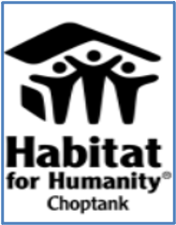

ONE MISSION CAMBRIDGE – Volunteers Needed

Are you looking for a great opportunity to positively impact your community? Would you like to meet your neighbors as well as other local volunteers? One Mission Cambridge has many opportunities to volunteer! You can shop with clients and be an encouragement to others at a vibrant mission center on Race Street in Cambridge. An average of 353 individuals use the mission center services every month, and we rely on volunteers to help us serve food and provide information! Would you like to tour the mission center and see how we impact the community? Would you like to join the mission center team? Please contact Susan, the One Mission Cambridge Manager, at manager@onemissioncambridge.org, 443-521-5226.

MIDSHORE MEALS TIL MONDAY

MidShore Meals 'til Monday is working to end childhood hunger on Maryland’s Eastern Shore by providing weekend food for food-insecure children in Dorchester County. Meals ‘til Monday sends home healthy, nutritious food for children at the end of each school week and during the summer months for breakfast, lunch and snacks to bridge the hunger gap for children without access to adequate food. Meals ‘til Monday currently provides food for more than 500 elementary, middle and high school students. Donations can be made at https://www.mscf.org/donate-online/. For more information, please call the Director at 703-371-5191 or visit their website at www.midshoremealstilmonday.org/.

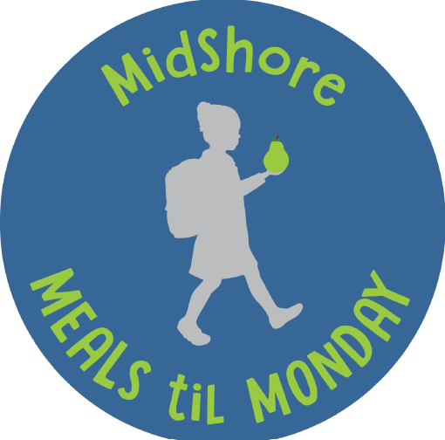

CAN MISSION, MEMBERSHIP, BOARD of DIRECTORS, and COMMITTEES

MISSION. The Cambridge Association of Neighborhoods (CAN) fosters neighborhood cohesion and community involvement to enhance the quality of community life for all residents of Cambridge through community events, social activities, and neighborly assistance. CAN protects and enhances properties in Cambridge by improving building and zoning codes, supporting adherence to those codes, and engaging constructively with City Government, including the Historic Preservation Commission. CAN’s Bylaws can be found on the CAN website at https://cambridgecan.org/welcome/about/bylaws/.

MEMBERSHIP. CAN welcomes members from all Cambridge area neighborhoods (broadly defined) who are interested in organizing and working together, building a diverse membership reflecting the diversity of Cambridge residents. Membership is FREE – information is available on the CAN website at https://cambridgecan.org/join-can/

CAN BOARD OF DIRECTORS. CAN is governed by a Board of Directors elected by CAN members at its annual January Business Meeting. Board Members whose terms expire in January 2026 are President – Chuck McFadden; Treasurer – Dave Thatcher; Members at Large – Mary Ellen Jesien, Kim Miller, Brad Rice, Donna Tower, and Judd Vickers. Board Members whose terms expire in January 2026 are Vice-President – Roman Jesien; Secretary – Tom Puglisi; Members at Large – Andre Duerinckx, Rick Klepfer, and Sharon Smith.

CAN HOUSING QUALITY COMMITTEE – PLANNING AND ZONING ISSUES. The Housing Quality Committee monitors issues affecting the quality of housing and the maintenance of property values in the City, including code enforcement. Committee members attend Planning Commission meetings to monitor zoning-related issues and report the information to the Board and Membership. Please contact Chuck McFadden at Ragtime31@gmail.com to volunteer.

NEIGHBORHOOD DEVELOPMENT COMMITTEE – SOCIAL EVENTS & ‘NEIGHBORS HELPING NEIGHBORS’.
"Neighborhoods" are organized by small groups willing to work together to address neighborhood issues through small social events and "neighbor-helping-neighbor” activities. The Social Events Subcommittee organizes community-wide events. Contact Chuck McFadden at Ragtime31@gmail.com to volunteer.

CAN COMMUNICATIONS COMMITTEE – WRITERS NEEDED. CAN'S Communications Committee needs writers, including volunteers to take unofficial notes at public meetings. Please contact Tom Puglisi at tom.puglisi@comcast.net to volunteer.

POWER WASHER AVAILABLE

CAN has an electric power washer available to members. Contact Chuck McFadden at Ragtime31@gmail.com.

