Newsletter #24.03 MARCH 2024

CAN member meetings are announced in advance and open to the public.
Everyone interested in CAN is invited to attend.

IN THIS ISSUE: page

PRESIDENT’S MESSAGE – What’s Wrong with CWDI? 2

CAMBRIDGE CORNER 3
- Cambridge Real Estate Trends 3
- Land Bank Authority for Cambridge 4
- Cambridge Police Department Update 5
- Cambridge Fun Facts and Lore - John Barth, Edna Ferber, and the Adams Floating Theatre 6

Community News – Cooperating Community OrganizationS 7
- Cambridge Empowerment Center 7
- A Note From the Dorchester County Public Library 8
- Friends of the Dorchester Country Public Library 8
- One Mission Cambridge – 2023 Review and 2024 Plans 9
- WHCP Car Donation Program 11
- Main Street Gallery – When Wylde Women Dream 11
- Midshore Meals ‘til Monday 12
- Habitat Choptank 12

CAN Mission Statement, MEMBERSHUP, Board OF DIRECTORS, and Committees 13

CURRENT LINKS

CAN’s Website – https://cambridgecan.org
JOIN CAN FOR FREE – https://cambridgecan.org/join-can/
CAN Meeting Minutes – https://cambridgecan.org/category/meetings/
CAN Meeting Videos – https://www.facebook.com/WHCPRadio/videos or
https://www.youtube.com/@whcpstudio4716
CAN’s City Council Meeting Notes – https://cambridgecan.org/category/news/city-council-notes/
CAN’s Planning & Zoning Notes – https://cambridgecan.org/category/news/p-and-z/
CAN on FaceBook – https://www.facebook.com/CambridgeAssociationofNeighborhoods/
Contact CAN – CambridgeCAN@yahoo.com

PRESIDENT'S MESSAGE – “What’s wrong with CWDI?”
-- Charles McFadden, President, CAN

Cambridge’s City Manager, Tom Carroll, resigned Monday over what he says is a lack of progress in changing the direction advanced by the Cambridge Waterfront Development Inc. (CWDI) for Cambridge Harbor. Mr. Carroll is the second City Manager to leave under this City Council in less than 3 years. So, what is CWDI and what are the problems?

CWDI is an independent non-profit agency set up in 2018 and funded by the City, the County and the State. The members of the board of CWDI were appointed (not elected) by the three entities. The purpose of CWDI is to oversee the development of the approximately 35 acres of land where the old hospital was on the Choptank River. By creating a single entity such as CWDI, the City, County and State allow developers to deal with just one agency instead of having to deal with the three different governmental entities. This idea has been used all over the US to develop areas but usually agencies such as CWDI hire experienced, professional development companies. CWDI is trying to develop the property on its own.

Our CWDI wants to set itself up as a permanent organization to handle all real estate, tax issues and maintenance in its area of control – very much like becoming a city within a city. CWDI is setting up funding streams using increased real estate taxes to pay for employees’ salaries and maintenance operations. This area of the City could have different codes and rules made by an appointed group and not by elected City officials. CWDI would have a separate maintenance organization, separate equipment to maintain its properties and a separate marina which it will operate.

Our CWDI wants the City, County and State to put up over $50 million for infrastructure – sewers, electrical, streets, parks, parking lots, sidewalks, and public art, etc. before any companies have committed to the project. The City would have to take out a huge loan of $33 million to net $22 million and would have to wait at least 30 years, if not more, to get paid back though increased taxes. It is estimated that the City and County would, with interest, pay $60 million over the life of the loan (or $2 million a year between the governments).

Keep in mind that even after the taxpayers have put up $60 million over 30 years for the Cambridge Harbor project, CWDI would, under their current proposal, still have a funding gap of millions. They would need to seek funding from other public subsidies or come back to the City for more funding to close this gap.

Our CWDI has an additional problem in that there is not enough “economic value” (taxable land) to make the project work financially for the City. CWDI has set aside almost the entire waterfront from the bridge around to the Richardson Museum for nonprofit use. In addition, they are planning to put the “Y” in the premier spot on the site. (CWDI states that there is no deal with the Y but if you follow the money, CWDI has spent $5,000 on plans for developing the old “Y” site and the “Y” has spent $47,000 of the City’s ARPA funds on plans for the CWDI site).

Our CWDI is very guarded with its information. It refuses to give the City pertinent information and is not cooperating with the City. Therefore, we now have two amphitheaters being planned, one at the Packing House and one at Cambridge Harbor. The City will also have two marinas – the old City Marina which is not full and needs a lot of work, and now a new proposed and taxpayer subsidized marina at Cambridge Harbor. It seems like there could be better coordination for multi-million-dollar projects like marinas and million-dollar projects like amphitheaters in a small City like Cambridge.

Our CWDI does not provide the public with minutes of its meetings, detailed budgets or the details of its plans. CWDI has been in existence for over 5 years and has yet to announce one private company committing to the site. Therefore, the City is being asked to develop the site with no tenants in sight. It could be a very lonely, expensive place.

There seem to be major problems with the CWDI, and the public does not know enough to make a fair assessment because the information needed is being held tightly. I can only assume that if the City Manager finds it so troubling that he feels he needs to resign, then the City Council should take action and lay out the issues to the citizens.

What can you do? Contact your City and County Council representatives and tell them to withhold any funds until all the issues are worked out in open sessions. Enough of this closed-door decision making – let the light shine in and let the citizens know what is going on.

-- Chuck McFadden, President

CAMBRIDGE CORNER

CAMBRIDGE REAL ESTATE TRENDS
-- Fred & Martha Phillips-Patrick

National and Regional Residential Real Estate Developments

According to Freddie Mac, “The 30-year fixed-rate mortgage decreased again this week, with declines totaling almost a quarter of a percent in two weeks’ time. Despite the recent dip, mortgage rates remain high as the market contends with the pressure of sticky inflation. In this environment, there is a good possibility that rates will stay higher for a longer period of time.”

Realtor.com reports that “according to February housing data, the spring housing market could shape up to provide home shoppers with a more plentiful supply of less expensive homes than last year, as the number of newly listed homes has significantly increased, median listing price growth has slowed, and the share of home listing price reductions has increased to the highest February levels since 2019. However, overall inventory still remains less affordable and more scarce than previous pre-pandemic years.”

Concerning the cost of buying and selling real estate, CNN reports: “In a sweeping move expected to dramatically reduce the cost of buying and selling a home, the National Association of Realtors announced Friday a settlement with groups of home sellers, agreeing to end landmark antitrust lawsuits by paying $418 million in damages and eliminating rules on commissions.” The standard 6% real estate commission rate is no longer!

How did Cambridge fare in this market environment in February, 2024? Let’s see.
Cambridge Market Update:

Rocket Homes reports that in February, Cambridge has remained a Buyers Housing Market, which means prices tend to be lower and homes stay on the market longer. The median home sold price in Cambridge was $262,000 in February, 2024, up 4.7% from last year, but down slightly from January. In February, 2023, the average time to sell was 90 days; in February, 2024, the average time to sell was 61 days, a decrease of 32%, a significant improvement.

Sales

Currently, according to Movoto.com, there are now 127 homes for sale (88 single family homes and 39 condos and townhomes) in the Cambridge area, up a bit from December. There are also 21 multifamily units for sale, as well as 49 farms and plots of land. The properties’ asking prices range from $15,000 for a small plot of land (.06 acres) on Phillips Street to $2,395,000 for house on Ross Neck Road.

According to Zillow, in February, 2024, 27 homes were sold, ranging in value from $27,000 to $550,000.

702 Rugby Ave $125K 300 Oakley St $285K 903 Peachblossom $220K
511 Goldsborough $101K 1642 Terrapin Cir $356K 1648 Terrapin Cir $355K
303 Yellow Bill Ln $220K 307 Yellow Bill Ln $225K 24 Saddle Bill Cir $36K
Snowy Egret Way $293K 3204 Ocean Gtwy $550K 606 Water St. #5 $150K
412 Boundary Ave $120K Albemarle Ct $439K 111 Willis St $295K
721 Washington St $41K 119 Belvedere Ave $307K 406 Light St $58K
Saddle Bill Cir $250K -- Yellow Bill Ln $230K 7 Oriole Dr $270K
720 Douglas St $27K 1644 Terrapin Cir $317K 608 Goldsborough $111K
404 Aurora St #404 $173K 130 Teal Ln 315K 301 Somerset Ave $260K

Dorchester County in the News

According to the Dorchester Star (March 6, 2024): “The Cambridge City Council is expected to address housing issues next month through taking on legislation that would establish a land bank authority. At a City Council meeting Feb. 26, council members heard from city staff and City Attorney Patrick Thomas on a draft ordinance and articles of incorporation documents that would establish the Land Bank Authority of Cambridge.

The land bank authority is intended to advance the city’s housing goals by giving it the ability to take an interventionist approach to the Cambridge housing market. If established, the land bank authority would have the power to take on, manage, and sell vacant land in order to stabilize neighborhoods and encourage redevelopment.” A potentially good way to increase the attractiveness of living in Cambridge…

Land Bank Authority of Cambridge (LBAC)
-- Judd Vickers

The Cambridge City Council is in the process of creating a land bank authority to address problem properties in Cambridge. A land bank is a public or community-owned corporation created to acquire, manage, maintain, and repurpose vacant, abandoned, and foreclosed properties. Twenty-five states have over 250 land bank organizations, but only the City of Wilmington, DE has one in our region. A land bank can:

- Acquire vacant properties for conversion into green spaces.
- Acquire a blighted property and demolish it, to prevent it from remaining a neighborhood nuisance.
- Acquire a neglected property, make renovations and then resell it.
- Lease a commercial space at a reduced rent to support strategies related to neighborhood revitalization.
- Work with the city to take possession of properties that are ignored.

The Cambridge City Council has allocated $1,000,000 in ARP (American Rescue Plan) funds to create a land bank. A city ordinance and articles of incorporation are being drafted. The plan is for the organization to be overseen by a board of directors, and managed by a part-time employee.

The City Manager had planned to have the land bank functioning this fiscal year.

CAMBRIDGE POLICE DEPARTMENT
“WITH PRIDE WE SERVE”

CHIEF JUSTIN TODD, N.A.
(410) 228-3333 / Fax# {4IO) 228-5836 / MD RELAY (TTY) 7•1·1 or l-800-735-2258
jtodd@cambridgepd.org

First, let me start off by saying Happy Spring!

As Easter is fast approaching, I want to remind everyone that our Cambridge Police Department annual Easter Egg Hunt will be held at Gerry Boyle Park at Great Marsh on March 23rd. Ages 1-5 begin at 12:00 pm, and ages 5-10 begin at 1:00 pm. There will be food, games, music, and lots of fun. We will also be having an adult sack race with the top prize for 1st place being $100.00.

Also, as I am sure you have hopefully heard, our Police Department is teaming up with the Governor's Office of Crime Prevention, Youth, and Victim Services, along with Maryland State Police and Under Armour to bring flag football to Cambridge. We are in the registration process now and are looking forward to this being a huge success. All games and practices will be held on Saturdays at J. Edward Walter Park. Children from grades K-8 can participate.

Every Wednesday during the month of May our department will be hosting our Citizen Police Academy. This is a great opportunity to learn more about the daily functions of the policing efforts in the City of Cambridge in addition to getting a firsthand experience in some of the training exercises that we put our officers through with our virtual reality equipment. Please contact us for an application.

I want to remind everyone to please remember to remove all personal items from your parked vehicles including your keys and remember to lock your doors. We have had an issue with juveniles stealing belongings from vehicles and committing motor vehicle theft. If you see suspicious activity in your neighborhood, please do not hesitate to contact us at 410-228-3333. If in an emergency dial 911. As always, anyone with any questions or concerns please do not hesitate to contact me at jtodd@cambridgepd.org.
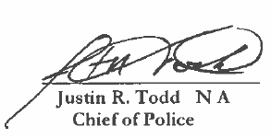

CAMBRIDGE FUN FACTS AND LORE – John Barth, Edna Ferber, and the Adams Floating Theatre
-- Martha Phillips-Patrick

John Barth's First Novel, The Floating Opera, was published in 1956 when he was only 26. The novel was set in a small coastal town in Maryland. As Kaye Wilkinson Barley remembers in her "Meanderings and Muses" Cambridge memoir, "The work most of Cambridge was most interested in was John Barth's first book. That's the book that was always selling out at Whitey's Candyland on Race Street. Although fiction, it still seemed a bit "familiar" to local residents who continue to swear they can spot certain individuals in the cast of characters in this novel."

John Barth and the Adams Floating Theater. It was the Adams Floating Theatre that docked in Cambridge at Long Wharf every year that inspired Barth's first novel's title, The Floating Opera. The Adams Floating Theatre, founded in 1914 by James and Gertrude Adams, toured the Chesapeake Bay staging performances in Maryland, Virginia, and in North Carolina until 1941 when it was destroyed by fire on its way to Savannah GA for refitting. The Adams Theatre, a barge with an auditorium, dressing rooms, and accommodations for actors and crew, measured 128' in length. It was towed by two tugboats (Trouper and Elk) and visited 142 different sites along the East coast during its 27-year run. The Adams Theatre was one of the last operational show boats in the country.

Edna Ferber and the Adams Floating Theater. The Adams Floating Theater not only provided literary inspiration for John Barth but also, thirty years earlier, for Edna Ferber for her novel, Show Boat, which was published in 1926 and was adapted by Jerome Kern and Oscar Hammerstein into the groundbreaking Broadway musical in 1927 and with three film adaptations over the next 25 years. Visiting a friend in 1925 on the East coast, Ferber chanced upon the Adams Floating Theatre and its director and chief actor, Charles Hunter "whose reminiscences fueled her imagination." Eventually she spent four days on the Floating Theater gathering a treasure trove of material, "immersing herself in the drama, glamour, and mystery of this unique American experience." Though her novel was set in Mississippi, the only showboat she ever visited was the Adams Floating Theater.

If anyone reading knew or remembers hearing first-hand accounts about John Barth, about the Candyland store in Cambridge, and/or about the Adams Floating Theater, please send your recollections, if you're willing to share them with the CAN community. Email address is 2adegree@gmail.com. Thanks!

COMMUNITY NEWS – COOPERATING COMMUNITY ORGANIZATIONS

CAMBRIDGE EMPOWERMENT CENTER

We’re planning our summer activities and hoping to grow at the same time! Every summer 45 children, ranging in ages from 5 to 13, come to us for a safe and productive summer to learn and grow. And this Fall we hope to start a fully funded, licensed Pre-K program!

Our summer program is comprised of 4 days a week of care and learning. It lasts for 9 weeks. During that time, the children will receive 2 meals and a snack daily. In addition to academics, the days will include arts and crafts, physical education, music, games, educational trips, science experiments, building and making things, sensory play, cooking and more.

A recent article in the New York Times presented a study which showed that in numerous areas of the country, including Dorchester County, children have not recovered from COVID academic losses. Many of our children are 2 years behind or more in math and reading. Our goals and passion are to assist these children recover some of their losses. Children will participate in learning activities, including an online learning program, for 2 or more hours each day. Last summer 70% of our students made a 2-month or more gain in reading level, and a 50% gain in math.

As all our children’s programs at the CEC are licensed by the State of Maryland, we are required to pay a higher salary for qualified staff. And, we have them. But we are looking for one or two Pre-K teachers who are willing to become licensed, at our cost. And, of course, some little kids, who will be warmly welcomed.

Our expenses also include operating costs of the building (electric, gas, WIFI, phone and more). We depend on generous donors, and grant funding to offer a full program of education, STEM, art and other fun activities for our children.

We are also looking for volunteers to help tutor, mentor, or work one-on-one with our students. To make a difference in a child’s life, please email us at info@cambempowermentcenter.org.

Please help us move forward! You can make a difference in the lives of our children and create a lasting impact in our community! To donate online, go to our website – cambridgeempowermentcenter.org or send a check to: Cambridge Empowerment Center, PO Box 494, Cambridge, Md. 21613

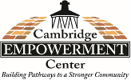

A NOTE FROM THE DORCHESTER COUNTY PUBLIC LIBRARY

Do you have Bibliomania? Love books, love learning and love visiting your local library? Do you have a library card? You can visit either branch and sign up for a free library card and open a whole wide world. And the library is literally right at your fingertips with Libby and Hoopla!

First, please know that both branches, Cambridge and Hurlock, are observing Spring hours. At the Cambridge Branch, the hours are Monday 9:00am to 5:00pm, Tuesday through Friday 10:00am to 6:00pm, and Saturday 9:00am to 5:00pm. The Hurlock Branch is open Monday -Wednesday 10am to 6pm and Thursday 10am to 7pm, closed Friday – Sunday. Quiet times at the libraries are generally during school hours except for the Wednesday Story Times and after school Anime and STEM Club times. Call your branch for more information. Cambridge: 410-228-7331 and Hurlock 410-943-4331.

The Cambridge Branch of the Dorchester Library hosts a wide variety of programming, from the weekly Wednesday Story Time, to STEM for middle and high schoolers, Stitch and Knit for fiber artists, visiting author programs and craft activities for all ages such as origami and other seasonal crafts. The Hurlock Branch also has a Wednesday Story Time for the little ones, STEM programs with hands-on activities, demos, and presentations on science, technology, engineering, and math. There are Master Gardener seminars and craft programs for all. Each month at both branches there are informational and educational (and fun) displays highlighting a special date, month or activity, such as Women’s History Month in March, Maryland Day, Black History Month, Jack the Pumpkin’s Demise and Rise, and more.

Every Summer, the Library hosts a Summer Reading Program. This summer the program is themed “Adventure Begins at Your Library” with a big kick-off celebration on June 15th at the Cambridge Branch. Details will be announced in the near future. Please put June 15th on your calendars and join the fun!

If you or your local business would like to support the libraries by becoming a Summer Reading Sponsor and have your name listed in the Summer Reading booklet and more, please visit:
https://www.dorchesterlibrary.org/summer-reading-sponsors for more information on how to become a Paperback Patron, Hardcover Hero, Bookworm Benefactor, Literary Legend, or a Library Luminary, and make your donation today. Donations must be made by April 1st for names and logos to be included in the Summer Reading materials.

There are always programs and events happening at the Dorchester County Public Libraries. For a complete list of programs, events, and closures, visit the calendar at Dorchesterlibrary.org, Facebook and/or Instagram. See you at the Library!  FRIENDS OF THE DORCHESTER COUNTY PUBLIC LIBRARY | 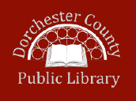

Greetings Friends:

The Friends of the Dorchester County Public Library is the fundraising arm for our Hurlock and Cambridge Libraries. Despite the word “County” in the name of the library, it is a non-profit 501(c)3 organization. That means a large portion of their funding must be raised through book sales, grants from foundations and donations and memberships from people like you! If you’d like to become a member, visit dorchesterlibrary.org and click on “Support Us.”

We the Friends host a Second Saturday Book Sale each month from 9am to 1pm at the Cambridge Library on the first floor in our “Book Cellar.” We literally have thousands of titles in all genres, in both hardback and paperback. There are also DVDs and books on tape. Paperbacks are just $1, and hardbacks are $2, with new books slightly higher, but Much lower than the publisher’s price! There is a bookshelf on the first floor with books for sale at the above price throughout the month. Our Cellar big sales are on Second Saturdays.

We accept donations, generally just a couple of boxes or books at a time. If you have a large donation to make, please email foldorchester@gmail.com to make arrangements for the donation. Donations are accepted on the first and second Saturdays of each month from 9am to 12 noon. Please make every effort to ensure your books are in good condition, without water or mold damage, and not ripped or torn.

We do NOT accept textbooks, magazines or encyclopedias. We do not have the ability to get rid of books that are not sale-worthy as the library has no trash pick-up! We thank you for sticking to our guidelines. It would really help us out! And if you’d like to help us out and volunteer to “play in the Book Cellar,” just email foldorchester@gmail.com. Just imagine being in the middle of thousands of books - you will always find a new title or two!

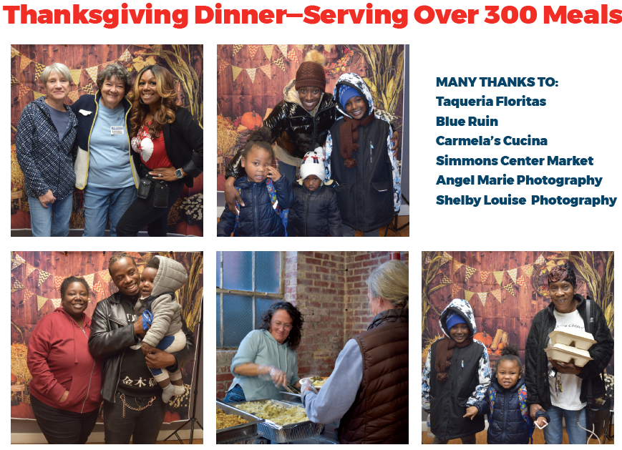
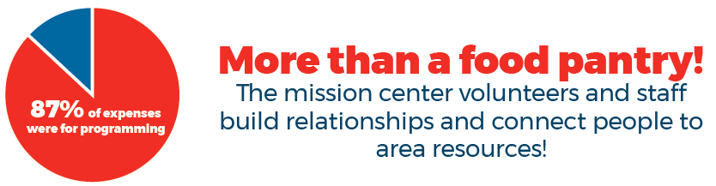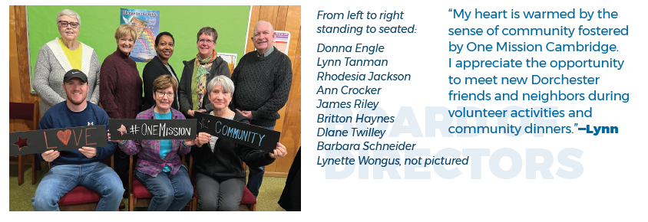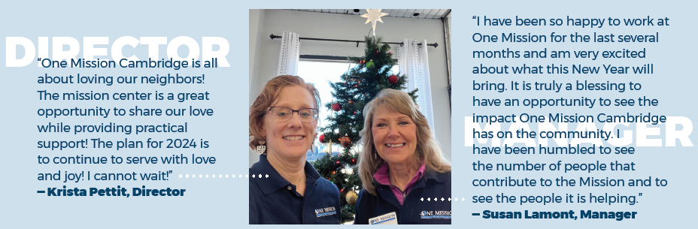

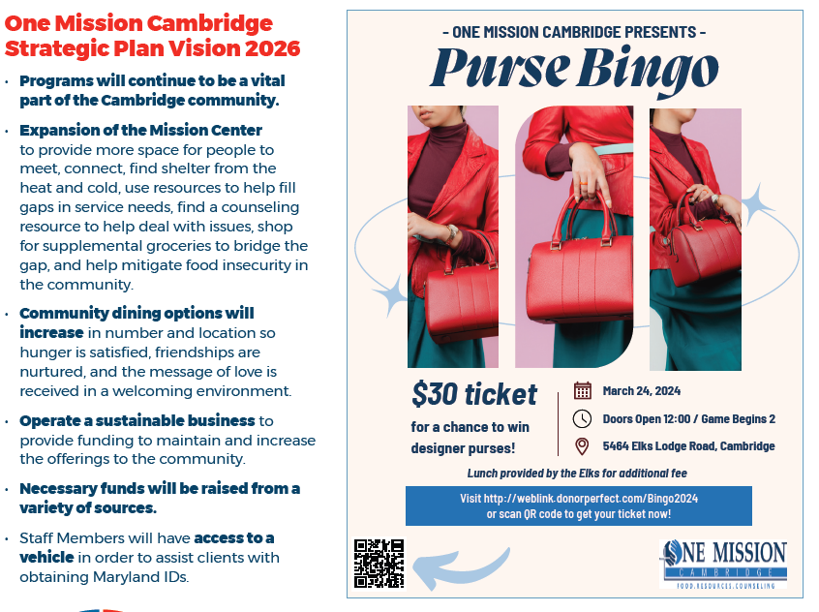

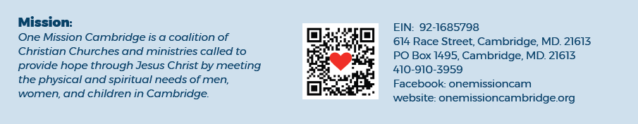
WHCP CAR DONATION PROGRAM

Do you have an old car sitting in your driveway that’s just taking up space? We have a great solution for you! WHCP has partnered with CARS, an organization that collects unwanted cars and turns them into donations to non-profits, like us. If you’d like to contribute to WHCP, donate your car today, and give it a new life! Just click https://whcp.careasy.org/home | 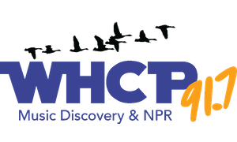

MAIN STREET GALLERY – When Wylde Women Dream

For Cambridge artist, Tammy Vitale, things that seem worn, torn or broken to most people are her treasures. She takes these cast offs and dreams up a new life for them by refashioning them into something different and altogether new! Colorful collages and engaging mixed media art pieces come to life under her skilled and creative hands. For March and April Tammy will be showing her collages and mixed media work along with pieces of her beadwork jewelry at the Main Street Gallery where she will be a guest artist. Her pieces will be shown alongside the work of the Gallery’s nine member artists.

When asked about the creative spelling of “wylde” in the title of her show, Tammy explained it’s something of a trademark for her. While living and working in Southern Maryland she was a part of a coop gallery where the women artists called themselves “wylde women” to express their open and experimental approach to their art. Wild became “wylde” to differentiate the word from meanings that might come up in a google search.

Since moving to town in March of 2023, Tammy has become well known in the community as a passionate promoter and defender of the visual arts in Cambridge. “I want to get the word out that the arts are truly alive here in Cambridge,” she says. “I want Cambridge to be the center of the art world on the Eastern Shore!” To that end the artist, who is working on an MFA in nonfiction writing, has been spreading the word by writing articles featuring Cambridge artists and art events for the Cambridge Spy. She also interviews Cambridge artists on her weekly radio spot called “The Arts Are Alive in Cambridge”. The spot airs on WHCP every Wednesday during the Midshore Midday program. In addition, Tammy maintains a FaceBook page with the same name.

When Wylde Women Dream will run through April 28. Gallery hours are Thursdays through Sundays from 11 am-4 pm through March and 11 am-5 pm starting in April. Tammy will be giving a brief talk at 6 pm during the April 13 Second Saturday artist reception. The 5-8 pm reception is free, and all are welcome. Light refreshments will be served. The gallery asks that children under 18 be accompanied by an adult.

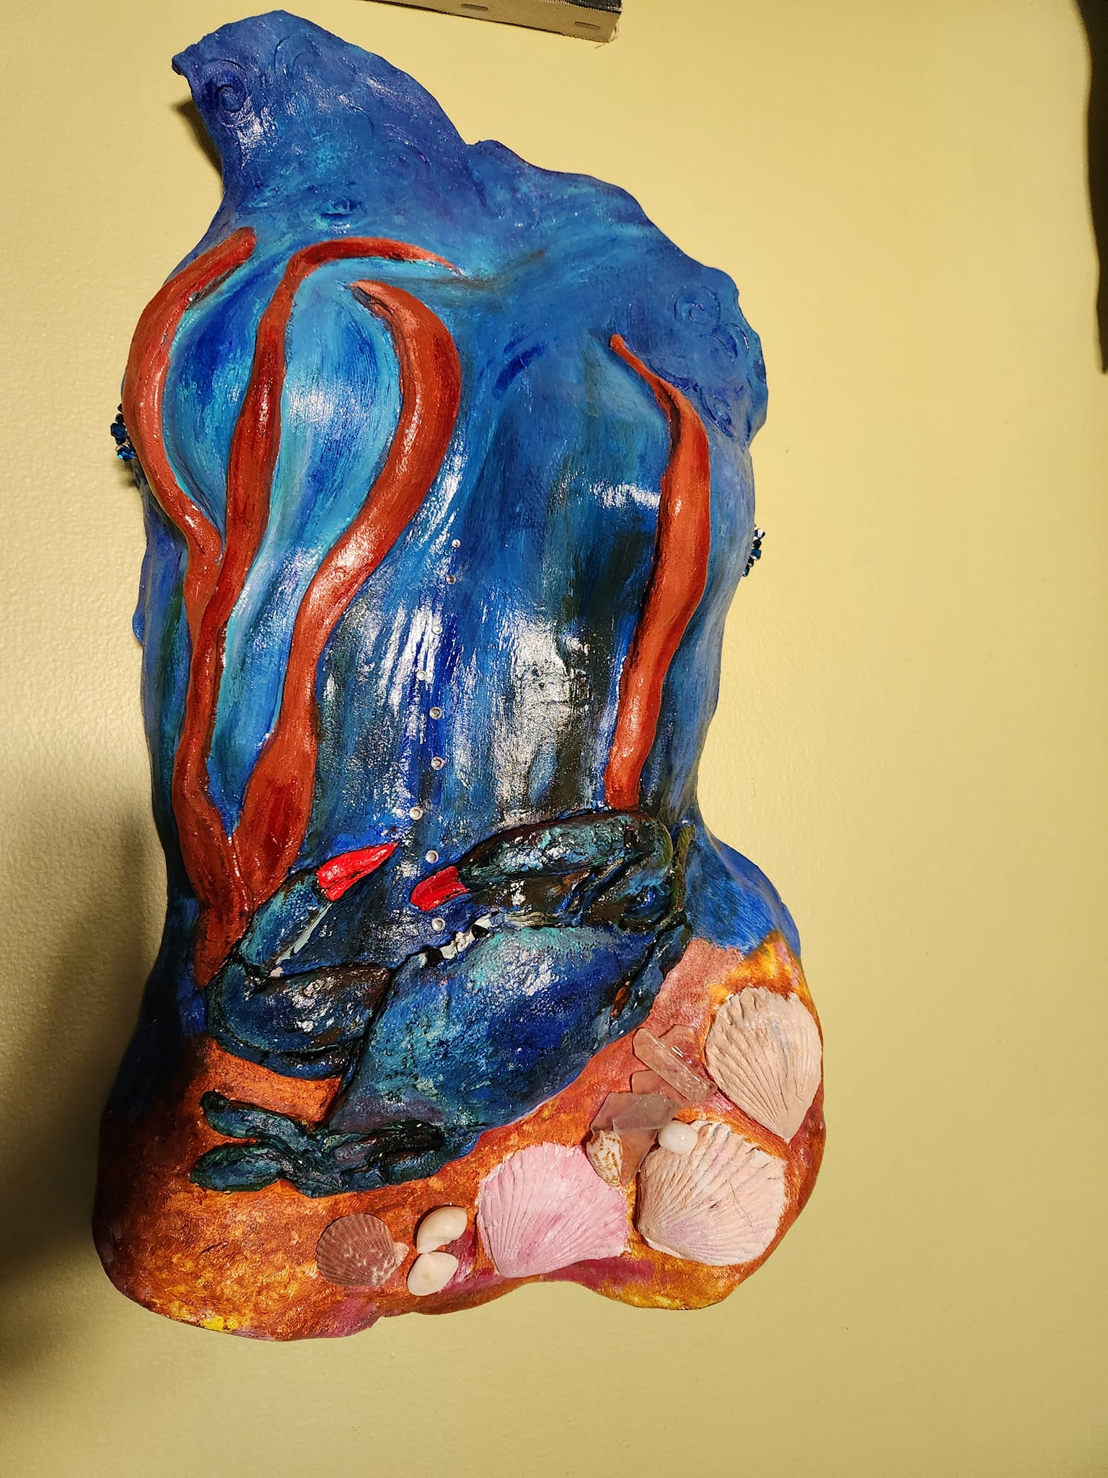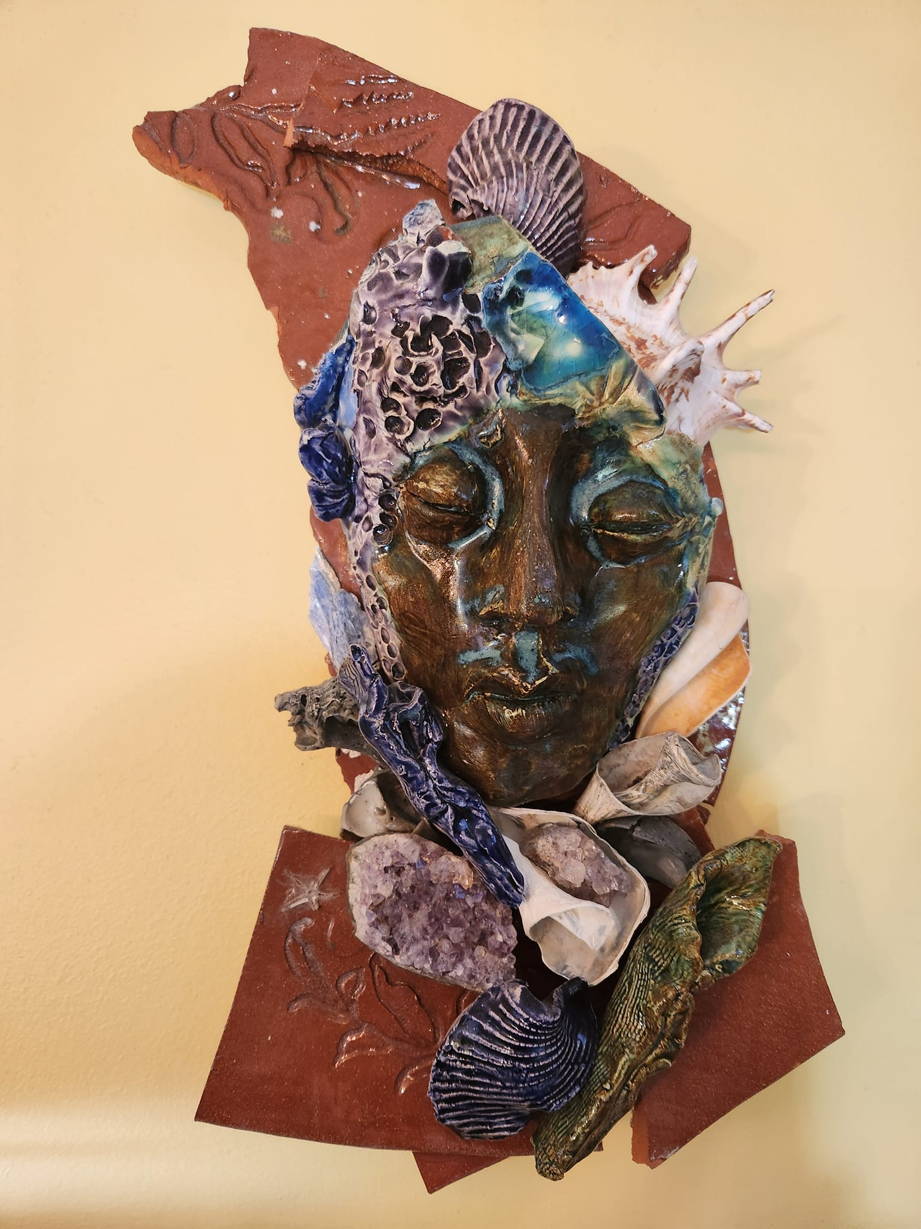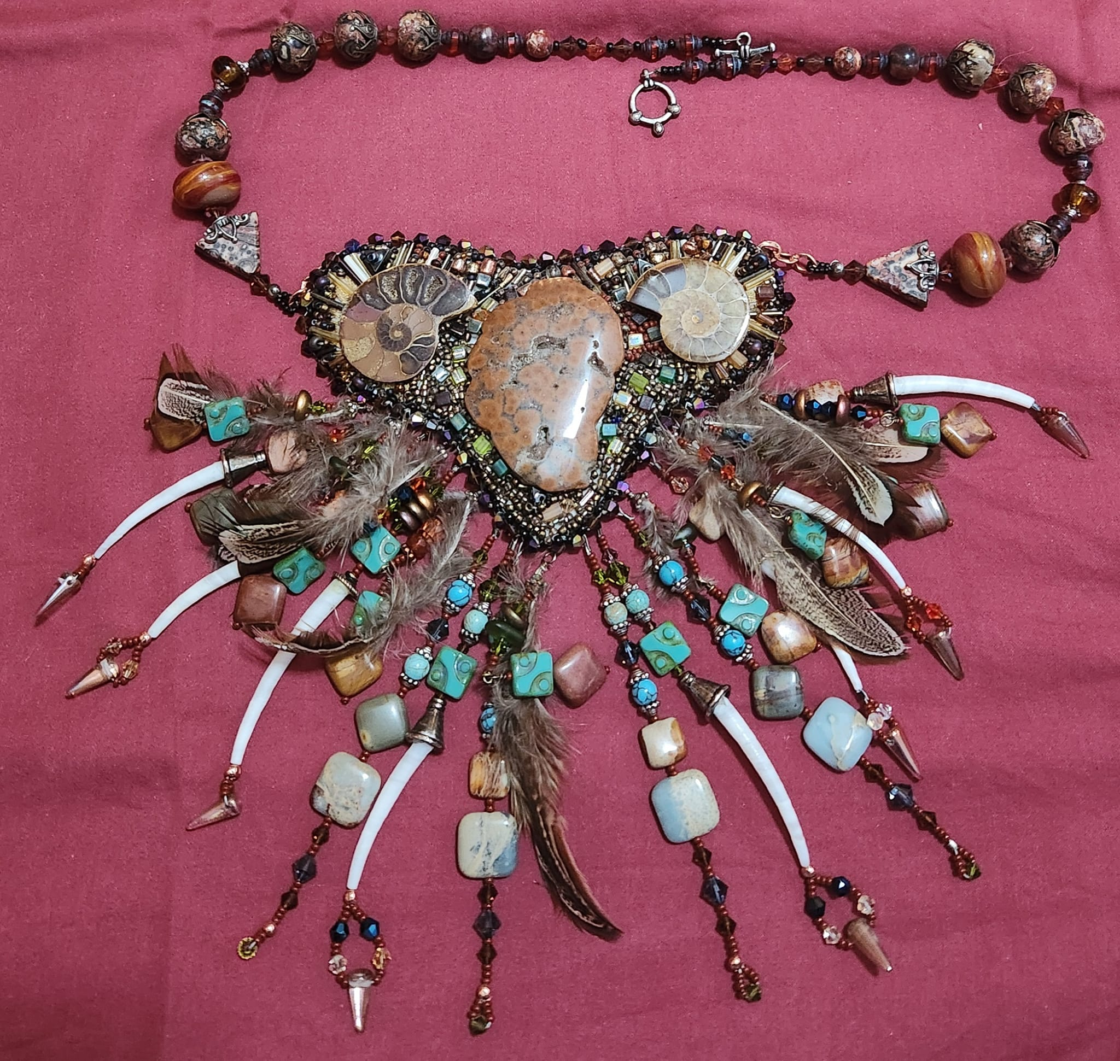
Main Street Gallery is located at 518 Poplar St. in Cambridge, and is part of the vibrant Arts and Entertainment District. The gallery is currently reviewing work from prospective members and guest artists. Please contact MSG through its website @mainstgallery.net or by phoning 410-330-4659 if interested.

MIDSHORE MEALS TIL MONDAY

MidShore Meals 'til Monday is working to end childhood hunger on Maryland’s Eastern Shore by providing weekend food for food-insecure children in Dorchester County. Meals ‘til Monday sends home healthy, nutritious food for children at the end of each school week and during the summer months for breakfast, lunch and snacks to bridge the hunger gap for children without access to adequate food.

Meals ‘til Monday currently provides food for more than 500 elementary, middle and high school students. Donations can be made at https://www.mscf.org/donate-online/. For more information, please call the Director at 703-371-5191 or visit their website at www.midshoremealstilmonday.org/.

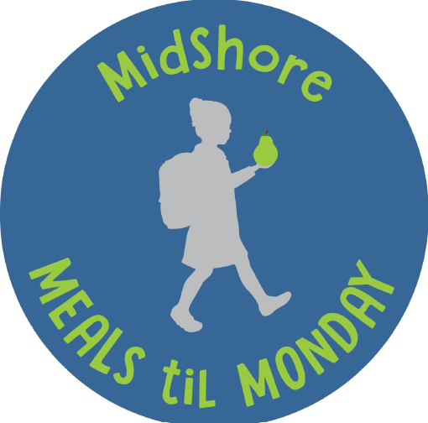

HABITAT CHOPTANK – Donate Your Car to Habitat

Did you know by donating your vehicle to Habitat you can help build and repair affordable homes while also helping the environment?

Since launching the national vehicle donation program, Cars for Homes, in 2005, Habitat has accepted over 120,000 vehicles for reselling or recycling, raising funds for Habitat to partner with local families to build stability and security that a safe affordable home allows. In addition to cars and trucks, Cars for Homes welcomes RVs, motorcycles, boats, and farm and construction equipment. Your vehicle donation does not have to be running, but it must be whole and have four inflated tires so it can be moved by Habitat’s towing operators.

Since Habitat is a 501(c)(3) nonprofit organization, vehicle donations may be claimed as deductions on your federal tax return if you itemize. Once your vehicle is sold, the selling price determines the amount of your donation. If your vehicle sells for more than $500, you may deduct the full selling price. If your vehicle sells for $500 or less, you can deduct the “fair market value” of your vehicle, up to $500. Habitat makes it fast and easy to donate a vehicle! Call 877-277-4344

CAN MISSION, MEMBERSHIP, BOARD of DIRECTORS, and COMMITTEES

MISSION. The Cambridge Association of Neighborhoods (CAN) fosters neighborhood cohesion and community involvement to enhance the quality of community life for all residents of Cambridge through community events, social activities, and neighborly assistance. CAN protects and enhances properties in Cambridge by improving building and zoning codes, supporting adherence to those codes, and engaging constructively with City Government, including the Historic Preservation Commission. CAN’s Bylaws can be found on the CAN website at https://cambridgecan.org/welcome/about/bylaws/.

MEMBERSHIP. CAN welcomes members from all Cambridge area neighborhoods (broadly defined) who are interested in organizing and working together, building a diverse membership reflecting the diversity of Cambridge residents. Membership is FREE – information is available on the CAN website at https://cambridgecan.org/join-can/

CAN BOARD OF DIRECTORS. CAN is governed by a Board of Directors elected by CAN members at its annual January Business Meeting. Board Members whose terms expire in January 2026 are President – Chuck McFadden; Treasurer – Dave Thatcher; Members at Large – Mary Ellen Jesien, Kim Miller, Brad Rice, Donna Tower, and Judd Vickers. Board Members whose terms expire in January 2026 are Vice-President – Roman Jesien; Secretary – Tom Puglisi; Members at Large – Andre Duerinckx, Rick Klepfer, and Sharon Smith.

CAN HOUSING QUALITY COMMITTEE – PLANNING AND ZONING ISSUES. The Housing Quality Committee monitors issues affecting the quality of housing and the maintenance of property values in the City, including code enforcement. Committee members attend Planning Commission meetings to monitor zoning-related issues and report the information to the Board and Membership. Please contact Chuck McFadden at Ragtime31@gmail.com to volunteer.

NEIGHBORHOOD DEVELOPMENT COMMITTEE – SOCIAL EVENTS & ‘NEIGHBORS HELPING NEIGHBORS’.
"Neighborhoods" are organized by small groups willing to work together to address neighborhood issues through small social events and "neighbor-helping-neighbor” activities. The Social Events Subcommittee organizes community-wide events. Contact Chuck McFadden at Ragtime31@gmail.com to volunteer.

CAN COMMUNICATIONS COMMITTEE – WRITERS NEEDED. CAN'S Communications Committee needs writers, including volunteers to take unofficial notes at public meetings. Please contact Tom Puglisi at tom.puglisi@comcast.net to volunteer.

POWER WASHER AVAILABLE

CAN has an electric power washer available to members. Contact Chuck McFadden at Ragtime31@gmail.com.

