Newsletter #24.04 APRIL 2024

CAN member meetings are announced in advance and open to the public.

Next CAN Public Membership Meeting – May 2, 6:30 pm, Dorchester County Public Library, Cambridge

Everyone interested in CAN is invited to attend.

IN THIS ISSUE: page

PRESIDENT’S MESSAGE – What’s Wrong with CWDI? 2
- CAN Public Membership Meeting – May 2 3

CAMBRIDGE CORNER 3
- WHCP News Reports – CWDI 3
- Cambridge Real Estate Trends 3
- Cambridge Fun Lore - John Barth 5

Community News – Cooperating Community OrganizationS 5
- Main Street Gallery – Joy Through Art 5
- Cambridge Empowerment Center 6
- ShoreRivers – Health of the Choptank Event 7
- Midshore Meals ‘til Monday 8
- Habitat Choptank 8

CAMBRIDGE POLICE DEPARTMENT QUARTERLY REPORT 8

CAN Mission Statement, MEMBERSHUP, Board OF DIRECTORS, and Committees 11

CURRENT LINKS

CAN’s Website – https://cambridgecan.org
JOIN CAN FOR FREE – https://cambridgecan.org/join-can/
CAN Meeting Minutes – https://cambridgecan.org/category/meetings/
CAN Meeting Videos – https://www.facebook.com/WHCPRadio/videos or
https://www.youtube.com/@whcpstudio4716
CAN’s City Council Meeting Notes – https://cambridgecan.org/category/news/city-council-notes/
CAN’s Planning & Zoning Notes – https://cambridgecan.org/category/news/p-and-z/
CAN on FaceBook – https://www.facebook.com/CambridgeAssociationofNeighborhoods/
Contact CAN – CambridgeCAN@yahoo.com

PRESIDENT'S MESSAGE – CWDI: What I Know and Don’t Know

I have been getting a lot of questions lately about the Cambridge Waterfront Development Inc. (CWDI) project. Here is what I know. These are simply the facts for you so you can make up your own mind.

The project covers almost 35 acres of the 6,734 acres of the City of Cambridge or one/half of one percent of the City. The project is centered at the old Hospital site with sides on the Choptank River and Cambridge Creek which is projected by CWDI to be the premier retail site in the City. CWDI wants the City to put up a $30.3 million loan to put in the infrastructure. The loan will be over 29.5 years at a projected interest rate of 5.5%. This will pay for roads, sidewalks, sewers, water, electrical, cable, etc. CWDI wants to put in the infrastructure before any developers are identified which may cause some difficulties. CWDI projects that there will be 543 people living at Cambridge Harbor when it is completed.

CWDI is planning on developing the land and maintaining it at least for the life of the loan. So, they will have their own management team, finance and maintenance groups, marina employees, and people to book and operate the amphitheater. The City will still provide police, fire and clean water. CWDI plans to build:

- A multi-storied hotel with 100 rooms to be opened by 2026. The hotel will employ 48 people and have an average cost of $171 per room per night. It will also have a roof-top restaurant with a great view of the River and Creek. Visitors to the harbor are projected to consume $121 on food and beverages on average.
- 30,000 sq ft of retail space mainly on the first floor of the Condos. This might sound like a lot of space, but it only amounts to about 10 sites at 3,000 sq ft each. CWDI projects it will be for banks, clothing stores, juice bars, coffee shops, Ice cream stores and other retail outlets.
- 110 condos with an average of 1,250 sq feet and with an average assessed value of $311,355. CWDI plans to start building some of these in 2026 and finish by 2028.
- 116 townhouses with an average assessed value of $347,262. Construction will start in 2026.
- Seven single family homes with an assessed value of $402,378, all to be built in 2026
- CWDI has projected that 2.3 persons will live in each of the above dwellings.
- A non-profit fitness and recreational facility, which will be built in 2026. This sounds like the YMCA, which spent $47,000 on site plans for that very spot. CWDI spent $5,000 on drawings to develop the current YMCA site, but CWDI insists that there is no agreement or contract with the YMCA, in spite of the fact that the YMCA was identified on a former map.
- A second City marina of 125 slips at a cost of $8 to $10 million to construct. The marina would have 12 employees. The current City marina of about 200 slips needs several million dollars to replace old docks E, F, and H. It has lots of vacancies and has 2.5 employees.
- A second City amphitheater at a cost unknown to me.
- An expansion of the swimming area next to the Visitors center at a cost unknown to me.
- A brick walkway on the River side at a cost unknown to me.

CWDI has also purchased the Richardson Museum property. Plans for development are unclear to me. CWDI also wants to sell 2.6 acres to Yacht Maintenance for a price unknown to me. How they arrived at the price is also unclear to me. It is also unclear to me who approves the CWDI budget.
As you can see there are a number of things, I do not know but I am sure some will be explained at the upcoming meeting on April 18th. Please keep in mind, however, when listening to CWDI’s presentation, whether this project is good just for CWDI or for the whole City of Cambridge.

CAN Public Membership Meeting – May 2nd

The next CAN Public Membership meeting will be held on Thursday, May 2nd at 6:30 pm in the Dorchester County Public Library basement meeting room at 303 Gay Street in Cambridge. The guest speaker will be City Manager, Tom Carroll, who will give us an update on the City budget and, I am sure, answer a question or two on CWDI. Come join us and bring a friend. The meeting will be livestreamed on YouTube and FaceBook at https://www.youtube.com/@whcpstudio4716 and at https://www.facebook.com/WHCPRadio/videos, respectively, and will be posted on these sites after the meeting.

-- Charles McFadden, President, CAN

CAMBRIDGE CORNER

WHCP-FM 91.7 NEWS REPORTS - CWDI

Cambridge Mayor Asserts City Control Over Waterfront Development
Originally airing on Tuesday April 16, 2024 by News Director Jim Brady.
CWDI (Cambridge Waterfront Development Inc) Fails to Meet City Contract Originally airing on Thursday April 11, 2024 by News Director Jim Brady.

CAMBRIDGE REAL ESTATE TRENDS
-- Fred & Martha Phillips-Patrick

National and Regional Residential Real Estate Developments

According to Freddie Mac, “Mortgage rates have been drifting higher for most of the year due to sustained inflation and the reevaluation of the Federal Reserve’s monetary policy path.” The current 30-year fixed mortgage rate is 6.88%, up slightly over the past month.

Realtor.com reports that: “As the nation enters the best week to list a home, April 14–20, fewer homeowners anticipate bidding wars and wild offers over the asking price, according to a recent survey from Realtor.com® and CensusWide. Homeowners are also expecting their homes will take longer to sell and fewer buyers will waive contingencies.”

“Home sellers have adjusted their expectations. They’re becoming a little more realistic given the current market conditions,” says Hannah Jones, senior economic research analyst at Realtor.com. “Home prices and mortgage rates remain elevated, so buyers are going to be a little bit pickier and are going to be looking for more flexibility from sellers.”

How did Cambridge fare in this market environment in March, 2024? Let’s see.

Cambridge Market Update

According to Realtor.com, Cambridge was still a buyer's market in March 2024, which means that the supply of homes is greater than the demand for homes. The median listing home price in Cambridge was $289K in March 2024, trending down -2.3% year-over-year. The median home sold price was $212.5K. Homes in Cambridge sold for approximately the asking price on average in March and, on average, sold after 49 days on the market. The trend for median days on market in Cambridge, MD has gone down since last month, and slightly down since last year.

Sales

Currently, according to Realtor.com, there are now 171 homes for sale (125 single family homes and 46 condos and townhomes) in the Cambridge area, up from February. There are also 3 multifamily units for sale, as well as 52 farms and plots of land. The properties’ asking prices range from $10,000 for a small plot of land (.06 acres) on Phillips Street to $2,345,000 for house on Ross Neck Road, which is down $50K from last month.

According to Zillow, in March, 2024, 25 homes were sold, ranging in value from $55,000 to $400,000.

829 Parkway St $230K 833 Parkway St $235K 400 N Seaway #134 $325K
162 Regulator Dr N $400K 625 Douglas St $117K 606 Water St #4 $155K
1656 Terrapin Cir $280K 713 Travers St $170K 317 Talbot Ave $173K
1103 Race St $240K 500 Merganser Way $250K 900 Phillips St $ 55K
309 Belvedere Ave $390K 5429 Whitehall Rd $396K 700 Cattail Cv #402 $226K
406 Ruddy Duck Ct $185K 1637 Terrapin Cir $269K 504 Merganser Way $240K
700 Cattail Cv #311 $226K 1646 Terrapin Cir $310K 432 Hight St $138K
800 Wood St $123K 333 Shipyard Dr $325K 383 Robbins Farm Rd $323K
2363 Church Creek $140K

Cambridge in the News

According to the Dorchester Star (April 10, 2024): “Later this month, residents will have the opportunity to have their questions answered and hear more about the plans for Cambridge Harbor, a development project along the Choptank River.

In a letter to the public, Cambridge Waterfront Development Inc. Board President Angie Hengst said people will be able to submit questions and get clarification on some of the topics “that have been circulating as of late.” She said CWDI has been “the topic of conversation” over the past few weeks.

The letter said CWDI will hold a public session on April 18. The session will be held at 6 p.m. at the Chesapeake Grove Intergenerational Center in Cambridge. It will also be live-streamed.

Hengst said that the public can always reach out to her at Angie.hengst@cwdimd.org, Leonard at matt.leonard@cwdimd.org or the other board members with questions or concerns.”

CAMBRIDGE LORE –
-- Martha Phillips-Patrick

John Simmons Barth, an author and native son of Cambridge, Maryland, died on April 2, 2024, at age 93.

Of what one cannot make sense, one can make art. In a story, fact and fiction become inextricable and complementary. The relation between fact and fiction, life and art, is not imitation of either by the other, but a sort of collaboration or reverberation. The story of life, this floating opera, is the ongoing, reciprocal shaping of our story by our imagination and of our imagination by our story thus far.

-- John Simmons Barth

COMMUNITY NEWS – COOPERATING COMMUNITY ORGANIZATIONS

MAIN STREET GALLERY - Joy Through Art is MSG’s Spring Show

Main Street Gallery is excited to be exhibiting the artwork of Joy Staniforth, as its guest artist for the May/June show. Joy, a resident of Cambridge, has titled her show “Joy Through Art,” and she will be showing alongside the nine member artists of the gallery. A maker of many types of art, Joy will be showing unique jewelry made of wire, textiles and tumbled rocks, as well as bold textile wall hangings and examples of her most recent artistic passion, a paper art called quilling.

Many in the Cambridge area know Joy Staniforth as the brave businesswoman who took a big risk and opened Joie de Vivre, a contemporary art gallery on Race Street. “There was not much going on in downtown Cambridge in those days” she says, “but the gallery was successful, selling to mainly second home owners.” Joy was personally successful as well. After having spent years raising a family and pursuing a career as an executive at the YMCA in N.J. and then here in Cambridge, she was finally able to start making and selling her own art through her gallery. “I was working in textiles,” she explains, “ dyeing silk and making jewelry.”

Joy has been interested in art from her childhood days in Wales, U.K. She grew up loving art in school, and was especially drawn to making crafts. Her parents played musical instruments at home so as a young girl she learned to play the piano and the violin as well. When she went away to college though, she decided to study visual arts. “My dorm walls were always covered in fabrics,” she says.

Joy retired from Joie de Vivre in 2015, but she’s hardly slowed down. Since then, she has been busy experimenting with wire, textiles, tumbling rocks and learning the paper art of quilling. She hasn’t forgotten her musical roots either, having been a member of the Baltimore Mandolin Orchestra for many years and currently playing the ukulele in a small group at the Dorchester Center for the Arts. Joy is also a past member of the Main Street Gallery. Director, Linda Starling says she and the other members are very excited about her show. “We are so happy to welcome Joy back as a guest artist”, she says, “and we look forward to having her work hanging on our walls again!”

Joy Through Art will open on May 2 and run through June 30. There will be two artist receptions at the gallery on Second Saturdays, May 11 and June 8 from 5-8 pm. The receptions are free and open to the public and all are welcome. Light refreshments will be served. Joy will give a workshop on quilling on June 8 from 1-3 pm at the gallery. This event will be free and open to all. She will also give a brief artist talk at the June 8 reception.

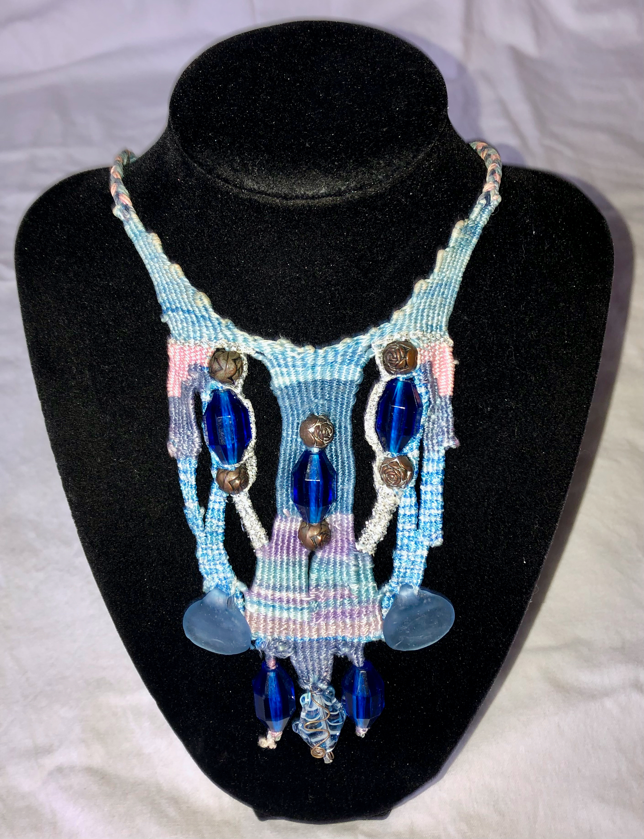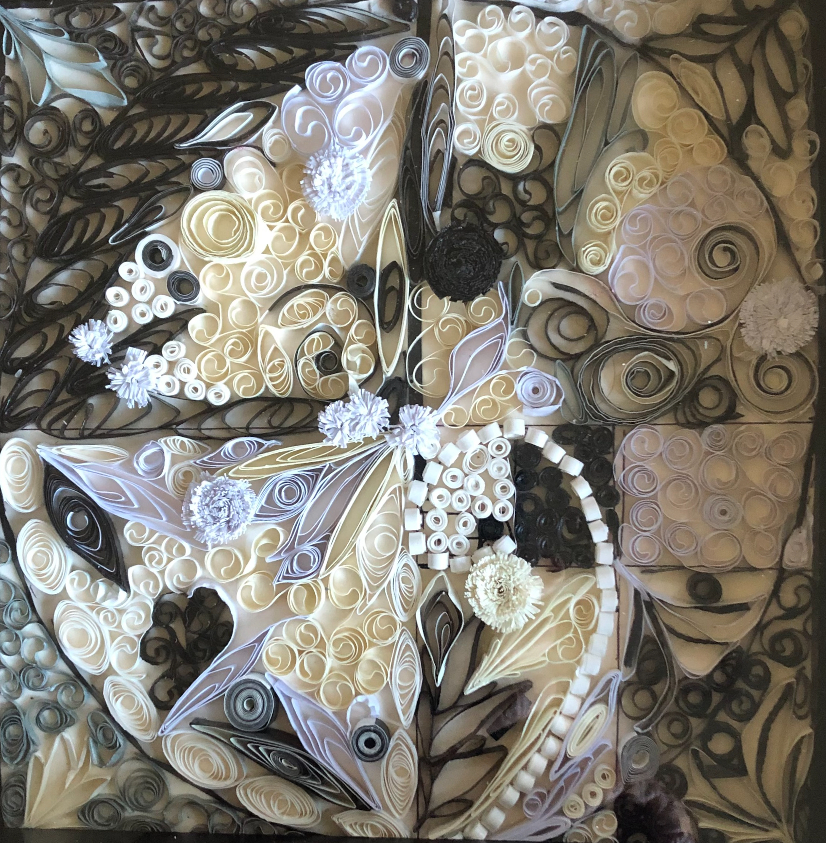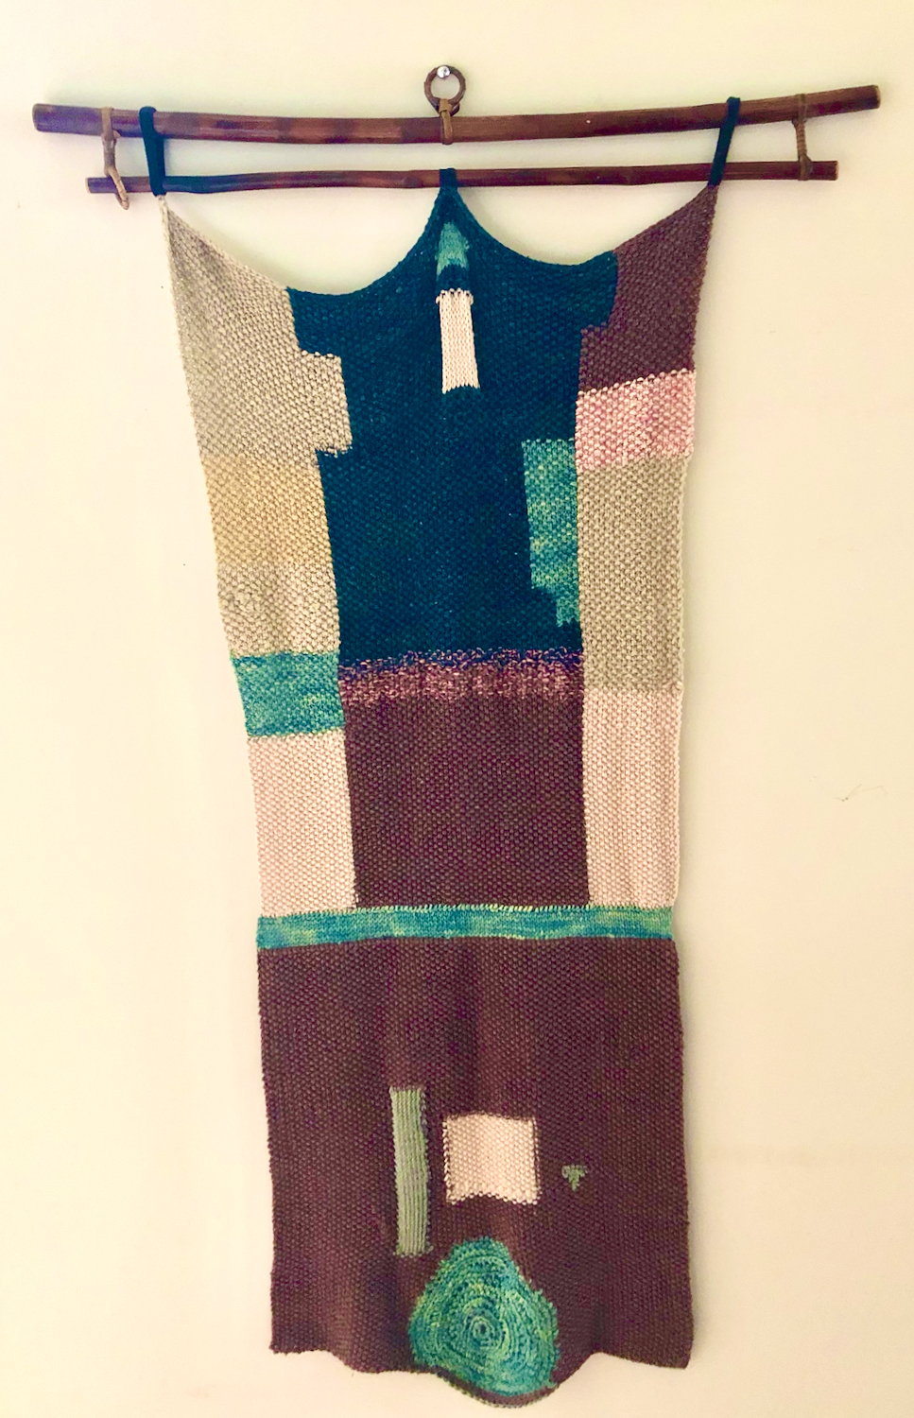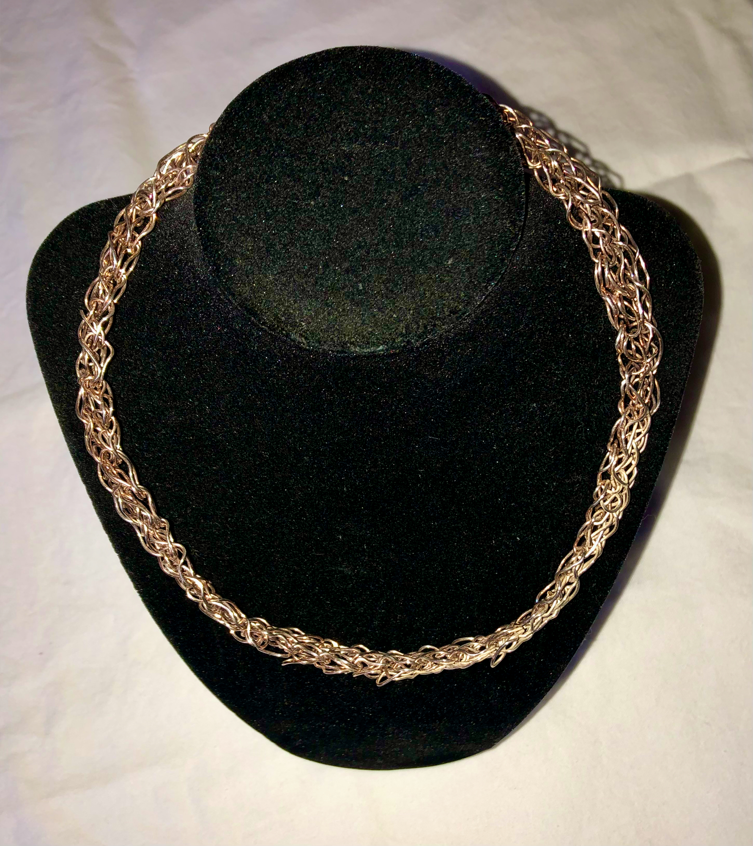

Main Street Gallery is located at 518 Poplar St. in Cambridge, and is part of the vibrant Arts and Entertainment District. Gallery hours are Thursdays through Mondays from 11-5. The gallery requests that children under 18 be accompanied by an adult. The gallery is currently reviewing work from prospective members and guest artists. Please contact MSG through its website @mainstgallery.net or by phoning 410-330-4659 if interested.

CAMBRIDGE EMPOWERMENT CENTER

Early sign-up for our popular “Summer Camp” program ends May 6th. Last year, we had a full house of 45 children, from economically depressed areas here in Dorchester County, ranging in ages from 5 to 13 years.
Our “campers” receive an exceptional program of education. Last summer 70% of our students made significant advances in reading and math. In addition to academics, their days with us include arts and crafts, physical education, music, games, educational trips, science experiments, building and making things, sensory play, cooking and more. Important also, we give them healthy food -- 2 meals and a snack each day.

So, what does early sign-up mean? $75 per child TOTAL! for our 9-week summer program. After May 6th, we’re raising the price to $100. Of course, our costs to deliver these programs is MUCH higher than parents can afford. We depend on generous donors and grant funding to be able to offer both our summer and after-school programs.
To make a difference in a child’s life, you can come over and volunteer as a tutor! Yay, You! We’d love to have you.
Or Donate. You can make a difference in the lives of our children and create a lasting impact in our community! To donate online, go to our website – cambridgeempowermentcenter.org or send a check to: Cambridge Empowerment Center, PO Box 494, Cambridge, Md. 21613

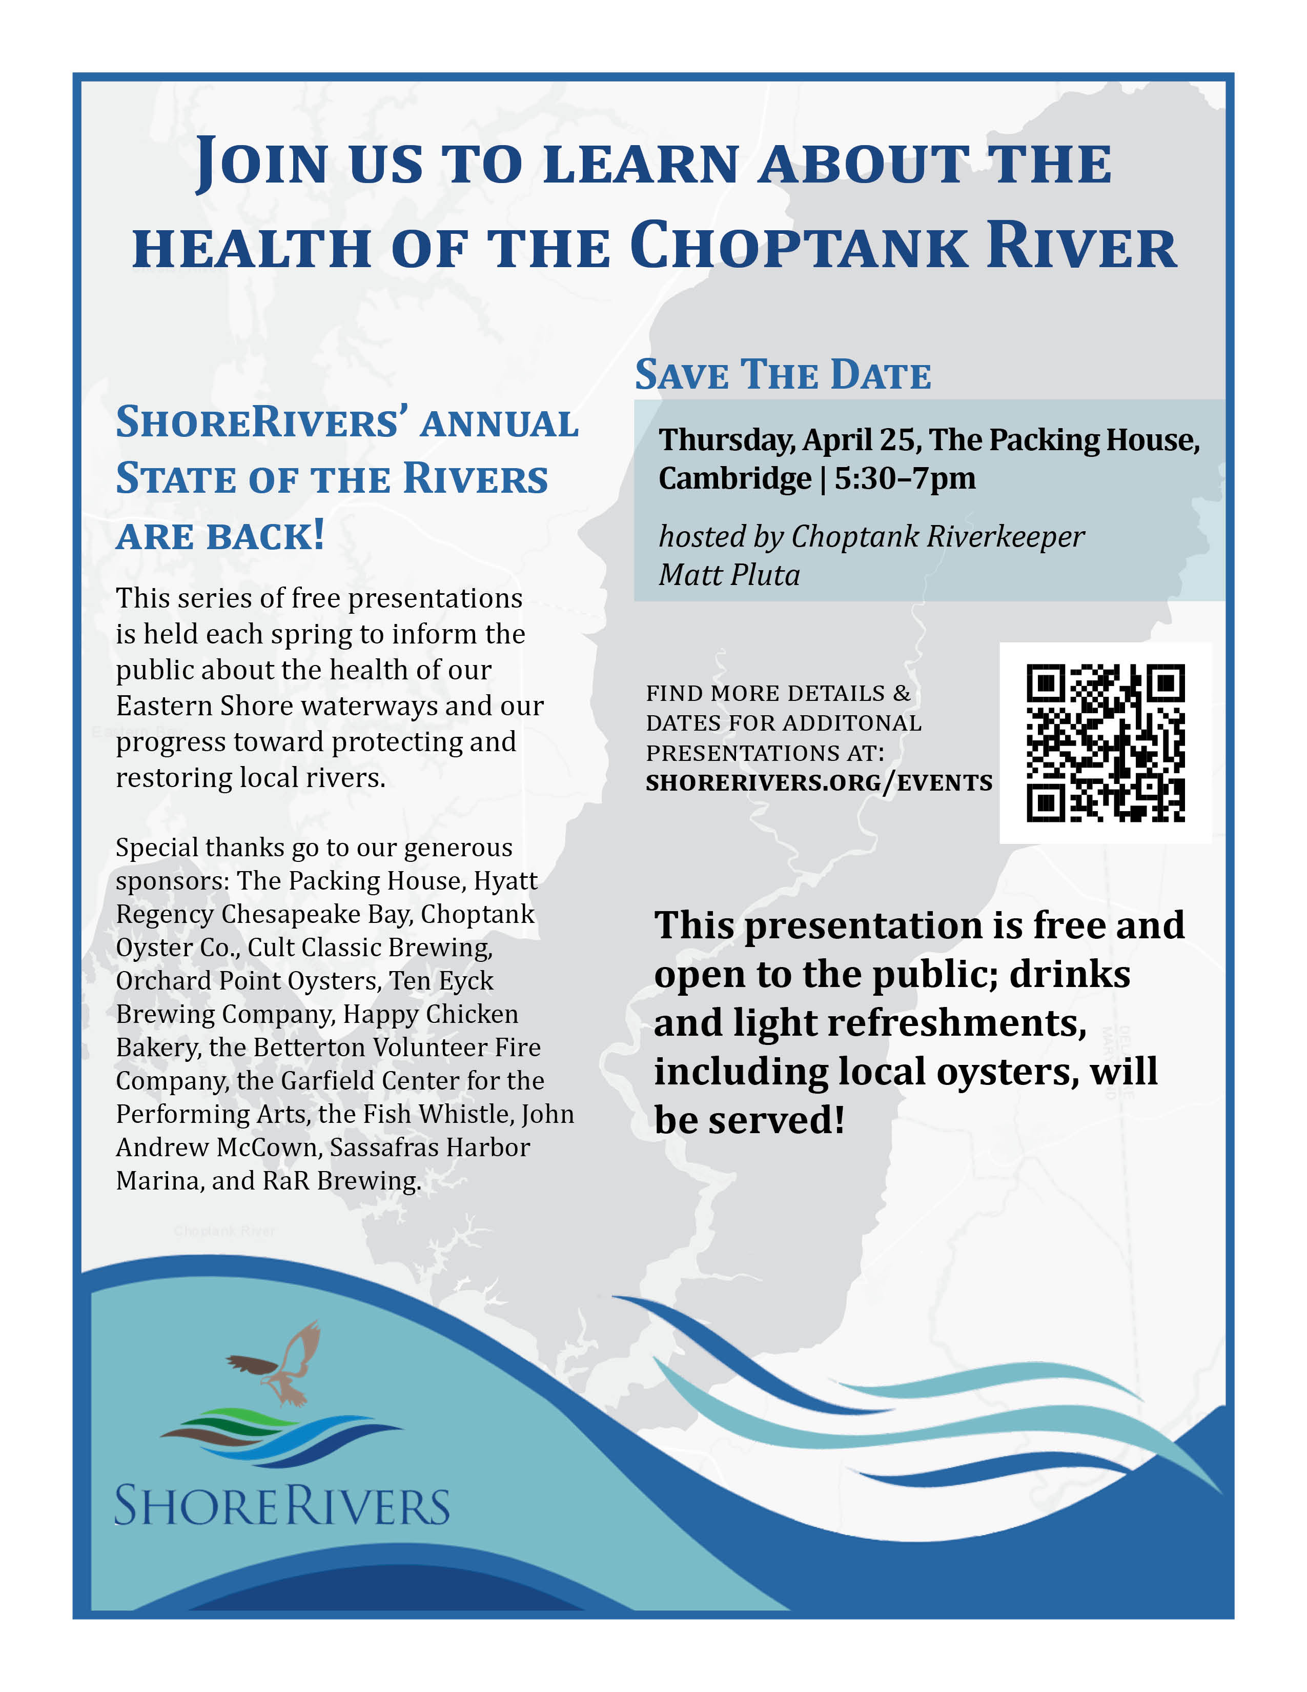

MIDSHORE MEALS TIL MONDAY

MidShore Meals 'til Monday is working to end childhood hunger on Maryland’s Eastern Shore by providing weekend food for food-insecure children in Dorchester County. Meals ‘til Monday sends home healthy, nutritious food for children at the end of each school week and during the summer months for breakfast, lunch and snacks to bridge the hunger gap for children without access to adequate food.

Meals ‘til Monday currently provides food for more than 500 elementary, middle and high school students. Donations can be made at https://www.mscf.org/donate-online/. For more information, please call the Director at 703-371-5191 or visit their website at www.midshoremealstilmonday.org/. | 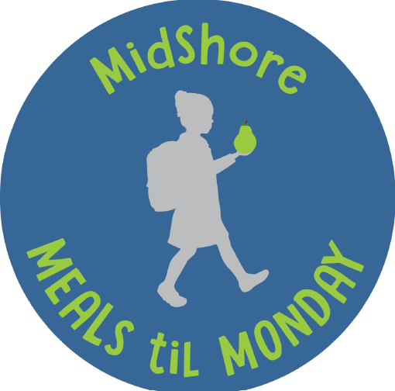

HABITAT CHOPTANK – Donate Your Car to Habitat

Did you know by donating your vehicle to Habitat you can help build and repair affordable homes while also helping the environment? Since launching the national vehicle donation program, Cars for Homes, in 2005, Habitat has accepted over 120,000 vehicles for reselling or recycling, raising funds for Habitat to partner with local families to build stability and security that a safe affordable home allows. In addition to cars and trucks, Cars for Homes welcomes RVs, motorcycles, boats, and farm and construction equipment. Your vehicle donation does not have to be running, but it must be whole and have four inflated tires so it can be moved by Habitat’s towing operators.

Since Habitat is a 501(c)(3) nonprofit organization, vehicle donations may be claimed as deductions on your federal tax return if you itemize. Once your vehicle is sold, the selling price determines the amount of your donation. If your vehicle sells for more than $500, you may deduct the full selling price. If your vehicle sells for $500 or less, you can deduct the “fair market value” of your vehicle, up to $500. Habitat makes it fast and easy to donate a vehicle! Call 877-277-4344.

CAMBRIDGE POLICE DEPARTMENT | 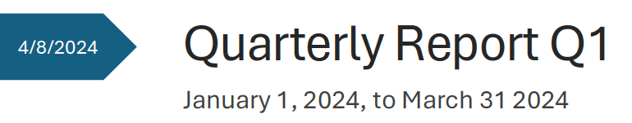
This report contains Calls for Service and Statistics for the Cambridge Police Department for the first quarter (Q1)of 2024 data is from January 1 2024 until March 31 2024. It is intended to provide a “snapshot” of activity as of this point in the year. Data is taken directly from the Cambridge Police FLEX/COMPSTAT software and NIBRS offenses as reported to the FBI, and includes arrest information for both juveniles and adults.

CONTENTS:
- Part A and Part B NIBRS Offenses Reported
- Criminal Arrests (Adult and Juvenile) / Juvenile Charges January-February-March / Total Arrests
- Traffic Enforcement / Non-Criminal CFS
- Shot Spotter & Shots Fired / Calls For Service by Squad /2023 Q-1/
- 2024 Q-1 vs 2023 Q-1 Comparisons – Part A & Part B, Shot Spotter, Calls for Service
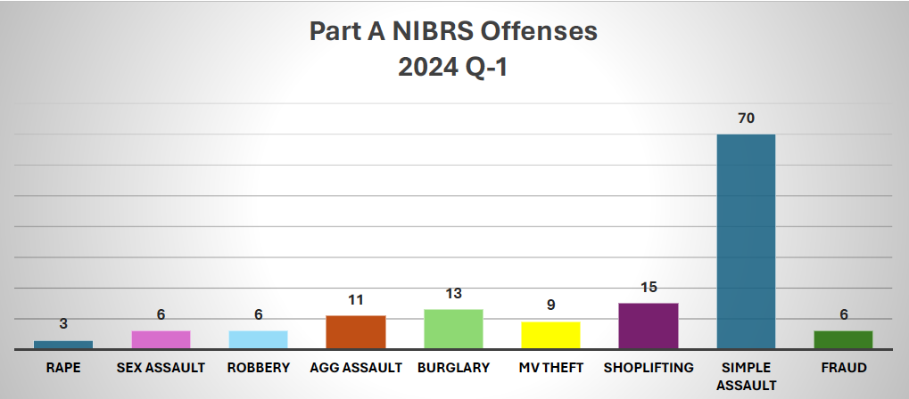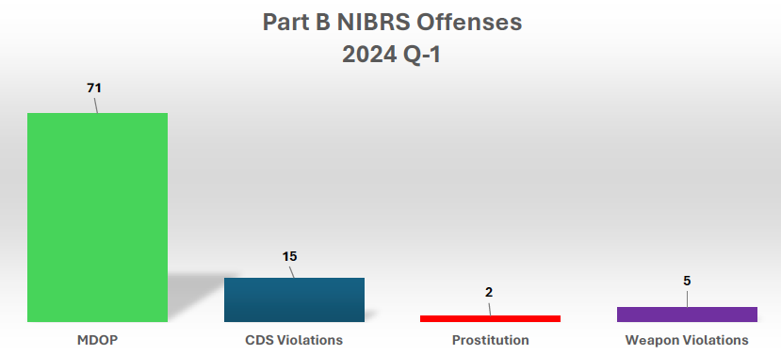

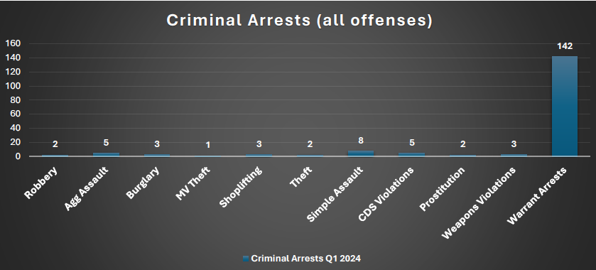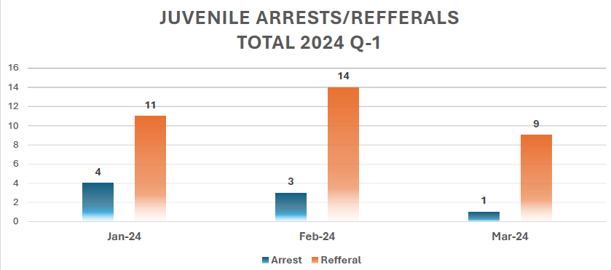

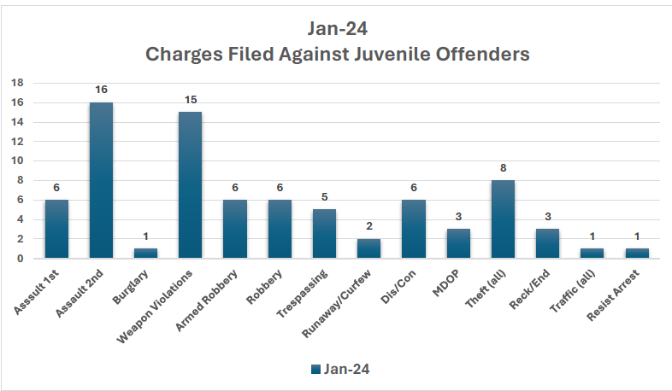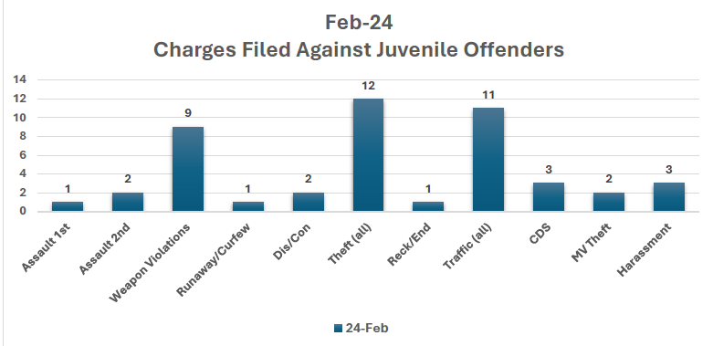

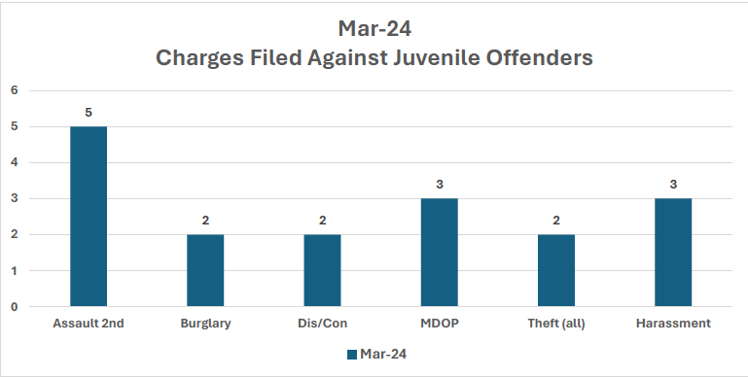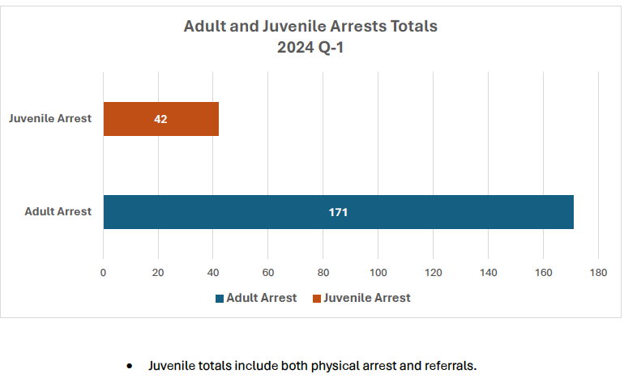

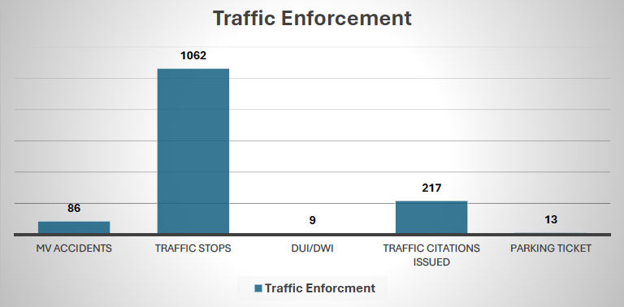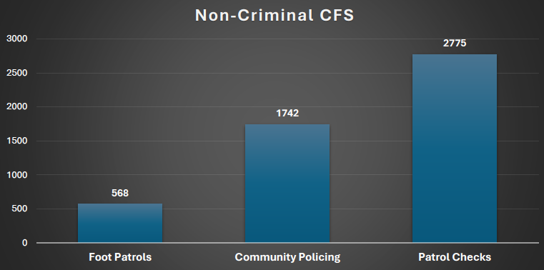

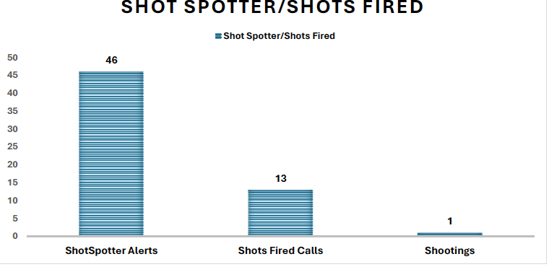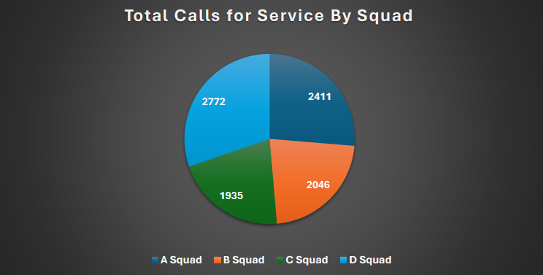

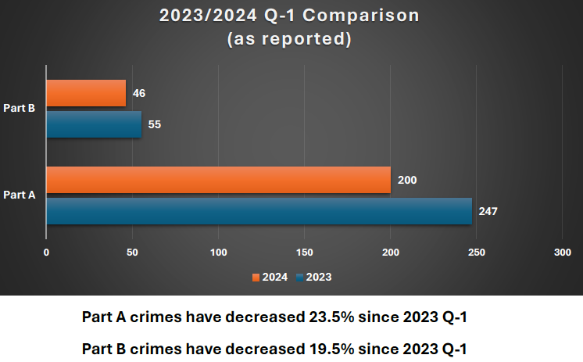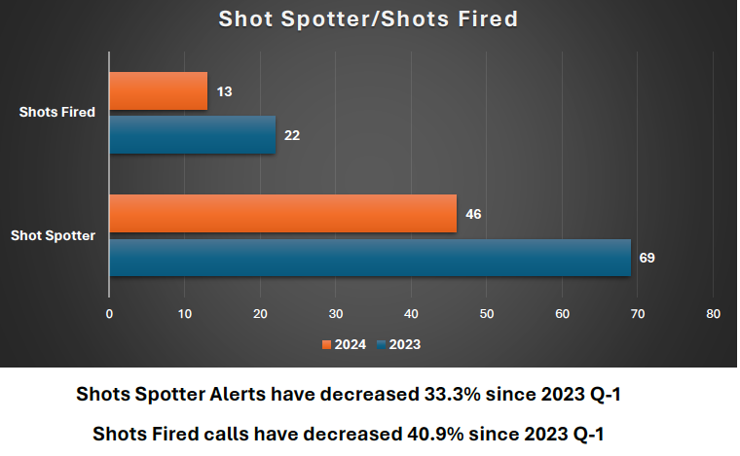

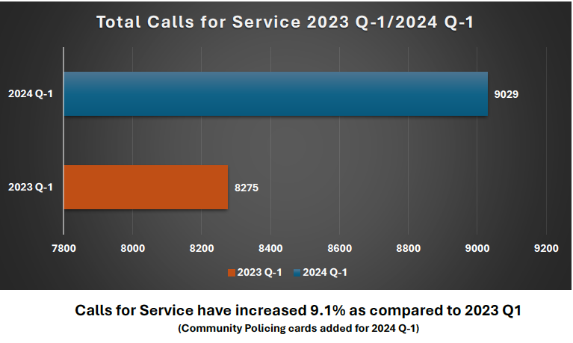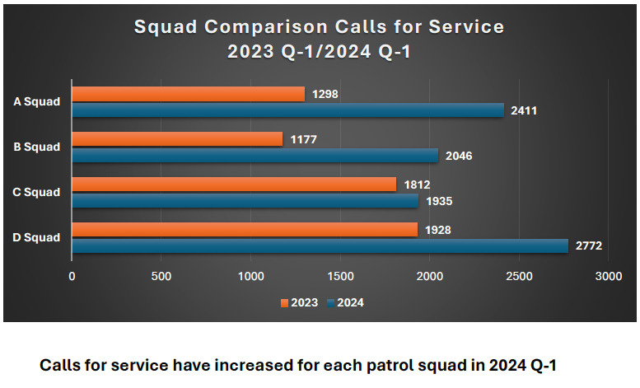

CAN MISSION, MEMBERSHIP, BOARD of DIRECTORS, and COMMITTEES

MISSION. The Cambridge Association of Neighborhoods (CAN) fosters neighborhood cohesion and community involvement to enhance the quality of community life for all residents of Cambridge through community events, social activities, and neighborly assistance. CAN protects and enhances properties in Cambridge by improving building and zoning codes, supporting adherence to those codes, and engaging constructively with City Government, including the Historic Preservation Commission. CAN’s Bylaws can be found on the CAN website at https://cambridgecan.org/welcome/about/bylaws/.

MEMBERSHIP. CAN welcomes members from all Cambridge area neighborhoods (broadly defined) who are interested in organizing and working together, building a diverse membership reflecting the diversity of Cambridge residents. Membership is FREE – information is available on the CAN website at https://cambridgecan.org/join-can/

CAN BOARD OF DIRECTORS. CAN is governed by a Board of Directors elected by CAN members at its annual January Business Meeting. Board Members whose terms expire in January 2026 are President – Chuck McFadden; Treasurer – Dave Thatcher; Members at Large – Mary Ellen Jesien, Kim Miller, Brad Rice, Donna Tower, and Judd Vickers. Board Members whose terms expire in January 2026 are Vice-President – Roman Jesien; Secretary – Tom Puglisi; Members at Large – Andre Duerinckx, Rick Klepfer, and Sharon Smith.

CAN HOUSING QUALITY COMMITTEE – PLANNING AND ZONING ISSUES. The Housing Quality Committee monitors issues affecting the quality of housing and the maintenance of property values in the City, including code enforcement. Committee members attend Planning Commission meetings to monitor zoning-related issues and report the information to the Board and Membership. Please contact Chuck McFadden at Ragtime31@gmail.com to volunteer.

NEIGHBORHOOD DEVELOPMENT COMMITTEE – SOCIAL EVENTS & ‘NEIGHBORS HELPING NEIGHBORS’.
"Neighborhoods" are organized by small groups willing to work together to address neighborhood issues through small social events and "neighbor-helping-neighbor” activities. The Social Events Subcommittee organizes community-wide events. Contact Chuck McFadden at Ragtime31@gmail.com to volunteer.

CAN COMMUNICATIONS COMMITTEE – WRITERS NEEDED. CAN'S Communications Committee needs writers, including volunteers to take unofficial notes at public meetings. Please contact Tom Puglisi at tom.puglisi@comcast.net to volunteer.

POWER WASHER AVAILABLE

CAN has an electric power washer available to members. Contact Chuck McFadden at Ragtime31@gmail.com.

