Newsletter #24.05 MAY 2024

CAN member meetings are announced in advance and open to the public.

Next CAN Public Meeting – July 11, 6:30 pm, Dorchester County Public Library, Cambridge

Everyone interested in CAN is invited to attend.

IN THIS ISSUE: page

PRESIDENT’S MESSAGE – Y the Y? 2

CAMBRIDGE CORNER 3
- CAN Community Assessment - CWDI and the YMCA 3
- Cambridge Real Estate Trends 5
- Cambridge Fun Lore – The Wallace Office Building 6
- Cambridge Harbor “TIF” Financing 7

Community News – Cooperating Community OrganizationS 9
- WHCP Membership Drive 9
- Cambridge Empowerment Center 9
- Habitat Choptank Restore 10
- Main Street Gallery – Joy Through Art 10
- Midshore Meals ‘til Monday 11
- ShoreRivers – Health of the Choptank Event 11

CAN Mission Statement, MEMBERSHUP, Board OF DIRECTORS, and Committees 12

CURRENT LINKS

CAN’s Website – https://cambridgecan.org
JOIN CAN FOR FREE – https://cambridgecan.org/join-can/
CAN Meeting Minutes – https://cambridgecan.org/category/meetings/
CAN Meeting Videos – https://www.facebook.com/WHCPRadio/videos or
https://www.youtube.com/@whcpstudio4716
CAN’s City Council Meeting Notes – https://cambridgecan.org/category/news/city-council-notes/
CAN’s Planning & Zoning Notes – https://cambridgecan.org/category/news/p-and-z/
CAN on FaceBook – https://www.facebook.com/CambridgeAssociationofNeighborhoods/
Contact CAN – CambridgeCAN@yahoo.com

PRESIDENT'S MESSAGE – Y the Y?
-- Chuck McFadden

The YMCA is still working on moving to Cambridge Harbor and although CWDI and the Y do not have a formal contract, they appear to have an understanding. I think it is a bad idea for the following reasons:

1. The YMCA spent $47,500 of the $50,000 that the City gave them to fix up the existing site on architectural drawings for a new building at Cambridge Harbor. The plans are specific to that site, but the Y said they could be used anywhere if they don’t go there. Ask any architect and they will tell you that the site and the building go hand in hand. Elevations of the site matter, orientation of the lobby, doors and exits matter, parking matters, fire lanes matter. Besides that, I think that is a lot of money for a non-profit to spend on speculation.

2. The City and County are being asked to put up at least $60 million for infrastructure (and some think that they are $10 million short). So, Cambridge Harbor needs to return the investment through property and sales taxes in a reasonable amount of time. So why would you take the premier lot and give it to a non- profit which will give you no property tax and a very, very low sales tax?

3. Why is there no parking? The proposal is that the Y will have 40 to 50 employees going there every day and another 900 visitors coming in to use the facility. So, in the morning and late afternoons when usage is highest, there will be at least 150 to 200 cars that need parking spaces. Where do they go? There is a neighborhood with street parking right across the street but if Y patrons park their residents will lose parking for guests. The Visitor’s Center is nearby so if Y patrons use those spaces, they will block out the visitor’s spaces which are used by, among others, families with kids who want to enjoy the playground and the swimming area. As for the Y users, they will most likely have to hunt to find an empty spot, several blocks away. The other spots available are in front of the retail spaces and the owners may not be happy having Y patrons use their customer spaces.

4. The Y and Cambridge Harbor are proposing a land swap. The Y would get one block on the water worth $40 million and Cambridge Harbor would get 6 acres in Ward 1 worth $7million. The Mayor, our former City Manager and many others have questioned whether CWDI has the authority to manage the property in Ward I and to get property tax from an area outside the boundaries outlined in the CWDI charter. I will let the lawyers handle that, but many find it disconcerting that CWDI, which is in essence creating a mini city, can pick and choose which City blocks it would like to control and maintain for the next 30 years.

5. Then there is the question of the “Y” in YMCA. The “Y” stands for “Young” and one of the main goals of the organization is to provide safe spaces and programs for our youth. The Y’s current location is in a kid friendly area easily accessed by youngsters on foot or on bicycles. It is located near Sandy Hill elementary and between the Y and the school, kids gather to enjoy playground areas, basketball and tennis courts, soccer fields, the swimming pool and the many other kid friendly programs the Y offers. The Y wants to move away from this site to a corner of the City where there are no schools, and the Y will be surrounded by one- and two-bedroom condos (not really kid friendly). A YMCA at Cambridge Harbor would require kids to walk or ride their bikes over the draw bridge and though all the housing and commercial development in Cambridge Harbor. This is a potentially dangerous route for our youth.

6. There is a concern that if the Y moves, the City will be left with another abandoned school building that will sit there rotting.

7. The Y and Cambridge Harbor say that the new site would be an asset for both organizations. They state that the Y will pick up a lot of people from Trappe and their new developments and that people driving to the beach would see the Y and stop for a quick workout. They also state that Y patrons will shop and dine after their workout. These arguments are shaky and unrealistic to a city that is putting a massive amount of money into 35 acres when the other 6,700 acres of the city need help.

8. Finally, over 85% of the 631 people surveyed by CAN wanted the Y to remain where it is. Only 12% were highly favorable of moving the Y to Cambridge Harbor. When 4 out of 5 people express their opinion, then someone should listen.

-- Charles McFadden, President, CAN

CAMBRIDGE CORNER

CAN COMMUNITY ASSESSMENT – CWDI AND THE YMCA
-- Kim Miller

On Friday, May 17, CAN closed a controlled survey conducted within Cambridge regarding the relocation of the YMCA and Y Headquarters to Cambridge Harbor. The presentation below displays the results that were shared at the City Council meeting on Monday, May 20th. These results and the full analysis were also emailed to the leadership of the City Council, CWDI, and YMCA.

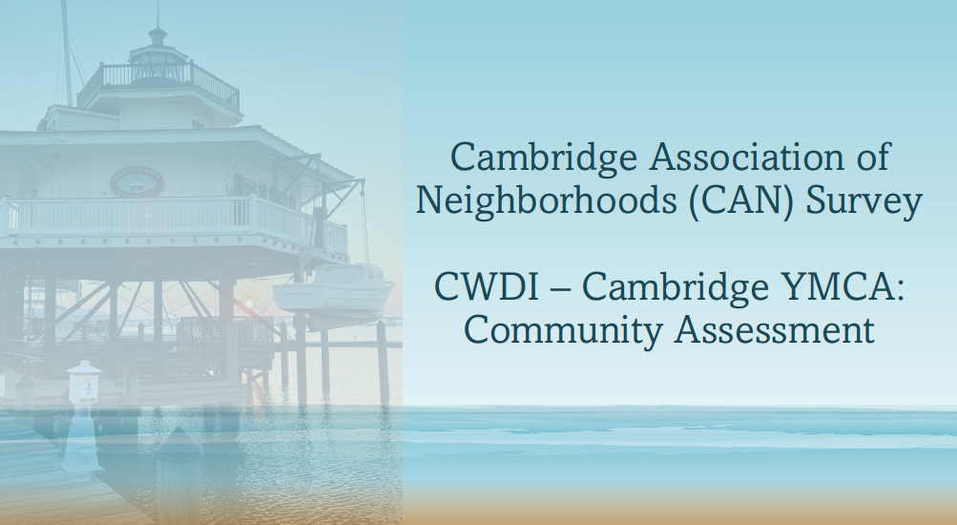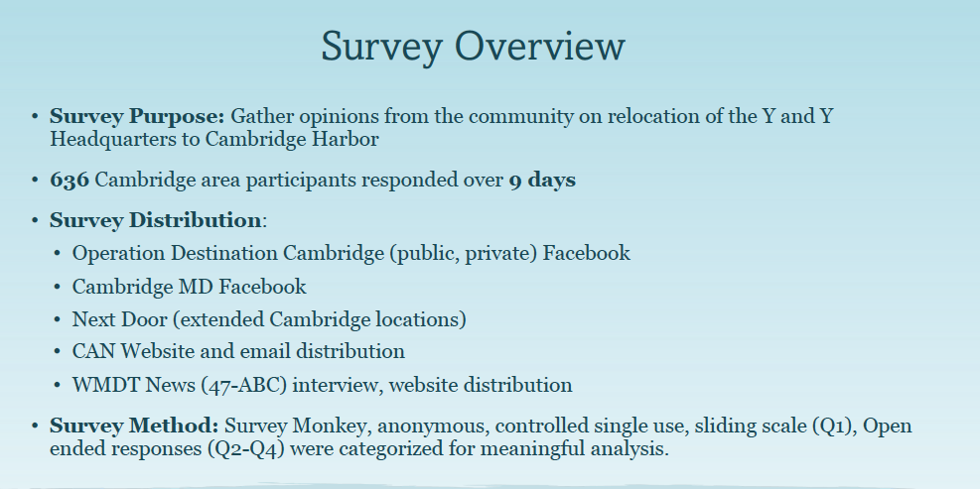

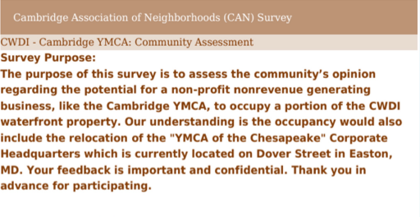 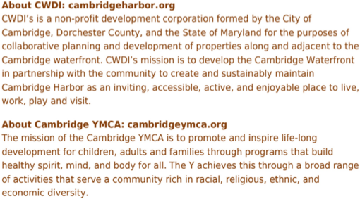,.
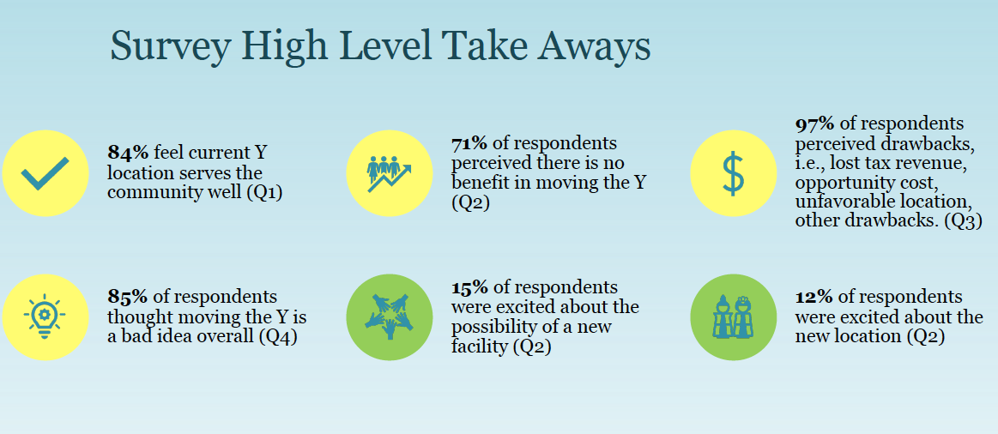

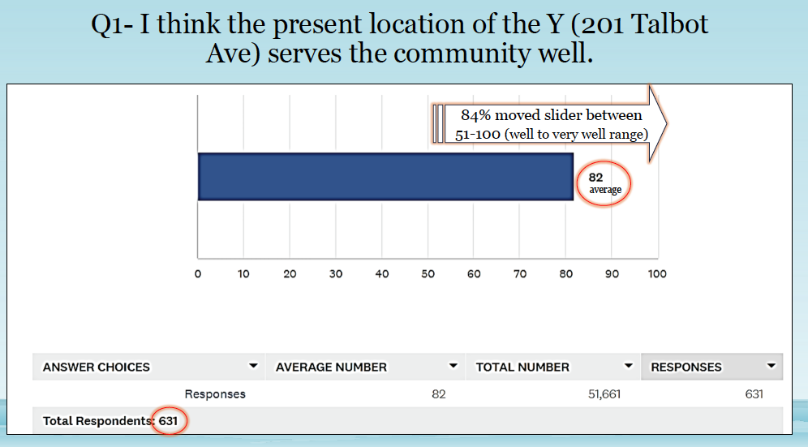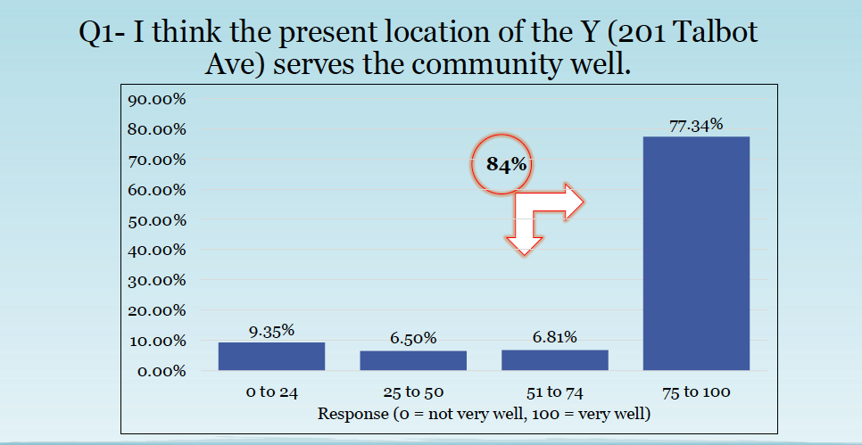

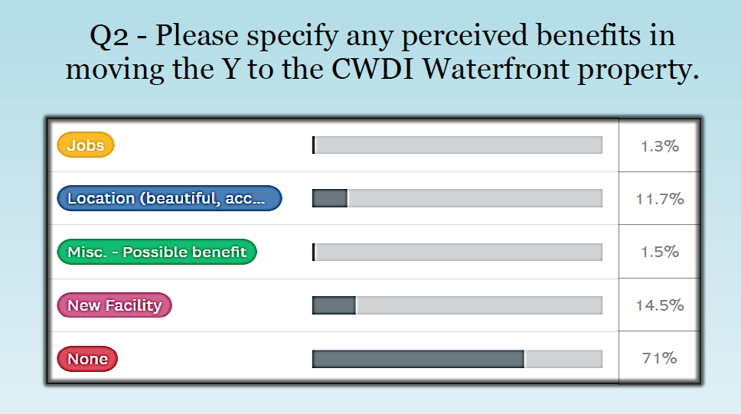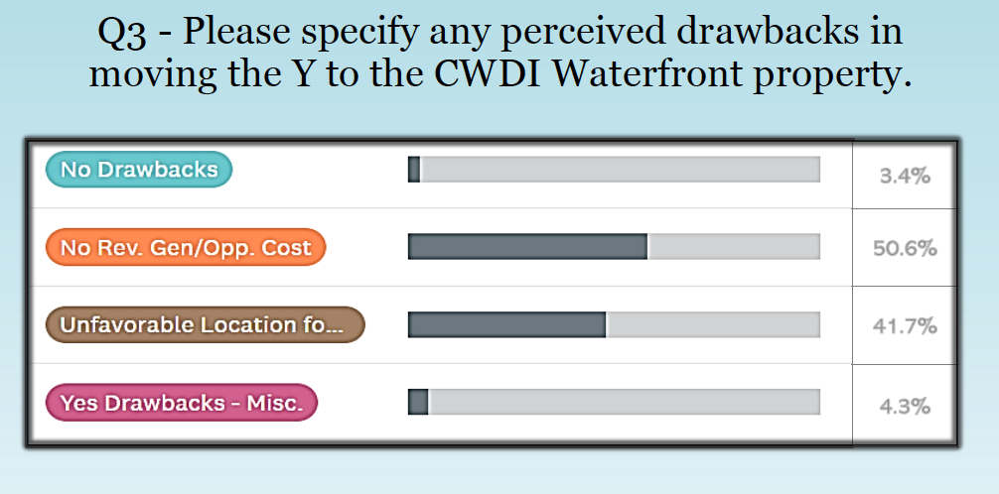

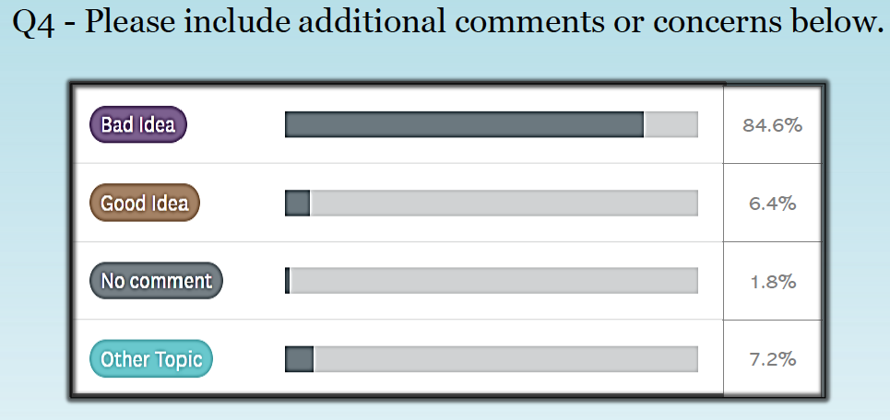
CAMBRIDGE REAL ESTATE TRENDS
-- Fred & Martha Phillips-Patrick

National and Regional Residential Real Estate Developments

May is traditionally one of the best months to put a house on the market. However, this year, high mortgages rates, limited supply of houses, and steep home prices have made this a tough market. According to Freddie Mac, “After a five week climb, mortgage rates ticked down (to 7.09% on a thirty-year fixed rate mortgage) following a weaker than expected jobs report. An environment where rates continue to hover above seven percent impacts both sellers and buyers. Many potential sellers remain hesitant to list their home and part with lower mortgage rates from years prior, adversely impacting supply and keeping house prices elevated. These elevated house prices add to the overall affordability challenges that potential buyers face in this high-rate environment.”

How did Cambridge fare in this tough market environment in April, 2024? Let’s see.

Cambridge Market Update

According to Realtor.com, Cambridge was no longer a buyer's market in April, 2024. It had become more balanced which means that the supply of homes is about equal to the demand for homes. The median listing home price in Cambridge was $289.9K, flat year-over-year. The median home sold price was $265K. The trend for median days on market, at 44 days, in Cambridge has gone down since last month, and slightly down since last year. Homes in Cambridge sold for 0.96% below asking price on average in April.

Sales

Currently, according to Realtor.com, there are now 182 homes for sale (136 single family homes and 46 condos and townhomes) in the Cambridge area, up from March. There are also 3 multifamily units for sale, as well as 50 farms and plots of land. The properties’ asking prices range from $10,000 for a small plot of land (.06 acres) on Phillips Street to $2,345,000 for a house on Ross Neck Road, the same as last month.

According to Zillow.com, in April, 2024, 56 houses, condos, and townhouses were sold in Cambridge. Only some of the listing provided information on sales price versus listing. Those marked in red were sold below listing price. For example, 807 Phillips St was listed at $62,000, but sold for $35,000. The sold properties ranged in value from 807 Phillips Street at $35,000 to 6142 Todds Point Road at $1,220,000.

145 Regulator Dr N $386K 509 Clinton St $ 67K 211 Yellow Bill Ln $239K
203 Yellow Bill Ln $210K 604 Bethel St $180K 2040 Dailsville Rd $ 75K
1003 Race St $221K 602 Widgeon Way $236K 406 Dorchester Ave $160K
103 Markley Ct $390K 2517 Southside Dr $450K 611 Wood Duck Dr $175K
1001 School St $275K 427 Willis St $ 85K 401 Yellow Bill Ln $238K
405 Yellow Bill Ln $214K 409 Yellow Bill Ln $237K 30 Saddle Bill Cir $305K
35 Marabou Way $326K Regulator Dr No Dr $386K 415 Kent St $100K
NE S Stone Boundary $1100K 411 Yellow Bill Ln $245K 32 Saddle Bill Cir $303K
509 Edgewood Ave $420K 303 Shepherd Ave $167K 403 Yellow Bill Ln $221K
31 Marabou Way $277K 1426 Town Point Rd $275K 18 Snowy Egret Way $257K
506 Rippling Rd $815K 603 Edlon Park $210K 700 Cattail CV #106 $190K
108 Audubon Ct $298K 703 Wood Duck Dr $180K 378 Robbins Farm $306K
2427 Rock Dr $320K 6142 Todds Point Rd $1220K 120 W End Ave $209K
219 Kilarney Rd $215 5307 Suburban Dr $ 66K 502 Merganser Way $210K
317 Oakley St $280K 3102 Aireys Rd $140K 323 W End Ave $124K
1654 Terrapin Cir $316K 411 Eagles Nest Way $255K 700 Cattail CV #310 $225K
385 Robbins Farm Rd $276K 807 Phillips St $ 35K 412 E Appleby Ave $150K
912 Peachblossom $190K 102 Choptank Ave $437K 374 Robbins Farm Rd $350K
378 Robbins Farm Rd $306K 389 Robbins Farm Rd $275K

Cambridge in the News

United States Department of Housing and Urban Development presented the City of Cambridge with a check for $1.8 million for a three-year Office of Lead Hazard Control and Healthy Homes Fiscal Year 2024 Lead Hazard Reduction Capacity Building grant program. The grant provides funding for training certified lead paint removal specialists and abating lead paint in homes older than 1978.

The goal of the program is to fix older housing, preserve affordable housing, and improve the health of children and families in the communities that received the grant. Cambridge was just one of four such communities to receive a grant in the State of Maryland. Nicely done.

CAMBRIDGE HARBOR “TIF” INFRASTRUCTURE FINANCING
-- Sharon Smith

Much controversy has arisen over the development of Cambridge Harbor, especially the up-front costs. For Cambridge Harbor (CH) to be developed, Cambridge Waterfront Development, Inc.(CWDI) maintains that infrastructure must be installed - water and sewerage lines, power, streets, sidewalks, parking, lighting, and telecommunications. CWDI estimates that the infrastructure improvements will cost over $40 million.

CWDI is proposing that the City and County sell over $30 million in bonds to pay for part of the infrastructure. The loan period for the bonds is for 29.5 years (2025-2054) during which time over $60 million will be paid out of City and County taxes for interest and principal on the bonds. The source of the tax revenue to pay off the bonds is through an approach called “tax increment financing” (TIF).

As Cambridge Harbor is developed, the assessed value of the property increases and, therefore, the property tax revenue from CH increases. If all goes as planned, payment for the infrastructure will come from this additional tax revenue that the City and County don’t currently receive. CWDI has not yet identified the source of the $10 million in infrastructure that the bonds don’t cover. The plan is for the bonds to be issued in January 2025, allowing a year for the infrastructure to be installed.

The development of Cambridge Harbor and associated completion dates are projected as follows:

- A 100-room hotel (2026)
- Food and beverage establishments (2026)
- Retail (2026-2027)
- A second municipal marina, 125 slips (2026)
- A tax-exempt fitness and recreation facility (YMCA) (2026)
- Sale of 2.6 acres to Yacht Maintenance (2024)
- 233 townhomes, single family homes, and condominiums (2026-2028).

All projections of costs and revenue into the future entail risks of being inaccurate, which would affect the ability to retire the bonds as scheduled. The assessed value of the improvements is what creates the tax revenue to retire the bonds and, ultimately, fund future city operations.

Some of the risks are more obvious than others. The “comparable” properties used to develop the assessment estimates for the improvements at CH – condos, townhouses, houses, hotel rooms, retail and commercial establishments — come from an odd selection of properties in Ocean City, Ocean Pines, Berlin, St. Michaels, Stevensville, and so on. Very few numbers are based on Cambridge property values. Given the relatively low assessed value of real estate in Cambridge, the projections of the value of CH real estate may be over-stated.

The rate at which the residences will be purchased and become tax-paying entities may be overly optimistic. The TIF projections assume that all 233 residences will be built and sold between 2026 and 2028, which averages 6 – 7 properties per month. Between April 2023 and March 2024, the 21613-zip code reported 282 sales, or 23.5/month, with about 150 on the market at any moment in time.

The challenge in meeting the projected sales for CH may be the competition. For example, The Tides at River Marsh (Hyatt) is currently offering townhomes at $299,990 for a 3 bedroom, 2.5 bath, 2,117 square foot home with garage and adjacent golf course, pool, swimming, marina, and restaurants. By contrast, Cambridge Harbor will be offering 116 townhomes of 1,696 square feet assessed at $406,961 each. Furthermore, LakeSide in Trappe is planned to offer 2,400 residences.

An important calculation that does not seem to be considered in the TIF projections is the speed with which assessed value converts to collectible tax revenue. The TIF appears to assume that the assessed value converts to collectible tax revenue within the year the property is sold. However, the State of Maryland assesses real estate on a three-year cycle, so tax revenue will always lag the TIF projection by several years.

Tax Increment Financing is a technique that has enabled municipalities to develop property ahead of tax revenue receipts for a number of years. MuniCap, Inc., which CWDI has engaged to create its financial projections, has extensive experience with this technique, but for everything to go as planned requires the calculations to be based on sound assumptions. (This analysis is based on the MuniCap, Inc. TIF Analysis #7, provided by CWDI).

CAMBRIDGE FUN FACTS AND LORE – A Little History and an Update on The Wallace Office Building
-- Martha Phillips-Patrick

The Wallace Office Building, the very small white building located on the front corner of the Public Library property on Gay Street, is one of the oldest commercial buildings in Cambridge.
A large brick mansion, nicknamed "The Hill," possibly dating back to the time of the Calvert family, also stood on what is now the Library property. It is thought that the mansion once served as home and headquarters of Sir Roger Woolford, a representative on the Eastern Shore to Lord Baltimore. The two large gravestones on the front lawn of the Library are those of John and Margaret Woolford, who died in the early 1770s and are assumed to have lived in the mansion during this time. The Wallace Office Building was a later addition to The Hill estate.

For a time, the mansion was home to James Wallace. It was Wallace who built the small Greek Revival Office Building on the property circa 1852 to serve as his law office (visitdorchester.org).The Hill property went through several other hands before being acquired by the City of Cambridge with the mansion serving as the Dorchester County Health Department from 1941 to 1971. The main building was demolished on March 11, 1971, to make way for the current Dorchester County Public Library.

The small Wallace Office Building on the property, however, survived. It was acquired with the Library's purchase of the land, is owned by the Library, and has been leased by various non-profit groups over the years (dorcesterlibrary.org/library-history). Crystal Henningsen, Director of the Dorchester County Public Library, provided the following information and history regarding renovation efforts for the Office Building from 2005 to the present.

From 2005 to 2017, the small Office Building was leased to the West End Citizens Association for renovation. The lease was terminated due to inactivity with the project. The Library then sought to continue efforts to renovate the Building and received a grant from the Maryland Historic Trust (MHT) in 2018. This grant covered the stabilization of the column on the front porch, removal of the floor damaged by Powder Post beetles, removal of the windows so that they would be protected, and removal of part of the exterior stucco.

When that grant was completed, the library applied for, but was not awarded, a subsequent grant to continue the project. This left the building without a floor, without its windows in place, without power or sewer, and with half of the exterior white stucco still in place; hence, the less than half-finished appearance of the building.

However, Historic Cambridge, Inc. (HCI) was able to secure a grant from MHT to continue the renovation project and leased the building beginning in 2019. Before work could begin and the grant be used, the pandemic occurred. Due to a lack of members and inactivity, the President of HCI dissolved the organization in December 2023. This put the Library back at square one once again with the building.

The Library Board of Trustees is currently considering the many factors involved in the Wallace Office Building renovation project, including the estimated amount of time and experience required to complete the project, additional funding considerations, the possible approval of a committee or another nonprofit group to take on the project, and the overall best path forward to prevent additional setbacks"
(Library.org/library-history, Visitdorchester.org).

Special thanks to Crystal Henningsen, Director of Dorchester County Public Library, for the updates regarding the continuing efforts by the Library to have the renovation of the Wallace Office Building completed and to preserve its historic importance in Cambridge.

COMMUNITY NEWS – COOPERATING COMMUNITY ORGANIZATIONS

WHCP-FM 91.7 – Spring Membership Drive is Here!

WHCP is a registered 501(c)3 non-profit organization supported by Membership Donations and Business Sponsorships. We are the only independently owned radio station on the Mid-Shore that provides local content, community news and information, and locally curated music programs! Our Giving Campaign runs until June 1st, and we hope you will consider making a tax-deductible donation. Thank you! | 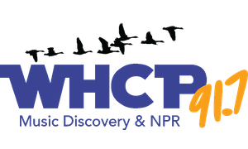

CAMBRIDGE EMPOWERMENT CENTER

We’re Growing! While we’re planning our summer activities, we’re growing into Pre-K for this Fall!
We’ve hired our necessary teachers and have enough little bitty kids to start, with room for more.

Gearing up for Summer. Every summer 45 children, ranging in ages from 5 to 13, come to us for a safe and productive summer to learn and grow. Our summer program is comprised of 4 days a week of care and learning. It lasts for 9 weeks. During that time, the children will receive 2 meals and a snack daily. In addition to academics, the days will include arts and crafts, physical education, music, games, educational trips, science experiments, building and making things, sensory play, cooking and more.

A recent article in the New York Times presented a study which showed that in numerous areas of the country, including Dorchester County, children have not recovered from COVID academic losses.
Many of our children are 2 years behind or more in math and reading. Our goals and passion are to assist these children recover some of their losses. Children will participate in learning activities, including an online learning program, for 2 or more hours each day. Last summer 70% of our students made a 2-month or more gain in reading level, and a 50% gain in math.

Winding Down our After School Program. Thanks to a grant from our Health Department, our “After-School” kids are learning about healthy living. Good food and no smoking/vaping. They are planning a menu for their parents! And we’ll host it and give them a big successful evening.

You can make a Difference! You can create a lasting impact in our community! We always looking for volunteers to help tutor, mentor, or work one-on-one with our students. To donate online, go to our website – cambridgeempowermentcenter.org or send a check to: Cambridge Empowerment Center, PO Box 494, Cambridge, Md. 21613

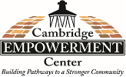
HABITAT CHOPTANK RESTORE

The Habitat Choptank ReStore, located in Easton, MD, is a retail business that sells donated goods to generate revenue to support Habitat Choptank and its mission to build homes, community and hope in Dorchester and Talbot Counties. The ReStore is looking for interested individuals, willing to volunteer in a variety of capacities in a flexible environment. Karen, a regular volunteer at the ReStore, shares some of her experience and what volunteering really means to her.

Karen lived in Massachusetts for the last 30 years and moved to the area just 3 years ago. Recently retired, she found herself wanting to give back her time through volunteering for an organization with a mission that was meaningful to her.  "The mission is important" shared Karen, "How much more can you help someone than with a home of their own. It's the most important thing in the world. It's dignity, it's everything. If someone is safe, secure, and has their own pride of ownership in housing, a lot of the other kind of issues that may have gotten in the way are alleviated."  When asked what she enjoys most about volunteering at the ReStore, her answer was simple - the people. From the care and intentionality of Anne, Kelly, Ryan and the ReStore team, to the volunteers and customers she gets to meet, "the work doesn't always sound glamorous, but it's a lot of fun," Karen explains. | 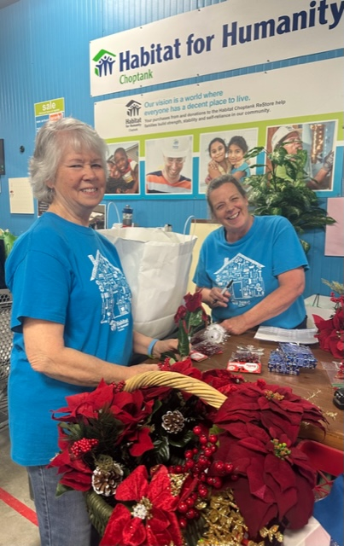  Pictured at left is  ReStore volunteer Karen

Interested in helping out at the ReStore?
Karen shares, "If you have an internal motivation and passion for a worthwhile mission and a good pair of shoes, you have a place here!" For more information on volunteering at ReStore, visit https://habitatchoptank.org/volunteer/individuals/ and fill out the interest form, or reach out at volunteers@habitatchoptank.org

MAIN STREET GALLERY - Joy Through Art is MSG’s Spring Show

Main Street Gallery is excited to be exhibiting the artwork of Joy Staniforth, as its guest artist for the May/June show. Joy, a resident of Cambridge, has titled her show “Joy Through Art,” and she will be showing alongside the nine member artists of the gallery. A maker of many types of art, Joy will be showing unique jewelry made of wire, textiles and tumbled rocks, as well as bold textile wall hangings and examples of her most recent artistic passion, a paper art called quilling.

Joy Through Art will open on run through June 30. There will be an artist reception at the gallery on Second Saturday, June 8 from 5-8 pm. The receptions are free and open to the public and all are welcome. Light refreshments will be served. Joy will give a workshop on quilling on June 8 from 1-3 pm at the gallery. This event will be free and open to all. She will also give a brief artist talk at the June 8 reception. Main Street Gallery is located at 518 Poplar St. in Cambridge, and is part of the vibrant Arts and Entertainment District. Gallery hours are Thursdays through Mondays from 11-5.

MIDSHORE MEALS TIL MONDAY

MidShore Meals 'til Monday is working to end childhood hunger on Maryland’s Eastern Shore by providing weekend food for food-insecure children in Dorchester County. Meals ‘til Monday sends home healthy, nutritious food for children at the end of each school week and during the summer months for breakfast, lunch and snacks to bridge the hunger gap for children without access to adequate food.

Meals ‘til Monday currently provides food for more than 500 elementary, middle and high school students. Donations can be made at https://www.mscf.org/donate-online/. For more information, please call the Director at 703-371-5191 or visit their website at www.midshoremealstilmonday.org/. | 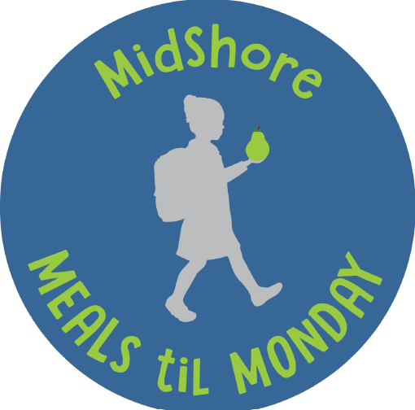

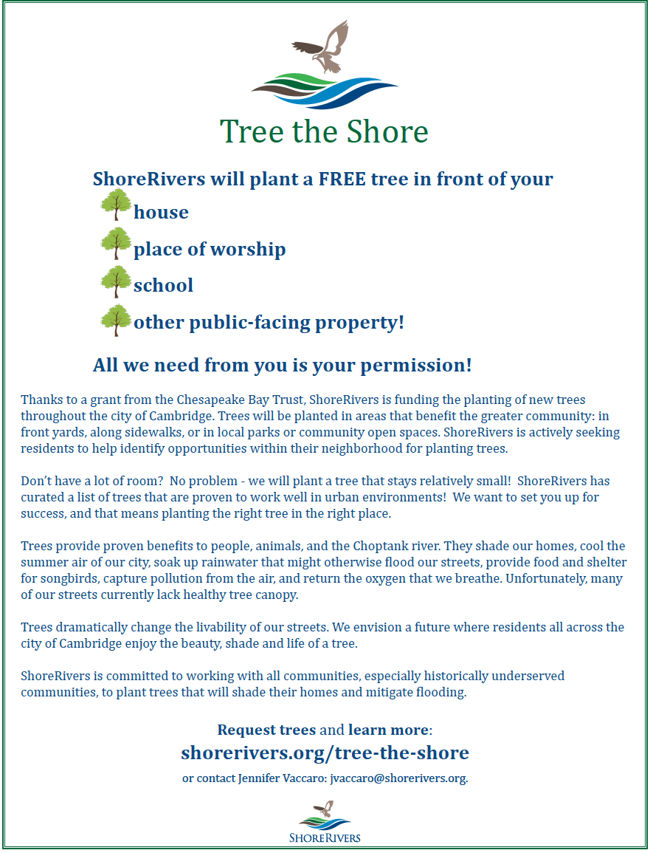

CAN MISSION, MEMBERSHIP, BOARD of DIRECTORS, and COMMITTEES

MISSION. The Cambridge Association of Neighborhoods (CAN) fosters neighborhood cohesion and community involvement to enhance the quality of community life for all residents of Cambridge through community events, social activities, and neighborly assistance. CAN protects and enhances properties in Cambridge by improving building and zoning codes, supporting adherence to those codes, and engaging constructively with City Government, including the Historic Preservation Commission. CAN’s Bylaws can be found on the CAN website at https://cambridgecan.org/welcome/about/bylaws/.

MEMBERSHIP. CAN welcomes members from all Cambridge area neighborhoods (broadly defined) who are interested in organizing and working together, building a diverse membership reflecting the diversity of Cambridge residents. Membership is FREE – information is available on the CAN website at https://cambridgecan.org/join-can/

CAN BOARD OF DIRECTORS. CAN is governed by a Board of Directors elected by CAN members at its annual January Business Meeting. Board Members whose terms expire in January 2026 are President – Chuck McFadden; Treasurer – Dave Thatcher; Members at Large – Mary Ellen Jesien, Kim Miller, Brad Rice, Donna Tower, and Judd Vickers. Board Members whose terms expire in January 2026 are Vice-President – Roman Jesien; Secretary – Tom Puglisi; Members at Large – Andre Duerinckx, Rick Klepfer, and Sharon Smith.

CAN HOUSING QUALITY COMMITTEE – PLANNING AND ZONING ISSUES. The Housing Quality Committee monitors issues affecting the quality of housing and the maintenance of property values in the City, including code enforcement. Committee members attend Planning Commission meetings to monitor zoning-related issues and report the information to the Board and Membership. Please contact Chuck McFadden at Ragtime31@gmail.com to volunteer.

NEIGHBORHOOD DEVELOPMENT COMMITTEE – SOCIAL EVENTS & ‘NEIGHBORS HELPING NEIGHBORS’.
"Neighborhoods" are organized by small groups willing to work together to address neighborhood issues through small social events and "neighbor-helping-neighbor” activities. The Social Events Subcommittee organizes community-wide events. Contact Chuck McFadden at Ragtime31@gmail.com to volunteer.

CAN COMMUNICATIONS COMMITTEE – WRITERS NEEDED. CAN'S Communications Committee needs writers, including volunteers to take unofficial notes at public meetings. Please contact Tom Puglisi at tom.puglisi@comcast.net to volunteer.

POWER WASHER AVAILABLE

CAN has an electric power washer available to members. Contact Chuck McFadden at Ragtime31@gmail.com.

