Newsletter #24.06 JUNE 2024

CAN member meetings are announced in advance and open to the public.

Next CAN Public Meeting – July 11, 6:30 pm, Dorchester County Public Library, Cambridge

Everyone interested in CAN is invited to attend.

IN THIS ISSUE: page

PRESIDENT’S MESSAGE – The YMCA Has Us Talking 2

CAMBRIDGE CORNER 2
- Cambridge Real Estate Trends 2
- Cambridge Police Department Update 4
- Cambridge Fun Lore – Jousting - Maryland’s State Sport 4
- Cambridge Shoreline Resilience 6

Community News – Cooperating Community OrganizationS 7
- WHCP Membership Drive 7
- Cambridge Empowerment Center 8
- Midshore Meals ‘til Monday 9
- Main Street Gallery – Joy Through Art 9

CAN Mission Statement, MEMBERSHUP, Board OF DIRECTORS, and Committees 11

CURRENT LINKS

CAN’s Website – https://cambridgecan.org
JOIN CAN FOR FREE – https://cambridgecan.org/join-can/
CAN Meeting Minutes – https://cambridgecan.org/category/meetings/
CAN Meeting Videos – https://www.facebook.com/WHCPRadio/videos or
https://www.youtube.com/@whcpstudio4716
CAN’s City Council Meeting Notes – https://cambridgecan.org/category/news/city-council-notes/
CAN’s Planning & Zoning Notes – https://cambridgecan.org/category/news/p-and-z/
CAN on FaceBook – https://www.facebook.com/CambridgeAssociationofNeighborhoods/
Contact CAN – CambridgeCAN@yahoo.com

PRESIDENT'S MESSAGE – The YMCA Has Us Talking!
-- Chuck McFadden

Well, the YMCA has the neighborhood talking about the “Move” – First, they seemed to announce in their own newsletter that the YMCA is “building a new Robbins Family Y at Cambridge Harbor” and then, they claimed there is no deal. Finally, they sent an invitation to a select group of Y members to RSVP to a meeting to clarify the situation and present the findings of their survey, which is now almost 2 years old.

What people need to keep in mind when considering Cambridge Harbor, is that it’s not what is good for the YMCA that counts, but what is good for the City of Cambridge. Since everything regarding Cambridge Harbor is held in the strictest of secrecy, no one ever really knows what is true and what is rumor. Does the possible YMCA-Cambridge Waterfront Development Inc. (CWDI) deal mean the Y wants to swap its 6 acres in Ward 1 for 1.2 acres in Cambridge Harbor, plus free parking for the estimated 900 Y members each day, plus use of the Sailwinds swimming area for YMCA programs and rental of kayaks and canoes?

Sounds like a good deal for the YMCA, since (i) they don’t have to pay market price for the land; (ii) they don’t have to demolish the old school building; (iii) they get free use and maintenance of the Sailwinds parking lots: and( iv) they are not charged for their use of the swimming area. The City gets (i) a low price for the Cambridge Harbor land, (ii) an unused school building at the current Y property, (iii) a non-tax paying entity, and (iv) a big industrial-looking building on the prime lot in Cambridge Harbor.

There are a number of questions about the value of the land the Y wants to give up to CWDI compared to the best lot in Cambridge Harbor that they’d be getting. Since all the discussions between the Y and CWDI are secret, it is difficult to understand what is going on. Hopefully, the mediation process with the City and CWDI will clarify what CWDI can and cannot do. In the meantime, the citizens of Cambridge wait in ignorance as to what is really going on.

More to come.

-- Charles McFadden, President, CAN

CAMBRIDGE CORNER

CAMBRIDGE REAL ESTATE TRENDS
-- Fred and Martha Phillips-Patrick

National and Regional Residential Real Estate Developments

According to Freddie Mac, “Mortgage rates continued to all back this week as incoming data suggests the economy is cooling to a more sustainable level of growth. Top-line inflation numbers were flat but shelter inflation, which measures rent and homeownership costs, increased showing that housing affordability continues to be an ongoing impediment for buyers on the house hunt.” Nationally, the average 30-year fixed rate mortgage fell slightly to 6.95%. However, a survey of local lenders in Maryland revealed that mortgage rates for these types of loans vary considerably, as much as 1 percent. Over the lifetime of a mortgage, a 1 percent lower rate could result in as much as $50,000 total lower loan repayments, based upon a $250,000 mortgage. Well worth the effort to shop around. How did Cambridge fare in this market environment in May, 2024? Let’s see.

Cambridge Market Update

According to Realtor.com, Cambridge returned to be a buyer’s market, where the supply of homes is greater than the demand for home. The median listing home price in Cambridge was $288K, up 6.7% from last year. The median home sold price was down to $225K. The trend for median days on market, at 55 days, in Cambridge has gone up since last month, but only slightly up since last year. Homes in Cambridge sold for approximately their asking price on average in May.

Sales

Currently, according to Realtor.com, there are now 182 homes for sale (132 single family homes and 50 condos and townhomes) in the Cambridge area, the same as April. There are also 4 multifamily units for sale, as well as 57 farms and plots of land. The properties’ asking prices range from $10,000 for a small plot of land (.06 acres) on Phillips Street to $2,950,000 for house on Hudson Road.

According to Zillow.com, in April, 2024, 44 houses, condos, and townhouses were sold in Cambridge. The sold properties ranged in value from 33 Saddle Bill Circle at $36,000 to 5816 Ross Neck Road at $1,450,000.

107 Albemarle Ct $403K 5704 Glasgow Ct $405K 33 Saddle Bill Cir $36K
1665 Terrapin Cir $300K 5340 Bucktown Rd $160K 511 Yellow Bill Ln $249K
9 Kiowa Rd $268K 1 Buena Vista Ave $195K 407 Yellow Bill Ln $203K
503 Yellow Bill Ln $222K 509 Yellow Bill Ln $228K 21 Saddle Bill Cir $259K
507 Yellow Bill Ln $232K 118 Black Duck Ct $219K 5415 Moose Lodge Rd $215K
512 Glenburn Ave $240K 408 Aurora St $170K 312 Somerset Ave $615K
400 Eagles Nest Way $365K 1019 Miles Ave $195K 3207 Holly Ln $335K
213 Oakley St $315K 1650 Terrapin Cir $270K 1105 Race St $205K
6126 Twin Point Cove $390K 112 W. End Ave $225K 213 Dorchester Ave $155K
1623 Terrapin Cir $280K 407 N Seaway Ct #132 $360K 338 Shipyard Dr $273K
423 Willis St $153K 340 Shipyard Dr $283K 104 Mill St $250K
164 N Regulator Dr $505K 393 Robbins Farm $285K 379 Robbins Farm Rd $280K
5816 Ross Neck Rd $1,450K 211 Buena Vista Ave $159K 801 Phillips St $125K
3954 Maple Dam Rd $ 95K 2700 Willow Oak #207D $418K 100 Willis St $425K
305 Glenburn Ave $380K 5532 Bonnie Brook Rd $669K

Cambridge in the News

According to the Dorchester Star: “The Federal Emergency Management Agency has awarded the City of Cambridge $1.7 million for a flood mitigation project along the shore of the Choptank River. According to a news release from the City, the "Make Cambridge Resilient Flood Mitigation Project" will stretch from west of City limits, near Gerry Boyle Park at Great Marsh, to the mouth of Cambridge Creek.
The project will create a flood barrier along the river that is integrated with a nature-based living shoreline. Along with the living shoreline, a stormwater management system will be put in place to reduce flood risk. The City will coordinate directly with affected property owners for concerns and property assessments.”

CAMBRIDGE POLICE DEPARTMENT UPDATE
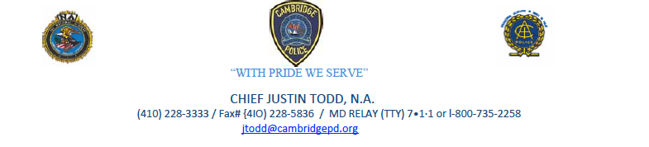
As the summer is in full swing this is just a reminder from your Police Department to please make sure you are locking your vehicles, and all personal belongings are removed from the clear view. Over the past several summers there has been an increase in theft from vehicles as well as vehicle thefts. The Cambridge Police Department is working hard to make sure we put an end to this trend but need your help to prevent crime as well.

Two new officers graduated from the Eastern Shore Criminal Justice Academy on June 14th and are now in their field training process. We also have one recruit that will be entering the police academy on July 1st. Since August of 2022, we have added ten officers to our force. I look forward to the continued success as we as an agency continue to build our force not just by manpower, but also by continuously upgrading our technology which allows our officers the ability to patrol with more purpose and prevent crimes before they occur. I would like to add that I am very happy that the city council approved a Drone program into the FY 25 CPD budget. As policing has changed, a Drone program will help assist us with crime, and improve both officer and citizen safety.

I would like to end with saying that one of the continued complaints that I and other members of the Police Department have received is the constant speeding and reckless operations throughout our neighborhoods. I want to assure everyone that we are aware and are completing a higher number of traffic enforcement than in recent years. We see the negligence of drivers as well and are working to control it throughout our city.

I thank you for your continued support and as always, if you should have any questions, please do not hesitate to contact me jtodd@cambridgepd.org.

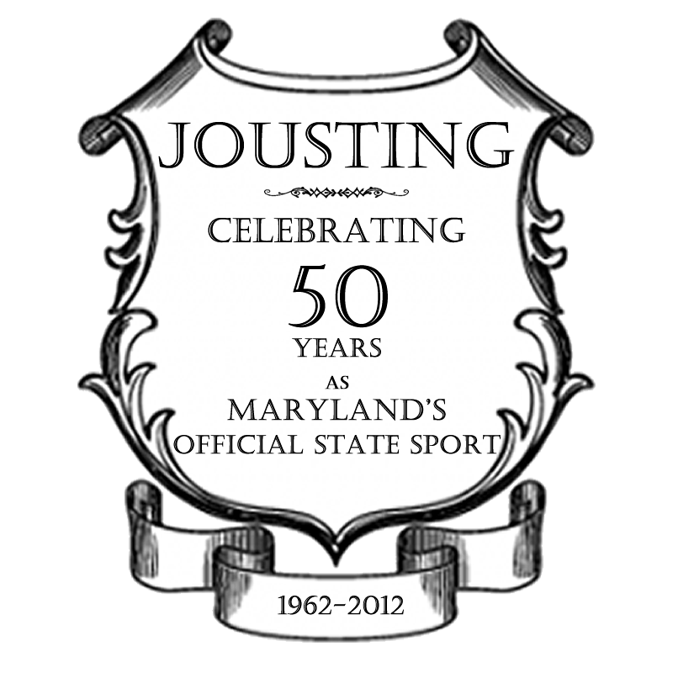
CAMBRIDGE FUN FACTS AND LORE – Ring Jousting -- "Maryland's Official State Sport"
-- Martha Phillips-Patrick

Jousting is a sport synonymous with Maryland history. It has survived in Maryland since the founding of the original colony. The people of Maryland enjoy this sport because of its colorful, friendly, traditional aspects. Men, women and children participate often in the same classes, and always under the same set of standard rules. A Maryland Jousting Tournament is unique in its own right, and depicts the motto of the Great Seal of Maryland. It is indeed a sport of “Manly Deeds and Womanly Words.”

During the special February session of the Maryland legislature in 1962, the Honorable Henry J. Fowler Sr., Delegate from St. Mary's County, introduced a bill into the Maryland House of Delegates giving recognition to the sport of jousting as the Official State Sport of Maryland. This bill passed both chambers of the Legislature by an overwhelming vote and was signed into law by Governor J. Millard Tawes.

Thus, as of June 1, 1962, Maryland became the first state in the United States to adopt an official state sport. We are proud of the honor and of the opportunity to present for the fine people of Maryland, as well as the tourists and visitors from other states, what we proudly hail as the Official State Sport of Maryland.
2024 Summer Schedule of Maryland Jousting Competitions in Our Area
Sponsored by the Maryland Jousting Tournament Association (founded in 1950)

DATE/TIME | JOUST

Sat. July 13, 2024  12:00 Noon | Talbot County Fair Joust  Easton, MD 21601
Sat. August 10, 2024  12:00 Noon | Caroline/Dorchester County Fair Joust  Denton, MD 21629
Fri. August 16, 2024  5:00 pm | Queen Anne's County Fair Joust  Centreville, MD 21617
Sun. August 25, 2024  2:00 pm  Covered dish follows | Queen Anne County Joust  Queen Anne, MD 21657
Sun. September 1, 2024  1:00 pm  Covered dish follows | Caroline County Joust  Denton, MD 21629
Sun. September 15, 2024  1:00 pm | Ridgely Joust  Queen Anne, MD 21657
Sun. September 29, 2024  1:00 pm | ESJA Pre-Championship Joust  Queen Anne, MD 21657
Sun. September 29, 2024  After Pre-Championship | ESJA Championship Joust  Queen Anne, MD 21657
Sat. November 9, 2024  Cocktails 6:00 pm, Dinner 7:00 pm | ESJA Banquet
CAMBRIDGE SHORELINE RESILIENCE –
Cambridge Flood Mitigation Project Phase 1 Awarded $1,706,800.00 – Survey Work to Start
-- Larry White and Virginia Smith

The City of Cambridge is proud to announce that it has received federal funding through FEMA for the design and permitting of its Make Cambridge Resilient Flood Mitigation Project along the shoreline of the Choptank River. The City of Cambridge issued a press release on June 5th informing the community.

Phase I Design will extend until about August 2025. As the design process unfolds, public outreach efforts will continue to ensure that the community is kept informed. These efforts will include but are not limited to direct mailings, in-person outreach sessions, articles in the CAN newsletter, press releases, and regular updates to the project website www.makecambridgeresilient.org.

The City and our consultant team are eager to get started on the Phase I Design process now that this long-awaited funding is available. The City’s design support consultant, Bayland Consultants & Designers, Inc., will be performing field investigations, modeling and assessments, and detailed design and permitting for the project. Performing field survey work as an initial step in the design process is necessary to document existing conditions and to assess stormwater runoff and flooding risks that the City’s Make Cambridge Resilient Flood Mitigation Project will be designed to protect us against. Offshore hydrographic surveys that measure tidal information and other physical features, such as the shape of the shoreline, currents, and water properties have already been completed. Topographic survey work will begin the week of June 17th, with BayLand personnel working intermittently on and around properties along the alignment of our flood mitigation project area for the various field surveys and assessment work.

Topographic survey will be necessary along waterfront properties from High Street to Pinks Pond and along portions of Water Street, Glenburn Avenue, Belvedere Avenue, Oakley Street, Bay Street, and Hambrooks Avenue. Below is a survey plan with topographic survey limits shown in green shading. The survey crew is scheduled to start surveying piers, revetments, bulkheads, etc. along the shoreline on Tuesday and Wednesday of this week.

All property owners within this survey received a letter informing them of this work. In addition, our Project Outreach Lead, Virginia Smith, will be continuously uploading information regarding this survey and future work to the project website.

Our FEMA grant covers both Phase I Design and Phase II Construction. Once FEMA approves our final design and our revised supporting documentation including our final Benefit Cost Analysis, the City will receive funding for construction. FEMA has reserved $16M for Phase II construction.

While we have been eagerly awaiting funding for our flood mitigation project over the last year, the City has expanded the scope of our Make Cambridge Resilient Initiative to include green stormwater management infrastructure, habitat restoration, and water quality improvement, essentially combining our community development efforts with our flood mitigation efforts to achieve resilience of climate change. We have developed a draft of a city-wide Green Infrastructure Plan and submitted a grant application under the NOAA Transformational Habitat Restoration Grant program, for the enhancement of the fish and wildlife habitat and water quality improvement within the living shoreline of our flood mitigation project as a complementary initiative.

In addition to public outreach efforts specific to the flood mitigation project, community development efforts have been ongoing. The Make Cambridge Resilient Initiative along with ShoreRivers co-hosted a “Soak Up the Rain” event on May 7th at the Packing House. The purpose of the session was to provide information to residents on what they can do to reduce the risk of local flooding due to major storms and rain events such as use of trees, vegetive rain gardens and the use of rain barrels. We gave away eleven rain barrels to local residents and provided support for their installation after the event.

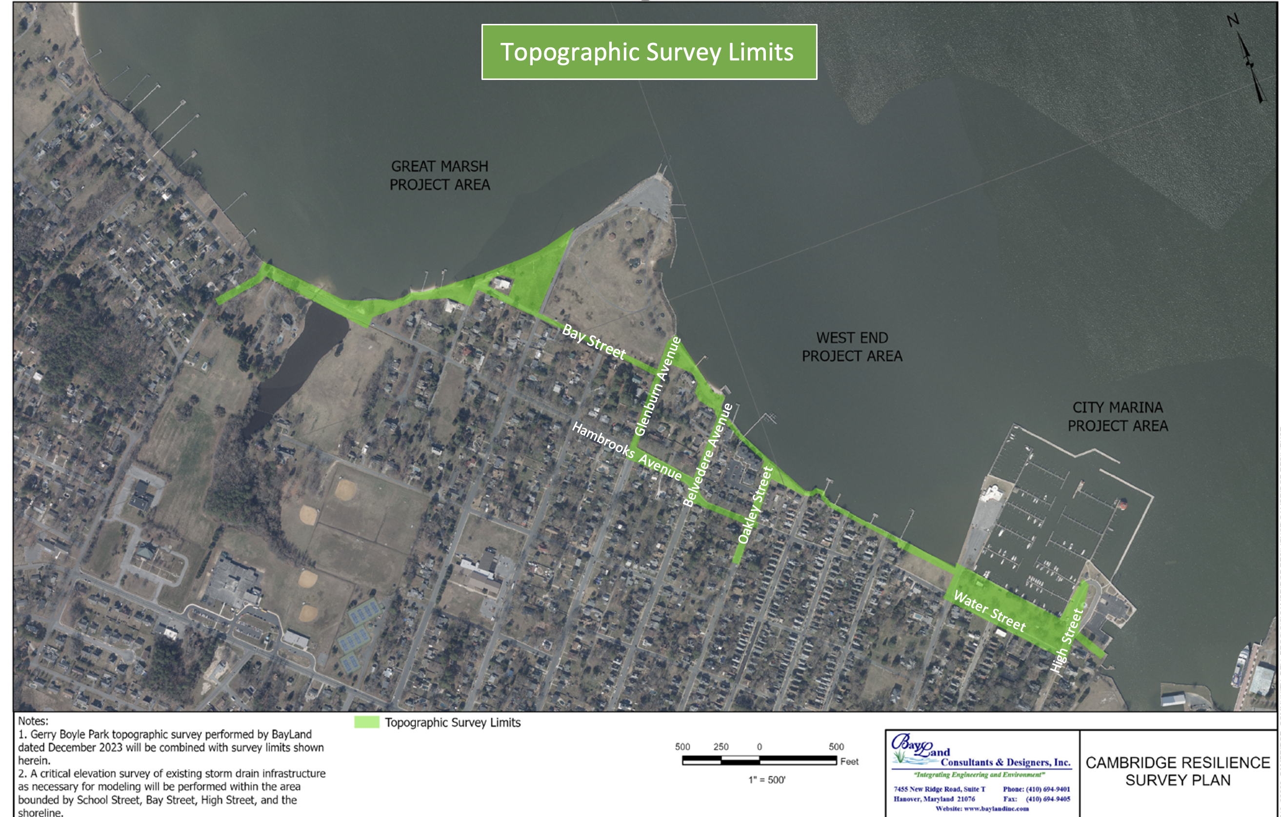

COMMUNITY NEWS – COOPERATING COMMUNITY ORGANIZATIONS

WHCP-FM 91.7 – Spring Membership Drive is Here!

WHCP is a registered 501(c)3 non-profit organization supported by Membership Donations and Business Sponsorships. We are the only independently owned radio station on the Mid-Shore that provides local content, community news and information, and locally curated music programs! Our Giving Campaign has been extended, and we hope you will consider making a tax-deductible donation. Thank you! | 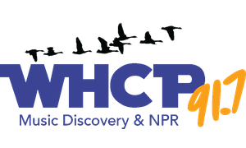

CAMBRIDGE EMPOWERMENT CENTER

We just completed a wonderful month of “Healthy Eating and Don’t Smoke or Vape” learning with our after-school kids.

This was thanks to a grant from the Dorchester Health Department and a shout-out to our Cambridge Police
substation, who coordinated with us for use of their kitchen. Activities included hygiene and food safety, learning about kitchen equipment, planning and making simple meals. It culminated in a community dinner. One additional fun component was a strawberry-picking trip to Emily’s Produce.

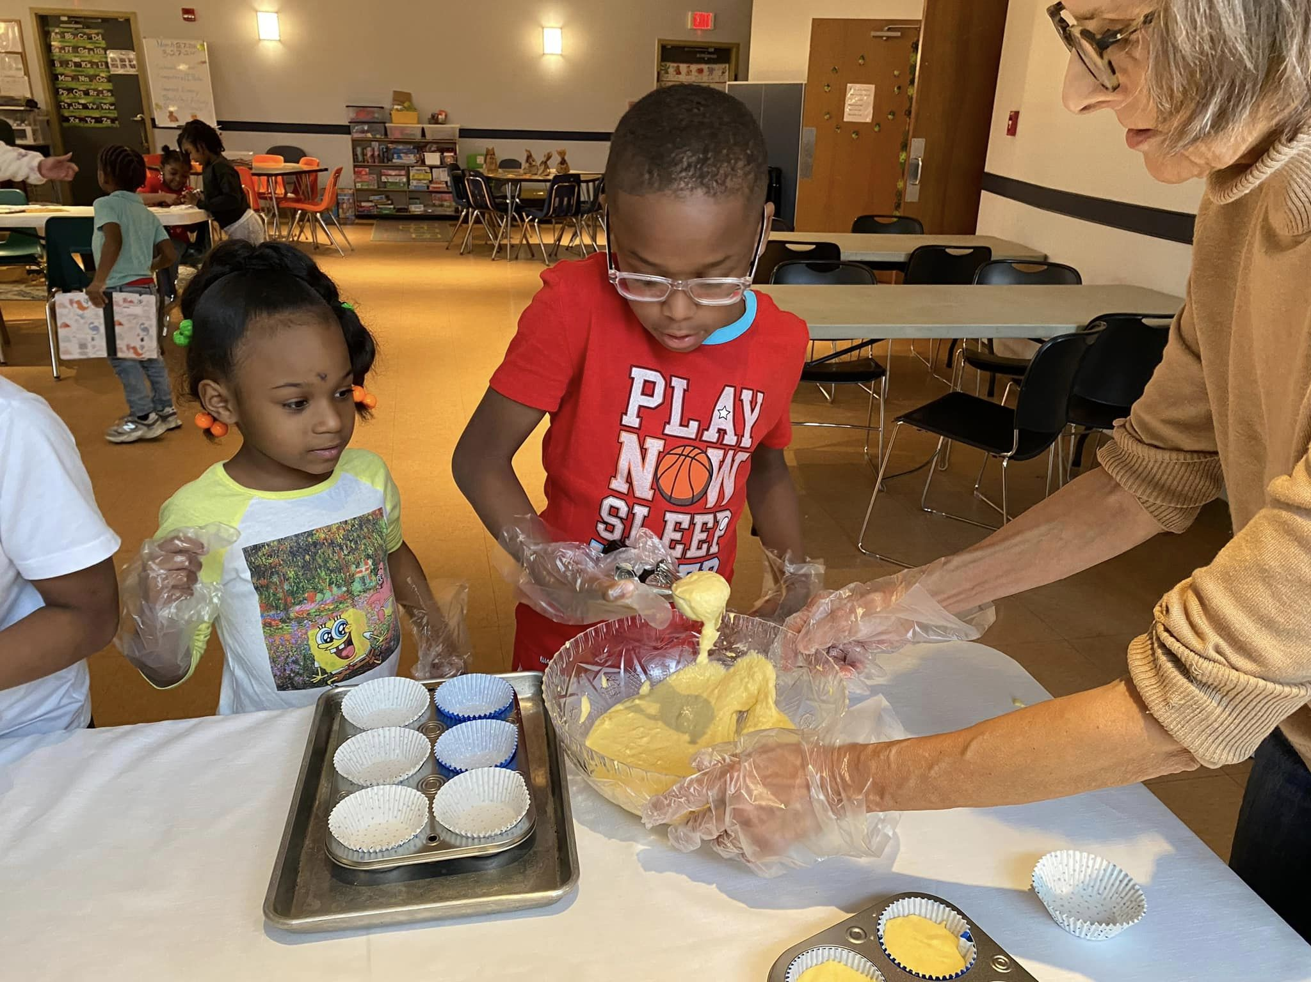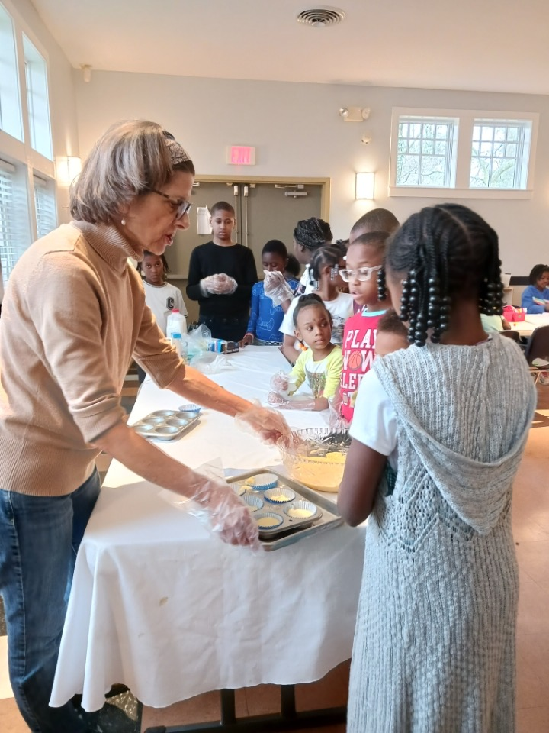

Our Pre-K program is on!

Starting this Fall, we are offering a private, low-cost Pre-K program from Sept to May for children ages 3 to 5
years old. This will run Monday - Thursday from 9AM to Noon.
We still have room. If you’re interested, call us for details.

Our Summer program is starting soon!
To make a difference in a child’s life, you can volunteer as a tutor! A few hoops to jump through for the safety of our kids. We’d love to have you. Call us for details.
Donations keep us alive to offer learning opportunities, field trips, food and more to our underserved community. Matching Grant available – Give $25 and we’ll get $50! Give $100 and we get $200!
You can make a difference in the lives of our children and create a lasting impact.
To donate online, go to our website – cambridgeempowermentcenter.org or send a check to: Cambridge Empowerment Center, PO Box 494, Cambridge, Md. 21613

As always, we thank you for your support.

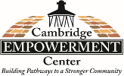

MIDSHORE MEALS TIL MONDAY

MidShore Meals 'til Monday is working to end childhood hunger on Maryland’s Eastern Shore by providing weekend food for food-insecure children in Dorchester County. Meals ‘til Monday sends home healthy, nutritious food for children at the end of each school week and during the summer months for breakfast, lunch and snacks to bridge the hunger gap for children without access to adequate food.

Meals ‘til Monday currently provides food for more than 500 elementary, middle and high school students. Donations can be made at https://www.mscf.org/donate-online/. For more information, please call the Director at 703-371-5191 or visit their website at www.midshoremealstilmonday.org/. | 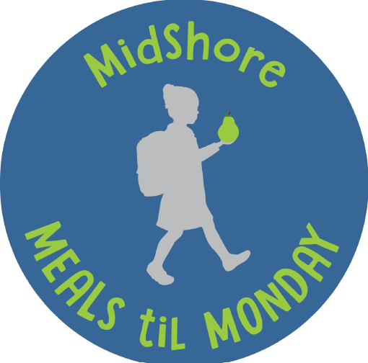

MAIN STREET GALLERY

The Main Street Gallery in Cambridge is delighted to present their summer show, Nature by Metal, with guest artist, Gary Schuler. The show will feature a variety of wild creatures such as a flock of flying geese, foxes, herons and a variety of other animals, all created by the artist from various kinds of metal.

Gary, who lives and works in Cambridge, uses different types of metals such as copper, steel, stainless steel and specialized finishes to create the wide variety of creatures you might encounter while wandering on the Eastern Shore. The artist says that "Living on the Eastern Shore of Maryland has given me a great appreciation of nature and the natural habitats of wildlife that I enjoy capturing in my metal art."

Gary, who will be showing his art among the gallery's nine member artists, says he prefers projects with intricate details and designs that challenge him to achieve the sense of realism he's after in his work. He uses a variety of tools and techniques to create his 3D geese in flight, a full-size 3D shark and bird tree spikes among various other wildlife pieces. His art is well suited for both indoor and outdoor spaces, he says. Some of his creatures, which include rockfish, crabs and deer, are as large as 4' x 4'. Many were commissions and have found new homes on barns, sheds and pole buildings.

Gary, who retired to Cambridge from Pennsylvania, is not new to metal working. He has 40 years’ experience working in aerospace manufacturing and engineering as a journeyman machinist, a certified welder, a manufacturing engineer and a plant manager. He has combined all the aspects of his professional career into his current metal art. "Many of the aerospace projects I worked on were like art unto themselves," he says.

Nature by Metal will open on Friday, July 5 and run through Sunday, September 1. There will be two artist's receptions on Second Saturdays, July 13 and August 10 and Gary will give a brief artist talk at the July reception. Both receptions are free and open to the public. Light refreshments will be served.

Main Street Gallery is located at 518 Poplar St. in Cambridge, and is part of the vibrant Arts and Entertainment District. Gallery hours are Fridays through Sundays from 11-5. The gallery requests that children under 18 be accompanied by an adult.

Main Street Gallery is currently reviewing work from prospective members and guest artists. Please contact MSG through its website @mainstgallery.net or by phoning 410-330-4659 if interested.

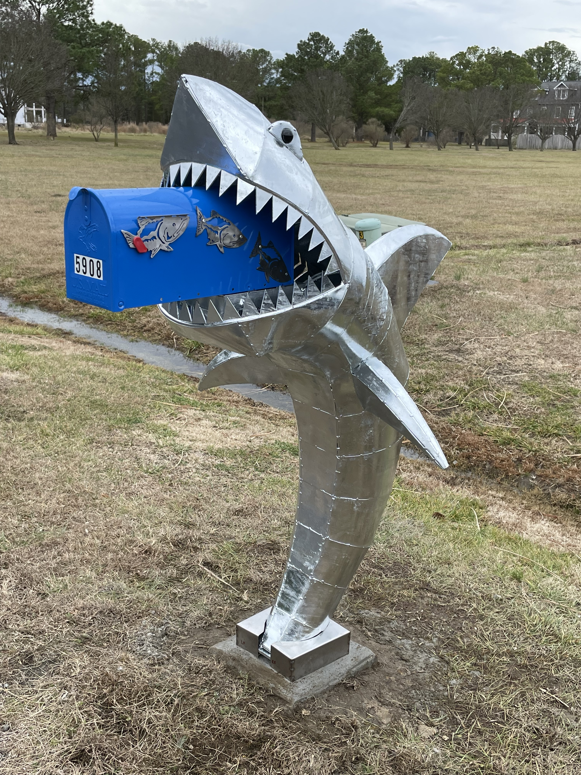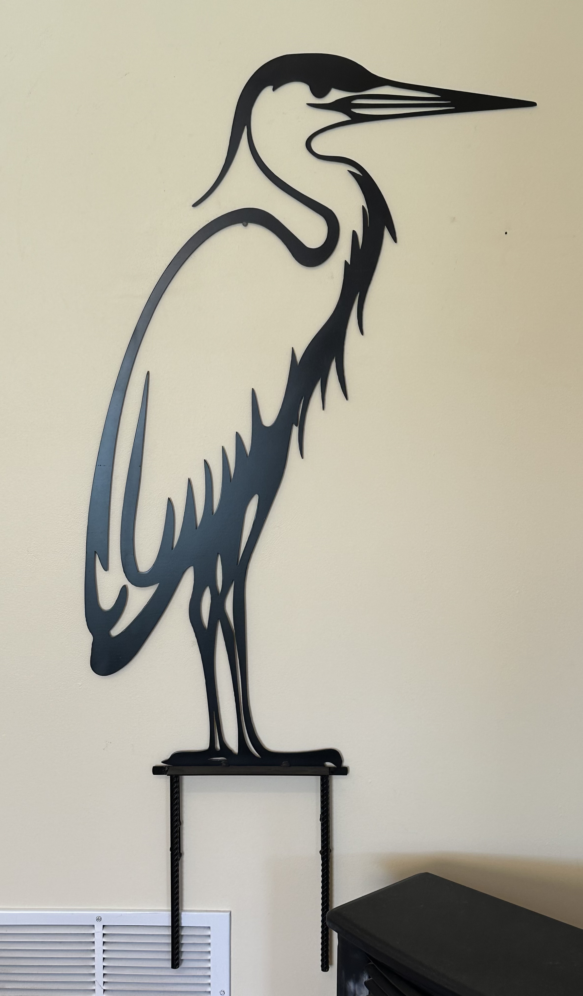

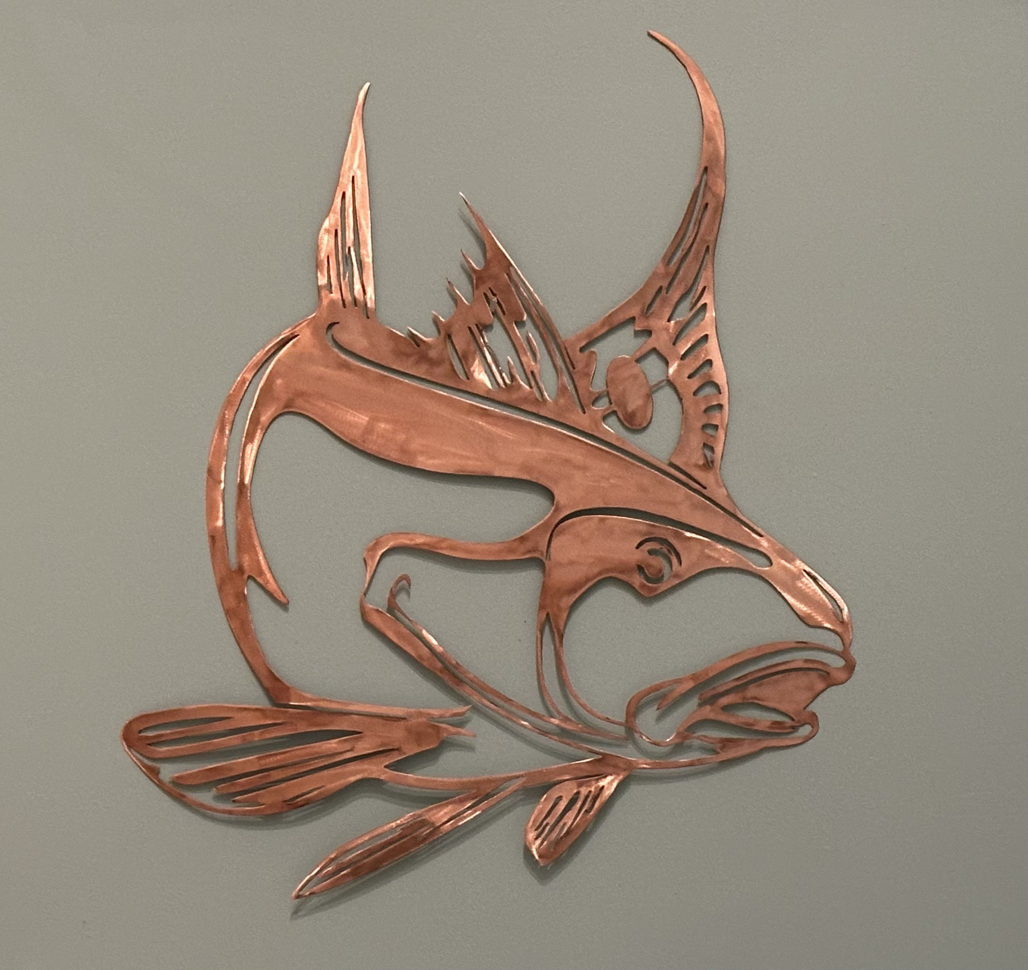

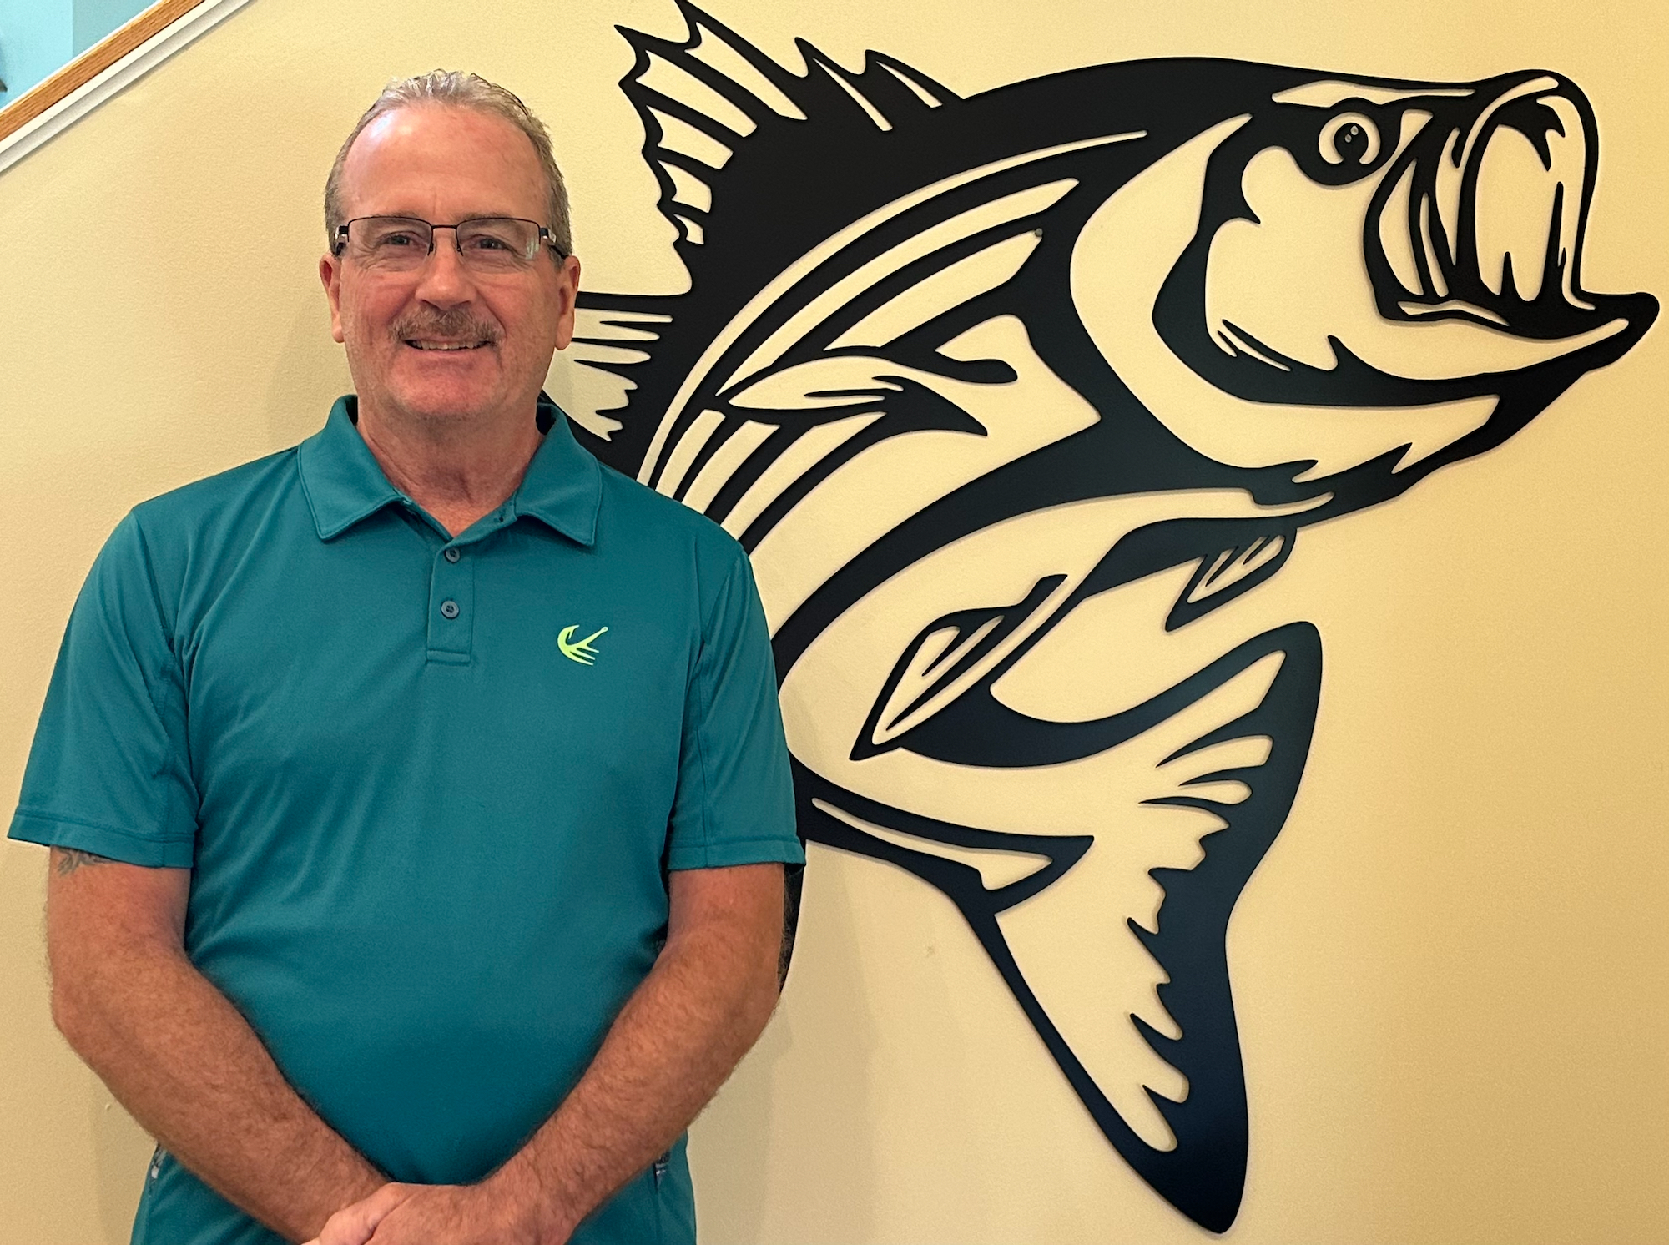

CAN MISSION, MEMBERSHIP, BOARD of DIRECTORS, and COMMITTEES

MISSION. The Cambridge Association of Neighborhoods (CAN) fosters neighborhood cohesion and community involvement to enhance the quality of community life for all residents of Cambridge through community events, social activities, and neighborly assistance. CAN protects and enhances properties in Cambridge by improving building and zoning codes, supporting adherence to those codes, and engaging constructively with City Government, including the Historic Preservation Commission. CAN’s Bylaws can be found on the CAN website at https://cambridgecan.org/welcome/about/bylaws/.

MEMBERSHIP. CAN welcomes members from all Cambridge area neighborhoods (broadly defined) who are interested in organizing and working together, building a diverse membership reflecting the diversity of Cambridge residents. Membership is FREE – information is available on the CAN website at https://cambridgecan.org/join-can/

CAN BOARD OF DIRECTORS. CAN is governed by a Board of Directors elected by CAN members at its annual January Business Meeting. Board Members whose terms expire in January 2026 are President – Chuck McFadden; Treasurer – Dave Thatcher; Members at Large – Mary Ellen Jesien, Kim Miller, Brad Rice, Donna Tower, and Judd Vickers. Board Members whose terms expire in January 2026 are Vice-President – Roman Jesien; Secretary – Tom Puglisi; Members at Large – Andre Duerinckx, Rick Klepfer, and Sharon Smith.

CAN HOUSING QUALITY COMMITTEE – PLANNING AND ZONING ISSUES. The Housing Quality Committee monitors issues affecting the quality of housing and the maintenance of property values in the City, including code enforcement. Committee members attend Planning Commission meetings to monitor zoning-related issues and report the information to the Board and Membership. Please contact Chuck McFadden at Ragtime31@gmail.com to volunteer.

NEIGHBORHOOD DEVELOPMENT COMMITTEE – SOCIAL EVENTS & ‘NEIGHBORS HELPING NEIGHBORS’.
"Neighborhoods" are organized by small groups willing to work together to address neighborhood issues through small social events and "neighbor-helping-neighbor” activities. The Social Events Subcommittee organizes community-wide events. Contact Chuck McFadden at Ragtime31@gmail.com to volunteer.

CAN COMMUNICATIONS COMMITTEE – WRITERS NEEDED. CAN'S Communications Committee needs writers, including volunteers to take unofficial notes at public meetings. Please contact Tom Puglisi at tom.puglisi@comcast.net to volunteer.

POWER WASHER AVAILABLE

CAN has an electric power washer available to members. Contact Chuck McFadden at Ragtime31@gmail.com.

