**Newsletter #24.07 JUNE 2024**

*CAN member meetings are announced in advance and open to the public.*

*Everyone interested in CAN is invited to attend.*

**IN THIS ISSUE:** page

**PRESIDENT’S MESSAGE – We Need a New CWDI 2**

**CAMBRIDGE CORNER 3**

* **Cambridge Real Estate Trends** 3
* **Cambridge Fun Lore – Joe Biden Visited Cambridge** 5
* **Cambridge Shoreline Resilience – Public Outreach Survey and Meeting** 5

**Community News – Cooperating Community OrganizationS 6**

* **WHCP – Music Event Series** 6
* **Cambridge Empowerment Center** 6
* **Shore Rivers** 7
* **Dorchester County Libraries – August Events** 8
* **Midshore Meals ‘til Monday** 9
* **Main Street Gallery – *Joy Through Art*** 9

**CAN Mission Statement, MEMBERSHUP, Board OF DIRECTORS, and Committees 10**

**CURRENT LINKS**

**CAN’s Website –** <https://cambridgecan.org>

**JOIN CAN FOR FREE –** <https://cambridgecan.org/join-can/>

**CAN Meeting Minutes –** <https://cambridgecan.org/category/meetings/>

**CAN Meeting Videos –** <https://www.facebook.com/WHCPRadio/videos> **or**

<https://www.youtube.com/@whcpstudio4716>

**CAN’s City Council Meeting Notes** – <https://cambridgecan.org/category/news/city-council-notes/>

**CAN’s Planning & Zoning Notes –** <https://cambridgecan.org/category/news/p-and-z/>

**CAN on FaceBook –** <https://www.facebook.com/CambridgeAssociationofNeighborhoods/>

**Contact CAN –** [CambridgeCAN@yahoo.com](mailto:CambridgeCAN@yahoo.com)



**PRESIDENT'S MESSAGE – We Need a New CWDI!**

*-- Chuck McFadden*

Cambridge Waterfront Development, Inc. (CWDI) was formed to streamline the process of developing the old hospital/tuna factory site on the Choptank River. In my opinion it has done the opposite by making itself the “master developer” instead of hiring development professionals. CWDI has been working for 4 years without much to show for its work except for producing some unpopular ideas. Lots has been written about the proposal to move the non-profit, non-taxpaying YMCA to the best lot on the site and providing it with free parking and control of the Choptank River swimming area.

Today, however, I would like to focus on, what I feel, is another questionable idea. CWDI is proposing to build a 125-slip marina maintained by 12 employees at a cost of $8 to $10 million of your tax dollars. The average slip rate will be $5,173 per the CWDI calculations. This marina is to attract wealthy boaters to come to the Harbor and spend money at the proposed hotel and retail area. Now this might sound like a good idea until you think about it.

First, the City already has a 240-slip marina with an average slip rate of $1,800. The marina, which has a fuel dock and is run by 3 employees, is only 70% filled. The City Marina needs major work, which includes replacing several docks at an estimated cost of $6 million that the City hopes to get though State grants and by financing a loan paid for by the users. So why would Cambridge citizens want to spend their tax dollars on another marina just across Cambridge Creek?

Second, the concept of attracting a hotel/marina has already been tried. The Hyatt, which is a first-class hotel with a first-class restaurant and a golf course is only a half mile up the River, at most. Looking at their marina in the middle of the boating season shows that they are only 30% full. So, if the Hyatt can’t attract boaters up the Choptank River, how will Cambridge Harbor?

Third, there are multiple boating locations that are jammed full with boats during the boating season – Annapolis, Galesville, Solomons, Rock Hall, Crisfield and Norfolk, to name a few. What do these places have in common? They are right off the Bay. Cambridge is 13 miles from the Bay. For a power boat, it is a 90-minute journey; however, it takes a lot of diesel/gas to get here and get back. For a sail boat, it takes 4 hours with a nice wind and the right tide. To get to Cambridge, boaters also have to pass Broad Creek, which is the “backdoor” to St. Michaels, and the Tred Avon River, which gets them to Oxford. Both of these are only 5 miles from the Bay and have lots of attractions for boaters.

I am not a developer. I am a budget guy who is used to looking at the facts before making major dollar decisions. When I look at the Cambridge Harbor marina proposal, the project does not come close to being a solid financial investment to me.

So, with CWDI proposing the YMCA move, a second city amphitheater, and another marina, all at taxpayer expense, I think it is time for a new idea – Get rid of CWDI and hire a professional developer.

*-- Charles McFadden, President, CAN*

**CAMBRIDGE CORNER**

**CAMBRIDGE REAL ESTATE TRENDS**

-- *Fred and Martha Phillips-Patrick*

**National and Regional Residential Real Estate Developments**

According to Freddie Mac, “Mortgage rates trickle down as the market digests recent economic data. Following June’s jobs report, which showed a cooling labor market, the 10-year Treasury yield decreased this week and mortgage rates followed suit. There is also more inventory on the market, including a fair number of listings with price cuts, which is an encouraging sign for prospective buyers.” The current thirty-year fixed rate mortgage is at 6.89%, down slightly since last year, and the fifteen-year fixed rate mortgage is at 6.17%, again down slightly since last year.”

The other development that might affect buyers and sellers is the recent court case that now prevents listing agents from posting buy-side commissions on the Multiple Listing Service. Prior to this case the listing agent could specify how much the seller would be willing to pay the buyer’s agent in a transaction, e.g., 2.5% to the buyer’s agent. Now they can no longer do that. In addition, a buyer’s agent must now have a written contract with the buyer specifying the fee.

As one commentor indicated, this arrangement can certainly complicate the transaction. “No longer advertising buyer agent commissions will only create a more confused and drawn-out transaction process as buyers, sellers and agents will have to negotiate the fee, who will pay for it and how much will be paid by each party. Due to this added level of complexity, buyers will almost certainly have to negotiate with more sellers before they find the deal they are satisfied with. Thus, the house-hunting period will extend for the average buyer.”

How did Cambridge fare in this market environment in June 2024? Let’s see.

**Cambridge Market Update**

According to Realtor.com, Cambridge returned to being a buyer’s market, where the supply of homes is greater than the demand for homes. In June, the median listing home price in Cambridge was $295K, trending up 13.5% year-over-year. The median home sold price was $268K, up from last month. On average, homes sold after 55 days on the market, the same as last month. The trend for median days on the market was flat since last month, and slightly up since last year. Homes sold for about 1.5% below asking price in June.

**Sales**

Currently, according to Realtor.com, there are now 191 homes for sale (144 single family homes and 47 condos and townhomes) in the Cambridge area, up from May. There are also 4 multifamily units for sale, as well as 55 farms and plots of land. The properties’ asking prices range from $10,000 for a small plot of land (.06 acres) on Phillips Street to $2 million for a house with 135 acres of land on Egypt Road.

According to Zillow.com, in June 2024, 31 houses, condos, and townhouses were sold in Cambridge. The sold properties ranged in value from $30,000 to $685,000.

**603 Academy St $30K** 619 Washington St $50K 1107 High St $230K

101 Canvasback Way $232K 114 Black Duck Ct $180K 430 Hight St $20K

**2802 Persimmon Pl D4 $685K** 506 Robbins St $70K 304 Shipyard Dr #34 $260K

5520 Bonnie Brook Rd $599K 406 Robbins St $255K 8 Harris Dr $331K

700 Cattail Cv #106 $190K 102 Somerset Ave $260K 18 Oak St $80K

430 Aurora St #2C $175K 6111 Twin Point Cv Rd $500K 141 Regulator Dr N $387K

401 Oakley St $95K 831 Parkway St $222K 913 Central Ave $176K

206 Regulator Dr S $400K 5313 Center Dr $167K 3850 Griffith Neck Rd $80K

5552 Bonnie Brook Rd $330K 260 Somerset Ave $260K 310 Talbot Ave $345K

381 Robbins Farm Rd $332K 140 Mariners Way C $315K 502 High St $95K

443 Willis St $86K

**Cambridge in the News**

Following a national search, the Board of Education of Dorchester County selected Dr. Jymil Thompson as Superintendent of Dorchester County Public Schools. The Cambridge Association of Neighborhoods (CAN) invited Dr. Thompson to speak at a June 11 meeting at the Dorchester Library on his goals for the Dorchester County School System. The notes from this meeting include the following:

Dr. Thompson indicated that 70% of DCPS students lack proficiency in reading and math, and that DCPS is ranked 23rd out of the 24 school systems in the state of Maryland. His goal as Superintendent is to increase teaching and learning such that DCPS ranks at least 15th in Maryland within the next four years. Individual goals of administrators and teachers need to be established to align with the overall goal of moving from 23 to 15.

Dr. Thompson stressed that, to achieve this goal, DCPS needs to improve standard Tier 1 instruction across the board at all levels. Tier 1 instruction should provide all students with high-quality, foundational classroom instruction tied to a consistent curriculum. He noted that DCPS is especially focusing on strengthening reading and math performance in grades 1 through 3, as these basic, foundational skills are essential for later learning.

Dr. Thompson also addressed issues such as school discipline, teacher development, and the high turnover rate among teachers. The entire meeting is available on YouTube at: https://www.youtube.com/@whcpstudio4716.

One of the major factors affecting real estate values in a community is the quality of its education system. Dr. Thompson looks to bring his experience and drive to the task of improving our school system from 23rd in the state to 15th in four years. That would be a terrific accomplishment.

**CAMBRIDGE FUN FACTS AND LORE – Joe Biden Visited Cambridge**

*-- Martha Phillips-Patrick*

While serving as VP to President Barack Obama, Joe Biden visited Cambridge three times to address Democratic leaders at their Annual Retreats held at the Hyatt Regency in 2011, 2012 and 2015.  He was scheduled to speak at the 2014 retreat at the Hyatt, but canceled due to snow in DC.  President Obama spoke at all four of these retreats in Cambridge.

**CAMBRIDGE SHORELINE RESILIENCE – Public Outreach Survey & Meeting**

**Cambridge Flood Mitigation Project Phase 1 Design**

**--** *Larry White and Virginia Smith*

The City of Cambridge is excited to announce that an online public survey has been launched to obtain the public’s preferences and concerns. The information obtained from the survey results will inform efforts to connect and engage with the community regarding the Make Cambridge Resilience Initiative. The survey should take about 7 minutes or less to complete.

Please participate in the **online public survey** using the link below or

QR Code to the right.

<https://www.surveymonkey.com/r/ZV8Q25Q>. A link to the survey is also

available on the project website at: [www.makecambridgeresilient.org](http://www.makecambridgeresilient.org/).

In addition to the online public survey, a **community meeting** has been

Scheduled to kick-off the Flood Mitigation Phase 1 Design.

Date: August 21, 2024.

Time: 6:00-7:30 PM

Location: Dorchester County Public Library, Cambridge Branch, Meeting Room

Agenda topics will include:

* Introduction of Project Team,
* FEMA Grant Award & Eligible Activities,
* Design Timeline and Project Milestones - BayLand Consultants & University of Maryland, Horn Point Lab, Center for Environmental Sciences.
* Results of Public Survey and Outreach Plan, and,

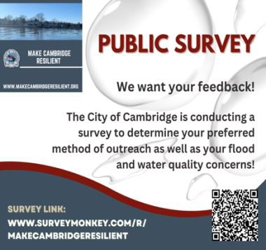

* Next Steps.

In addition to the information provided in this newsletter, information

on both the online public survey and community meeting will be shared

via social media, project website, city website, local media outlets, and the

project website email contact listing.

We look forward to your participation in the survey and seeing you at the

upcoming community meeting.

**COMMUNITY NEWS – COOPERATING COMMUNITY ORGANIZATIONS**

**WHCP-FM 91.7 – Music Event Series**

|  |  |
| --- | --- |
| WHCP is a registered 501(c)3 non-profit organization supported by Membership Donations and Business Sponsorships. We are the only independently owned radio station on the Mid-Shore that provides local content, community news and information, and locally curated music programs! Get ready for the start of WHCP’s Live Music Events, presented as a part of our on-going commitment to bringing live music to the area and support local musicians too. Info at [https://whcp.org/events/](mailto:https://whcp.org/events/) |  |

**CAMBRIDGE EMPOWERMENT CENTER**

We have a matching grant! Any donation will be doubled now through September 1st. Give on our website, [cambridgeempowermentcenter.org](http://cambridgeempowermentcenter.org/), or send a check to Cambridge Empowerment Center, PO Box 494, Cambridge, MD 21613. You can make a difference for our children and create a lasting impact.

**Open House rescheduled to Friday August 2, 2024 9:00am - 12noon.** Learn about our new Pre-K Program. which is opening this September 2024, Ages: 3,4,5 years old. Enroll Now !!!

**Our Summer Program is Underway.** This summer, 45 children ages 5 to 13 are enjoying a fun-filled learning program as a part of the Pine Street Enrichment Program. This is an 9-week program, Monday through Thursday, 8 AM to 4:30 PM. Every day, these children experience learning through activities which include computer online programs, arts and crafts, physical education, sports, music, cooking, STEM projects and field trips. We collaborate with other organizations such as the Dorchester Library, the Health Department, Dorchester Recreation and Parks, The Harriet Tubman Museum and Educational Center and others.

Our Executive Director, Sharon Chester, and our Youth Program Director, Tammy Washington, have done a fantastic job of setting up the program, hiring the staff, and running the day-to-day operations. **Last summer 70% of our students made a 2-month or more gain in reading level, and a 50% gain in math.**

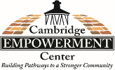 

**SHORERIVERS –Tree the Shore**

You may have noticed new trees popping up around town! On June 5th ShoreRivers volunteers helped to plant 33 trees in front of homes all around Cambridge. The trees were planted as part of ShoreRivers’ new program: Tree the Shore. ShoreRivers received grant funding to plant 1,000 trees by Spring of 2026 across Cambridge, Easton, Denton and Chestertown.

Despite a rainy evening, volunteers forged ahead with their task. Most of the trees were in the ground by the end of the night and McHale Landscaping finished the job the next afternoon. Homeowners paid

nothing for the trees, but did commit to watering their trees for the first two years as they get established. Terry Wheatley proclaimed: “I LOVE LOVE my trees. The girls were wonderful, and they did a GREAT job!!! Thank you again!!”

The trees range from 4’ - 8’ tall at the time of planting. Each tree received a wire cage to protect it while it gets established and most trees also have a green “gator bag”, to be filled with water weekly. The water then slowly releases into the soil around the tree, keeping it from drying out.

Some tree species, such as Sweet Bay Magnolia, will top out at 20’ tall - perfect for growing under power lines. Others such as Burr Oaks and Black Gums will grow to be 50-60’ tall one day, providing shade for the next generation of Cambridge residents.

ShoreRivers will plant trees for FREE in front of your house, place of worship, school, or other public- facing property! All they need from you is your permission. ShoreRivers is actively seeking residents to request trees for their properties.

Don’t have a lot of room? No problem - they will plant a tree that stays relatively small! ShoreRivers has curated a list of trees that are proven to work well in urban environments! They want to set you up for success, and that means planting the right tree in the right place.

Trees provide proven benefits to people, animals, and the Choptank river. They shade our homes, cool the summer air of our city, soak up rainwater that might otherwise flood our streets, provide food and shelter for songbirds, capture pollution from the air, and return the oxygen that we breathe. Unfortunately, many of our streets currently lack healthy tree canopy. Visit ShoreRivers’ website to **request trees and learn more: shorerivers.org/tree-the-s**

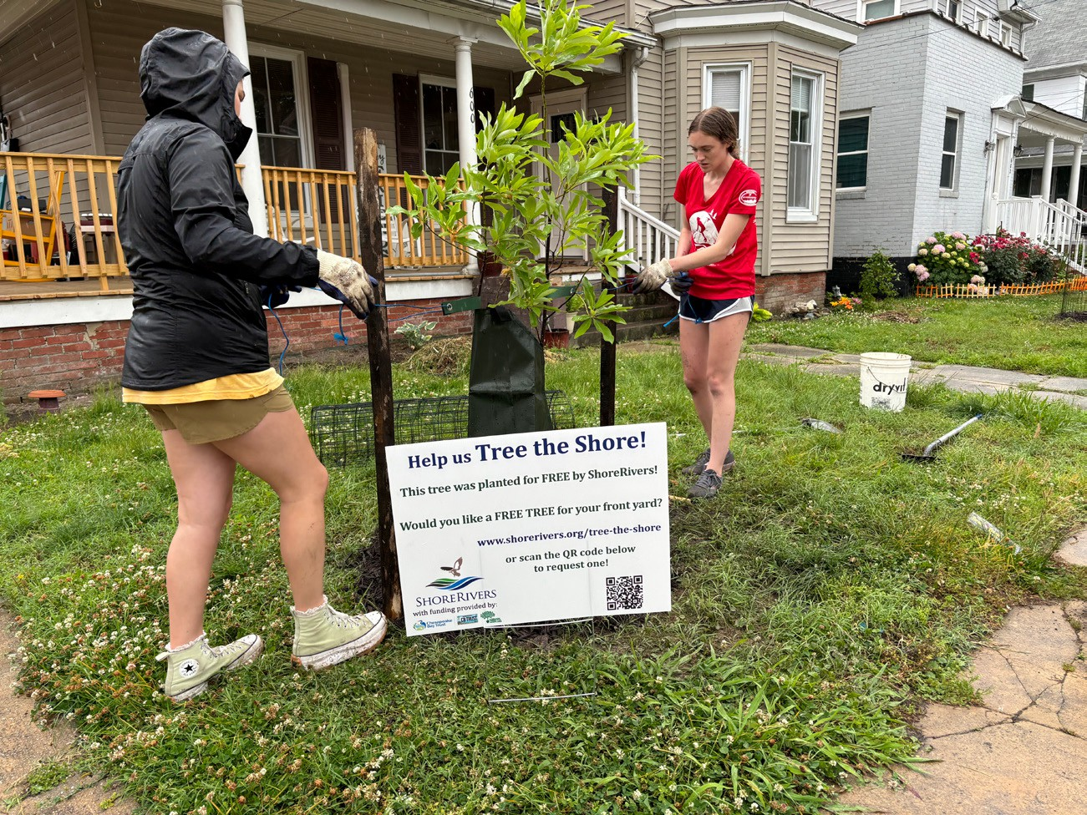



**DORCHESTER COUNTY LIBRARIES – August Events**

Things are hopping! So many fun and interesting events for all ages!

Events in Cambridge during the month of August:

* Salisbury Zoo Animal Workshop (Pre-registration required. Ages 6+), 08.05 @ 11 AM
* Coast Guard Visit (all ages), 08.12 @ 10: 30 AM
* Family Fun Night, Velvet Mandala Coloring Craft - 08.06 @ 5:30 PM;
* Family Fun Night, Stitch & Knit 08.13 @ 5:30 PM
* DIY Spa Workshop (13+ program), 08.20 @ 5:30 PM
* Generation RX Class (adult program), 08.27 @ 11: 30 AM, Registration Available Soon
* Story Time (newborn - 7), Every Wednesday @ 10:30 AM
  + Special Guests: 8/7 (Kathy MacMillan, ASL) and 8/14 (Lion's Club)
* Kids' Book Club (8 - 12), 08.07 & 08.14 @ 10:30 AM
* Teen Anime Club (12-17), Every Wednesday @ 4 PM
* STEM Lab (8+), 08.01, 08.08, 08.15 @  2PM
* Habitat for Humanity: Financial Literacy I – Banking/Budgeting (adults) 08.22 @ 5:30 PM
  + Register at: <https://habitatchoptank.charityproud.org/Events>
* Friends of the Library Book Sale (all ages), 08.10 @ 9 AM - 1 PM
* End of Summer Reading Party & Raffle Drawing (all ages), 08.17 @ 2 PM
* Spoken Word Open Mic (13+), 08.24 @ 3 PM

Events in e Hurlock during the month of August:

* Story Time (newborn - 7), Every Wednesday @ 10:30 AM
  + Special Guests: 8/7 (Lion's Club) and 8/14 (Kathy Burtman-Gardening)
* DIY Spa Workshop (13+ program, 08.08 @4:30 PM
* Game Night (all ages), 08.13 @ 4:30 PM
* End of the Summer Field Day, 08.15 @ 4:30 PM-6:30 PM
* Salisbury Zoo Animal Workshop (Pre-registration required. Ages 6+), 08.12 - 11 AM
* Drop-in Activities:
  + 07.22 - 08.01, Building Challenge; 08.12 - 08.16, Jr. Detectives Kit
* Historical Fiction Book Club Meeting, 08.22 @ 5 PM

Plus, we have a scavenger hunt for kids and another for teens and young adults at Cambridge Library. We also have a community scavenger hunt at Hurlock Library.



**MIDSHORE MEALS TIL MONDAY**

*MidShore Meals 'til Monday* is working to end childhood hunger on Maryland’s Eastern Shore by providing weekend food for food-insecure children in Dorchester County. *Meals ‘til Monday* sends home healthy, nutritious food for children at the end of each school week and during the summer months for breakfast, lunch and snacks to bridge the hunger gap for children without access to adequate food.

|  |  |
| --- | --- |
| *Meals ‘til Monday* currently provides food for more than 500 elementary, middle and high school students. Donations can be made at [*https://www.mscf.org/donate-online/*](https://www.mscf.org/donate-online/)*.*  For more information, please call the Director at 703-371-5191 or visit their website at [*www.midshoremealstilmonday.org/*](http://www.midshoremealstilmonday.org/)*.* |  |

**MAIN STREET GALLERY**

The *Main Street Gallery* in Cambridge is delighted to present their summer show, *Nature by Metal,*with guest artist, Gary Schuler. The show will feature a variety of wild creatures such as a flock of flying geese, foxes, herons and a variety of other animals, all created by the artist from various kinds of metal.

Gary, who lives and works in Cambridge, uses different types of metals such as copper, steel, stainless steel and specialized finishes to create the wide variety of creatures you might encounter while wandering on the Eastern Shore. The artist says that "Living on the Eastern Shore of Maryland has given me a great appreciation of nature and the natural habitats of wildlife that I enjoy capturing in my metal art."

Gary, who will be showing his art among the gallery's nine member artists, says he prefers projects with intricate details and designs that challenge him to achieve the sense of realism he's after in his work. He uses a variety of tools and techniques to create his 3D geese in flight, a full-size 3D shark and bird tree spikes among various other wildlife pieces. His art is well suited for both indoor and outdoor spaces, he says.  Some of his creatures, which include rockfish, crabs and deer, are as large as 4' x 4'. Many were commissions and have found new homes on barns, sheds and pole buildings.

Gary, who retired to Cambridge from Pennsylvania, is not new to metal working. He has 40 years’ experience working in aerospace manufacturing and engineering as a journeyman machinist, a certified welder, a manufacturing engineer and a plant manager. He has combined all the aspects of his professional career into his current metal art. "Many of the aerospace projects I worked on were like art unto themselves," he says.

*Nature by Metal* will open on Friday, July 5 and run through Sunday, September 1. There will be two artist's receptions on Second Saturdays, July 13 and August 10 and Gary will give a brief artist talk at the July reception. Both receptions are free and open to the public. Light refreshments will be served.

Main Street Gallery is located at 518 Poplar St. in Cambridge, and is part of the vibrant Arts and Entertainment District. Gallery hours are Fridays through Sundays from 11-5. The gallery requests that children under 18 be accompanied by an adult.

**CAN MISSION, MEMBERSHIP, BOARD of DIRECTORS, and COMMITTEES**

**MISSION.** The Cambridge Association of Neighborhoods (CAN) fosters neighborhood cohesion and community involvement to enhance the quality of community life for all residents of Cambridge through community events, social activities, and neighborly assistance. CAN protects and enhances properties in Cambridge by improving building and zoning codes, supporting adherence to those codes, and engaging constructively with City Government, including the Historic Preservation Commission. CAN’s Bylaws can be found on the CAN website at [*https://cambridgecan.org/welcome/about/bylaws/*](https://cambridgecan.org/welcome/about/bylaws/)*.*

**MEMBERSHIP.** CAN welcomes members from **all Cambridge area neighborhoods** (broadly defined) who are interested in organizing and working together, building a diverse membership reflecting the diversity of Cambridge residents. **Membership is FREE**  – information is available on the CAN website at [*https://cambridgecan.org/join-can/*](https://cambridgecan.org/join-can/)

**CAN BOARD OF DIRECTORS.** CAN is governed by a Board of Directors elected by CAN members at its annual January Business Meeting. Board Members whose terms expire in January 2026 are President – Chuck McFadden; Treasurer – Dave Thatcher; Members at Large – Mary Ellen Jesien, Kim Miller, Brad Rice, Donna Tower, and Judd Vickers. Board Members whose terms expire in January 2026 areVice-President – Roman Jesien; Secretary – Tom Puglisi; Members at Large – Andre Duerinckx, Rick Klepfer, and Sharon Smith.

**CAN HOUSING QUALITY COMMITTEE – PLANNING AND ZONING ISSUES.** The Housing Quality Committee monitors issues affecting the quality of housing and the maintenance of property values in the City, including code enforcement. Committee members attend Planning Commission meetings to monitor zoning-related issues and report the information to the Board and Membership. *Please contact* Chuck McFadden at [*Ragtime31@gmail.com*](mailto:Ragtime31@gmail.com)to volunteer.

**NEIGHBORHOOD DEVELOPMENT COMMITTEE – SOCIAL EVENTS & ‘NEIGHBORS HELPING NEIGHBORS’.**

"Neighborhoods" are organized by small groups willing to work together to address neighborhood issuesthrough small social events and "neighbor-helping-neighbor” activities. The **Social Events Subcommittee** organizes community-wide events. *Contact* Chuck McFadden at [*Ragtime31@gmail.com*](mailto:Ragtime31@gmail.com) to volunteer.

**CAN COMMUNICATIONS COMMITTEE – WRITERS NEEDED**. CAN'S Communications Committee needs writers, including volunteers to take unofficial notes at public meetings. *Please contact Tom Puglisi at* [*tom.puglisi@comcast.net*](mailto:tom.puglisi@comcast.net) *to volunteer.*

**POWER WASHER AVAILABLE**

CAN has an electric power washer available to members. Contact Chuck McFadden at [*Ragtime31@gmail.com*](mailto:Ragtime31@gmail.com)*.*

