Newsletter #24.08 AUGUST 2024

CAN member meetings are announced in advance and open to the public.

Everyone interested in CAN is invited to attend.

IN THIS ISSUE: page

PRESIDENT’S MESSAGE – CITY ELECTION ISSUES 2
- Candidates Debates 2
- Candidates 2
- Timeline 2

CAMBRIDGE CORNER 3
- Cambridge Real Estate Trends 3
- Cambridge Police Department Update 4
- Cambridge Fun Facts & Lore –Lincoln, Loyalty, and Liberties on the Eastern Shore 5

Community News – Cooperating Community OrganizationS 6
- Main Street Gallery –Cooking Up Some Art 6
- WHCP – Music Event Series 8
- Dorchester County Libraries 8
- Midshore Meals ‘til Monday 9
- One Mission Cambridge 10
- Habitat Choptank 10

CAN Mission Statement, MEMBERSHUP, Board OF DIRECTORS, and Committees 11

CURRENT LINKS

CAN’s Website – https://cambridgecan.org
JOIN CAN FOR FREE – https://cambridgecan.org/join-can/
CAN Meeting Minutes – https://cambridgecan.org/category/meetings/
CAN Meeting Videos – https://www.facebook.com/WHCPRadio/videos or
https://www.youtube.com/@whcpstudio4716
CAN’s City Council Meeting Notes – https://cambridgecan.org/category/news/city-council-notes/
CAN’s Planning & Zoning Notes – https://cambridgecan.org/category/news/p-and-z/
CAN on FaceBook – https://www.facebook.com/CambridgeAssociationofNeighborhoods/
Contact CAN – CambridgeCAN@yahoo.com


PRESIDENT'S MESSAGE – City Election Issues
-- Chuck McFadden

Now that all the candidates are known for Mayor and City Council Commissioners, we need to get to their positions on critical topics of interest to the community. My own list of issues is as follows:

- Do they support the non-profit, non-tax paying YMCA moving to Cambridge Harbor?
- Do they support building a second $8 to $10 million marina in Cambridge Harbor?
- Do they want CWDI to develop Cambridge Harbor on their own or to get a professional developer?
- What is their position on spending $20 million on converting the Hearn Building to low-cost housing?
- Do they have any ideas on how to revitalize the downtown area?
- What ideas do they have on bringing the City together?
- Finally, and this is unusual for City politics, should the City find a way get more involved in the School system? The schools in Dorchester Co are the purview of the County Council, which provides funding (along with the State). However, Cambridge makes up 41% of the County population, and the City has no say in how the money is spent. My bet is that more money is spent on under-populated schools “down county” than those in the City. Cambridge has a major problem with the school system, and if we want to attract young families, we need to have good schools.

The new Council needs to stop holding 30-minute meetings and start discussing publicly the issues that are important to the citizens of Cambridge. I am sure you have other issues that should be addressed so let CAN know though the Welcome/Contact US page on our website (at https://cambridgecan.org/contact-us/?contact-form-hash=6c6651aead71a4f643a62575a0238fa0a360377b) or email tom.puglisi@comcast.net.

-- Charles McFadden, President, CAN

Candidate Debates – October 5

CAN, along with WCHP, The Spy, and the Dorchester Star will be holding debates on October 5th between the candidates for Mayor and City Council. More details to follow as plans are firmed up.

Qualified Candidates
Mayor: Lajan Cephas; Andrew Bradshaw; La-Shon Foster
Ward 1: Laurel Atkiss; Brett Summers
Ward 2: Jenna LeCompte; Nancy Jackson; Jermaine Anderson; Shay Lewis-Sisco
Ward 3: Frank Stout; Gary Gordy
Ward 4: Sputty Cephas; Dave Cannon
Ward 5: Brian Roche

Timeline
September 27 (Friday): Voter registration deadline, 4 pm, Dorchester County Board of Elections
October 5 (Saturday): Candidate Debates
October 19 (Saturday): Election
December 3 (Tuesday): Run-off election, if necessary

CAMBRIDGE CORNER

CAMBRIDGE REAL ESTATE TRENDS
-- Fred and Martha Phillips-Patrick

National and Regional Residential Real Estate Developments

According to Sam Khater, Freddie Mac’s Chief Economist, “While rates increased slightly this week, they remain more than half a percent lower than the same time last year. In 2023, the 30-year fixed-rate mortgage nearly hit 8 percent, slamming the brakes on the housing market. Now, the 30-year fixed-rate hovers around 6.5 percent and will likely trend down in the coming months as inflation continues to slow.

Lower rates are good news for potential buyers and sellers alike. The 30-year FRM averaged 6.49 percent as of August 15, 2024, up slightly from last week when it averaged 6.47 percent. A year ago, at this time, the 30-year FRM averaged 7.09 percent.”

The other development that is likely to affect buyers and sellers is the recent court case that now prevents listing agents from posting buy-side commissions on the Multiple Listing Service. Prior to this case the listing agent could specify how much the seller would be willing to pay the buyer’s agent in a transaction, e.g., 2.5% to the buyer’s agent. Now they can no longer do that. In addition, a buyer’s agent must now have a written contract with the buyer specifying the fee. This rule goes into effect on August 18, 2024.

How did Cambridge fare in this market environment in July 2024? Let’s see.

Cambridge Market Update

According to RocketHomes.com, in July, Cambridge became a “neutral market”, which means prices tend to be reasonable and homes stay on the market for a typical length of time. In July, the median home sold price was $255K, down from last month. On average, homes sold after 37 days on the market, 20 days fewer than last month. However, almost half of the houses sold in July sold for less than their asking price.

Sales

Currently, according to Realtor.com, there are now 164 homes for sale (120 single family homes and 44 condos and townhomes) in the Cambridge area, down slightly from June. There are also 4 multifamily units for sale, as well as 66 farms and plots of land. The properties’ asking prices range from $10,000 for a small plot of land (.06 acres) on Phillips Street to $1,595,000 for an estate at 5411 Casson Neck.

According to Zillow.com, in June 2024, 36 houses, condos, and townhouses were sold in Cambridge in July. The sold properties ranged in value from $6,000 to $1,7000,000.

108 Glenburn Ave $450K 605 Wood Duck Dr $181K 4425 Egypt Rd $1.15M
5844 Ross Neck Rd $725K 2202 Horns Pt Rd $1.70M 5429 Town Pt Rd $350K
203 Phillips Ave $225K 911 Race St $250K 335 Appleby Sch. Rd $220K
1653 Terrapin Cir $353K 8 Talbot Ave $288K 708 Douglas St $52K
334 Shipyard Dr $300k 203 Glenburn Ave $470K 641 Washington St $6K
208 Regulator Dr S $355K 770 Hills Point Rd $1.05M 336 Appleby Sch Rd $260K
719 Pine St $30K 1106 Holland Ave $189K 802 Fairmount Ave $55K
801 Truman St $89K 310 Henry St $35K 2113 Horns Pt Rd $79K
104 W End Ave $424K 211 Willis St $275K 1404 Glasgow St $225K
894 Hudson Rd $122K 827 Parkway St $218K 390 Robbins Farm Rd $310K
205 Oakley St $496K 406 Osprey Cir $350K 6114 Twin Point Cove $775K
714 Hughlett St $60K 2303 Hambrooks Blvd $245K 609 Wood Duck Dr $175K

Marketing and Real Estate

In a recent interview, we asked a very successful real estate agent what two factors under the owner’s control, aside from price, most affected a home’s attractiveness. Her response was quick and succinct: declutter and curb appeal. Easier said than done. Curb appeal depends on such things as hedges freshly trimmed, flower beds edged, weeded and mulched, lawn freshly mowed, maybe new hardware on the front door, good porch lights, cobwebs removed, etc. Details are important. A chair or swing on the front porch to make it appealing. For decluttering, try the 12-12-12 rule. Find 12 things to throw out, 12 things to donate, and 12 things to put in their right place. Lather, Rinse, Repeat… These efforts, the real estate agent said, will be well rewarded in both the sales price and the quickness of the sale. Good luck!

CAMBRIDGE POLICE DEPARTMENT UPDATE
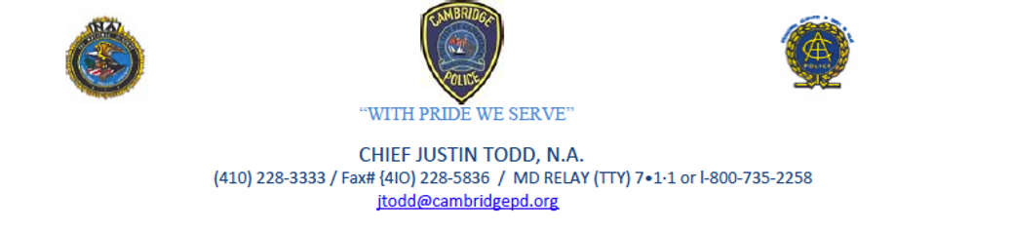
I hope everyone has enjoyed their summer and has had a chance to enjoy many of the events and happenings around our community. It is always exciting to see so many familiar faces at different events and the volunteers that assist to make each event a success.

As we will soon be seeing the school buses out on our roadways as well as children walking or biking to school, this is just a reminder to take that extra time to make sure we are making every effort to ensure the safety of our children and everyone else on our roadways. The Cambridge Police Department is looking forward to being a part of our city schools again this and working with the superintendent, principals, and other board of education staff to make the 2024-2025 school year a success. This will be our third year having a School Resource Officer at the Maces Lane Middle School and the second year having Cpl. Joesph Jones as the officer. I believe in the last year we made some positive strides working with the schools and with juvenile services to attempt to provide the best possible services to our children and their parents/guardians.

I am also proud to say that we had two high schoolers (one student was from Cambridge South Dorchester H.S and the other was from the Dorchester Career and Technology Criminal Justice Program) that completed internships with us beginning in February and ending in May. One of those students has extended their internship by being a part of the Portia Johnson-Ennels Youth Internship Program. The other student came back this summer and volunteered in our building before heading off to Salisbury University this fall.

As we move into the fall the Cambridge Police Department will be beginning a new program called Cambridge Teen Court. There is much more information to come with this, but we see this as another opportunity to reach our youth that commit minor violations that otherwise would not be a crime that would make it as far as our judicial system. This program will not only help with interactions between the police and the youth, but also show that there are consequences to the youth's actions that were committed. In addition, it will help provide further resources to the parents/guardians. We have been in the planning stages of this program for the last several months working closely with juvenile services and local leaders to ensure this will be a success.

Our Drone program that the council approved for the FY2024-25 budget year is making headway. We have narrowed down six officers that the Cambridge Police Department will have as pilots for the program. It is my goal to have a Drone Pilot on duty as much as possible and the drone be ready to be deployed at any moment. Our first Drone at CPD is expected to arrive in mid-to-late September, and training will follow. As you can imagine, getting through the training and certifications is a process, and we look forward to being up and flying soon. I believe this will be a great tool and a new way to handle certain situations that we encounter in the future

I would like to end by thanking everyone for their support. We have received some great donations from organizations, businesses, and individuals as we continue to strive to build relationships and strengthen our work in our community. As always, please feel free to reach out with any questions or concerns by contacting me at jtodd@cambridgepd.org.

CAMBRIDGE FUN FACTS AND LORE – Lincoln, Loyalty, and Liberties on the Eastern Shore
-- Martha Phillips-Patrick

Due to the secessionist threat posed by the State of Maryland and the need for Maryland's compliance with Union war efforts, due to its proximity to Washington and as a border State to the South, Lincoln (by a much-contested Executive Order) suspended the basic Constitutional right of habeas corpus to citizens of Maryland in April of 1861.

Initially, though, Lincoln thought the Eastern Shore of Maryland (in particular) might be a place to set precedents for restoring secessionists to Union loyalty. Consequently, during the war, Lincoln took a conciliatory posture with the Eastern Shore, even installing a “Delmarvan” as the commanding general of the Union occupation.
Even more remarkable, in 1863, Lincoln exempted the entire "loyal" Delmarva Peninsula from the Emancipation Proclamation, even with little evidence that Union sentiments were strengthening on the Shore.

Marylander's covert and overt resistance, and continued blockade running eventually forced Lincoln to use a harder hand against the Shore. "The region proved to be a critical battlefield where martial and civil law collided, and the fate of liberty often depended on exhibiting the 'right spirit'."

NOTE: Mostly based on coverage of a presentation by Kellee Blake in 2015 at the Edward H. Nabb Research Center Gallery at Salisbury University in Salisbury, MD.)

COMMUNITY NEWS – COOPERATING COMMUNITY ORGANIZATIONS

MAIN STREET GALLERY – Cooking Up Some Art
-- Theresa Knight McFadden

For its fall show, Main Street Gallery in Cambridge is excited to present Cooking Up Some Art, a collaborative show of 11 guest artists who are friends and have been members of a 30-plus-year-old cooking group. The artists work in a variety of media that include painting, book art, photography, digital art, printmaking, collage, sculpture and fiber art and while their subjects vary widely, at least one creates delicious oil paintings of food. The guests will show alongside the gallery's eight member artists.

The group formed in the DC area when its founder, the late Michael B. Platt, a renowned artist and art professor at Howard University and Northern Virginia Community College, suggested to a few of his artist friends and art students that they all get together and cook. In those days, a cooking event took an entire day as the group gathered early to shop at area markets, groceries and specialty stores and then went to one or the other’s homes and spent the rest of the day cooking and enjoying their feast. The group sometimes travelled as well to members' summer houses on the Shenandoah and the Choptank River where swimming, kayaking, fishing and sailing were also on the menu.

In those early days there was a rule, set forth by Platt, that they cook only food they’d never had before. This resulted in some dinners with wild game, game fish and exotic side dishes. While the group no longer holds steadfastly to that rule, their dinners are reportedly still very creative. For their last gathering they created dishes from their individual travels. The food sparked lively dinner conversations about places they had visited, the art scene in DC and remembrances about past dinners. “There is always lots of food and lots of laughter at our dinners” says member artist Randi Trinka. “Over the past 30 plus years we’ve had so many crazy, memorable times together, and it’s always great fun to reminisce about them. And of course, we always remember Mike Platt, the creative guy who got us all together.”

Cooking Group artists who are exhibiting at MSG are Washington DC artists, Carol Beane, Barbara Frank, Michael Platt, Lynn Sylvester, Ernestine Martin Wyatt and Donald Wyatt; Cambridge MD artist Theresa Knight McFadden; Takoma Park MD artist, Stephanie Sove Ney’ Laurel MD artists, Debra Mathews Tyler and Dwight Tyler; and Springfield VA artist, Randi Trinka.

Cooking Up Some Art will open on Friday September 6 and run through Sunday October 27. There will be two artist  receptions at the gallery on Second Saturdays, September 14 and October 12 from 5-8 pm.  The receptions are free and open to the public and all are welcome. Light refreshments will be served. There will also be a brief artist talk at the September 14th reception. | 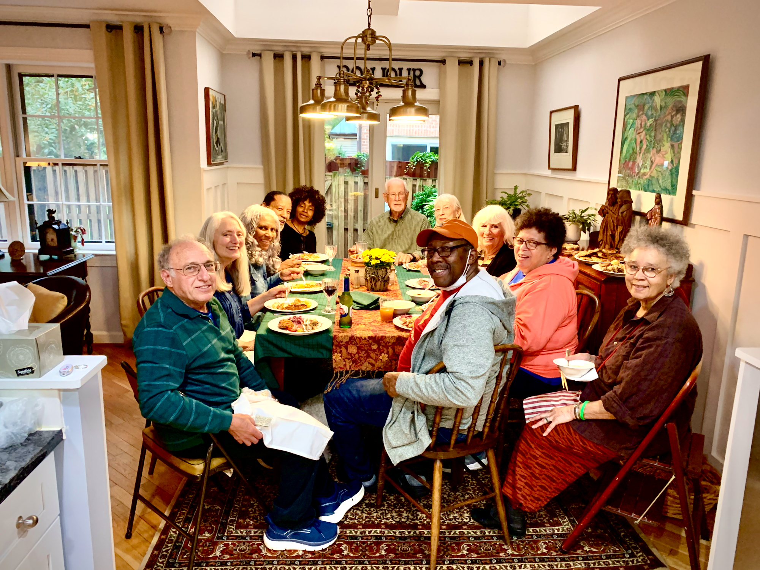

Main Street Gallery is located at 518 Poplar St. in Cambridge, and is part of the vibrant Arts and Entertainment District. Gallery hours are Friday through Sunday from 11-5. The gallery requests that children under 18 be accompanied by an adult.

The gallery is currently reviewing work from prospective members and guest artists. Please contact MSG through its website @mainstgallery.net or by phoning 410-330-4659 if interested.

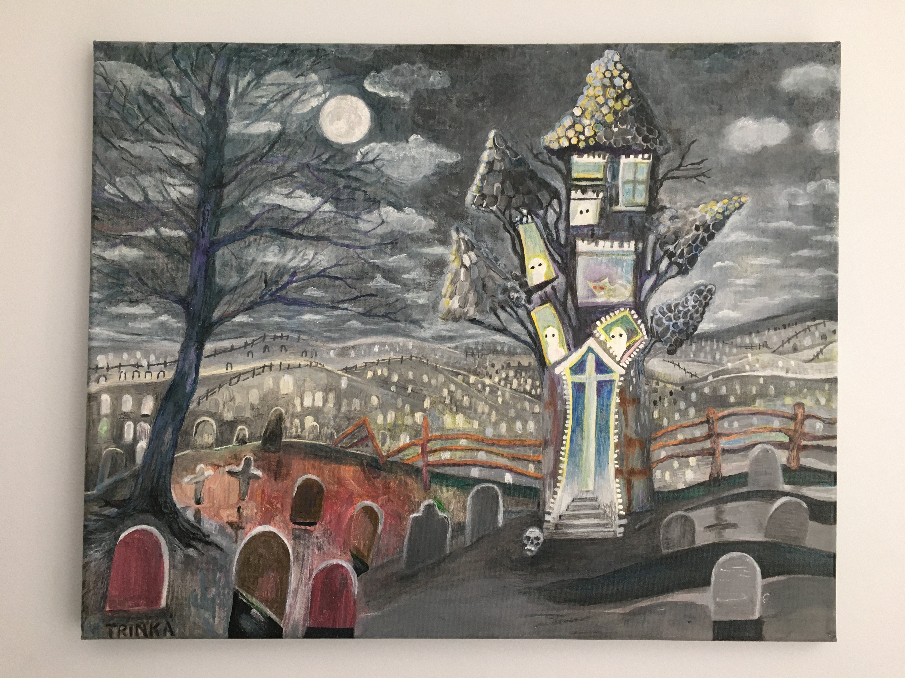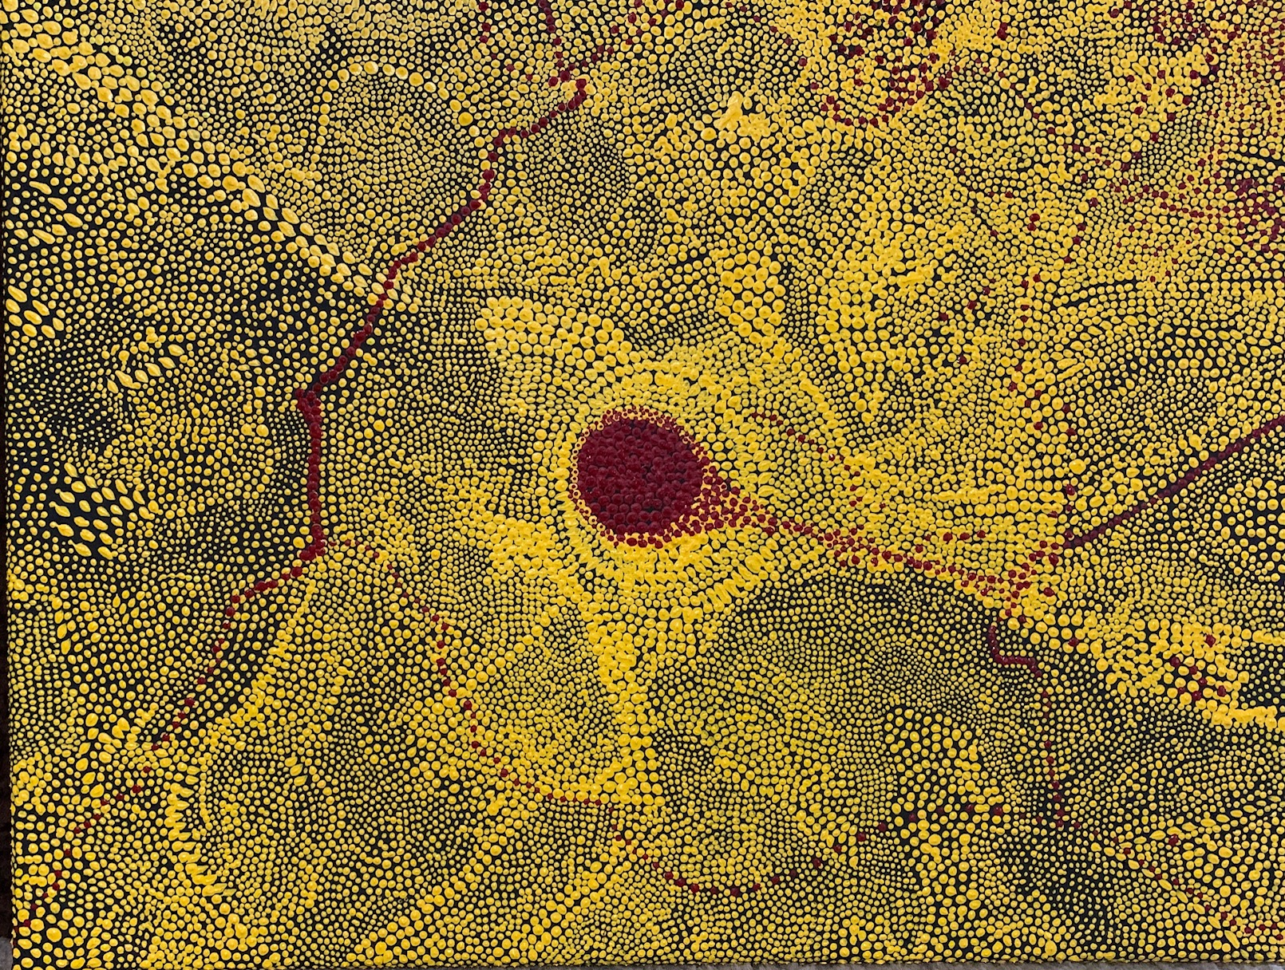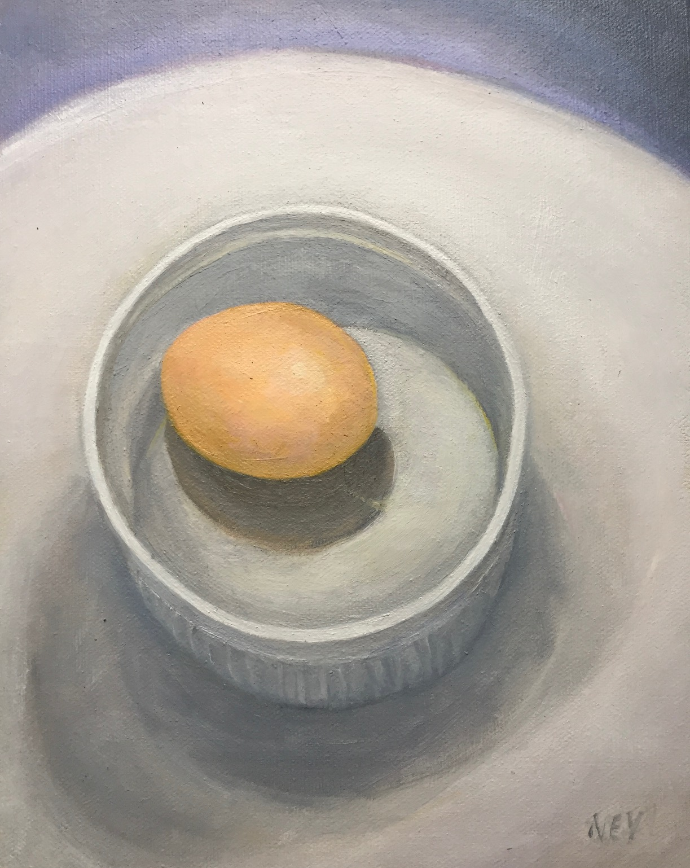

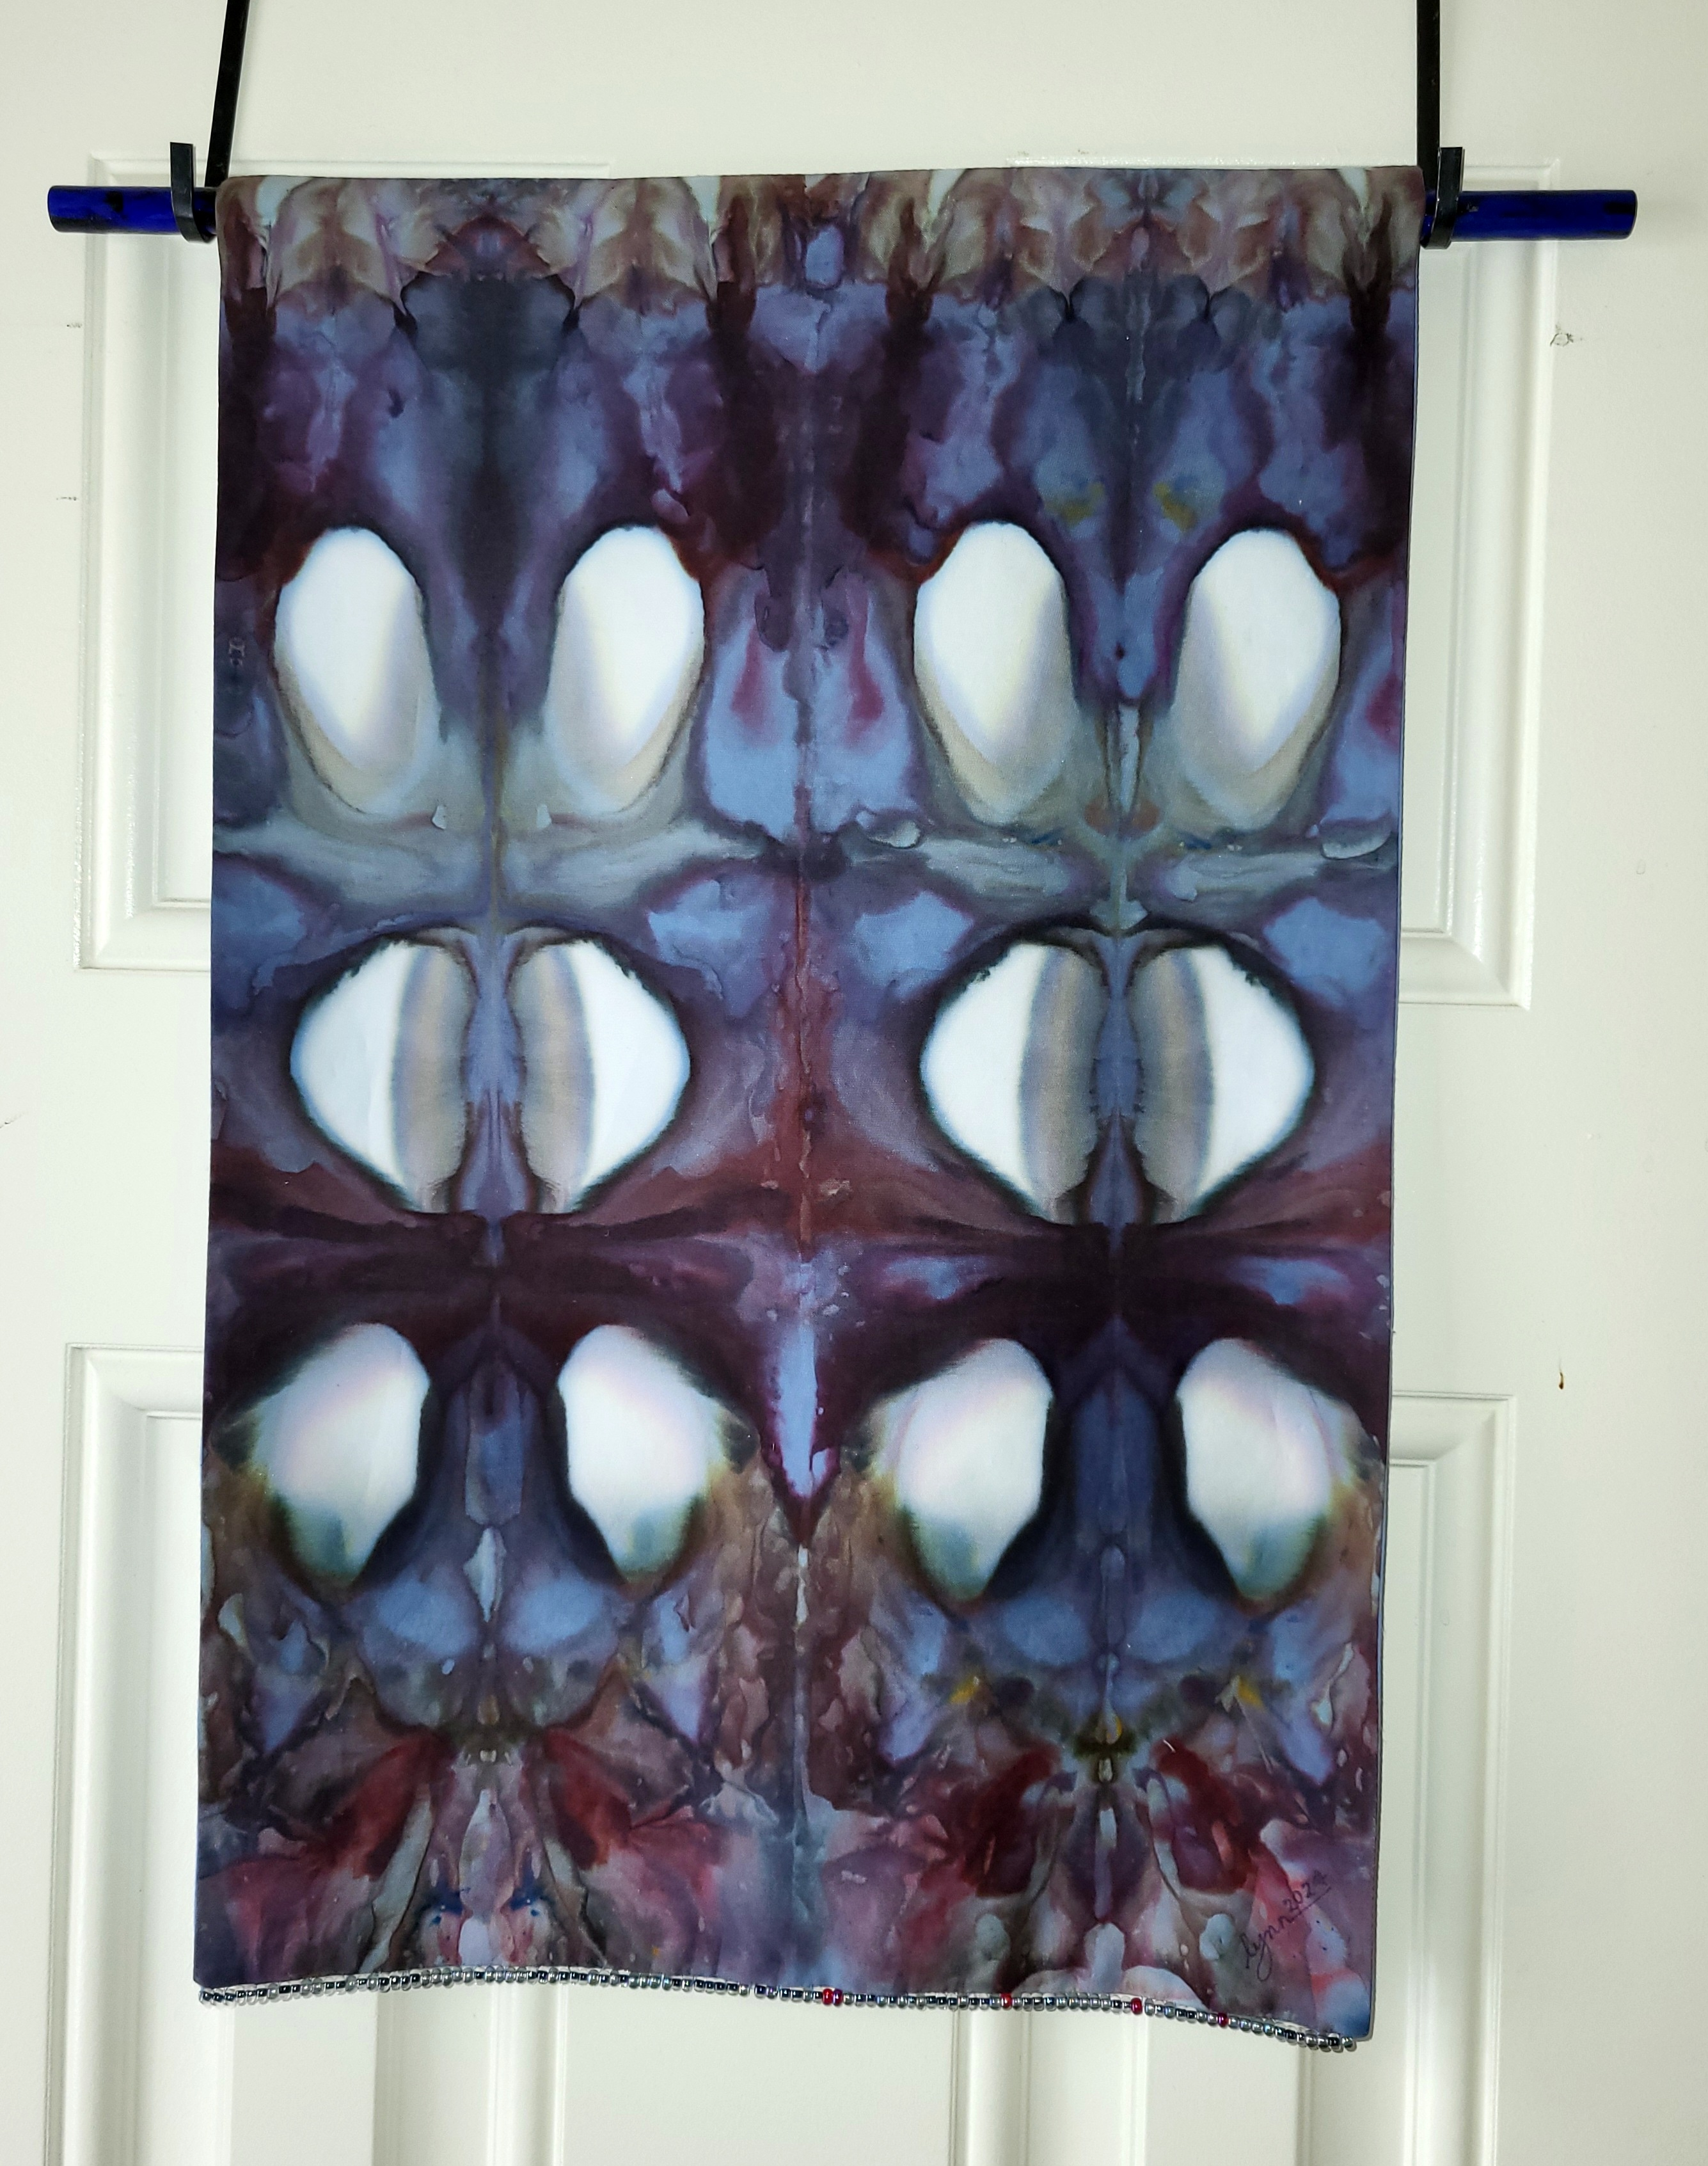

WHCP-FM 91.7 – Music Event Series

WHCP is a registered 501(c)3 non-profit organization supported by Membership Donations and Business Sponsorships. We are the only independently owned radio station on the Mid-Shore that provides local content, community news and information, and locally curated music programs! Get ready for the start of WHCP’s Live Music Events, presented as a part of our on-going commitment to bringing live music to the area and support local musicians too. Info at https://whcp.org/events/ | 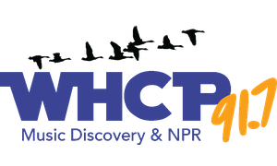

DORCHESTER COUNTY LIBRARIES

Summer has come to a close - but the adventures continue! We signed up over 1,065 people for the Summer Reading Program between both libraries and provided nearly a dozen daycares, day-camps, and youth organizations with activity booklets, community coupons, free comic books (thanks to Portals in Easton) and reading-related games and incentives. Children from Choptank Elementary, Warwick Elementary, and homeschool families led the charge on most readers signed up!

If you participated in the Summer Reading Program this year or attended library events, please take a moment to complete a brief survey to help us plan for next summer! Paper copies are available at either library branch or online at www.dorchesterlibrary.org. We appreciate your time and feedback!

Did you know September is Library Card Sign-Up Month? If you do not have a card, now is your chance to open a world of possibilities - for free! Just stop by one of our Library branches with your photo ID (and a piece of mail with current address if your ID is not up-to-date). Library cards provide access to both digital and print resources - stop by for more information!

Just a heads up that both branches of the Dorchester County Public Library will be closed Saturday, August 31st-Monday, September 2nd, in observance of Labor Day.

Announcement: The Cambridge Library will change over to Fall/Winter hours beginning Tuesday, September 3rd, 2024. Hurlock Library's hours will remain the same.

Cambridge hours will be:  Monday - Wednesday 10am-6pm  Thursday - Saturday 9am-5pm  Cambridge Library Events: |  | Hurlock hours will be:  Monday-Wednesday - 10am – 6pm  Thursday - 11am – 7pm  Thursday - 11am – 7pm  Friday-Sunday - Closed

Weekly
- Every Wednesday, 10:30am - Story Time (Stories, songs, and crafts for ages 0-5.)
- Every Wednesday, 4-5pm - Teen Anime Club (Anime related activities, games, prizes for ages 12-17.)
Monthly
- Every 2nd Tuesday (9/10), 4:30-5:30pm - STEM Lab (Science, technology, engineering, and math related activities for ages 6+.)
- Every 2nd Saturday (9/14), 9:00am-1:00pm - Friends of the Library Book Sale (Proceeds benefit library programs and materials!)
- Every 3rd Monday (9/16), 4:30-5:30pm - Fun Art Night (Drawing, painting, and more! Aimed at adults, but 13+ may attend.)
- Every 3rd Tuesday (9/17), 4:30-5:30pm - Stitch & Knit (Calling all handicrafters - bring your crochet and knitting needles and get stitching with us! Aimed at adults, but 13+ may attend.)
- Every 4th Monday (9/23), 4:30-5:30pm - Dorchester Discussions Book Club (Fun fiction and light refreshments. Aimed at adults, but 16+ may attend.

Hurlock Library Events:

Weekly
- Every Wednesday, 10:30am - Story Time (ages 0-5)

Special/Monthly
- Thursday, 9/5, 5:30pm - Stitch & Knit (Calling all handicrafters - bring your crochet and knitting needles and get stitching with us! For adults)
- Tuesday, 9/10, 4:30pm - Board Game Night (Everyone is welcome to come play - for all ages.)
- Thursday, 9/19, 5:30pm - Mandala Coloring (Get your Zen on with some markers and velvet lined mandalas - for ages 8 and up!)
- Thursday, 9/26, 5:00pm - Book Club (Fun fiction and light refreshments for adults.)

And as always, both Library branches continue to offer meal bags and non-perishable items for those in-need through an ongoing partnership with Midshore Meals til Monday. If you would like to help support our community, donations of unexpired non-perishables or new hygiene products are accepted at the Cambridge Library. Please see a staff member when donating. Both Library branches also offer free COVID-19 tests, thanks to the Dorchester County Health Department. There's something for everyone at the library!

MIDSHORE MEALS TIL MONDAY

MidShore Meals 'til Monday is working to end childhood hunger on Maryland’s Eastern Shore by providing weekend food for food-insecure children in Dorchester County. Meals ‘til Monday sends home healthy, nutritious food for children at the end of each school week and during the summer months for breakfast, lunch and snacks to bridge the hunger gap for children without access to adequate food.

Meals ‘til Monday currently provides food for more than 500 elementary, middle and high school students. Donations can be made at https://www.mscf.org/donate-online/.  For more information, please call the Director at 703-371-5191 or visit their website at www.midshoremealstilmonday.org/. | 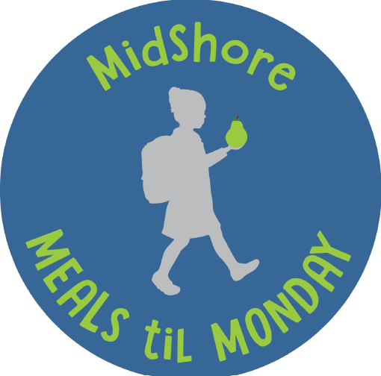
ONE MISSION CAMBRIDGE

Since June 2022, One Mission Cambridge has operated a vibrant mission center in the heart of Cambridge. The mission center is operational on a consistent schedule. The consensus among clients is that these ministries operate in a manner that projects love, compassion, and grace. The vast majority of clients view the mission center favorably and often comment on how well they are greeted and treated at the mission center. The positive feedback from the community, expressing appreciation for the excellent work of assisting the vulnerable population, is a testament to the value of our mission center.

The mission center is a hub of activity, offering a wide range of services during its daily opening hours to meet the diverse needs of our community. From food distribution to computer access, assistance with job applications, lunch, and fellowship, the center is a one-stop shop for those in need. It is also a crucial resource for homeless individuals and others, providing a safe space for cooling/warming and emotional support. The center's doors are open to new individuals daily, further expanding its reach and impact.

In the summer of 2024, the mission center expanded its space to nearly twice the size. This has allowed the organization to serve better the increasing number of guests requesting assistance. Volunteers are the lifeblood of our mission center, and we need your help to continue our fantastic work. If you want to make a difference in our community, please consider volunteering. Contact our mission center manager, Shelly, at 443-521-5226 or manager@onemissioncambridge.org for more details.



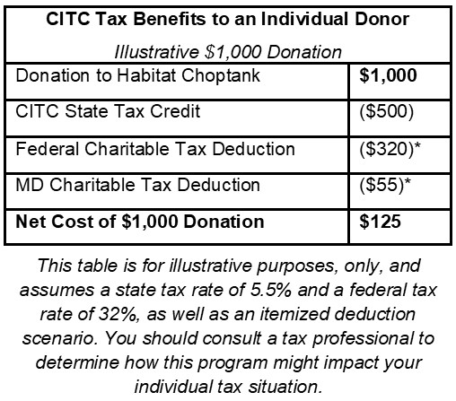
HABITAT CHOPTANK

Habitat Choptank has tax credits to offer as part of the Community Investment Tax Credit (CITC) program! This program is funded by the State of Maryland and allows qualified nonprofits to use state tax credits as incentive for donations.

Habitat Choptank’s tax credit donations are for our Maces Lane project in Cambridge to fund market research and site planning for a new mixed-income neighborhood that will include home ownership opportunities, as well as rental units to meet the diverse array of housing needs and income levels in this community. Here’s how the CITC program works (see table for an illustration):

- Tax credits equal 50% of the value of the donation. Minimum gift is $500.
This table is for illustrative purposes, only, and assumes a state tax rate of 5.5% and a federal tax rate of 32%, as well as an itemized deduction scenario. You should consult a tax professional to determine how this program might impact your individual tax situation.
- Tax credits are in addition to deductions on both Federal and State taxes for a charitable contribution.
- Tax credits must be used in the year in which the donation is made.
- Tax credits are on a first come, first served basis and are limited.
- You must contact us first to receive the proper forms and instructions.
- For more information, contact us at 410-476-3204 or development@habitatchoptank.org.

CAN MISSION, MEMBERSHIP, BOARD of DIRECTORS, and COMMITTEES

MISSION. The Cambridge Association of Neighborhoods (CAN) fosters neighborhood cohesion and community involvement to enhance the quality of community life for all residents of Cambridge through community events, social activities, and neighborly assistance. CAN protects and enhances properties in Cambridge by improving building and zoning codes, supporting adherence to those codes, and engaging constructively with City Government, including the Historic Preservation Commission. CAN’s Bylaws can be found on the CAN website at https://cambridgecan.org/welcome/about/bylaws/.

MEMBERSHIP. CAN welcomes members from all Cambridge area neighborhoods (broadly defined) who are interested in organizing and working together, building a diverse membership reflecting the diversity of Cambridge residents. Membership is FREE – information is available on the CAN website at https://cambridgecan.org/join-can/

CAN BOARD OF DIRECTORS. CAN is governed by a Board of Directors elected by CAN members at its annual January Business Meeting. Board Members whose terms expire in January 2026 are President – Chuck McFadden; Treasurer – Dave Thatcher; Members at Large – Mary Ellen Jesien, Kim Miller, Brad Rice, Donna Tower, and Judd Vickers. Board Members whose terms expire in January 2026 are Vice-President – Roman Jesien; Secretary – Tom Puglisi; Members at Large – Andre Duerinckx, Rick Klepfer, and Sharon Smith.

CAN HOUSING QUALITY COMMITTEE – PLANNING AND ZONING ISSUES. The Housing Quality Committee monitors issues affecting the quality of housing and the maintenance of property values in the City, including code enforcement. Committee members attend Planning Commission meetings to monitor zoning-related issues and report the information to the Board and Membership. Please contact Chuck McFadden at Ragtime31@gmail.com to volunteer.

NEIGHBORHOOD DEVELOPMENT COMMITTEE – SOCIAL EVENTS & ‘NEIGHBORS HELPING NEIGHBORS’.
"Neighborhoods" are organized by small groups willing to work together to address neighborhood issues through small social events and "neighbor-helping-neighbor” activities. The Social Events Subcommittee organizes community-wide events. Contact Chuck McFadden at Ragtime31@gmail.com to volunteer.

CAN COMMUNICATIONS COMMITTEE – WRITERS NEEDED. CAN'S Communications Committee needs writers, including volunteers to take unofficial notes at public meetings. Please contact Tom Puglisi at tom.puglisi@comcast.net to volunteer.

POWER WASHER AVAILABLE

CAN has an electric power washer available to members. Contact Chuck McFadden at Ragtime31@gmail.com.

