**Newsletter #24.11 NOVEMBER/DECEMBER 2024**

*CAN member meetings are announced in advance and open to the public.*

*Everyone interested in CAN is invited to attend.*

**IN THIS ISSUE:** Page

**PRESIDENT’S MESSAGE – CAN PRIORITIES FOR 2025** 1

**CAMBRIDGE CORNER**

* **Cambridge Real Estate Trends** 3
* **Cambridge Fun Facts & Lore** 4
* **Cambridge Department of Police** 4

**Community News – Cooperating Community OrganizationS**

* **Habitat for Humanity Choptank – Seeking Events Committee Members** 5
* **Main Street Gallery – All That Glitters**  6

**CAN Mission Statement, MEMBERSHiP, Board OF DIRECTORS, and Committees** 7

**CURRENT LINKS**

CAN’s Website – <https://cambridgecan.org>

JOIN CAN FOR FREE – <https://cambridgecan.org/join-can/>

CAN Meeting Minutes – <https://cambridgecan.org/category/meetings/>

CAN Meeting Videos – <https://www.facebook.com/WHCPRadio/videos> or

<https://www.youtube.com/@whcpstudio4716>

CAN’s City Council Meeting Notes – <https://cambridgecan.org/category/news/city-council-notes/>

CAN’s Planning & Zoning Notes – <https://cambridgecan.org/category/news/p-and-z/>

CAN on Facebook – <https://www.facebook.com/groups/cambridgeassociationofneighborhoods>

Contact CAN – [cambridgecan.org@gmail.com](mailto:cambridgecan.org@gmail.com) (please note email change)

**PRESIDENT'S MESSAGE**

*Chuck McFadden*

First of all, Happy Holidays to everyone. This is the time of year to reflect on all the good (and maybe the not so good) things that have happened and to plan for a better coming year. CAN held a member’s meeting on December 5, 2024, to decide on its priorities for the coming year.

Perhaps the most important part of CAN’s mission is to monitor and report on City and County activities and we can advocate certain positions that the City/County should take based on citizen feedback.

Another high priority for the CAN board is continued reporting on the City and County Council meetings, the Planning and Zoning meetings, and the P and Z Board of Appeals meetings.

During the group discussion on December 5th, some key issues rose to the top:

* Cambridge Waterfront Development Inc. (CWDI). This project continues to hold everyone’s attention. CWDI has a new Board after the settlement with the City so we will have to wait to see in what direction they will go. They had one meeting so far and it was far more open and transparent than in the past, which is a good sign for the future.
* Code Enforcement was also raised as a top issue. There are several aspects to this area which include: enforcement of existing codes especially on dwellings owned by slum landlords; concern about the expansion of the number of half-way houses in Cambridge and also whether landlords are following all the codes; enforcement of the rules regarding multiplex houses that are vacant and should be converted back to single family homes; and overall zoning issues which might affect everyone.
* Economic Development which includes issues such as downtown revitalization, the development of the industrial park and expanding job opportunities throughout the city. Cambridge needs to grow its business opportunities with incentives and easing regulatory requirements.
* Community involvement/ outreach/ clean-up projects. Helping people in need to attempt to improve the overall quality of life in Cambridge.
* Concerns about the success of Cannery Park which is an underpublicized effort to enhance the center of the city. The city has purchased 6.5 acres behind the Packing House and has already put in a bike path and a pavilion using grant funding. The city has funding to put in a dog park and two play areas and also to clear out trees to open up the creek area. Funds are also available to extend the bike path to Woods Road. There are a number of future plans if funding can be identified, so it is a work in progress.

CAN will continue to: 1) communicate to the Cambridge Community through emails, local Facebook sites, US Mail, Next Door via newsletters, unofficial meeting minutes, news articles, announcements and updates, 2) hold public meetings, 3) maintain the CAN website and CAN Facebook site and 4) work to expand and diversify membership from 1100.

The above areas were the top concerns expressed at the meeting. CAN will put emphasis on these but will also try to monitor the following:

* Crime – what are the trends and what can the city do about it? Police Chief Todd will be our guest speaker at the January 7, 2025, meeting and will discuss the crime statistics for 2024.
* The Shoreline Resiliency project – this is fully funded ($22 million) and planning is almost completed. This project involves building a berm from Great Marsh Park to Cambridge Creek to keep the rising river from flooding the streets and houses.
* Rehabilitation of the Administrative building - (estimated to cost $10 million). This project has a high priority with the City and the State and there are hopes that it will be completed in 3 to 4 years.
* Other areas of concern to CAN include the proposed rebuilding of the Hearn Building, Mill Street School, the revitalization of Pine Street, the county school system and the modernization of the fire department’s outdated equipment.

CAN’s ability to monitor and report on all the above areas depends on the number of volunteers we have that are willing to put in the effort. If you would like to support CAN and do research and reporting on any of the above topics, please contact Chuck McFadden at [Ragtime31@gmail.com](mailto:Ragtime31@gmail.com).

Have a happy holiday.

*Charles McFadden, President, CAN*

**CAMBRIDGE CORNER**

**CAMBRIDGE REAL ESTATE TRENDS**

*Fred and Martha Phillips-Patrick*

**National and Regional Residential Real Estate Developments:**

According to Freddie Mac, “Mortgage rates decreased to their lowest level in over a month. Despite just a modest drop in rates, consumers clearly have responded as purchase demand has noticeably improved. The responsiveness of prospective homebuyers to even small changes in rates illustrates that affordability headwinds persist.”

Redfin reports for the latest data available that: “In October 2024, home prices in Maryland were up 7.2% compared with last year, selling for a median price of $434,600. On average, the number of homes sold was up 12.1% year over year and there were 5,817 homes sold in October this year, up 5,189 homes sold in October last year. The median days on the market was 33 days, up 7 days year over year.” How did Cambridge fare in this market environment in November 2024? Let’s see.

**Cambridge Market Update:**

Rocket Homes reports that a total of 24 homes and land were sold or pending in Cambridge in November 2024, down by 7.7% month-over-month. Of the 24 sold, 63% sold under asking, 25% sold at asking, and 13% sold over asking. The median home sold price in Cambridge was $267,000 in November 2024, up 0.8% from last year. Rocket Homes characterized the market as slightly a seller’s market.

**Sales**

Currently, Rocket Homes shows that there are now 112 homes for sale (79 single family homes and 33 condos, townhomes, and multifamily units) in the Cambridge area. There are also 35 farms and plots of land. The properties’ asking prices range from $10,000 for a small plot of land (.06 acres) on Phillips Street to $2,350,000 for 5202 Heron Road, a five-bedroom estate on four acres on Three Creeks Point.

Rocket Homes details that in November 2024, twenty-one houses, condos, and townhouses were sold in Cambridge. The sold properties ranged in value from $112,500 to $775,000.

304 Academy St #302 $425K 108 Albemarle Ct $655K 6104 Twin Pt Cove Rd $775K

104 Willis St $381K 503 Merganser Way $225K 121 Choptank Ave $375K

705 Peach Blossom Ave $150K 5540 Bonnie Brook Rd $438K 1256 Hudson Rd $400K

902 Hudson Rd $120K 2700 Willow Oak 310C $395K 305 Terrapin Ct $349K

1520 Osprey Cir $385K 902 Talisman Ln $205K 610 Church St $495K

407 Eagles Nest Way $355K 203 Brant Way $200K 601 Widgeon Way $228K

608 High St $113K 700 Cattail Cove #309 $270K 304 Oakley St $628K

**Economic Forecast for Delmarva**

WMDT, Channel 47, reports that “the future of Maryland’s Economy was discussed today (December 6th) at the 37th annual Southern Delmarva Economic Forecast at Salisbury University.

Economic Forecast -On the Eastern Shore, 2025 is looking a bit gloomy for the state of Maryland. Experts pointing to minimum wage laws, high business taxes, small businesses struggling, and residents and business owners alike leaving the state.

Salisbury Area Chamber of Commerce President Bill Chambers says this year’s Economic forecast leaves cause for concern. “Maryland’s not a friendly state to do business. We have the highest corporate income tax rate of any of our neighbors. The business community for years has been asking to lower that rate. It’s an impediment.” However, the state is currently running a budget deficit and thus tax cuts are unlikely.

All these factors affect our local economy and thus our real estate prices going forward.

**CAMBRIDGE FUN FACTS & LORE – Best Christmas Town**

*Martha Phillips-Patrick*

Cambridge has long been regarded as one of the "best Christmas towns" in Maryland. This recognition rests largely on holiday events that Cambridge has dependably offered for many decades.  These include: the Cambridge-Dorchester County Christmas Parade, once regarded as the largest nighttime parade in Maryland, now celebrating its 75th year; the RFC Cambridge Train Garden in its 90th year of operation; and the Cambridge Woman’s Club Christmas Home Tour started in 1984. More recently (2014), the Crab Basket Tree, has joined the ranks of major holiday attractions in Cambridge as well as the holiday boat parade. Along with these, are street festivals, holiday music and arts offerings, and, of course, holiday shopping and dining venues.

A new Cambridge tradition perhaps? This year for the first time, the Hyatt Regency Resort, in partnership with Blackwater Adventures, has opened a synthetic ice-skating rink and winter village for the holidays and winter season. The rink is open to both resort guests and the local community. The rink is located next to the Regatta Pavillion. Skate rentals are available, and the Winter Village also provides refreshment stations, fire pits for s'more roasting, and holiday shopping opportunities from local vendors. For December, the rink and Winter Village are open on Thursdays and Fridays from 4 to 9pm; Saturdays from noon to 9pm and on Sundays from noon to 5pm. Admission is $15 and $10 for children 10 and under.

**CAMBRIDGE POLICE DEPARTMENT**

*Justin R. Todd, Chief of Police*

On behalf of all the staff at the Cambridge Police Department, I would like to wish everyone a great holiday season. As many of us will be out shopping and enjoying time with our families this holiday season, we would like to provide just a few safety tops to keep you, and your property protected. In past years, during the holiday season, the Police Department received an uptick in thefts from vehicles and

theft of packages from residences, etc. We will have extra holiday patrols out; however, we will need your help to make sure that everyone stays as safe as possible.

Here are just a few tips:

* When shopping, park in lighted areas.
* Make sure when you park your vehicle that all valuables, including packages and bags, are placed out of sight and LOCK YOUR DOORS!
* Don’t be an easy target when walking from the store to your vehicle. Always walk with others when possible and be aware of your surroundings.
* When receiving packages at home, network with neighbors or have packages delivered to your place of work when possible. In addition, having security cameras around your property is always a big deterrent to thieves.
* When the holidays are over and gifts have been opened, make sure to break down the boxes. Do not leave boxes outside by the trash as an advertisement of what you received for Christmas.

These are just a few tips. Remember the saying, “If you see something, say something.” If you see anything suspicious, please contact us and let us investigate. The non-emergency number is

410-228-3333.

I look forward to speaking with you at an upcoming CAN meeting to discuss some of the goals I hope to see the CPD accomplish as we enter into 2025. Until then have a great holiday season. If anyone has any questions or concerns, please do not hesitate to contact me at [jtodd@cambridgepd.org](mailto:jtodd@cambridgepd.org).

**COMMUNITY NEWS – COOPERATING COMMUNITY ORGANIZATIONS**

**HABITAT FOR HUMANITY CHOPTANK – SEEKING EVENTS COMMITTEE MEMBERS**

*Emily Brohawn, Community Engagement and Marketing Manager*

Habitat Choptank’s signature fundraising event, Hard Hats and High Heels, is a night of fundraising, live music, good food and networking. Though previously held at the Waterfowl Building in Easton, next year’s event is scheduled for October 18th, 2025, and will take place at 447 Venue in Cambridge. Habitat Choptank is currently seeking interested and enthusiastic individuals to serve on the events committee with focused efforts on Hard Hats and High Heels. Serving on the committee includes attending regular meetings for planning and brainstorming, assisting with auction and sponsorship solicitation, decorating, and other event related topics.

Since 1992, Habitat Choptank has made homeownership possible for over 120 families and completed critical health and safety repairs in partnership with over 300 qualifying homeowners. Habitat Choptank’s mission is to work in partnership with God and all people to build, rehab, and repair homes, improve the quality of life in communities and help to restore hope in the lives of those we serve. Hard Hats and High Heels and serving on the event committee is a great way to get involved and help make homeownership a reality for more neighbors in Dorchester and Talbot County. Proceeds from this event benefit the continued work in Cambridge, both in the completion of the Wells Street neighborhood and the upcoming project beginning in 2025 of a new 12 home neighborhood off of Camper Street. These neighborhoods, representing only a handful of the 121 homes completed since 1992, continue to bring hope and stability to children, families, and the entire community.

For more information on ways to get involved, email [engagementmgr@habitatchoptank.org](mailto:engagementmgr@habitatchoptank.org) or call the office at 410-476-3204 x 317. You can also visit our website and fill out an inquiry form at <https://habitatchoptank.org/volunteer/individuals/>

**MAIN STREET GALLERY**

ALL THAT GLITTERS: A METALSMITH COLLECTIVE - this third annual holiday show of fine jewelry and art glass will extend its run into January and February 2025 at the Main Street Gallery in Cambridge. The gallery is delighted to have the group of seven jewelry and glass artists, all of whom live and create their art in areas around the Bay, showing into the new year. "Our customers have responded so positively to this show," says director Linda Starling, who is also a member of the metalsmith collective. "They appreciate the artistry that has gone into the handcrafted silver jewelry and hand formed art glass pieces. This show has really been a big hit, and it will be especially nice to have these works available in February for Valentine's Day giving".

ALL THAT GLITTERS will continue at the Gallery alongside works by the gallery’s member artists. It will run through Saturday, March 1. Exhibiting “Glitter” artists are Cindy Ayd, Wanda Jester, Alexa Matthai, Charles McMillin, Robin Morgan, Linda Starling and Barbara Trower. The gallery, at 518 Poplar St., will host two artist's receptions on Second Saturdays January 11 and February 8 from 5-8 pm. There will be a brief artist talk at each reception. The receptions are free, and all are invited. Light refreshments will be served. You can view photos of jewelry and other artwork for sale on the Main Street Gallery website – www.mainstgallery.net.

For the winter months Main Street Gallery will be open Fridays and Saturdays from 11-5 and by appointment. Online shopping is always available at mainstgallery.net. The gallery is located in Cambridge’s thriving arts and entertainment district and is the city’s only artist owned and operated cooperative. It has been operating continuously downtown for over 13 years. The gallery is currently reviewing work by prospective members and guest artists. Please contact the gallery through its website or by calling 410-330-4659 if you are interested in being part of this vibrant artist community.

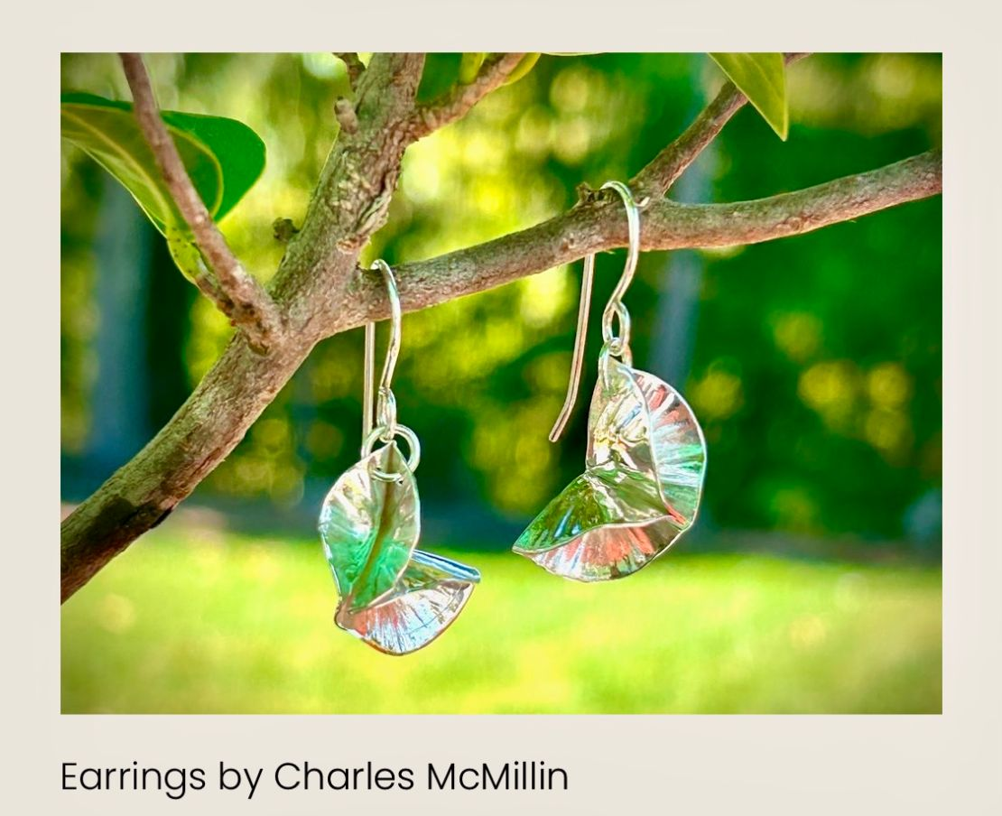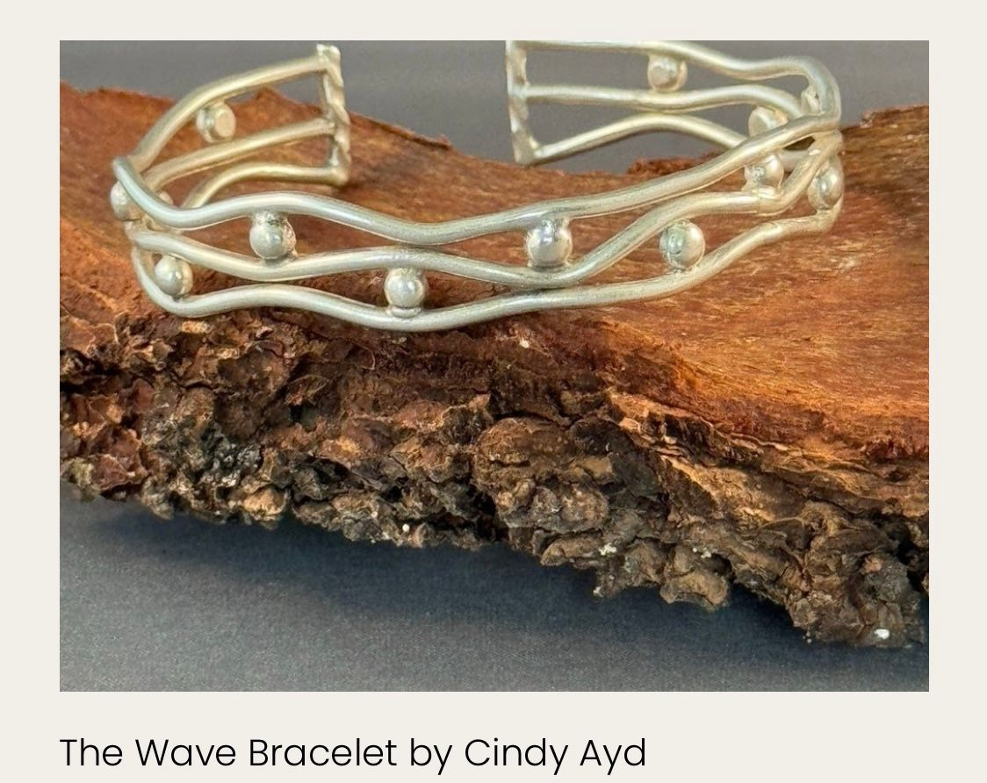

**CAN MISSION, MEMBERSHIP, BOARD of DIRECTORS, and COMMITTEES**

**MISSION.** The Cambridge Association of Neighborhoods (CAN) fosters neighborhood cohesion and community involvement to enhance the quality of community life for all residents of Cambridge through community events, social activities, and neighborly assistance. CAN protects and enhances properties in Cambridge by improving building and zoning codes, supporting adherence to those codes, and engaging constructively with City Government, including the Historic Preservation Commission. CAN’s Bylaws can be found on the CAN website at [*https://cambridgecan.org/welcome/about/bylaws/*](https://cambridgecan.org/welcome/about/bylaws/)*.*

**MEMBERSHIP.** CAN welcomes members from **all Cambridge area neighborhoods** (broadly defined) who are interested in organizing and working together, building a diverse membership reflecting the diversity of Cambridge residents. **Membership is FREE** – information is available on the CAN website at [*https://cambridgecan.org/join-can/*](https://cambridgecan.org/join-can/)

**CAN BOARD OF DIRECTORS.** CAN is governed by a Board of Directors elected by CAN members at its annual January Business Meeting. Board Members whose terms expire in January 2026 are President – Chuck McFadden; Treasurer – Dave Thatcher; Members at Large – Mary Ellen Jesien, Kim Miller, Brad Rice, Donna Tower, and Judd Vickers. Board Members whose terms expire in January 2025 areVice-President – Roman Jesien; Secretary – Tom Puglisi; Members at Large – Andre Duerinckx, Rick Klepfer, and Sharon Smith.

**CAN HOUSING QUALITY COMMITTEE – PLANNING AND ZONING ISSUES.** The Housing Quality Committee monitors issues affecting the quality of housing and the maintenance of property values in the City, including code enforcement. Committee members attend Planning Commission meetings to monitor zoning-related issues and report the information to the Board and membership. *Please contact* Chuck McFadden at [*Ragtime31@gmail.com*](mailto:Ragtime31@gmail.com)to volunteer.

**NEIGHBORHOOD DEVELOPMENT COMMITTEE – SOCIAL EVENTS & ‘NEIGHBORS HELPING NEIGHBORS’.**

"Neighborhoods" are organized by small groups willing to work together to address neighborhood issuesthrough small social events and "neighbor-helping-neighbor” activities. The **Social Events Subcommittee** organizes community-wide events. *Contact* Chuck McFadden at [*Ragtime31@gmail.com*](mailto:Ragtime31@gmail.com) to volunteer.

**CAN COMMUNICATIONS COMMITTEE – WRITERS NEEDED**. CAN'S Communications Committee needs writers, including volunteers to take unofficial notes at public meetings. *Contact* Chuck McFadden at [*Ragtime31@gmail.com*](mailto:Ragtime31@gmail.com) to volunteer.

**POWER WASHER AVAILABLE**

CAN has an electric power washer available to members. Contact Chuck McFadden at [*Ragtime31@gmail.com*](mailto:Ragtime31@gmail.com)*.*