CAMBRIDGE ASSOCIATION OF NEIGHBORHOODS
PUBLIC MEETING MINUTES
30January2025 6PM
https://www.youtube.com/live/aNV1J7UCxfU?si=mslCxGhTDXvdysUq

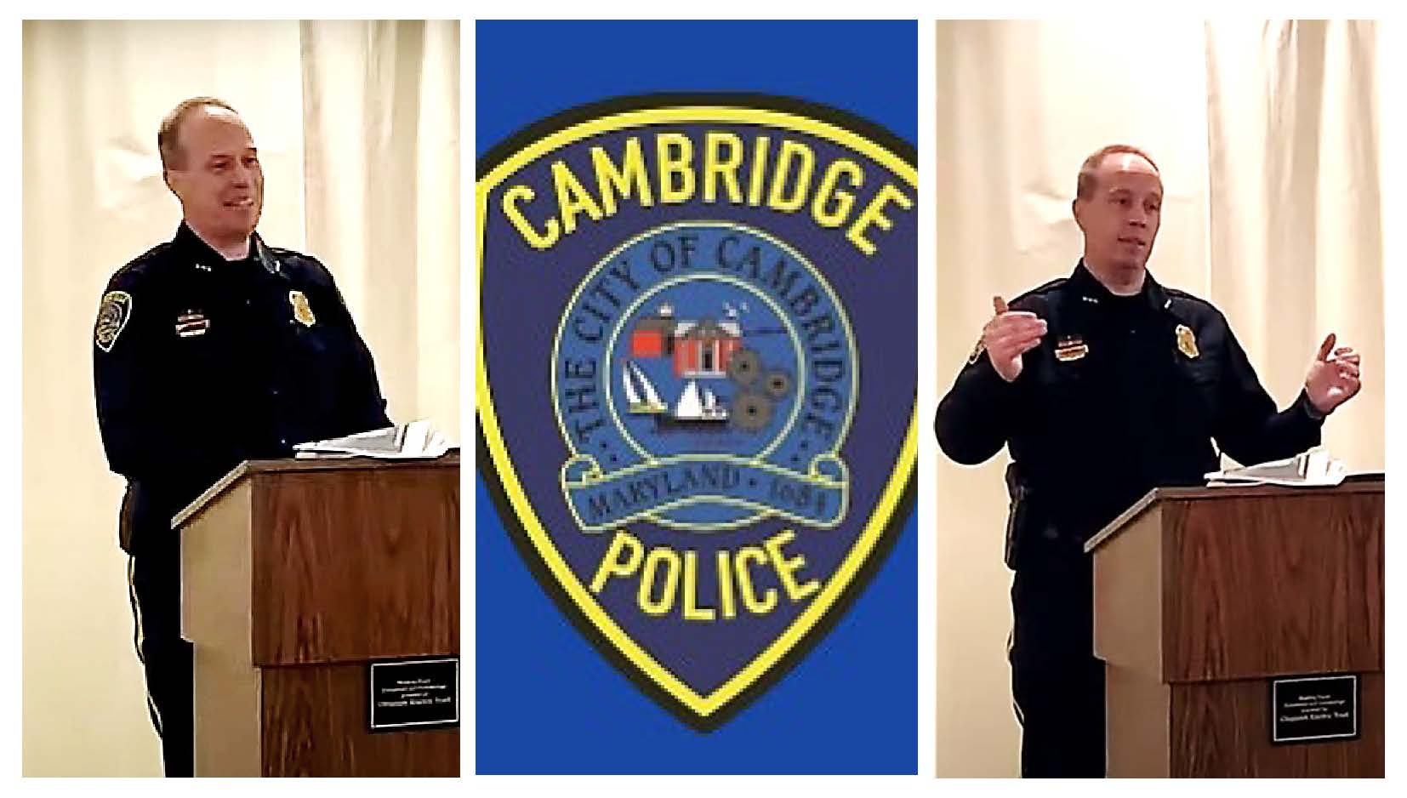

Board Members Present: Chuck McFadden (President), Roman Jesien (Vice President), Kim Miller, Sharon Smith, Judd Vickers, Brad Rice, Mary Ellen Jesien,
Board Members Absent: Dave Thatcher (Treasurer), Andre Duerinckx

Opening Comments: Chuck McFadden (President)
- Introductions of all present in the room
- CAN Donations and Volunteers are welcome

Topics:
1 -Annual Voting for Board Members
  - Renewal of Sharon Smith, Andre Duerinckx, Roman Jesien to the Board. There was a unanimous vote to renew all 3 Board Members.
  - Kim Miller was nominated previously to assume the role of Secretary from her Board Member role. There was a unanimous vote for Kim Miller to assume the role of Secretary.

2- Chief Justin Todd of Cambridge Police Department (CPD) has joined us as a guest speaker to discuss the 2024 crime statistics and the new initiatives put in place this past year.
  - 3 years as Chief, 25 years in Cambridge PD
  - Type of Policing
- Community Orienting Policing (started in 2022)- “bringing the community together and be in that support system for our community” – like doing things with the kids. PAL basketball leagues. Every officer is community policing officer (not just during special events) – It’s about public and social interactions. “The respect you give is the respect you'll get and that's what we try to instill into our officers.”
- Patrolling with purpose (started in 2023) – with crime mapping (using GIS Mapping) we can know where crime is occurring and look at trends to be proactive in preventing crime when possible. Patrol in certain areas for certain time intervals
- Results: Overall crime has decreased by 14.5% in the past year!
- It takes city wide commitment.
- Code enforcement is important. Apartment Complex Manager’s support. Law enforcement presence at the Apartment Complex (i.e., Greenwood Ave. Apartment rented by PD). This was done to reduce crime and gun violence in that area, and it really made a difference.
  - Training is also critical. Laws change and skills need to be kept up to be best prepared. We logged over 6000 training hours across 36 officers
  - Partnering well with Juvenile Services and The Board of Education to initiate a Teen Court, intended for children who commit minor infractions that would not be eligible to go into the official court system. They have a chance to be judged by their peers in an actual court setting. Great opportunity to get the parents and the kids to be involved. If found guilty they would have to do community service hours, possibly with community police.
  - Partnering with Dorchester County Health Dept to support the mental health for both the community and for police officers especially if traumatic event occurs.
  - The drone program was funded last year. Testing and pilots licensing should commence around April timeframe. Will not replace police officers. It is considered a safety tool and has benefits for law enforcement in fighting crime.
  - Staffing: There are currently 36 police officers which includes 2 captains and 1 chief. The goal (per budget) was 40. The department is still working toward the goal of 40 to reduce overtime and potential burnout. Still with 36 officers, CPD answered 37,000 calls of service last year.
  - Some Statistics 2024 compared to 2022: For more see the Annual Report at this link: https://www.choosecambridge.com/ArchiveCenter/ViewFile/Item/80
  - Sexual assaults/offenses are up by 12%
  - Burglaries are down by 12%
  - Aggressive assault (assault with weapon) went down from 110 in 2022 to 30 in 2024.
  - Homicide in 2022 = 7 vs. 2024 = 1 (+1 kidnapping from another county leading to death here)
  - Car thefts are down 54%
  - Juvenile crime also improved in the past 1.5 years. Juvenile referrals are up by 32.4% in the past year and physical arrests are down by 17.2%. The curfew has helped a lot. CPD partners well with Juvenile Services and the States Attorney Offices to manage the juvenile crimes. The Teen Court initiative should help improve the situation even more.
    - School Officer (CPD) at Macey’s Lane Middle school. Hands are pretty tied with Juvenile of a certain age, hence the reason for curfew. Small number of kids are disruptive. Most are good.
  - Traffic crashes (injury accidents) are up 7%
  - Property damage is up 18%
  - CPD made 3588 traffic stops
  - DUIs are up to 40 (convicted in court)
- Divisions (4)
  - Criminal Investigation – handles the major stuff – robberies, theft, fraud, homicide. Last year they had a 69.6% closure rate which exceeds the national average of 28%. They also are proactive in community engagement in the hotspots, developing relationships and preventing crime.
  - Patrol Department – averages 102 calls each day. 4.25 calls/hr. 12-hour shifts, 5-6 per squad. First on scene. Preventing crime
  - Community Policing – 188 community events – PAL basketball league, flag football. Keep kids active and in sports. 3-4 coaches this year that are CPD.
  - Administrative - Civilians responsible for entry/removal of warrants & protective orders issued by courts, as well as NIBRS and UCR reporting to the FBI. In 2024, there were 156 arrest warrants, and 192 protective orders entered.
  - There is also an internal Police accountability board; internal affairs and an independent charging committee (ACC) that reviews any issues/complaints

3 - Questions/Comments from the audience.
  - Question about Shot spotter: 2022 implementation – 50% reduction in shots fired. Allows CPD to identify guns and suspects through a system based on shell casing found. The IT department and cameras also help to solve homicide cases and support court cases.
  - Do you have stats on who has households with cameras? It would be a good initiative. They do make notes for people who have provided videos in the past. Anyone is welcome to let CPD know that they have cameras.
  - Question about recent large cocaine drug bust.: Distribution was intended for Dorchester County. Cocaine and Heroin is a big problem for this area.
  - Intense effort on minor crimes and results? Traffic enforcement efforts, stopping bikes and scooters due to complaints. There was much public appreciation.
  - Is the curfew still being enforced? Yes. It is beneficial because it shows who is outside at that time. Not seeing as much as before. There is a big difference since 2022.
  - Suspicious activity question. i.e., Car is pulling up routinely… bottom line: If you suspect something get a tag number and call it in.
  - Question about security at Great Marsh. Lights and cameras have been placed at Boyle Park, Great Marsh. Some crimes have been solved since.
  - Have you had any part in immigration issues since the changes? No immigration role at present time. No ICE presence is known.
  - What would you consider a full complement of officers? Back in 2010 there were 52 officers with bike patrols. Estimating 40 to 45 would be acceptable today, but 40 would be good to accomplish goals and initiatives. Some challenges have been qualifications and retention in terms of competitive salaries. It depends on what motivates the individual. Some are dedicated to the town because they are from here and stay.
  - Citizen’s Police Academy - Judge and States Attorney’s Office participate. This is a classroom scenario for citizens. There are actual simulations of traffic stops showing the mindset of an officer’s training and split-second decisions that need to be made to shoot or not.
  - Police officers in schools? Macy’s lane – Cambridge officer; Highschool -Sheriff’s officer
  - Comment - Come to appreciate that the CPD is involved in so many things…
  - Apartment Complex - extra security presence.
      - Repeat search warrant issues (repeat offender) since the same people rent when they should not be allowed to. CPD works with Code Enforcement to manage the situation with the Apartment Complex.
  - Knocking on doors to move cars off snow emergency route (community policing).

Chuck McFadden thanked Chief Todd for his presentation and the audience for participating in the meeting. The meeting was adjourned at 7:00 pm.

