**Newsletter #25.1 FEBRUARY 2025**

*CAN member meetings are announced in advance and open to the public.*

*Everyone interested in CAN is invited to attend.*

**IN THIS ISSUE:** Page

**PRESIDENT’S MESSAGE – North Star Village** 1

**CAMBRIDGE CORNER**

* **CAN Volunteers Needed** 3
* **Cambridge Real Estate Trends and Revitalization Awards** 4
* **Eastern Shore Political Opinion Poll** 5

**Community News – Cooperating Community OrganizationS**

* **Habitat for Humanity Choptank ReStore** 5
* **Cambridge Empowerment Center** 5
* **Choptank Writers** 6
* **Main Street Gallery** 6

**CAN Mission Statement, MEMBERSHiP, Board OF DIRECTORS, and Committees** 8

**CURRENT LINKS**

CAN’s Website – <https://cambridgecan.org>

JOIN CAN FOR FREE – <https://cambridgecan.org/join-can/>

CAN Meeting Minutes – <https://cambridgecan.org/category/meetings/>

CAN Meeting Videos – <https://www.facebook.com/WHCPRadio/videos> or

<https://www.youtube.com/@whcpstudio4716>

CAN’s City Council Meeting Notes – <https://cambridgecan.org/category/news/city-council-notes/>

CAN’s Planning & Zoning Notes – <https://cambridgecan.org/category/news/p-and-z/>

CAN on Facebook – <https://www.facebook.com/groups/cambridgeassociationofneighborhoods>

Contact CAN – [cambridgecan.org@gmail.com](mailto:cambridgecan.org@gmail.com)   (please note email change)

**PRESIDENT'S MESSAGE**

*Chuck McFadden*

At the January 27th City Council meeting, the Council got an in-depth briefing on the proposed “North Star Village” or the Cannery Way Improvement Project. The briefing was led by Alpha Genesis Community Development Corporation’s President Adrian Holmes. As her presentation notes state, this is a joint project between Alpha Genesis, the City, the State’s Housing and Community Development, the Maryland Historic Trust, the Rural Maryland Council and our State Legislators. The project’s purpose is to bring major improvements around the area of the Harriet Tubman “Take My Hand” mural.

The partnership has Alpha Genesis improving its own properties at 428-432 Race Street and making the second floor of those properties into Alpha Genesis headquarters. There is also a second story open air patio which looks like a dining area. All of the above would be under the control of Alpha Genesis. Alpha Genesis has also raised money through grants for building a 24 by 60-foot Solar Canopy that will supply electricity for the rest rooms, outside lighting and the Alpha Genesis Headquarters. The Canopy will be able to seat 160 people beneath it for community events or 72 people for classroom type events.

As for the rest of the proposed structures in the North Star Village, it was unclear who was paying for them and on what property they would exist. These structures include: a replica of Harriet Tubman’s father’s cabin, the “Ben Ross Cabin”; rest rooms and meeting room; and 732 square feet of community gardens.

There was no mention in the notes of any plans for maintenance of the North Star Village or the role of the Harriet Tubman Museum and Education Center, which is adjacent to the proposed village and who actually owns the mural, would play. There is also confusion among Alpha Genesis, the Tubman Museum and the City as to who owns what property. The City is having a professional survey done to determine who owns what piece of land.

I am all for improving the area around the mural. My concern, however, is that the City will, as it has several times in the past, simply look at this individual project while not taking into account the cost of maintaining it. The City has two employees to maintain all the parks and playgrounds in the City. In addition, it has created 3 new major parks – Cannery Park and Bike Path behind the Packing House, the new walkway and proposed park at Cambridge Harbor and the new Park on Leonards Lane. All of these new parks will need maintenance which is currently not funded by the City. My estimate is that the City will have to hire 3 new park maintenance people to keep these new areas in useable condition.

The City now has concerns as to who is going to maintain this new “North Star Park”. It is proposed to have restrooms, a meeting room, a historic cabin, 732 square feet of community gardens and a canopy that can seat 160 people beneath it. So, is the City going to hire a person to maintain this at a high level or try to absorb the additional work with the existing staff?

Another problem with the proposal is that Alpha Genesis says it has raised about $1 million to build the proposed buildings. These buildings would be adjacent to The Harriet Tubman Museum and Education Center and in plain view of the very popular “Take My Hand” mural. The mural is essential to the concept and design of the North Star Village however the mural belongs to the Harriet Tubman Museum which does not benefit from any of the grant money. In addition, the Museum has its own plans for development of its property which include landscaping and an area for music events. This could cause conflict when both entities are planning events at the same time and brings up the question of who will maintain the schedule of events – Alpha Genesis, the Tubman Museum or the City? An additional concern is what would happen if Alpha Genesis moves on to another location – who will maintain all these privately, owned structures? What if a new owner of the Alpha Genesis property enclosed the canopy and blocked the view of the mural? And what is the advisability of going into a major development with a non-profit which may or may not be active in five years?

The Council did ask about the costs of on-going maintenance, but Alpha Genesis did not give a clear answer as to who would be responsible for what structures. Alpha Genesis did mention the possibility of hiring interns to keep the site maintained. I seriously doubt that an intern would want a job cleaning bathrooms or picking up trash around the site.

The City Council needs to look at the entire picture of both the proposed North Star Village and its other City parks and they need to consider the on-going costs of maintenance before making any decisions about the proposed North Star Village Project. Please contact your Council person if you have questions or comments on the above.

*Charles McFadden, President, CAN*

**CAMBRIDGE CORNER**

**CAN VOLUNTEERS NEEDED**

The CAN Board has developed a list of projects that it would like to pursue in 2025 and is looking for volunteers to help. The following is the list and the board member or volunteer who has stepped up to be the coordinator.

* Reporting on City Council meetings – Allison Kennedy, needs a backup
* Reporting on County Council Meetings – Sharon Smith, needs a backup
* Code Enforcement – Judd Vickers, needs numerous volunteers to cover and follow up with the City on code violations
* Monitor and Report on CWDI (Cambridge Waterfront Development) – Brad Rice; needs a backup
* Cannery Park – Chuck McFadden needs help covering different aspects of development
* Marina – Chuck McFadden/Pete Doyle need assistance in developing a long-range plan for financing and improvements to the City Marina
* Monitor the Resilience Project – need ongoing reporting on the progress of this project
* Education – Brad Rice needs assistance reporting on the school system
* Monitoring and reporting on Cannery Way (North Star Village) – need someone to follow and report on the events of this project
* Police and crime reporting – need someone to follow and report on the crime statistics in the City and on the police department and their efforts to combat crime especially Community Policing efforts.
* City Government – monitor and report on the Cambridge City government projects, i.e., the old City Hall, street improvements, snow removal, etc.

If you are interested in helping in any of these areas, please contact Chuck McFadden at Ragtime31@gmail.com.

**CAMBRIDGE REAL ESTATE TRENDS**

*Fred and Martha Phillips-Patrick*

**National and Regional Residential Real Estate Developments:**

According to Freddie Mac, “The 30-year fixed-rate has hovered between 6% and 7% for most of the last two and a half years. That trend continued, with the average rate remaining essentially flat at 6.7%. Driven by these higher rates and a persistent supply shortage, affordability hurdles still exist for many homebuyers and a significant number of them remain on the sidelines.”

Redfin reports for the latest data available that: “In December 2024, U.S. home prices were up 6.2% compared to last year, selling for a median price of $427,430. On average, the number of homes sold was up 11.8% year over year and there were 400,538 homes sold in December this year, up 358,408 homes sold in December last year. The national average 30-year fixed rate mortgage rate is at 6.7% and down 0.1 points year over year.” How did Cambridge fare in this market environment in December 2024? Let’s see.

**Cambridge Market Update:**

Rocket Homes reports that a total of 24 homes and land were sold or pending in Cambridge in December 2024, up by 4.2% month-over-month. Of the 24 sold, 14 were sold under asking, 6 were sold at asking, and 4 were sold over asking. The median home sold price was $270,000 in December, up 1.9% from last year.

**Sales**

Currently, Rocket Homes shows that there were 113 homes for sale (64 single family homes and 49 condos, townhomes, and multifamily units) in the Cambridge area. There are also 42 farms and plots of land. The property’s asking prices range from $10,000 for a small plot of land (.06 acres) on Phillips Street to $3,100,000 for a poultry farm at 4890 Drawbridge Road.

Rocket Homes details that in December 2024, 24 houses, condos, and townhouses were sold in Cambridge. The properties sold ranged in value from $83,000 to $1,225,000.

202 Rambler Rd $180K 5476 Ragged Pt Rd $1,225K 314 Mill St $650K

1110 Holland Ave $233K 303 Washington St $83K 7 Oak St $135K

172 Regulator Dr N $394K 5326 Suburban Dr $270K 5 Mimosa Ct $371K

207 Johnson St $438K 2816 Persimmon Pl $393K 104 Cambridge Ldg $610K

12 Snowy Egret $285K 1668 Terrapin Cir $325K 601 Goldsborough Ave $196K

204 Oak St $450K 105 Mill St $430K 112 Choptank Terr $449K

301 Shipyard Dr $275K 303 Riverside Ln $308K 2700 Willow Oak Dr $415K

507 Merganser Way $219K 501 Merganser Way $229K 801 Wood Duck Dr $215K

**City of Cambridge Receives over $1 million in Revitalization Awards**

On January 22, 2025, WMD reported that “The City of Cambridge has received multiple awards from the State of Maryland for community revitalization projects. The awards are administered by the Maryland Department of Housing and Community Development, totaling $1,150,000.“ Programs receiving funding:

* The Mace’s Lane Community Center: $500K from the Strategic Demolition Fund to complete the construction and remaining renovation of the building.
* The 444-448 Race St. Development Project: $500K for its Phase III work, which entails the creating three retail spaces and nine apartments.
* “Old City Hall” renovation project at 307 Gay St.: $100K for the creation of a community room.
* Cambridge’s Façade Improvement program: $50K to improve the appearance and historic appeal of commercial building exteriors in Cambridge’s Sustainable Community area.
* The Packing House: Additionally, two awards totaling $550K to furnish the shared-use commercial kitchen and complete the interior and exterior event spaces.

**EASTERN SHORE POLITICAL OPINION POLL**

In the fall of 2022 Washington College designed and sponsored an online political opinion survey of 686 registered voters on the Eastern Shore (1st Congressional District) of Maryland. Poll results highlight a significant partisan divide over what Eastern Shore voters consider the most important issues facing the District as well as suggesting that Eastern Shore voting patterns tend to differ from those state-wide. The survey and its results can be accessed here:

<https://www.washcoll.edu/academic_departments/political-science/eastern-shore-opinion-poll.php>

**COMMUNITY NEWS – COOPERATING COMMUNITY ORGANIZATIONS**

**HABITAT FOR HUMANITY CHOPTANK ReSTORE**

Have A Heart for Volunteering? Do you have a heart for volunteering and a desire for putting your creativity into action? The Habitat Choptank ReStore located in Easton, MD is currently seeking interested individuals willing to volunteer on the sales floor to help with displays, décor, staging, and similar tasks. The ReStore has a team of passionate staff that cultivate an energetic environment, one that creates impact far beyond the walls of the ReStore.

The ReStore helps fuel the mission of building homes, community and hope for neighbors in Dorchester and Talbot County. Revenue from the store helps with funding for affordable housing and creating homeownership opportunities for more individuals. Consider volunteering with the ReStore so you too can be a part of making impact in our community. For more information on how to get involved, visit <https://habitatchoptank.org/volunteer/volunteer-orientation/> and start volunteer orientation today or email [volunteers@habitatchoptank.org](mailto:volunteers@habitatchoptank.org).

# **CAMBRIDGE EMPOWERMENT CENTER**

# **Creatures & Characters – a Fun Event!**

# February 8, 2025 from 12:00 to 2:00 pm

# Location: Harry & Jeanette Intergenerational Center, 109 Chesapeake Street, Cambridge MD

## Join Timothy Young – toy designer; Illustrator; sculptor; author; puppet maker and more fun stuff!

This event is for children 3-12 years old; parent (or adult relative) must accompany their child.

In cooperation with:

* Cambridge Empowerment Center
* Dorchester County Campaign for Grade Level Reading
* J2W Foundation
* Harvesting Hope Youth and Family Wellness
* Boys and Girls Club
* Dorchester County Library
* Supported by Moving Dorchester Forward

## Sign up on Cambridge Empowerment Center site. Box lunches will be provided to those who sign up.



**CHOPTANK WRITERS**

Are you interested in sharing your writing with a positive, supportive audience and receiving constructive feedback that may help you improve writing skills, foster motivation, and gain fresh perspectives? If so, we invite you to join Choptank Writers. All genres are welcome. Founded in 2009, Choptank Writers meet each Wednesday from 2:30-4:30 pm at the Dorchester Center for the Arts in Cambridge, MD. Contact: Judy Holland at jleeholl@gmail.com.

**MAIN STREET GALLERY**

Whitney Elliott believes that as long as art exists, joy exists too. Her show, JOY ALWAYS EXISTS, exudes that spirit through the large, colorful macrame wall hangings she has knotted and tied by hand. These artful works are fashioned into patterns under the artist's skilled hands, using cords of various colored fibers. Finished works include found objects such as crystals and metal images of birds and flowers woven into them. While Whitney's work definitely feels fresh and new, her medium dates back centuries to France and has been continuously practiced around the world. Macrame had a heyday in the 1970's as part of the back-to-earth movement. It was especially popular among hippies and counterculture folk who were attracted to an art form that needed no tools but their hands to create wall hangings, plant hangers and even clothing.

Whitney came to discover macrame in 2018 while out shopping for home decor. She came across a macrame wall hanging and said to herself.  "I could probably make something like that."  And that's exactly what she did. By 2019 her macrame-making was in full gear and she had opened a new business called *Double Rainbow Design.* Whitney says her art is heavily influenced by nature and the spiritual realm and crystals are her jam. "I am a self-proclaimed crystal witch who is looking to heal the world through crystal magic and beautiful art" she says. "Along the journey I have tied hundreds of thousands of knots, connected with countless people, fulfilled over a thousand sales, and been featured on sites like Voyager Baltimore and Beyonce.com"

JOY ALWAYS EXISTS will open on Friday March 1 at Main Street Gallery at 518 Poplar St., in Cambridge and run through Sunday April 28. There will be two artist receptions at the Gallery on Second Saturdays March 9 and April 13 from 5-8 pm and Whitney will give a brief artist talk during the first reception. The receptions are free and all are invited. Light refreshments will be served.

Starting in March, Main Street Gallery is open Thursday through Saturdays from 11-5 and online shopping is always available at [mainstgallery.net](http://mainstgallery.net/). The gallery, located in Cambridge’s thriving arts and entertainment district, is the city’s only artist owned and operated cooperative and has been downtown for over 13 years. The gallery is currently reviewing work by prospective members and guest artists. Please contact us through our website or by calling 410-330-4659 if you are interested in being part of this vibrant artist community.

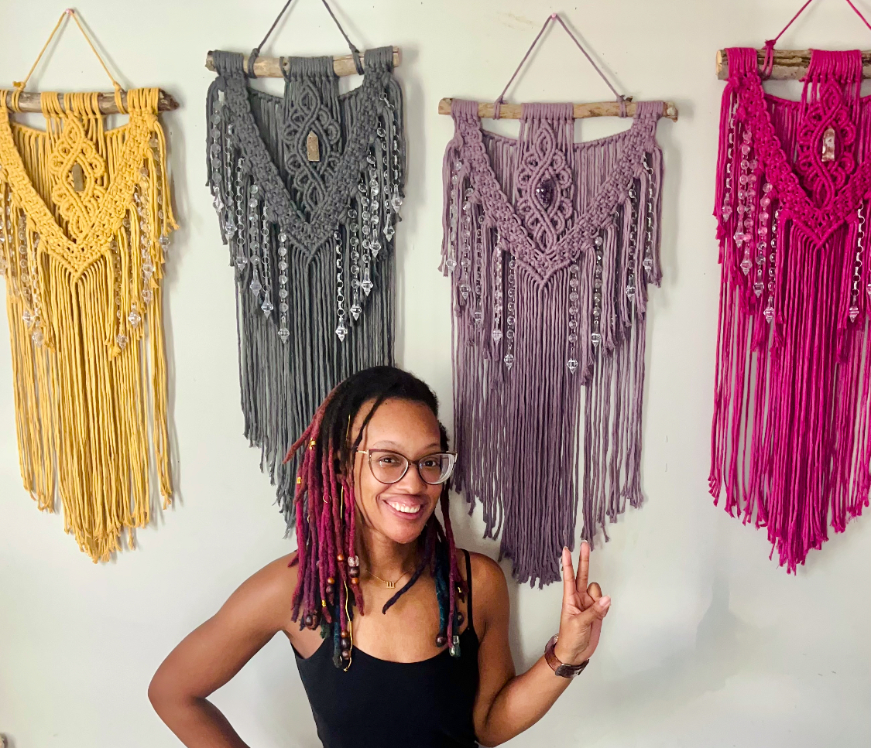

**CAN MISSION, MEMBERSHIP, BOARD of DIRECTORS, and COMMITTEES**

**MISSION.** The Cambridge Association of Neighborhoods (CAN) fosters neighborhood cohesion and community involvement to enhance the quality of community life for all residents of Cambridge through community events, social activities, and neighborly assistance. CAN protects and enhances properties in Cambridge by improving building and zoning codes, supporting adherence to those codes, and engaging constructively with City Government, including the Historic Preservation Commission. CAN’s Bylaws can be found on the CAN website at [*https://cambridgecan.org/welcome/about/bylaws/*](https://cambridgecan.org/welcome/about/bylaws/)*.*

**MEMBERSHIP.** CAN welcomes members from **all Cambridge area neighborhoods** (broadly defined) who are interested in organizing and working together, building a diverse membership reflecting the diversity of Cambridge residents. **Membership is FREE** – information is available on the CAN website at [*https://cambridgecan.org/join-can/*](https://cambridgecan.org/join-can/)

**CAN BOARD OF DIRECTORS.** CAN is governed by a Board of Directors elected by CAN members at its annual January Business Meeting. Board Members: President – Chuck McFadden; Vice President – Roman Jesien; Treasurer – Dave Thatcher; Secretary – Kim Miller; Members at Large – Andre Duerinckx, Mary Ellen Jesien, Brad Rice, Sharon Smith, Donna Tower, and Judd Vickers.

**CAN HOUSING QUALITY COMMITTEE – PLANNING AND ZONING ISSUES.** The Housing Quality Committee monitors issues affecting the quality of housing and the maintenance of property values in the City, including code enforcement. Committee members attend Planning Commission meetings to monitor zoning-related issues and report the information to the Board and membership. *Please contact* Chuck McFadden at [*Ragtime31@gmail.com*](mailto:Ragtime31@gmail.com)to volunteer.

**NEIGHBORHOOD DEVELOPMENT COMMITTEE – SOCIAL EVENTS & ‘NEIGHBORS HELPING NEIGHBORS.’**

"Neighborhoods" are organized by small groups willing to work together to address neighborhood issuesthrough small social events and "neighbor-helping-neighbor” activities. The **Social Events Subcommittee** organizes community-wide events. *Contact* Chuck McFadden at [*Ragtime31@gmail.com*](mailto:Ragtime31@gmail.com) to volunteer.

**CAN COMMUNICATIONS COMMITTEE – WRITERS NEEDED**. CAN'S Communications Committee needs writers, including volunteers to take unofficial notes at public meetings. *Contact* Chuck McFadden at [*Ragtime31@gmail.com*](mailto:Ragtime31@gmail.com) to volunteer.

**POWER WASHER AVAILABLE**

CAN has an electric power washer available to members. Contact Chuck McFadden at [*Ragtime31@gmail.com*](mailto:Ragtime31@gmail.com)*.*