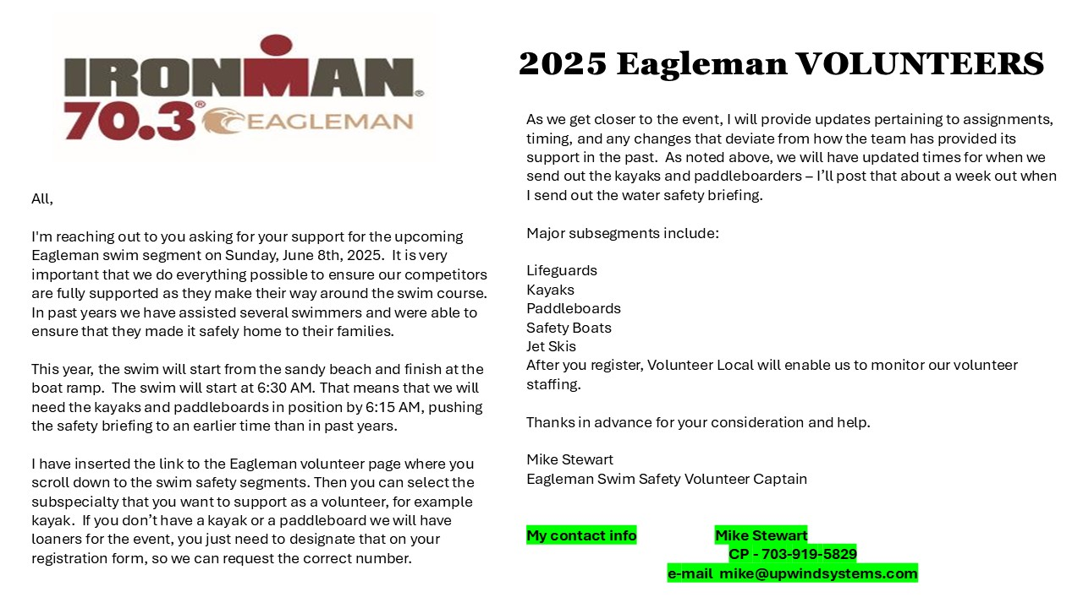
Attention! 2025 Eagleman Volunteers for the Swimming portion of the Triathlon!
Register here at the IRONMAN 70.3 Eagleman Website:
Volunteers Register Here

