CAMBRIDGE ASSOCIATION OF NEIGHBORHOODS

PUBLIC MEETING MINUTES

JUNE 18, 2025 6:30 PM
CAN Meeting
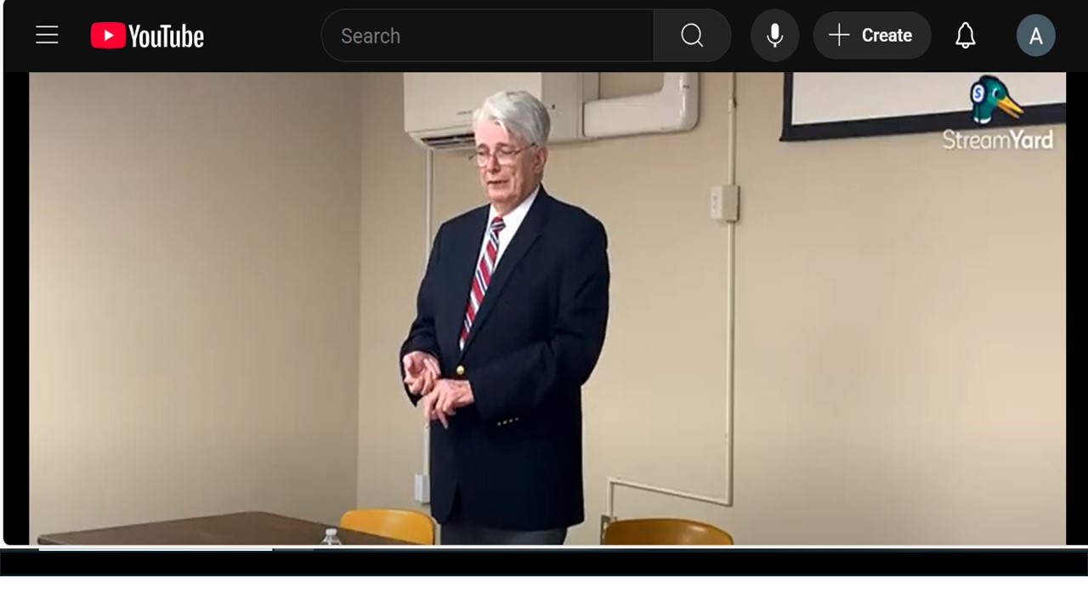
Board Members Present: Chuck McFadden, Sharon Smith, Judd Vickers, Roman Jesien, Mary Ellen Jesien, Donna Tower, Alison Kennedy
Board Members Absent: Brad Rice, Dave Thatcher, Andre Duerinckx
Introduction
The meeting began with introductions of everyone in the room.
Chuck McFadden, President of CAN, spoke about reviewing the city budget this year with City Finance Director, Perry Peregoy. He explained the 44 different revenue streams that come into the general fund that must be managed. He commented that it was the most sophisticated budget he had seen executed by the city over the last 20 years. The finance staff is composed of six people and they do a great job. He praised Mr Steckman for creating a Maintenance Reserve fund for the city to handle things that breakdown unexpectedly and providing monies set aside for city salaries.
Presentation
Glenn Steckman has 35 years experience as a city manager. Early in his career, he served as city councilman for 10 years in Ocean City, MD. Since then, he has held the position of city manager in multiple cities in Pennsylvania, Maryland and lastly in Gnome, Alaska before coming to Cambridge. Mr. Steckman gave the assembled audience a short synopsis of his wealth of knowledge dealing with bankrupt cities, overhauling a wastewater station costing millions of dollars, solving a municipality’s long list of unsolved sexual assaults and bringing the police department back to accreditation and respect. He believes he has developed a specialty for cities that are facing multiple challenges.
Mr Steckman shared the positive news about Cambridge:
- The city is financially stable at this time.
- There is roughly $5m unrestricted in the bank.
- Audits are done.
- He wants the city council to convert to a discipline where certain monies are controlled by an ordinance rather than a resolution. If you want to take money out or spend it for something, it requires public notice and two votes by the council. It alerts the community that money is being tapped into that has restrictions on it.
- Looking to make a “Rainy Day“ fund that is more restricted. He does not want to tie up all the money but does want to make sure there is thought that goes into the process.

The budget presented is the city manager’s budget. Mr. Steckman and the Finance Director, Mr. Peregoy, spent many hours with department heads to make sure their needs were covered.
The budget includes:
  - A salary study to make sure that the city employees are being properly compensated.
  - A study to evaluate the water and wastewater rates.

The sewer system pipes are underground and no one is sure about the condition of the system overall. The city has found wooden pipes transporting waste and water. There are regular overflows in areas facing the Choptank. One of the pump stations was upgraded. Another pump station at Trenton Street will need to be overhauled and it will be expensive. It is next to a six story building and pilings must be driven into the ground. The construction company is worried about disrupting the foundation of the building. Mr. Steckman said he will be asking the state for money to help with the overhaul of this pump station.

The percentage of low income families in Cambridge is down 51%. Once we go below 51% before the year 2030, our ability to use grant money will go away. The city will have to demonstrate an improvement made with grants is good for the entire community. Perry Peregoy explained that Cambridge is considered a “distressed community” at this time. The ability to get grants and use the money in a way the city finds favorable will be restricted when the label of “distressed” is removed. Mr. Steckman said that we have a lot of work to get done. When the “distressed” designation goes away, community block funding will have to benefit the whole city not just a section of it.

Updates on Projects/Hot Topics

CWDI
- They are meeting every month now and meetings are recorded and on townhall streams website.
Cannery Park
- They are clearing out the concrete and will be constructing a dog park this summer.
- It will tie more into the pool area.
- There will be a sprinkler system for the children to run through.
- There will be a low key skate park built.
Paving
- Waiting to hear from David Bramble to start the 2.5 miles of repaving of roads the city is doing this year.
- The corner ramps are being updated to meet ADA standards.
Cannery Way
- Took down all the invasive trees that should never have been planted along the alley.
- Bollards will be placed at the end of Cannery Way to prevent car travel.
- The city will be working with Alpha Genesis to move the brick wall which will open up the area. Currently it is 8 feet in from the city line.
Press Releases
- Trash Cans
- Grass Cutting
- Addressing cars being parked the wrong way
Rental inspection
- Will begin taking place soon
- Hired another Code inspector
HUD Apartments
- Bradford House had a fire last week and 19 apartments were condemned. The new management company responded quickly and got residents into hotel rooms.
- The Altair Apartments have a lot of attention now. Both Bradford House and Altair are HUD managed facilities. It is not unusual for the city to have to step into the management of HUD facilities. Mr Steckman has been dealing with HUD managed apartments for many years.
Group Homes
- The issues with the group homes and definitions of similar businesses as assisted living facility and halfway house need to be addressed.
- Waiting for the language definitions of the different types of facilities to come up before the city council.
- Most of the regulations surrounding these types of facilities are under jurisdiction of state and federal government.
Miscellaneous
- Must borrow $1.5m to replace the HVAC system in the Public Traffic and Safety building.
- Maintains an open door policy. He is in the office on certain weekends.
- Looking into new signage and street markings for the city.
- Cambridge needs to grow their industrial presence and bring businesses to downtown.

Q&A
- Status of North Star Village on Cannery Way?
- Partnership project between Alpha Genesis and the city on Cannery Way. Will not be built this summer.
- Alpha Genesis has received state funding for this project to recreate where Harriet Tubman lived and to tie into the Harriet Tubman mural and museum and make it a bigger attraction.
- Alpha Genesis had wanted public bathrooms available on the city owned part of Cannery Way.
- The city would have to find reliable staff to take care of that bathroom which is a challenge.
- Money was promised to Alpha Genesis 2 years ago. Senator Mautz got money from the state, a $500,000 grant (state contributing $300k, the city contributing $200k). The money from the city was never fully executed. The city budget contains the remainder of the funding ($112k).

- Comments by Mr. Steckman on ARPA Funds
- ARPA Funds (America Rescue Plan Act) – federal funds given to provide financial relief during COVID.
- Mr Steckman found that municipalities treated the funds more like play money.
- Cambridge got $13.5m in ARPA funds
- Cambridge bought a $1.7m fire truck, many other city vehicles, property for the Land Bank fund, $2.5m to paving, $1m given to charitable organizations.
- Mr. Steckman would have probably put the money toward getting the City Hall renovated.

- Question about the 51% drop in low income families – won’t the increase in tax revenue created by more homeowners coming to town offset the loss of grant money Cambridge now receives?
- Answer from Mr. Steckman and Mr Peregoy: No, there is not a dollar for dollar match. Even with the new homes being built around the Hyatt, which will bring in about $1m in tax revenue. Right now, Cambridge gets grants that are between $3m - $5m, due to the “distressed community” designation.

- How has the tightening of grants from the state and federal government affected Cambridge?
- Answer: So far the worst has been the loss of the FEMA BRIC grants for the shoreline resiliency project. We were promised $17m - $19m by FEMA.
- Hopefully, someone will help us fund this in the future.
- On top of climate change, Cambridge is sinking so solving our shoreline issues are critical.
- What complicates things is that our Engineer, Bucky Jackson is leaving to go teach at Easton high school.
- We may have to have a company help us with engineering decisions temporarily. Hiring a civil engineer will cost us a lot more money.
- In addition, we have been unable to get a junior engineer and the county has also been unable to fill their position.

- Rental properties that are vacant over 90 days are supposed to convert back to single family homes. Do you support this regulation?
- Buildings that have fires, and have been vacant for 90 days must be given time to renovate. As long as the owner is moving with the insurance company, they need the time to repair. Insurance companies are a problem in acting in a timely way. The house in question had 3 apartments and no fire escape to the third floor. Where was the Fire Marshall on that situation?
- Having active rental inspections will help and we are going to try to enforce it. The city must see the building before the law can be enforced.

- The way the law is written, 90 days is supposed to allow time for renovation after a fire has occurred. 1105 Locust had a fire and was vacant for 2 years.
- Answer: I refer to the city attorney on issues like this. I have to abide by what the city attorney tells me to avoid lawsuits against the city.
- Right now, we are having an issue with 200 High St which is bank owned. The roof has a hole in it. We are having this conversation now with the city attorney; what do we have to do to be able to go on the property without notice to put a tarp on the roof until the situation is addressed?

- Question about 123 Choptank Ave. which had been converted to a 2 unit apartment building then sold. The distant owner is slowly making some repairs but it has been over 90 days. The workmen on the property said that the building remains 2 units like it was before but it should revert back to a single family home. It was a terribly managed property before and no visible outstanding repairs have been done to it that we can see.
- Answer: Need the cooperation of the Realty Association to enforce the 90 day rule. They should tell prospective buyers that the home must go back to being a single family home and must be rented as such. They are not doing that.
- On the city website is a portal to be used by residents to file complaints. These complaints get a number. When the complaint is solved, it goes away. I am encouraging everyone to use this portal to file a complaint and let us know your issue.

- Question about parking in downtown – the parking lot behind ThaiItalian is chained off. This prohibits parking for Second Saturday events and hurts business.
- Answer: I am going to disagree a little bit with you. There are plenty of parking areas downtown (e g. Behind Chesapeake College, Behind Blackwater Bakery, City parking lot). What we lack is signage telling people where to park.

9a. The walkways around Cannery Way are uneven and some are not ADA accessible. These were supposed to be fixed a couple years ago. Are these going to be fixed soon?
- Answer: There are many bad sidewalks in downtown. High Street’s sidewalks need addressing as well. The repair of the sidewalks are the responsibility of the property owners. We are signing agreements with property owners to repair their sidewalks. We bring in a company a couple times a year to take care of a number of them that signed up. We get a great price because the company knows they are going to get paid. All we need is time. The city has a very long list of things to fix. I drive around every Monday and send notes to the staff about certain properties. Many times they are aware of the issues with those properties. I bring it to the attention of the code officer but it is still his decision on how he disperses that information to his officers. We do not have a large enough staff of people to do the work so please be patient with us.
9b. What about the ADA regulations? The sidewalks are not compliant to regulations that were made 4
years ago.
- Answer: If you feel that things are not following ADA regulations, you can file a complaint with the state.

- The Land Bank was launched a few years ago to come down hard on slumlords. Will that be supported and continued?
- Answer: It will be an independent organization and will not be run by the city. It will be run by citizens. We are working with our attorneys on the logistics of how it will work so we are in compliance with Maryland law. I believe we will be the first municipality in MD to have a Land Bank.
- One of the problems is that Rental inspections were at first very strict when first rolled out. The inspections were then rolled back for a time. Now they are becoming strict again.
- There is one liability and this is why I am so cautious. The city could be subject to being sued if inspections are not up to standard.

- Why was the tax money given back to CWDI and the 2024 taxes abated?
- Answer: CWDI, while it is an independent organization it is also a child of the city, county and state. State regulations make CWDI a development organization but it should really be treated as a nonprofit. They're developing the property for the city because we're trying to increase the tax base. CWDI went to the county and the county wanted to abate the taxes. I didn't see a problem with it. The goal is to get money back into the organization because they have operational costs and they have to pay insurance.
- Jerry Jones, County manager, and I are ex-officio members of the CWDI board and have been meeting monthly to build a working relationship between city and county. It is because there was no blow up with the county by the city that our tax differential was preserved.

- What is happening with the WBOC tower and the land next to Gerry Boyle Park?
- Answer: We were hoping to get the tower down this year. There is a lot of responsibility with that tower because the light must be kept lit. The land was purchased with grant money dollars so I would have to investigate whether the building could be sold.

- What is being done to bring back the properties on Pine Street and revitalize the neighborhoods around Pine Street?
- Answer: There is quite a bit of housing that is taking place in the Pine Street area. Initially, it was mostly Habitat for Humanity that was refurbishing homes in that area. Over the past year, there have been homes built on Douglass St and Chesapeake is coming. The housing should be affordable for people living in that area. Some of it is subsidized housing by state funding. Secretary Holt is responsible for bringing money to Cambridge and that is how the homes on Douglass Street were built.
- Code enforcement will help keep community homes up to standard. Right now we are dealing with homes being overrun by mice.

