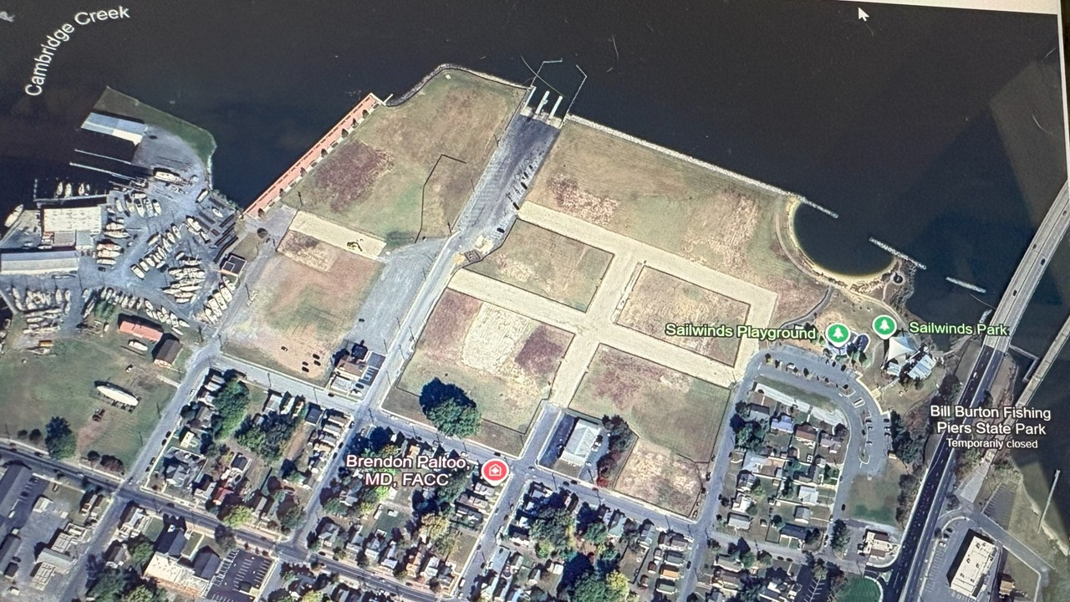

CWDI Partner Meeting
Wednesday, August 27, 2025 at 6:00 PM
501 Court St. Rm 110, County Council Bldg
County Council Members were in attendance, Commissioner Shay Lewis-Sisco, Ward 2, Brett Summers, Ward 1, Mayor Lajan Cephas, City Manager Glenn Steckman, County Msanager, Jerry Jones, Perry Peregoy, City Finance Director

The highlights:

- Concept design documents that were shared at the CWDI Community Meeting on July 31 were shown to the County Councilmen.

- Commissioner Brett Summers, Ward 1, asked about the old Burger King site and what was planned for that. Tim Crosby, Planning Committee of CWDI, shared that it is part of Phase 1. CWDI would like to have a new mural that would be a beautiful entry into Cambridge. Summers encouraged CWDI to include this in their presentation to get the community excited about the project.

- Concerns raised by County Councilman Ricky Travers - timeline of CWDI regarding the hotel. Needs to start Phase 1 ASAP. Jan 1, 2026 is supposed to be the start date. City Manager, Glenn Steckman confirmed that things are moving in a positive direction with the hotel. The hotelier would like to bring a hotel brand like Hilton or Marriot to the site.

- Concerns of Councilman Mike Detmer - green space too big at the waterfront. Community can't afford to devote so much space to that. He stated there are parks in Cambridge that are underutilized and can be used for events. The waterfront development must be an economic driver. Suggested a boardwalk by the water instead. He is concerned about the limitations on the residential units to a 3 story maximum. Thinks they should go higher if the developer wants that. Concerned that density isn't being maximized. Concern that there are limitations being set that will interfere with developers' interest in the site. He commented that CWDI sounds more like the developers of the site.

- Mayor Lajan Cephas supported Detmer's statement that Cambridge has some beautiful parks that are underutilized.

- Concern of Commissioner Lewis-Sisco, Ward 2 -CWDI said that the green space on the water could accommodate 4000 people. Compared to the Freeman Arts Center in Delaware. Where are the parking areas for those people. Consultant, Ken Usab, said the people would have to be shuttled from a designated parking area.

- Comments by Commissioner Brett Summers, Ward 1 - He is working with Ed Johnson from Network Realty Partners. They are trying to generate interest in the site. They have been contacting brokers, national and international. They have gotten some real interest. One broker from Easton and one from Baltimore. In all, 5-6 brokers showed interest. Tim Crosby on CWDI board showed some prospective brokers the site and CWDI's vision for the area.

- Multiple councilmen expressed concerns of CWDI moving ahead with their concept designs. They have been moving through Planning and Zoning since January 2025 with their plans. Soon they will go before city council for approval of their plans. This could very much be a timing issue. Concern raised that things are being locked in and becoming too rigid before developers involved.

Notes by CAN Acting Secretary, A. Kennedy

