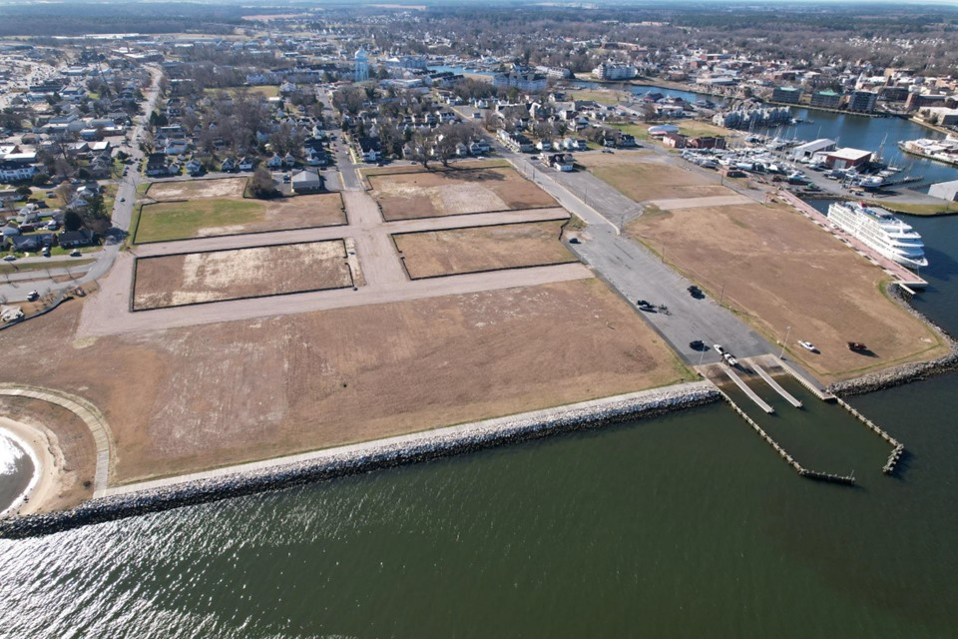
CWDI Board of Directors Meeting Notes, September 11, 2025 – by Sharon Smith, CAN

Present: Angie Hengst – President, Michael Frenz – VP (remote), Frank Narr, Tim Crosby, Gaver Nichols (remote), Bernard Brathwaite (remote), Natalie Chabot (remote), Glenn Steckman - City Manager, Jerry Jones - County Manager

Outreach and Communications Committee-Angie Hengst
Several “trash free” park signs have been installed. More will be installed as construction allows. A Partner Meeting was held with city and county representatives on August 27th and went well and useful feedback was received.
The board discussed requests for information from the public. Angie Hencks suggested that requesters be directed to obtain information from the source to ensure accuracy and timeliness. Glenn Steckman encouraged board members to reply to requests straightaway if they have the information and be as transparent as possible.

Finance Committee – Frank Narr
YTD July financial statements were voted on and approved. Use of property sales proceeds reported to the city and county for August. $561K cash on hand.

Planning Committee – Tim Crosby
An agreement with the hotelier is being drafted with a target date for signing in October 2025 and construction beginning in December 2026. This will “activate” the site, which is a requirement for issuing bonds (TIF) for infrastructure installation.
The zoning overlay for the site, being created with the city planning department, should be completed in October, after which it goes for approval to the city council and the planning commission. Public input sessions will be held prior to approvals.
The RFP for a commercial broker has been completed and the board voted unanimously to approve it. It will now be published in the marketplace where there is reportedly interest in the opportunity.
Yacht Maintenance’s large travel-lift construction is on schedule.

Executive Committee – Angie Hengst
The job announcement for Chief Administrative Officer, previously the Chief Executive Officer position, has resulted in several promising applications. Interviews are being conducted.
A meeting with Maryland Department of Housing and Community Development was held on September 4th with Secretary Jake Day, previously Mayor of Salisbury. Future funding needs were discussed, and the state remains committed to supporting the Cambridge Harbor project.
CWDI, the city, and county leadership are penning a letter of support to the Department of Natural Resources for the fishing pier. The pier may be as much as 2,500’ in length, which allows access to larger, deeper dwelling fish and be a competitive advantage in drawing visitors. Tie-ups at the pier will not be allowed to ensure free access for people fishing.

Public Comments
Concerns were expressed about the level of detail and elapsed time that CWDI is investing in planning the site, given that there is a desire to obtain creative, fresh ideas from potential developers. Tim Crosby confirmed that detailed planning and zoning now will allow for a speedier, smoother development process in the future.

The next monthly CWDI Board of Directors meeting will be held on October 9, 2025, at 4pm in the City Council meeting room at 305 Gay Street. The public is welcome to attend.
The board meetings are available for viewing on Townhallstreams.com

