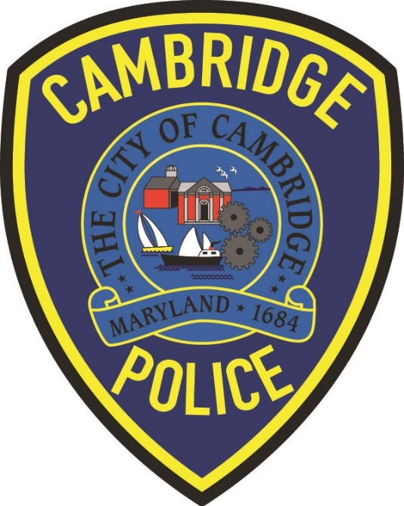

Police Chief Todd of the Cambridge Police Department recently spoke with residents at the CAN meeting about police work statistics for 2025. There were some questions about the difference between the entities the Police Advisory Board and the Police Accountability Board. This is the difference.

The Police Advisory Board
The Police Advisory Board has been a board that has existed within the City for many years. The board is made up of representatives that are appointed by city council members from each of their respected wards that they serve. The Mayor and one council member also sit on the board as well. We usually meet quarterly to go over what is happening in the Police Department and any issues, complaints that have been brought to members of the Police Advisory Board for us to address. As I mentioned at the CAN meeting the other evening, I want to have the board be more involved, by being able to pass information along to the members and have them assist in pushing information out to citizens, while bringing information back to the Police Department.
Police Accountability Board
The Police Accountability Board was established due to the Maryland Police Accountability Act established in 2021 which monitors police accountability and discipline across Maryland. Each County in Maryland was tasked with developing a Police Accountability Board to oversee police conduct and improve policing practices. This board is responsible for receiving complaints of police misconduct. The board is made up of civilian members and holds quarterly meetings with heads of law enforcement agencies throughout the county to improve matters of policing. The board also receives complaints and appoints civilian members to the Dorchester County Administrative Charging Committee who reviews outcomes of disciplinary matters.

