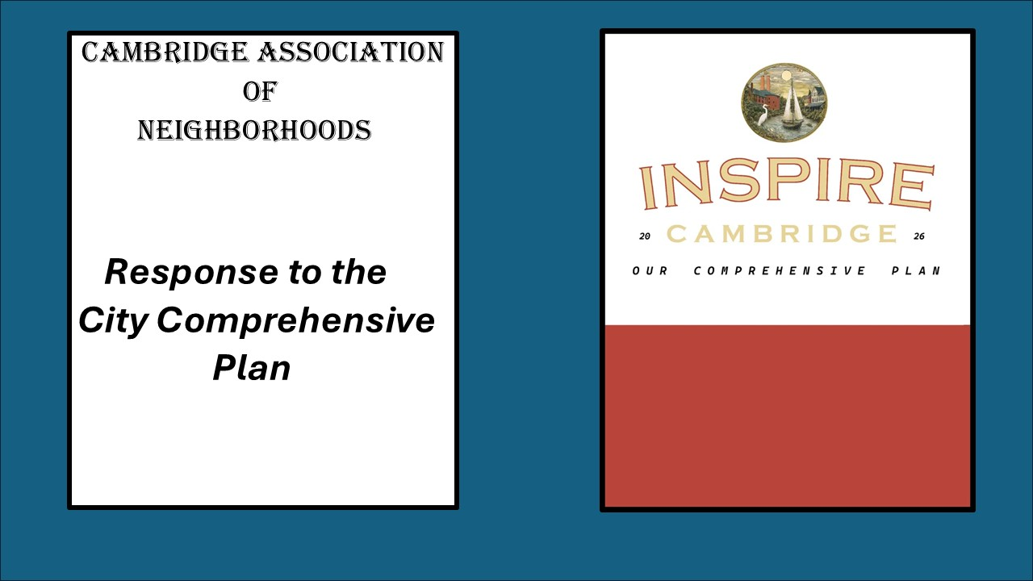

The Cambridge Association of Neighborhoods (CAN) Comprehensive Plan Committee reviewed the Plan draft over the past several weeks. We offer feedback on the Plan’s ideas and policies. We appreciate the opportunity to review the proposed plan and would be happy to meet at your convenience if you'd like to discuss. Many thanks for your efforts.
CAN appreciates and acknowledges the effort and proposals in this Plan. The Plan is based on the “Five Big Ideas” that came out of the charrettes: Make the downtown vibrant and multi- generational, new development should create great places, safe comfortable streets for walking and biking, connecting the city to the waterfront and add cross city trails, and build for the future, an infrastructure that is sustainable, resilient and equitable. These Five Big Ideas drive the Plan through all of the Chapters. These ideas are broad and can be interpreted in many different ways.
In general, the Plan effectively presents a comprehensive vision of a well-designed and secure small-town community. Strengths we see is that some items appear cost effective and could create immediate, satisfactory results. For example: bike lanes, reconfiguring wide roads, planting trees. Other strengths of the document include the inclusion of community concerns and a focus on culture and diversity.
These are some of the chapters that we support strongly in relation to the 5 Big Ideas. Chapter 3, Sensitive Areas, which suggests the rehabilitation of brownfields and utilizing those lots for other things. Chapter 4, Community Design and Historic Preservation, has desirable design suggestions and policy considerations. Chapter 6, Mobility and Transportation, talks about a trolley and a water taxi to connect areas of Cambridge and offer alternative travel. Chapter 10, identifies parks and trails that will connect across the community, bringing people together. Chapter 11, Cultural Resources, identifies many of the cultural resources that Cambridge is proud of and attracts people to visit us. Chapter 12, Economic Development is extremely important to Cambridge’s future. Cambridge is at an inflection point and without studious attention to how development is allowed to proceed, it is ripe for exploitation to the detriment of the community and its culture. Better to lead and guide than to become the victim of circumstances.
Even though the 5 Big Ideas capture the spirit and thoughtful participation of Cambridge residents, they remain mostly aspirational with few things that are actionable and measurable. The entire plan is driven by "5 Big Ideas" that were created by "visioning in the absence of data". The plan contains many "nice to have" improvements that will take money and effort, but will yield little economic growth or population growth. An example: The roundabout design for one of Cambridge’s entryways into the city, at Academy St and Maryland Ave. The roundabout is inviting. However, it will also highlight the fact that 2 major buildings on that roundabout are vacant and have remained vacant for several years.
The Plan prioritizes visual appeal but offers little substance on the deeper, more pressing issues such as the shortage of police, medical professionals, and educators. While our community urgently needs these professionals, the current median income makes it difficult to attract them to live and work here.
A common theme in the Plan is also to increase density throughout the City. This could be particularly impactful in the historic neighborhoods where aging infrastructure could be a concern. Additionally, restrictive covenants in some of the newer neighborhoods would likely prohibit any increase in density in those areas, increasing pressure in long established neighborhoods. We need to ask ourselves how much do we want to grow? Do we want to remain a small town, or become a small City?
There is no mention of the public school district in the plan. If Cambridge wants to attract families with children to live and work here, attention must be paid to the performance and overall presentation of the public schools. That picture has improved as far as MCAP scores over the past year, but many issues remain.
Chesapeake College has a satellite campus in Cambridge’s downtown. There needs to be more links between the college, the city and community resources, specifically the skilled trades and adult education.
Gentrification may appear beneficial in theory, but in practice it often pushes disadvantaged residents into more vulnerable positions. For instance, policies meant to support renters can backfire when landlords simply pass increased costs on to them. Older residents may unexpectedly find themselves unable to pay property taxes on homes they have occupied for decades, and their fixed incomes may be insufficient to cover the costs of necessary property improvements, such as sidewalk repairs or tree planting.
Below are CAN’s detailed recommendations regarding revisions to the language about neighborhoods as addressed extensively in Chapter 7 on Housing.
CAN requests changes:
Introduction – Page 1.17 - We strongly suggest the removal of the sentence “This includes converting larger homes into multi-family units.” Cambridge has a history of poorly managed apartment houses that were once single-family homes and has pursued a decades-long effort to reverse these poor conversions. See Page 275 of the Unified Development Code: Conversions of single-family dwellings into “dwelling, two-family” or into “dwelling, multi-family” are strictly prohibited.
Introduction – Page 1.7 - We support, within reasonable limits, missing middle housing and suggest that Paragraph 2, read as follows: Support development of a broader range of housing types, including missing middle housing (duplexes, triplexes, townhomes, accessory dwelling units and tiny homes), where appropriate and supported by adequate infrastructure.
Introduction - Page 1.39. Suggestion modification of Policy 1-2.1.2 as follows:
Historic areas under the purview of the Cambridge Historic Preservation Commission are governed by design guidelines adopted and approved by the Maryland Historical Trust. Therefore, areas under the oversight of the Cambridge Historic Preservation Commission will remain outside of other changes. The existing guidelines will not be subsumed by anything in the Comprehensive Plan or other actions.
Inclusion of two additional policy goals:
1) Administrative approvals by Planning Staff should be presented to the Planning Commission on the consent agenda; and 2) Ensure that “spot-zoned” institutional uses within residential areas revert to zoning compatible with the surrounding neighborhoods when uses such as schools, gyms, athletic facilities and churches cease to be viable in those locations.
Community Design & Historic Preservation - 4.3 - Additional community concerns not captured: 1) Vacant buildings could actually be highlighted by road improvements and a roundabout; 2) City should prioritize hiring or contracting an economic development team; and 3) City should consider annexing adjacent areas to grow tax base and manage growth consistently.
Housing – Page 7.5 We strongly suggest removal of the statement “Support cautious conversion of larger homes into apartments while preserving historic character.” for reasons as stated above.
Housing - Page 7.12 - We strongly suggest removal of “Incentivize adaptive reuse of larger or historic homes into multifamily units.”
Housing Policy 7-2.1.3 - We strongly encourage replacement of this policy as follows:
“Incentivize single-family use in historic homes and prohibit their conversion to two-family or multi-family. Gently increase density in historic areas by encouraging accessory dwelling units and modestly scaled new construction that fit the historic fabric of those neighborhoods.”

