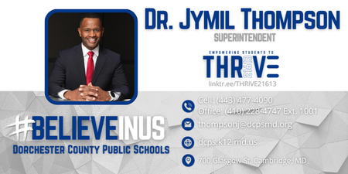
Sheila Johnson Jones and the rest of the Cambridge Association of Neighborhoods (CAN) board members invite you to our community meeting.

Guest Speaker: Dr Jymil Thompson

Where: Dorchester County Public Library 303 Gay St, Cambridge MD

When: Tuesday, August 18, 2026, 6:30 PM – 8:00 PM

Topics: *THRIVE 21613 initiative - A system of integrated community support designed to advance student success and propel economic mobility in the 21613 community of Dorchester County
*Elementary schools replacement project
*The Promis Pathway based on the Harlem Children’s Zone
*Concerning Cultural climate in the
schools…………..and more!
Please join us!

