Last week was a big deal

Friday, July 24, 2026
addition of walking trails on these paper streets,

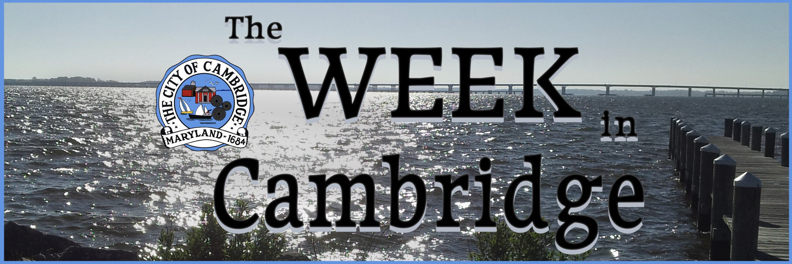
City Manager Glenn Steckman and Cambridge Chief of Police Justin Todd held the first Coffee with the Chief and City Manager event at the Pine Street Community Market. A few people came through and shared their thoughts. Items discussed included parking issues and helping more community seniors participate in the Walk for Wellness at 7 am on Monday and Friday mornings at Great Marsh Park.
In the same time frame, Commissioner Shay Lewis-Sisco held a community clean-up even in Ward 2. This was just the latest clean-up in the city, as part of the effort to promote beautification and make the city welcoming to tourists and potential residents.
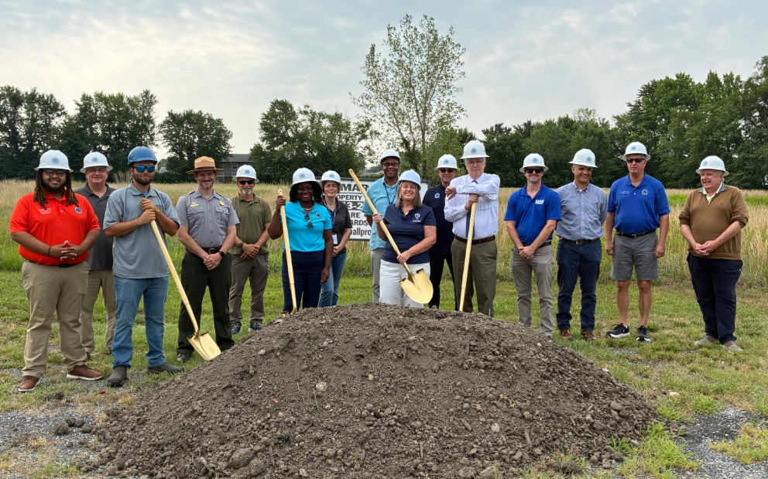
The city held a Groundbreaking Ceremony for Leonard Lane Park. Mayor Lajan Cephas-Bey said, “This is a wonderful opportunity to activate about three to four acres of space. Not only are we giving our children something to do, we're also connecting communities. … With the
it truly connects communities instead of allowing roads and streets to separate us.”
This phase of the project will include a parking lot, basketball court and infrastructure for other components of the project. Work will start in a few weeks and should be completed before the end of the year.
The Cambridge Police Department’s second quarter report is complete and was presented to the Police Advisory Board at their meeting.
Highlights include a reduction in Part A crimes, violent offenses, of 12.9% and a reduction of Part B crimes, the quality-of-life offenses, of 17.6% Chief Todd highlighted a notable decrease in burglary, larceny, motor vehicle theft and fraud.
Det. Sgt. Howard and Capt. Patton also reported during the meeting. Sgt. Howard shared that there is a slight increase in the number of juveniles being recruited for criminal activity, the number of scams being directed towards senior citizens and the number of mental health-related cases.
There was talk about the proactive work of the department, especially as it relates to work on
For more information, visit the City's website: choosecambridge. com. You can also call the city offices 410-228-4020 or the public

cold cases and testing of evidence using new techniques, improved organization and storage of records and evidence, and protecting the mental health of law enforcement officers.
Past and ongoing community activities reported include Walking for Wellness; the success of this year’s Flag Football League, with our team ranking 3rd in the nation; and the Passport to Manhood program for middle school boys. For the fall, Cambridge’s Night Out is tentatively scheduled for Oct. 7th and a Christmas Dinner for the Community on Dec. 18th.
The department is also considering repeating Cooking with a Cop again this year, reporting that it was great fun and a success the last time.
There was also discussion of our co-responder program, with the Chief noting that ours is one of only a few in the state and that we have gone over a year without a homicide in the city.

That’s Not All … Next Week
The City Council will hold its regular meeting at 6 p.m. on Monday, July 27 in the City Council Chambers on Gay Street. Resolutions for first reading include a resolution for adopting the “2026 Inspire Cambridge – Our Comprehensive Plan” as the comprehensive plan for Cambridge. If you are interested in reviewing the final public draft of the plan, it can be found at https://www.plancambridgemd.com/.
There are no additional resolutions or ordinances to be presented at this meeting. New business includes a report to the council on the Public Safety Building HVAC Replacement Study and a request for approval, and information report on the HUD Lead Hazard Reduction Capacity Building Program, the approval of the city representative to the Cambridge Waterfront Development Board (CWDI) and the approval of the Land Bank Board. Chief Todd will also take questions from the Council on his second quarter report.

CPD Partners with Affiliated Santé Group

Cambridge Police Department (CPD), in its ongoing efforts to provide value-added service to the community, has partnered with Santé to
enhance the flexibility and functionality of crisis intervention in Cambridge. Together, they are implementing a Co-Responder Mobile Crisis Program in the area.
The co-responder system addresses this by partnering CPD crisis intervention team officers with a behavioral health clinician to respond to individuals in crisis. This model makes a wider variety of resources available at the start of an incident, providing a greater probability of the best outcomes.
This partnership will include ongoing critical incident training. Chief Todd describes these training sessions as crucial. He hopes the community will see the partnerships the department is forming to add to their benefit to the community will “build trust and bridge gaps.” He added that it is more important to note that “the police will know how to find the resources to help with whatever situation they find themselves in.”
Santé, a nonprofit behavioral health crisis response and outpatient provider who has provided crisis services on the Eastern Shore since 2010, is excited to expand the crisis services they provide to Cambridge. Michelle
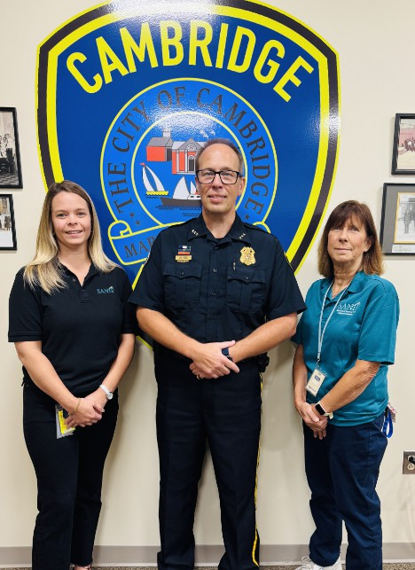
Grigsby-Hackett, CEO adds “We are honored to be in partnership with CPD to provide additional supports to individuals who are experiencing a crisis and help with diversion from the criminal justice system.” They will be responsible for collecting statistics for accurate tracking of
program progress and effectiveness. The assigned Santé staff will operate from the Public Safety Building during the project.

This program comes to Cambridge at no cost, as it will be funded by $499,000 in Fiscal Year 2024 Congressionally Directed Spending secured by U.S Senator Chris Van Hollen.

